Listening Speaking Reading Grammar Writing

Topic:
Interesting Facts

Instructor:  Jin | Level:  Intermediate | Students:  # 7 | Length:  30 Minutes

Materials: Visual aids (Pictures #4)
Worksheet for vocabulary (#7)
Worksheet for main idea (#7)
Worksheet for O/X activity (#1)

Aims
- Ss will be able to comprehend the text through skimming and scanning.
- Ss will be able to practice speaking by sharing their own opinions about topic.
- I want to show them what the respect is. I want them to respect each other and have an open-minded to understand other’s opinion.

Language Skills
-Phonology : Theobromine[θì:əbróumi:n,-min], Xantheose[zǽnθi:n,-θin]
-Lexis : vertebra, mammal, fatal, Theobromine, equivalent
-Grammar : Present Simple Tense (locates or event in present time)
I/We/You/They + (Base form of )Verb, He/She/It + (Base form of) Verb -s,-es
-Function : Giving Information
-Discourse : Discussion

Language Systems
-Reading : Ss will read script of topic through skimming and scanning.
-Listening : Ss will listen ideas about the article from other people.
-Speaking : Ss will discuss about “Interesting Facts that you should know” and share their own ideas.
-Writing : Ss will make sentences after seeing the pictures.

Assumptions
-Ss should know most of vocabularies from the passage.
-Ss should know how to do skimming and scanning.
-Ss should know some common sense.

Anticipated Errors and Solutions:
-Ss are afraid to speak or show their own opinion : Encourage Students
-Some of Ss could need more time to finish their activity
: Be flexible with time. Give Ss more time to finish it.
-Some of Ss could lose their attention to lesson
: Teacher will care about them keeping eyes on and asking some questions to Ss.

References:
Visual aid http://xaxor.com/funny-pics/20414-funny-interesting-facts-in-drawings.html
http://corporatechrist.co.uk/tag/interesting/
Main script and activity Qs http://www.interestingfacts.net

Dictionary

Lead-In
Materials: None
Time | Set Up | Procedure
2min |  | Hello. Guys! How are you doing, today?  Do you know any common senses? Yes/No  How about this one?  Is it true that a giraffe’s neck has the same amount bones as a human’s neck? (Yes. 7 bones)  So then, How many bones in a duck’s neck? (More than a giraffe’s neck has)

Pre-Activity
Materials: Visual Aid (4 Pictures, White Board and Maker), Worksheet (Vocabulary)
Paper for activity
Time | Set Up | Procedure
1.5 min  2.5  min  2.5  min | Whole  Class  Pair  Work  Whole  class | - Brainstorming  Elicit and Demo  (Show the students visual aid – the picture of interesting facts)  There is a picture I’m holding.  What can you see in this picture?  -The statue of liberty, Pyramid..  What do you think this picture express?  -The statue of liberty was intended for Egypt.  Have you guys known about this fact before?  -Yes/No  Model  (Write down on the board)  “ Interesting Facts ”  Today, I wil introduce the topic that raises your interest.  - Warm up  -Teacher hands out 3 pictures about interesting facts that Ss may not know.  -“Lets guess the picture like we’ve done before with your partner”  -I’ll give you 1.5mins to discuss about that picture and then you guys present your idea for other friends..  Monitoring  Monitor discreetly. Guide Ss if they ask questions.  Check Answers  -How do you guys guess about the picture?  -Ss present their ideas.  (If Ss might guess different way, encourage them.)  -Answers  (Mosquitoes are attracted to people who have just eaten bananas.)  (French fries did not originate in France)  (The chicken is the closest living relative to the “T rex”)  - Pre-teach vocabulary  Instruction  Before studying the text about Interesting Facts, we’re going to learn about new vocabularies.  Matching Activity  (Handling out the worksheet for Vocabulary)  -Try to match the vocabulary with definitions individually.  - Word list : vertebra, mammal, fatal, Theobromine, equivalent  -I’ll give you 1.5 mins because it’s quite easy to figure out.  ICQ  -Is it pair work or individual work?  Checking answer and feedback  -Teacher checks the answers with Ss.  : The answer is B-D-A-C-E  -Teacher gives Ss feedback  : Great work guys. Now, you have ideas about topic. Are you ready to start learning more about Interesting facts. Okay-

Main Activity
Materials: Worksheet for Interesting facts, White board and marker
Time | Set Up | Procedure
2min  2min  2min  6.5  Min | Whole  Class  Pair  work | (Write down on the board Q1. Q2)  Q1. Can giraffes go without water longer than camels?  Q2. Does human cry because of feeling?  (Handling out the worksheet for main ideas)  - Skimming the passage  -You’re going to skim the passage. After skimming, try to answer the questions.  -Feedback after Ss answer  :Nice.. You’re the fastest skimmer in our classroom ^O^  - Scanning the passage  -Teacher tells the Ss. This time you are going to scan the passage and share the ideas what you read. This work will be with your partner.  -Teacher gives time to SS for 2mins  Monitoring  Make sure Ss focus on the passage or not.  - Sharing ideas about the passage.  -Telling the things each other for 2mins.  Monitoring  Monitor discreetly.  CCQ  Okay, Times up  (Pick 2 students)  -Can a lion mate more than 50 times a day? (Yes)  -Do elephants have no knee? (No, They are the only animal with 4 knees )  - Activity (O/X quiz)  -Let’s play the O/X quiz  -Teacher participate as an examiner  Instruction  .-Guess what the right sentence is.  -Last one who remaining person is winner  .-If you think the sentence is right, go to O side  If you think the sentence is wrong, go to X side..  Demonstration  -Teacher asks about question. Ss answer it  Teacher: Cold weather makes fingernails grow faster.  Students: O or X  : The answer is O. If you’re standing O side, you can keep participating the game. Unfortunately if you’re standing X side, back to your seat and watch the other people’s answer comparing with your answer.  This time was practice.  ICQ  -If your answer is wrong, Are you going to join next quiz?  -Who will be the winner?  Activity and Monitoring  Teacher checks question and answer  Try to make Ss to focus on activity  Teacher has to check the time  Error correction : If it is needed  Times up.  Closing  -Good job, guys!!, Great! Awesome!  -How was an activity?  -Did you have fun?  -Was it a bit difficult?

Post Activity
Materials: None
Time | Set Up | Procedure
9min | Whole  Class  Group  work | Now, we are going to discuss anything about interesting facts that you have known. Telling to friends things.that the other people may not know. Any topic is alight.  (Ex) How to clean sink, Secret ingredient, Useful idea for living life, Food….  Teacher’s Demo  Do you know?  Strawberry itself doesn’t make the milk turn pink.  They usually use food cosmetic dye bugs which are bugs used to extract food coloring. They raise these bugs and once full  grown, boil them in water to extract the coloring. Then they use  this coloring to make strawberry milk into pink.  These bug are absolutely harmless and it’s not disgusting to drink strawberry milk because it is pasteurized.  Discussion  -Do you know anything about Interesting facts?  -Let’s make 2 groups. (Dividing 3people and 4 people)  -I’ll give you 5 mins to discuss.  ICQ  -How much time do you have?  -Are you going to tell your own ideas?  Monitoring  Monitor discreetly. Guide Ss if they ask questions.  Times up.  Presentation  -Did you share any Interesting things?  -Let’s share facts to the other group.  (If Ss doesn’t answer spontaneously, pick any 2 people in a group)  Error correction  If necessary.  Feedback  -Wow. You guys know many things!  -Were you interested in this topic?  -Did you learn something from others?  Conclude lesson  Today, We study about Interesting facts. Hope you guys know new information through this lesson and hope you enjoyed time with me.  Thank you guys!

SOS Activity
Materials: A4 Paper #3, Pens
Time | Set Up | Procedure
5min | Pair  work | Making a poster  Now, please make a poster about what you discussed.  (Handling out A4 paper)  Work with your partner and make like this.  (Show them the picture I used before: French Fries)  You might draw key point of sentence and write down sentence any space.  Monitoring  Monitor discreetly. Answer and guide students if they ask questions.  Feedback  Okay, Let’s present to friends and put posters on the wall.  Everybody did great job. Thank you all.

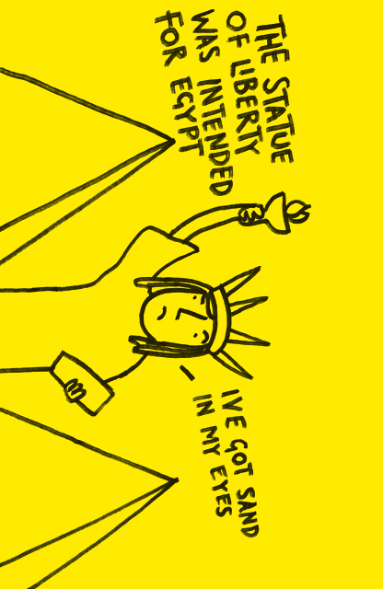(T)
(S)
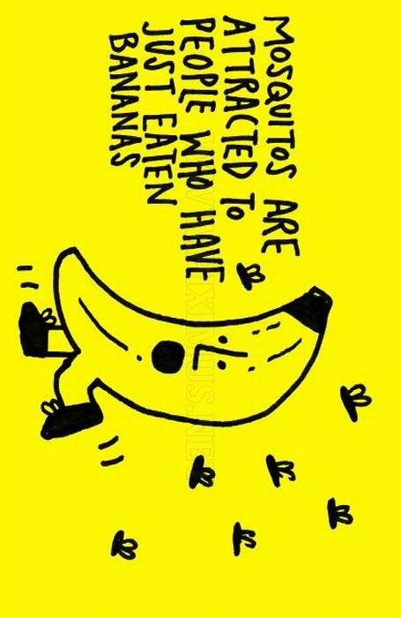(T)
(S)
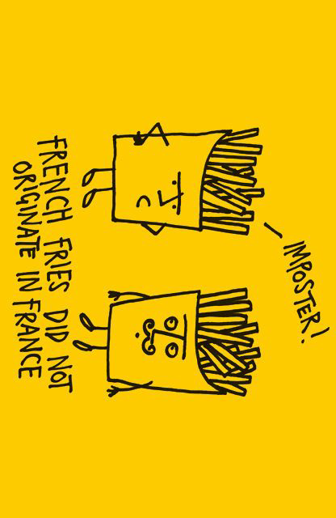(T)
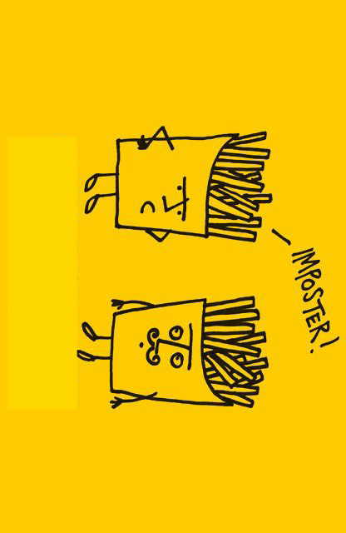(S)
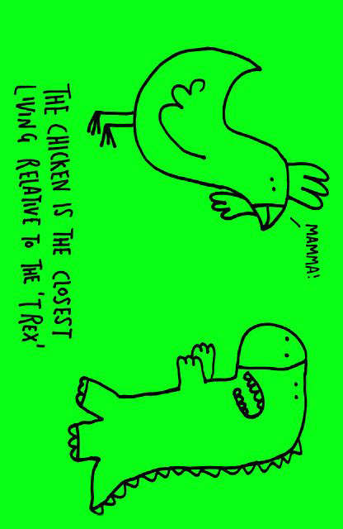(T)
(S)
Interesting Facts
-Honey is the only food that doesn’t spoil. To make 1 pound of honey, bees would have to visit over 2 million flowers.
-Did you know that the very first lemon seeds were brought to the Americas by Christopher Columbus?
-Giraffes can go without water longer than a camel. That’s wild!
-In 1938, Time Magazine chose Adolf Hitler for man of the year.
-Humans and giraffes both have seven vertebrae bones in the neck. It’s not unusual for a mammal to have 7 vertebra bones in the neck but it’s interesting that the long neck of a full grown giraffe has the same amount.
-More people are killed from donkeys in a year than planes.
-A lion can mate more than 50 times in one day. Huh!
-The active ingredient in most toothpastes is called sodium fluoride. Sodium fluoride can be lethal, young children using regular toothpaste with this ingredient should be monitored. Even swallowing small amounts can cause stomach problems or worse.
-There are no land snakes in New Zealand. It’s part of New Zealand’s bio security to keep all snakes out and if a person is aware of a snake, by law it must be reported.
-The color of a hens earlobes will usually determine the color of the egg shell. Farmers know hens with red or darker colored earlobes are most likely to lay brown eggs and hens with lighter colored or white earlobes will usually lay white eggs.
-Dogs can have a fatal reaction to eating chocolate. Chocolate contains a bitter alkaloid called Theobromine also known as Xantheose and that’s the active ingredient that’s bad for the dog.
-If an infant becomes blind soon after they’re born they will still almost always see images in their dreams, but infants born with blindness will most likely never have dreams with images. People who were born blind do still have very emotionally intense dreams which include hearing, smells, feeling and taste.
-Only humans cry because of feelings. Awesome!
-Squirrels forget where about 50% of the nuts they’ve hidden are. Useless.
-A person eats around 60,000 pounds worth of food during his life which is the equivalent of six elephants. Incredible!
-The only animal with four knees is the elephant.
-Did you know the first bullet proof vest and windshield wiper blades were both invented by women? Cool!
-Almonds are members of the rose flower family or rosaceae family. The peach is also a member of the rose family
Matching Vocabularies

Vertebra [|v3:rtɪbrə]
Ex) The horse broke a vertebra in the neck.
Mammal [|mӕml]
Ex) Elephants have a longer gestation period than any other mammal - nearly 22 months.
Fatal [|feɪtl]
Ex) Very severe radiation sickness is often fatal.
Theobromine [θì:əbróumi:n,-min], Xantheose
Ex) These jars had a chemical called theobromine in them.
Equivalent [ɪ|kwɪvələnt]
Ex) The two computers are equivalent in speed.

A. [ADJ] An action has very undesirable effects.

[ADJ] An accident or illness causes someone's death.

B. [NOUN] The small circular bones that form the spine of a human being or animal.

C. [NOUN] a white crystalline slightly water-soluble alkaloid that occurs in many plants, such as tea and cacao: formerly used to treat asthma. Formula: C 7H 8N 4O 2 See also xanthine.

D. [NOUN] animals such as humans, dogs, lions, and whales. In general, female mammals give birth to babies rather than laying eggs, and feed their young with milk

E. [NOUN] [oft N of n] If one amount or value is the same.

Activity (Questions about Interesting Facts)
- Cold weather makes fingernails grow faster. Weird!
- The tallest girl in the world ever recorded was 8 feet 2 inches tall and died at the young age of 17.
- A cat’s ear has a total of thirty two muscles.
- It’s true! There is only one metal that’s in liquid form at room temperature and that’s Mercury.
- Ants can pull about 30 times their own weight and lift about 50 times their own weight.
- Twelve people have walked on the moon but the last time was 1972 so it’s now been over 40 years since anyone has stepped foot on the moon.
- Jupiter is the largest planet in the earth’s solar system.
- It takes about 7 minutes for the average person to fall asleep.
- When water freezes it expands by 10%.
- Snails can sleep for up to 3 years.
- Lung cancer… That’s how the cigarette company Marlboro’s first owner died.
- Human brains are estimated to be 70 – 75% h2o.
- Four out of five people over 100 years old are women.
- If an infant becomes blind soon after they’re born they will still almost always see images in their dreams, but infants born with blindness will most likely never have dreams with images. People who were born blind do still have very emotionally intense dreams which include hearing, smells, feeling and taste.
- The average person laughs 15 times per day
- The average human with a full head of hair contains between 85,000 to 150,000 hairs.
- The price of the Titanic cost about $7 million to build and the price of the Titanic movie was about $200 million to make.
- The largest milk producing country by volume in the whole world is India.
- Some sharks lose over 30,000 teeth in a lifetime.

