Listening Speaking Reading Grammar Writing

You need to be brave for eating Korean foods

Instructor:  TSEliot Kim | Level:  Intermediate | Students:  4 | Length:  30 Mins

Materials:
Board & markers, some blank papers, pictures of Korean bizarre foods

Aims:
Main Aim: To enable Ss to improve their speaking skills by having Ss discuss the culture of Korean bizarre foods.

- Secondary Aim: Ss will talk about Korean foods by having Ss do a fill in the blank work sheet, learn singular and plural concepts, role playing in a restaurant, and having Ss create a new Korean dish.
- Personal Aim: I want to reduce my commentary.
.

Language Skills:

- Ss will listen to T’s instructions, explanations, and Ss’ talks.
- Ss need to speak during drilling, individual real play, and pair work.
- Ss need to read worksheet and fill in the blank.
- Ss should write their thoughts/ideas/answers to given directions.

Language Systems:

- Lexis: article, the definite article, indefinite article, a proper noun
- Phonology: none to discuss
- Grammatical: singular nouns and plural nouns
- Function: discussing other Korean bizarre foods, explaining what they are, discussing their tastes and feelings in terms of foreigner’s perspective and experiences
- Discourse: none to discuss

Assumptions:
- Some Ss may already know the vocabulary to present.
- Ss have had some positive/negative experiences with some Korean weird foods.
- Ss enjoy sharing some personal experiences on Korean weird foods.
- Ss have experienced culture shock with other national foods.

Anticipated Problems and Solutions:

Ss may not understand the meaning of words.
→ Provide more examples.
Ss may have a hard time drilling.
→ Encourage Ss to do it.
→ If Ss cannot correct their pronunciation by themselves, help Ss with it.
Ss may have some hard time doing individual or pair work.
→ Help Ss with matters but not so much.
If time is short,
→ Cut off post activity and ask Ss do homework instead.
→ Wrap up the lesson immediately.
If Ss finish practice activities earlier than anticipated.
→ Change partner, then practice conversation.

References:
Internet articles on Korean Bizarre foods
http://www.food.com/recipes/bizarre

Lead-In
Materials:
Board, markers, some pictures
Time | Set Up | Student Activity | Teacher Talk
3 | T-WC | Guiding Qs | < Greeting >  T: Hello, everyone. How are you today?  ( Engage Ss in the class with greeting talks)  T: S name, what is your favorite Korean food?  T: S name, what is your favorite western food?  T: S name, when was your last time to visit other countries? Which country? Did you have weird food?

Pre-Activity
Materials:
Board, markers, some pictures
Time | Set Up | Student Activity | Teacher Talk
1  3  6 | T-Ss  WC  WC | Eliciting  Grouping  Introduction  Demonstration  ICQ’s | (Showing Ss some pictures of weird Korean foods)  T: Good! Let’s take a look at the picture. From this picture, what do you see? Can you share whether you like them or not.  (Anticipate Ss to answer their experiences on the foods )  T: Thank you for sharing. What is a synonym for a weird food = Bizarre.  CCQ: Show a picture of an apple?  Ask: Is this a bizarre food = No  Show a picture of a mouse in the hamburger and say is this a bizarre food= Yes.  T: Ok, we are going to share our experiences of having bizarre Korean foods with your partner and make a two team.  T: Repeat after me and ShuRack, you are Weird and RadioGaga, you are Bizarre, Weird, Bizarre to other Ss….  T: Weird team, stand up and come to right side of class room and Bizarre team, some to left side of class room.  The craziest food I ever had was blood arkshell___Show a picture…  Instructions: Now, its your turn. Work individually  T: Discuss and share you crazy food experience for 3 minutes and write down three crazy foods to the paper  ICQ’s  What are you doing?  How much time do you have?  Are you working individually?  Explicit Instructions:  I don’t want you to start until I finish passing out the papers and I say begin.  Explicit ICQ’s  . begin when I give you the paper? =No  When I say “begin” =Y  T: one minute left 30 sec 10 sec.  T:Times up and Bizarre team, Weird team.  Who wears a watch today? A person who wears a watch is a writer on the white board.  (T draws a table on the white board with each team’s name)  Ss Present:  Grammar learning  T: is “two chicken foots” correct? =NO  What is correct? = two chicken feet  T: I will pass out a work sheet of singular/plural and you can do it at home.

Main Activity
Materials:
Board, markers, demonstration dialogue paper

Time | Set Up | Student Activity | Teacher Talk
12 | WC  T-Ss | Eliciting  Demonstration  Instruction  Grouping  Role Play  ICQs  Explicit ICQ’s  Feedback | T: Great!  T: Clara, what is your favorite restaurant in your town?  Judy, what is your favorite food in a restaurant? When did you have it?  RadioGaga, have you experienced a bad service from a waiter/waitress in a restaurant? How was your feeling?  T: Thank you for sharing.  CCQ: Show a picture of waiter in a restaurant.  Ask: Is he a customer = No  Show a picture of waitress, say is she a waitress= Yes.  T: Ok, we are going to play a role play and I will be a waiter and serve a customer.  (show a picture of complaining to a waiter)  Customer: how come did you put a cockroach on top of my steak?  Waiter: well, sir, steak has fewer proteins so we put extra protein for your balanced diet.  Instructions: Now, its your turn. Work on a pair.  T: Repeat after me and ShuRack, you are Waiter and RadioGaga, you are Customer, Waiter, Customer to other Ss….  T: Who is a waiter, stand up and come to right side of class room and who is a customer?, come to left side of class room.  T: Shurack and Radio Gaga, you two sit down to a dining table and play your role in a restaurant.  Clara and Judy, you two do a same thing.  Customer: how come you put -------------------?  Waiter: well, sir, ___ has ____ so we put ______for your balanced diet.  T: Change your role and share you crazy food experiences for 5 minutes and write down to the paper  ICQ’s  What are you doing?  How much time do you have?  Are you working individually?  Explicit Instructions:  I don’t want you to start until I finish passing out the papers and I say begin.  T: Begin when I give you the paper? =No  When I say “begin” =Yes  T: one minute left 30 sec 10 sec.  T:Times up and ShuRack/RadiGaga, show your three crazy foods experiences.  Ss Present:  T:Clrala and Judy, show your three crazy foods experiences.  Ss Present:  T: Thank you for sharing. It was very meaningful.

Post Activity
Materials:
Board, markers, recipe tables, color pencils
Time | Set Up | Student Activity | Teacher Talk
3  2 | Eliciting | T-Ss  Eliciting  Explicit Instructions  ICQs  Time Mgmt  Feedback  Error correction/scramble a word | T: Great!  T: Clara, what is your favorite restaurant in your town?  Judy, what is your favorite food in a restaurant? When did you have it?  RadioGaga, have you cooked any food lately? How was the taste? Was it good?  T: Thank you for sharing.  CCQ: Show a picture of weird food.  Ask: Is it good food? = No  Is it good food? = yes  T: Ok, we are going to cook a food and I will be a chef and cook a dish with my recipe.  (show a picture of a new dish advertisement)  Instructions: Now, its your turn. Work on a pair.  T: Repeat after me and ShuRack, you are Chef and RadioGaga, you are advertiser, Chef and advertiser to other Ss….  T: Who is a chef, stand up and come to right side of class room and who is advertiser?, come to left side of class room.  T: Shurack and Radio Gaga, you two sit down to a dining table and cook a dish and draw it on the paper with advertising words. You have 3 mins.  Clara and Judy, you two do a same thing.  Advertiser will present it  ICQ’s  What are you doing?  How much time do you have?  Are you working individually?  Who is a presenter?  Explicit Instructions:  I don’t want you to start until I finish passing out the papers and I say begin.  T: Begin when I give you the paper? =No  When I say “begin” =Yes  T: one minute left 30 sec 10 sec.  T:Times up and ShuRack/RadiGaga, show you’re a new dish to other Ss.  Ss Present:  T:Clrala and Judy, show your new dish.  Ss Present:  T: All, thank you for sharing and go to your seat.  T: are two chicken foots correct? = No,  Are two pig feet correct? = yes  We have irregular plural words.  (descramble a bizarre like this “izrebra”)  T: what is a correct word for “izrebra”  < Closing >  T: Today we learned about bizarre foods and shared your own recipe. Was it fun? You guys really did good job. I’m very impressed. See you next time.
SOS Activities
Materials: white b/d, blank papers

Time | Set Up | Student Activity | Teacher Talk
5 | Eliciting | T-Ss  Demonstration  Instruction  Time Mgmt  Closing | < Eliciting and Prediction >  (Showing Ss a picture & story about weird Korean foods)  T: Judy ? which food you like among them?  Clara? Which one you don’t like? Why?  (Anticipate Ss to answer their experiences on the foods )  T: Right! This is about 5 Crazy, Weird, Bizarre Korean Foods for the Brave.  What do you call them in English?  T: I like _____food because______________  I don’t like _______food because__________.  Instructions: Now, its your turn. Work it individually. You have 2 mins to write down your sentences on the paper.  ICQ’s  What are you doing?  How much time do you have?  Are you working individually?  Explicit Instructions:  I don’t want you to start until I finish passing out the papers and I say begin.  T: Begin when I give you the paper? =No  When I say “begin” =Yes  T: 30 sec 10 sec left  T:Times up and ShuRack/RadiGaga, share your food experience.  Ss Present:  T:Clrala and Judy, share your thoughts.  Ss Present:  T: All, thank you for sharing.  T: We learned about weird Korean foods and we shared why people like them or don’t like them, it was very meaningful.

<First photos>
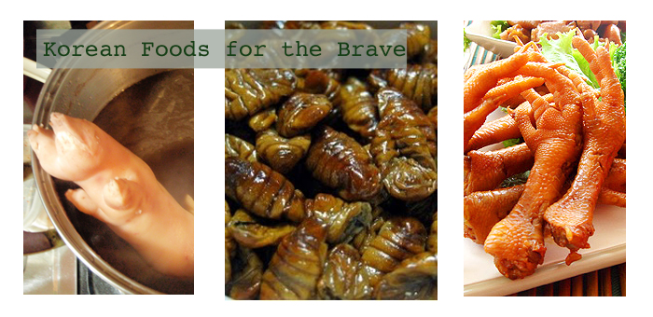
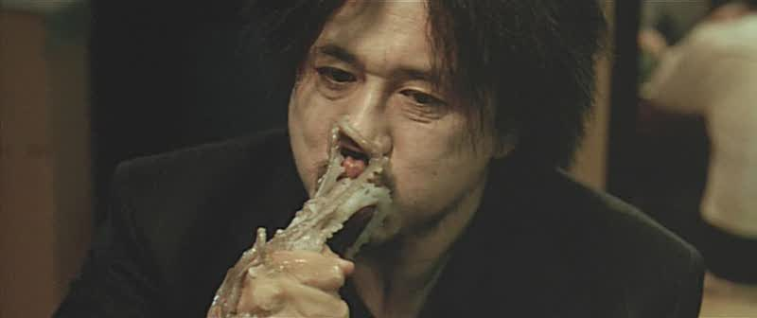

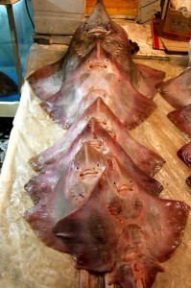

2nd Picture

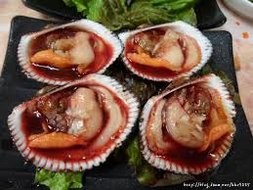

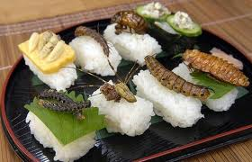
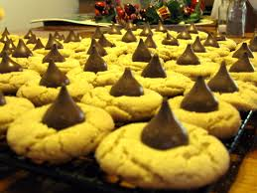

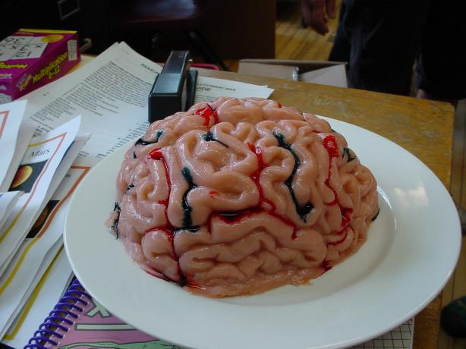
Try Brain Gelatin and Never forget it !!

Ingredients:

2 (6 ounce) boxes

gelatin, mix any flavor

(peach or watermelon give the best color)

1 3/4 cups

boiling water

3/4 cup

cold

water

9 ounces
fat-free evaporated milk

(must be fat-free or it will curdle)

to make gray

15 drops

red food coloring

15 drops
green food coloring
15 drops

Directions:

1 Before each use, wash the mold with warm soapy water and a soft cloth or sponge.

2 Spray or smear the inside of the mold with a small amount of vegetable oil, then wipe out the excess.

3 Put the gelatin mix in a large bowl and add the boiling water.

4 Stir about two minutes until the mix is dissolved.

5 Stir in the cold water.

6 Stir in the evaporated milk and food coloring.

7 Adjust coloring until it is the perfect pinkish-gray and stir.

8 Pour the mixture in the brain mold, stopping about 1/4 inch from the top.

9 Place the brain mold in a shallow bowl so it will sit level, and refrigerate overnight.

10 To remove the brain, shake the mold gently until the gelatin loosens.

11 Place a flat plate upside down over the open side of the mold, then flip the mold and the plate together.

12 Lift the mold off, leaving the brain on the plate.

