Name:
Worksheet #1
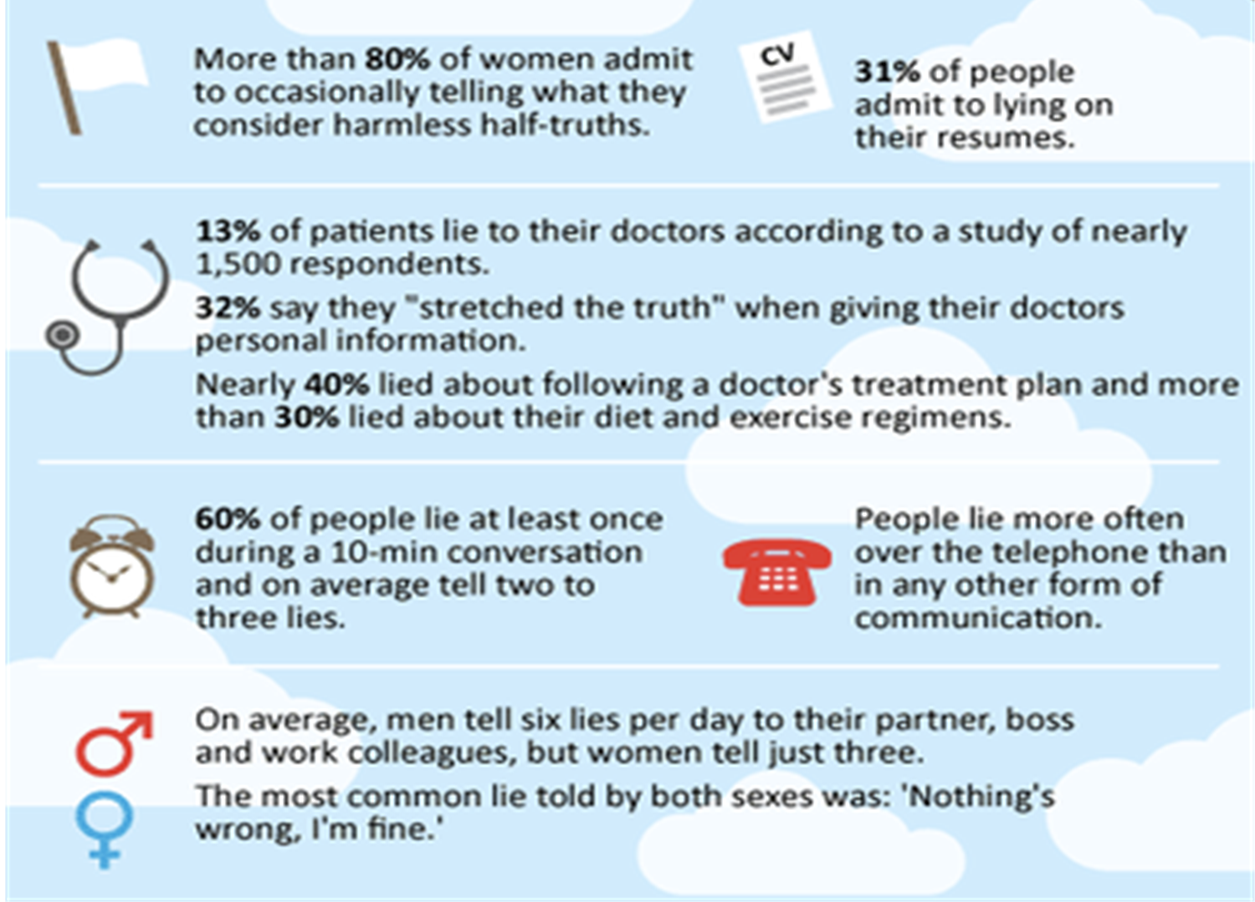
“Some statistics about lie“

1
2

3

4

5
6

7

Worksheet #2 Name:
Worksheet # 2
Sharing views on Lie.
- Do you think lie is always bad?
- Do you always want to know the truth?
- How do you deal with the lie?
- Do you have your own clues to detect lies?
- In modern society, is it easier to lie ?

- How to Spot a Liar ?
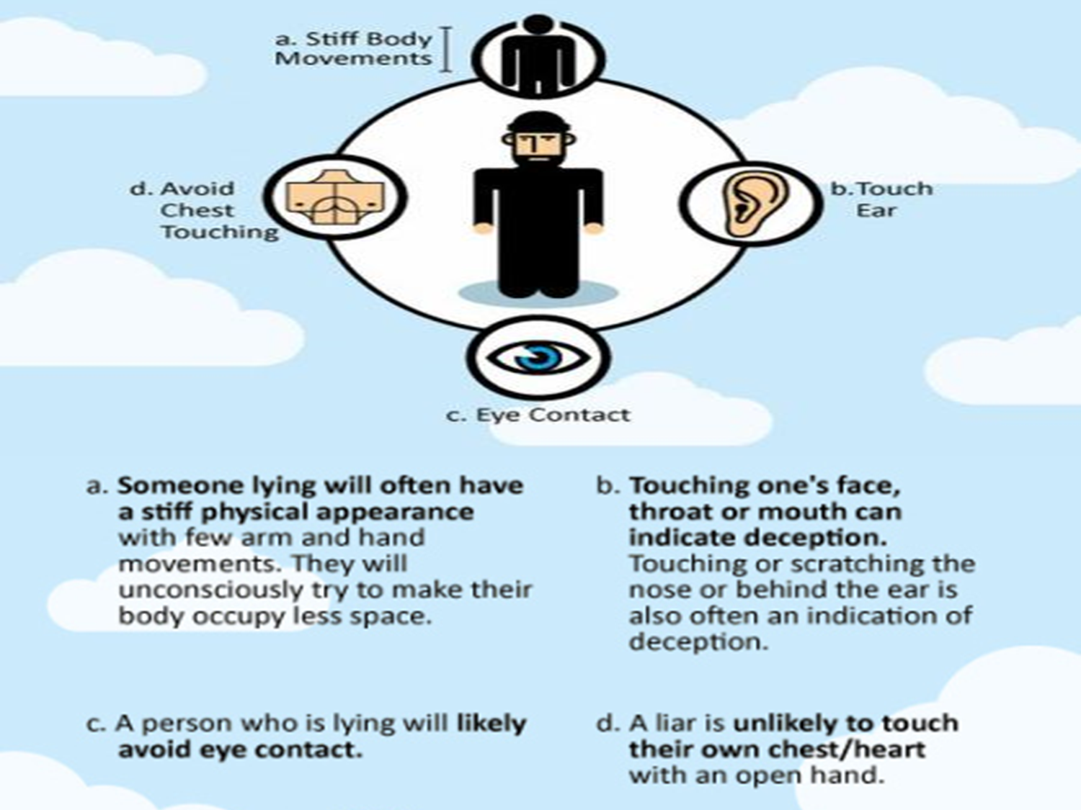
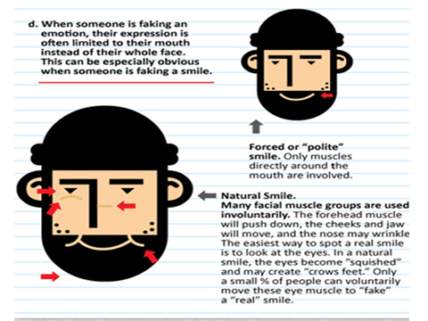

- How to Spot a Liar?
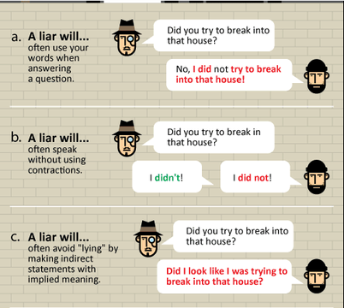
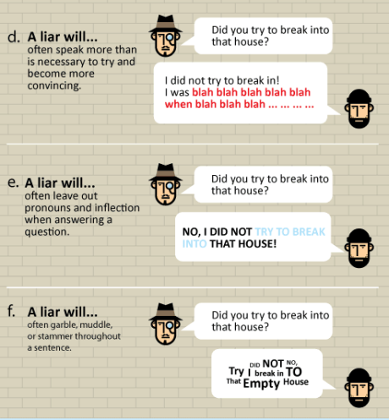
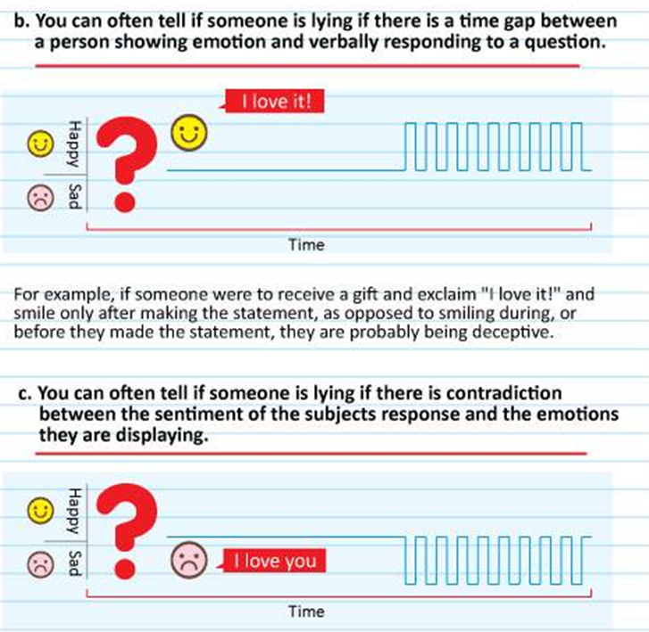
- How to Spot a Liar?

