Reading
Topic: Guinness World Records

Instructor:  Mandy | Level:  Intermediate | Students:  7 | Length:  30 Minutes

Materials:
- 2 pictures for eliciting ‘The world records’
- Worksheet #1.Vocabulary (7 copies)
- Worksheet #2.Reading text (8 copies; 4 types of the records * 2)
- Worksheet #3.Discussion (7 copies)

Aims:
- Main Aim : Ss will be able to learn vocabulary about “The world records” by words matching worksheets.
- Secondary Aim : Ss will be able to improve their reading skills by summarizing the reading text.
- Personal Aim : I want to improve my teaching skill by teaching them.

Language Skills:
- Listening : Listening to other’s saying and speech.
- Speaking : Talking about ‘what would you challenge?’ in discussion.
- Reading : Reading and summarizing about ‘the world records’
- Writing : Answering some questions on the worksheet #3 <discussion>

Language Systems:
- Lexis : New vocabulary regarding the main idea (e.g. solar-power, include, ..)
- Phonology : Promote (prə-mōt′)
- Grammar : A passive form (e.g is classified, was born ..)
- Function : At the passage, explaining about various world records.

Assumptions:
- Ss will be able to understand most of vocabulary from the worksheet#1.
- Ss are familiar with an expression of their own opinion.
- Ss know how to do skim the text.

Anticipated Errors and Solutions:
- Some of Ss could feet that several words are not familiar with them.
: After teacher shows the picture, talk about relating the situation.
- Some of Ss could need more time to finish their activity
: Be flexible with the time. Give Ss more time to finish their activity.
- Some of Ss could not follow the lesson due to difficult words.
: Teacher will make several examples using easy words.

References:
English definitions & New vocabulary (http://www.thefreedictionary.com)
Reading text (http://richardlstansfield.wordpress.com/2012/05/08/the-guinness-book-of-world-records/)
Pictures & article (www.worldrecordacademy.com)

Lead-In
Materials: 2 pictures, Board, Board markers

Time | Set Up | Procedure
3min | Whole class | - Greeting :  Hello, everyone~. How do you feel today? Good? Yeah, I'm good, too.  - Eliciting :  Have you ever tried to become the best in the world?  Let me show you some pictures.  Let's see these pictures. Here, look at this. What do you see?  (Ss answer by looking at the picture)  Yeah, He is the tallest man living.  How about this picture?  What do you think he is doing? (SS answer)  Yes, he has the widest mouth.  What can you tell by looking at these pictures?  Can you guess today's topic?  (Ss answer => World records)  Yeah, Today's topic is Guinness world records.  (Write down "Guinness world records" on the board)  We are going to take a look at Guinness world records.  Transition: Let's jump right into the lesson.

Pre-Activity
Materials: Worksheet #1 for new vocabulary

Time | Set Up | Procedure
6min  3min | Pair work  Whole class | - Instruction :  Before you start reading, you are going to learn some new words from the text. So now, I'll give you worksheets about new vocabulary. On the paper, there are several words & the meanings of the words.  You will work in pairs. Guess the meaning of these words and then, match the word with their meaning which is given at the bottom. Then, fill the correct number in the blank. I'll give you 4min to finish.  - Demonstration:  "I'll do first one with you. For example, there is the word 'Inanimate'. You can guess, what does Inanimate mean? It means that it is not animated or energetic. Therefore, You can write ‘H’ in the blank."  - ICQs: - Is it pair work? = Ss answer yes  - What do you have to do? = Ss answer matching the words  - How much do you have? = Ss answer 4min  (Distribute the worksheet and begin task)  - Monitor discreetly and answer if students ask questions.  "after 4min, we will check the answers together."  - Checking answer and feedback :  (Give time warning : 1min left)  Do you need more time?  Let's have a look at the words together.  (Pick up Ss)  What is the meaning of the word ' Promote '?  What is the word form?  Yes, it is a verb.  (Go through the words one by one.)  Now, are you ready for some activities?  => Ss answer yes or no  if no, I think you are ready.  - CCQs : What does solar power use? =>Ss answer the sun.  And Is inanimate energetic? =>Ss answer No.  - Error correction is needed if necessary.  Okay, I think everyone did good job.

Main Activity
Materials: Worksheet #2 for jigsaw (summarizing)

Time | Set Up | Procedure
3min  7min | Whole class/  Pair work  Pair work | Instructions: Let's move on to the next activity. guys  Please continue working with same partner.  I will give you guys a hand out now.  There are 4 interesting records.  You are going to choose one of them.  First one is the largest solar-powered boat. And next one ....  You will read it for 2 minutes.  You are going to discuss with your partner and summarize it. You are going to present at the front.  - ICQ : How much do you have? => Ss answer 2min  What do you have to do? => Ss answer summarize and present  Let's begin!  (Time warning 30sec)  Do you need more time? (or Monitor to check where they are at.)  Time's up!  Come up to the front and present your topic!  Who's going to present in this group?  - Feedback about each topic.  Please give your hand. Good job! Well done guys.  Was it interesting? There is not limitation about the categories to be ranked on the Guinness book.  Everyone did a good job!

Post Activity
Materials: Worksheet #3 for discussion and presentation

Time | Set Up | Procedure
2min  5min  3min | Whole class  Pair work/ Group work | Free production – discussion  ( Productive task : speaking )  - Instructions:  Now, We are going to discuss something related to the records.  I’ll give you the last worksheet for today. Discuss the questions on the worksheet with your partner. One of your group members will tell us what you have discussed at the end. I will give you 5minutes for discussion.  - Demonstration : Here, (showing the worksheet) on the paper, there are several categories about the world records. You can choose more than 2 things that you want to challenge. Or you can challenge by creating something that is not on the list. Get creative and discuss.  ( Distribute the worksheet )  - ICQs: What are you going to do? Ss answer discussion.  And after the discussion? Ss answer presentation.  Let’s begin!  (time warning 1min left)  Time’s up!  One of your group members will share what they have talked about. Who’s going to present in this group?  Feedback : It’s good idea. Everyone did a good job!  - Conclude lesson  Conclude the main idea of today’s topic  Today, we have learned about the world records. We end up knowing new several vocabularies by matching. We know the records are ranked regardless of the category.  Close: Congratulate the students on a job well done,  SOS: Have the students write an essay using the key vocabulary from the lesson.

Name:________

New Vocabulary (Worksheet #1)

- Matching

  - Inanimate ( )
  - Solar-powered ( )
  - Promote ( )
  - Renewable ( )
  - Circumnavigation ( )
  - Mount ( )
  - Cockpit ( )
  - Photovoltaic ( )

- That can be renewed
- To raise to a more important or responsible job or rank
- To set in a raised position
- Energy from the sun that is converted into electrical energy
- To sail or fly completely around.
- The space set apart for the pilot and crew, as in a helicopter, large airliner, or transport aircraft
- Capable of producing a voltage when exposed to radiant energy, especially light.
- Not animated or energetic; dull
The largest solar-powered boat

The Guinness Book of world records is something that many people are interested in. There are many categories in the Guinness book of world records. One category is sports, which includes Age, Score and Time. The category of Age is classified into under aged people and adults. The category of Score is classified into highest score or lowest score. The category of Time is the same as the category of score. Some of categories are Food, such as how fast it was made or how much was eaten. The Guinness Book of Records is categorized into human and not human. Humans are classified as Groups or solo. Not Humans are classified as Animals or Inanimate objects. Some categories are making things such as how big, how long etc.

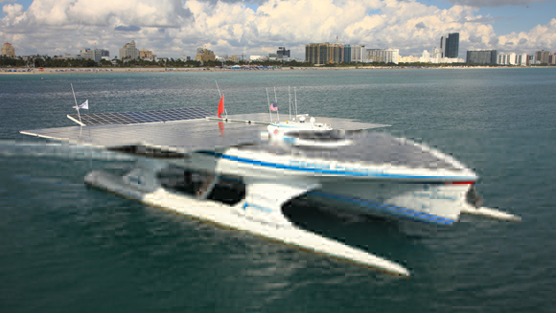

This boat is world’s largest solar-powered boat and world’s fastest crossing of the Atlantic
by solar power and the fastest crossing of South China Sea by solar power.
This boat begun its voyage in September 2010 with a mission to promote renewable energy
and completed its circumnavigate May 2012.
It’s black solar panels 31-metres in length and featuring 537 square metres and mounted around its raised cockpit.
The boat sailed more than 60,000 km during its 19-month adventure, travelling over every ocean and continent using only photovoltaic energy.

The tallest man

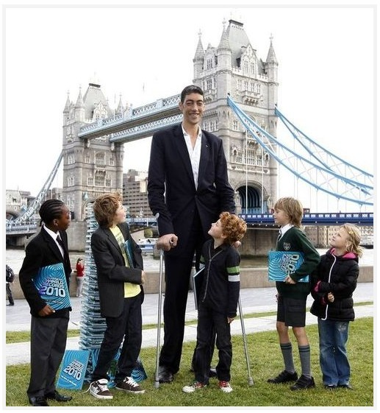The Guinness Book of world records is something that many people are interested in. There are many categories in the Guinness book of world records. One category is sports, which includes Age, Score and Time. The category of Age is classified into under aged people and adults. The category of Score is classified into highest score or lowest score. The category of Time is the same as the category of score. Some of categories are Food, such as how fast it was made or how much was eaten. The Guinness Book of Records is categorized into human and not human. Humans are classified as Groups or solo. Not Humans are classified as Animals or Inanimate objects. Some categories are making things such as how big, how long etc.

Sultan Kösen is Turkey who is the tallest man-living. He was born in 1982, December.
He was 251cm tall when he checked it on February 2011.
There is Robert Pershing Wadlow who was the tallest man before him. Robert checked his height in 1940 and he was 272cm.
However, he passed away in the same year he measured it. Sultan also has the record of widest hand span as 30.48cm and
largest feet 38.1cm for left foot and 37.5cm for right foot out of all living people.
The funny thing is that his whole family has just normal sizes unlike him. And the uncomfortable things in his living are that he can hardly find his size of clothes and shoes.

The widest mouth

The Guinness Book of world records is something that many people are interested in. There are many categories in the Guinness book of world records. One category is sports, which includes Age, Score and Time. The category of Age is classified into under aged people and adults. The category of Score is classified into highest score or lowest score. The category of Time is the same as the category of score. Some of categories are Food, such as how fast it was made or how much was eaten. The Guinness Book of Records is categorized into human and not human. Humans are classified as Groups or solo. Not Humans are classified as Animals or Inanimate objects. Some categories are making things such as how big, how long etc.

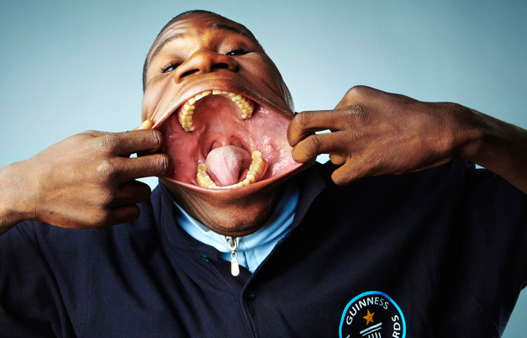

Because of the widest mouth, he was recorded in the Guinness Book of World Records.
His name is Francisco Domingos Joaquim.
His mouth is 17cm(6.69 inch) wide and can put a Coca-Cola can.
It was measured in Rome, Italy, on 18 March 2010.
He became famous through YouTube, but people couldn’t believe it.
After he recorded in the Guinness Book of World Records, people were amazed.

Longest time spinning a book

The Guinness Book of world records is something that many people are interested in. There are many categories in the Guinness book of world records. One category is sports, which includes Age, Score and Time. The category of Age is classified into under aged people and adults. The category of Score is classified into highest score or lowest score. The category of Time is the same as the category of score. Some of categories are Food, such as how fast it was made or how much was eaten. The Guinness Book of Records is categorized into human and not human. Humans are classified as Groups or solo. Not Humans are classified as Animals or Inanimate objects. Some categories are making things such as how big, how long etc.

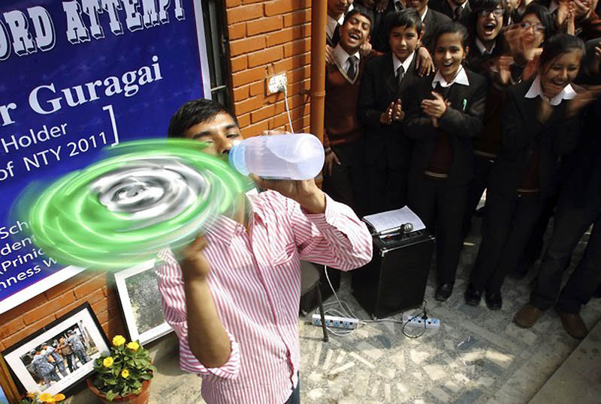

This guy spun a Guinness World record book for the longest time in April 16th, 2012. He spun the book while drinking water and talking to somebody.
His name is Thaneshvar Guragon.
The last record was 6 minutes and 51seconds, but he broke the record with 30minutes.
He had to spin the book by using only one finger. Can you believe it? If I spin that book for 30 minutes by using one finger, my finger may break

Name : ________________
Discussion (worksheet#3)

- What would you want to do in the list?
- Or if there is not in the list, What would you challenge?
  - Biggest world records
Ex) Tallest lego tower: South Korea sets world record

  - Food, Drink world records
Ex) Most People Opening Bottles in a Relay: Sheraton Macao Hotel breaks Guinness world record

  - Hobbies world records
Ex) Fastest time for solving 3x3x3 Rubik's Cube in 7.08 seconds - world record set by Erik Akkersdijk

  - Human body world records
Ex) Hairiest Girl: Thai girl Supatra Sasuphan sets world record
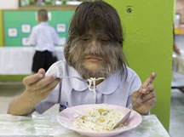

  - Sports and games worlds records
Ex) Longest poker game for over 115 hours - Phil Laak sets world record

