Grammar
Topic: Prepositions of place ( in, on, under, beside)

Instructor:Maurin  Seung-A Cho | Level:  Elementary (Child) | Students:  7 | Length:  30Minutes

* Materials:White board, Board markers.
* 7 pieces of matching activity worksheets.
* Pictures
* 7 pieces of worksheets.

Aims: Students will know how to use preposition through the pictures easily.

Students are enable to improve speaking skills by present to groups or whole
class.

Language Skills:
Reading: Students will read text and worksheets.
Listening:Students will listen to other students and teacher's talk.
Writing: Students will fill the blanks and write sentences.
Speaking: Students will discuss and talk about the answers in pair or group.

Language Systems:
Phonology: Students will listen to others and teacher.
Lexis: Vocabulary related with preposition
Function: How to use preposition of place ex) in / on / under / beside /
Grammar: Preposition of place
Discourse: Discuss in group or pair work.

Assumptions:
Students are all elementary school students.
Students may not know how to use preposition on / in / under/ beside

Anticipated Errors and Solutions:
Students will be confused between in and on.
Show clear pictures for their good understand.

References: English Grammer step 2

Lead-In
Materials:
Board and markers

Time | Set Up | Procedure
3min | Whole  class | [Greeting~]  Hello, everyone? How are you today?  Did you sleep well last night? Yes~me,too.  [Eliciting]  “Sumin, where is **** now?”  “ She is beside of me”  “Yes, She is beside of you .”  “What about the chair? ****** is sitting on the chair, right?”  Have you guys already noticed?  Today we are going to learn about prepositions of place.  Write down 'prepositions of place ' ( on, in, under, beside)on the board

Pre-Activity
Materials:
Pictures, Computer, Projector, Board, Marker, Worksheets

Time | Set Up | Procedure
3min  5min | Whole  class  indivisually | (Show this picture through projecter)  “Look at this picture everyone~  There are five cats here, can you see it?”  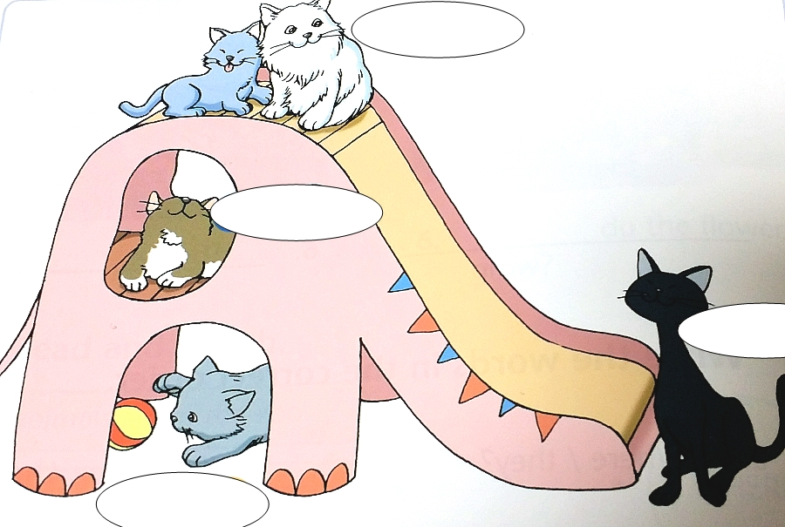  “Chloe, can you tell me where is the white cat?”  ========> It's on top of the slide.  (If students make mistakes, help students to correct themselves)  “Mega, where is the brown cat?”  =========> It is in the slide  “ Sean, where is the black cat?  ========> it is beside the slide  “Sumin, where is the grey cat with a ball?  ========>It is under the slide  Ok! good job, everyone~~  (distribute worksheets)  Now, you guys are working indivisually  Look at the worksheet I gave you guys.  There are questions and blanks.  Fill the blanks  I will give you three minutes.  ICQ: Are you work alone or indivisually?  (3minutes later)  Did you fiil the blanks?  First one, who's going to answer, any volunteer?  (students will talk and answer the questions)  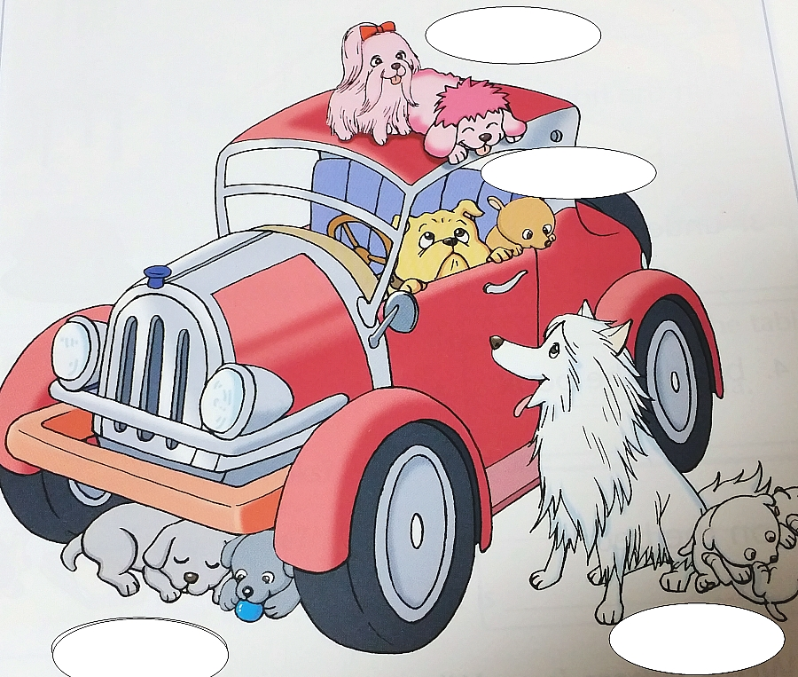  (students will talk and answer the questions)  Where are the pink dogs? They are on the car.  Where are the brown dogs? They are in the car.  Where are the gray dogs? They are under the car  Where are the white dogs? They are beside the car  Great! Well done!!

Main Activity
Materials:Pictures, computer, projector, matching activity worksheets.

Time | Set Up | Procedure
9min | whole  class | Now, let me introduce my little boy, his name is Biscuit and his  nickname is Ddukki.  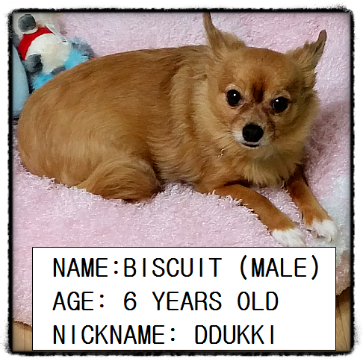  I took some pictures for your good understanding about preposition  that we have learned. Let's see all together.  WHERE IS DDUKKI? I will ask you guys 'Where is Ddukki' as a song,  (simple melody) then you need to answer as a song  ( show demonstration, Ddukki~~ is ~~on~~ the chair~~~)  and ask the question to the other student as a song. You can make the  melody whatever you want~  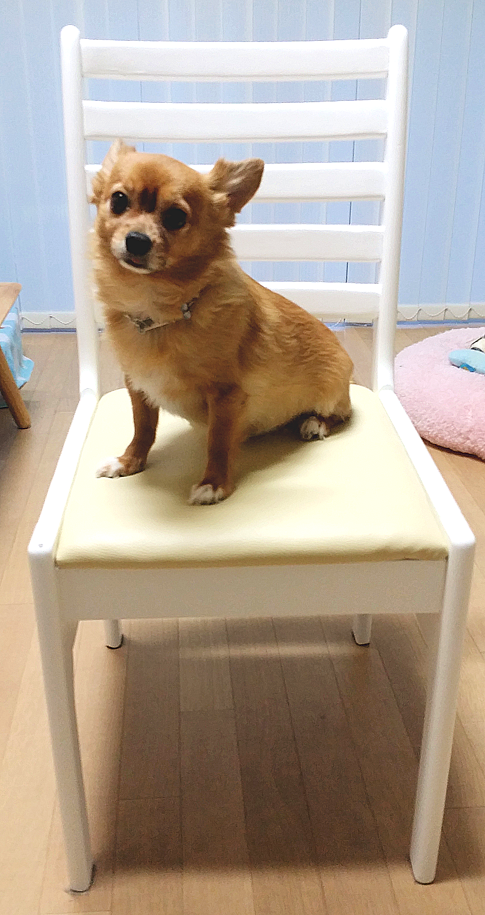  Where is Ddukki? He is on the chair.  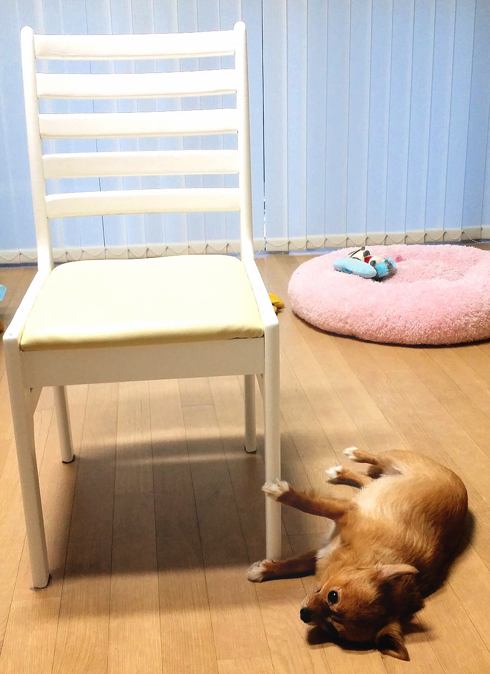  Where is Ddukki? He is beside the chair.  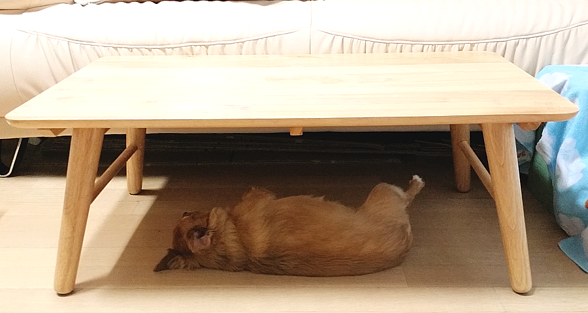  Where is Ddukki? He is under the table  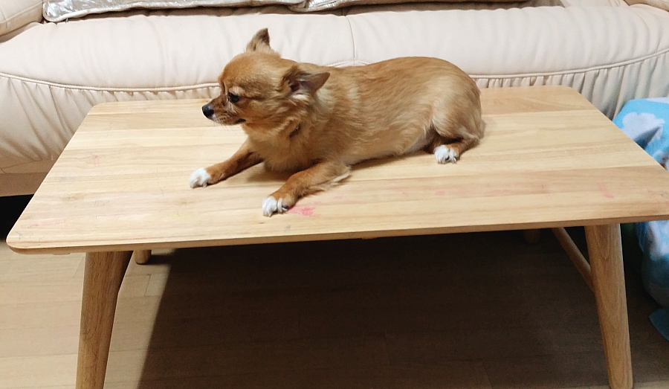  Where is Ddukki? He is on the table  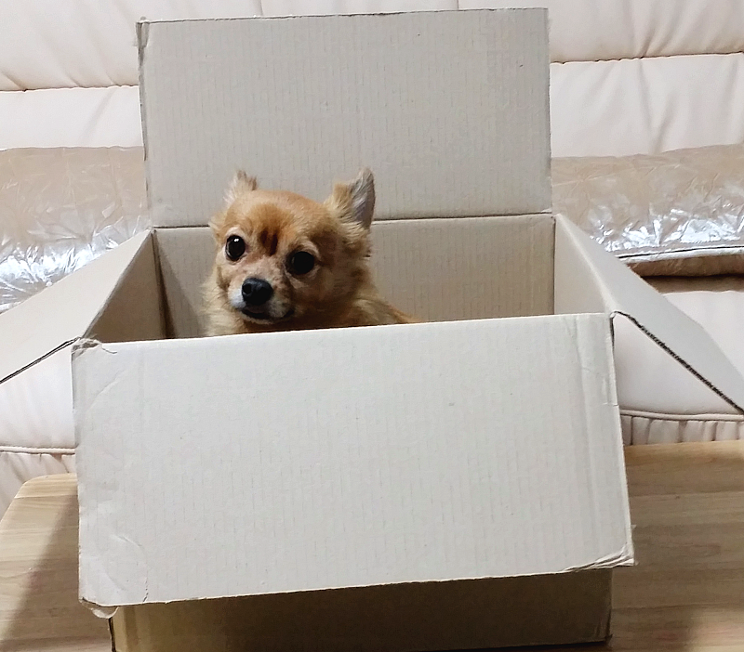  Where is Ddukki? He is in the box  And where is the box? It is on the table  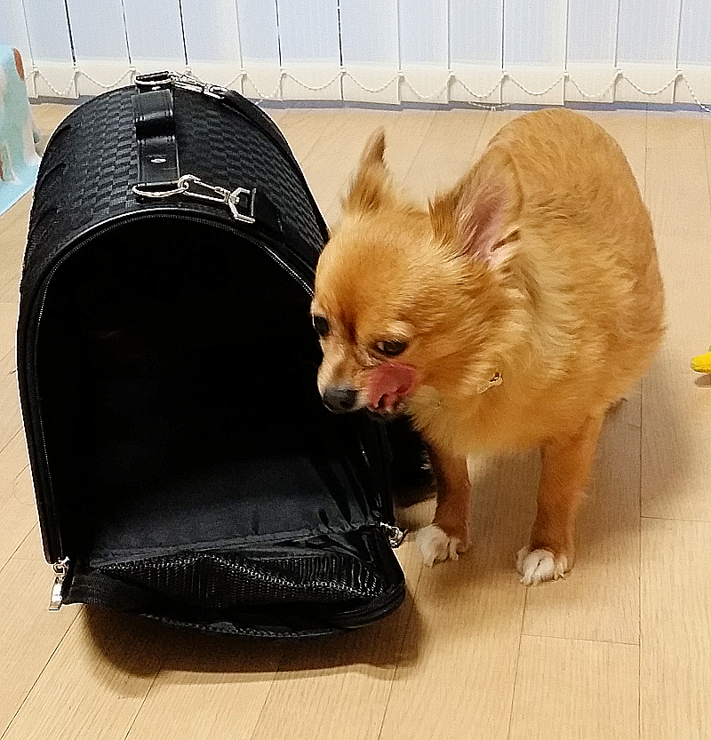  Where is Ddukki? He is beside the bag.  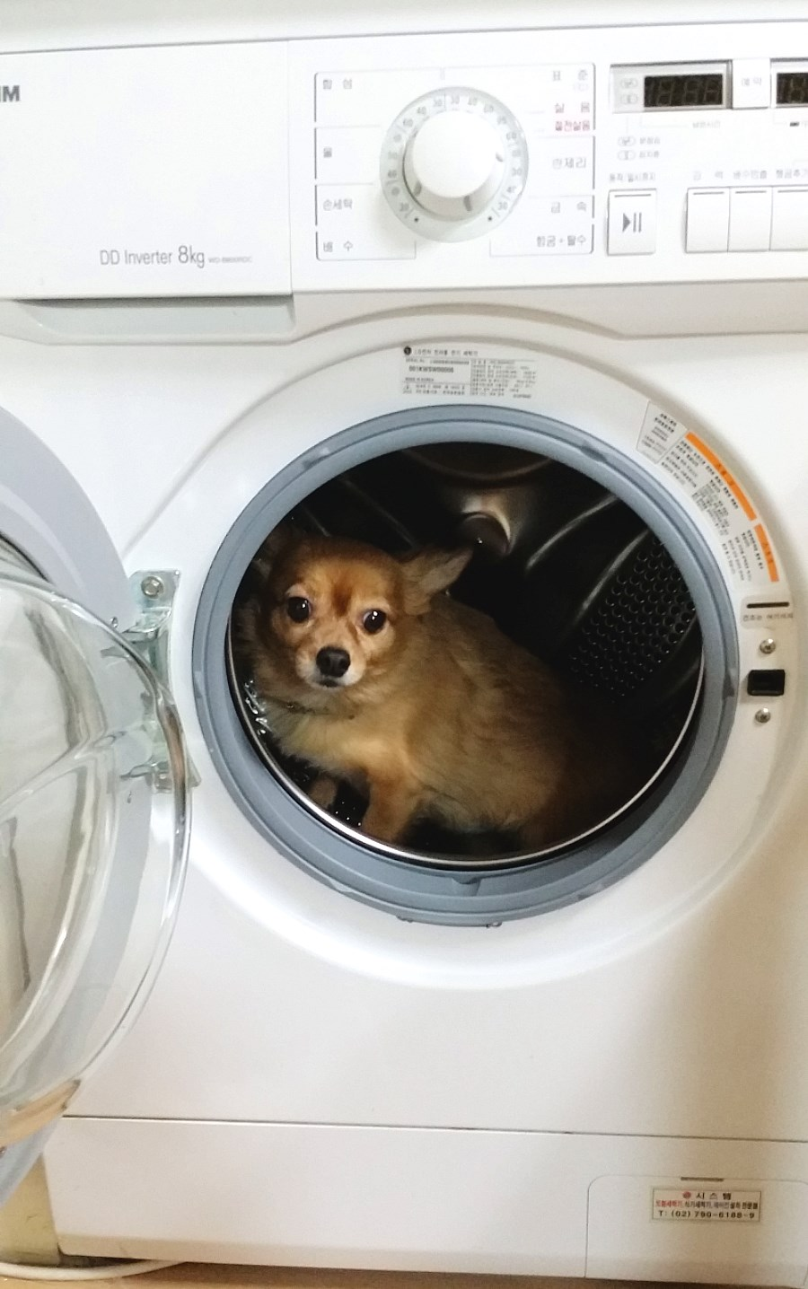  Where is Ddukki? He is in the washing machine

Good job everyone~~~~

Now I will give matching activity worksheets for you guys~

Work it indivisually, ok?

ICQ: What do you have to do now? Are you working pairs? No, work alone~good.

Matching Activity
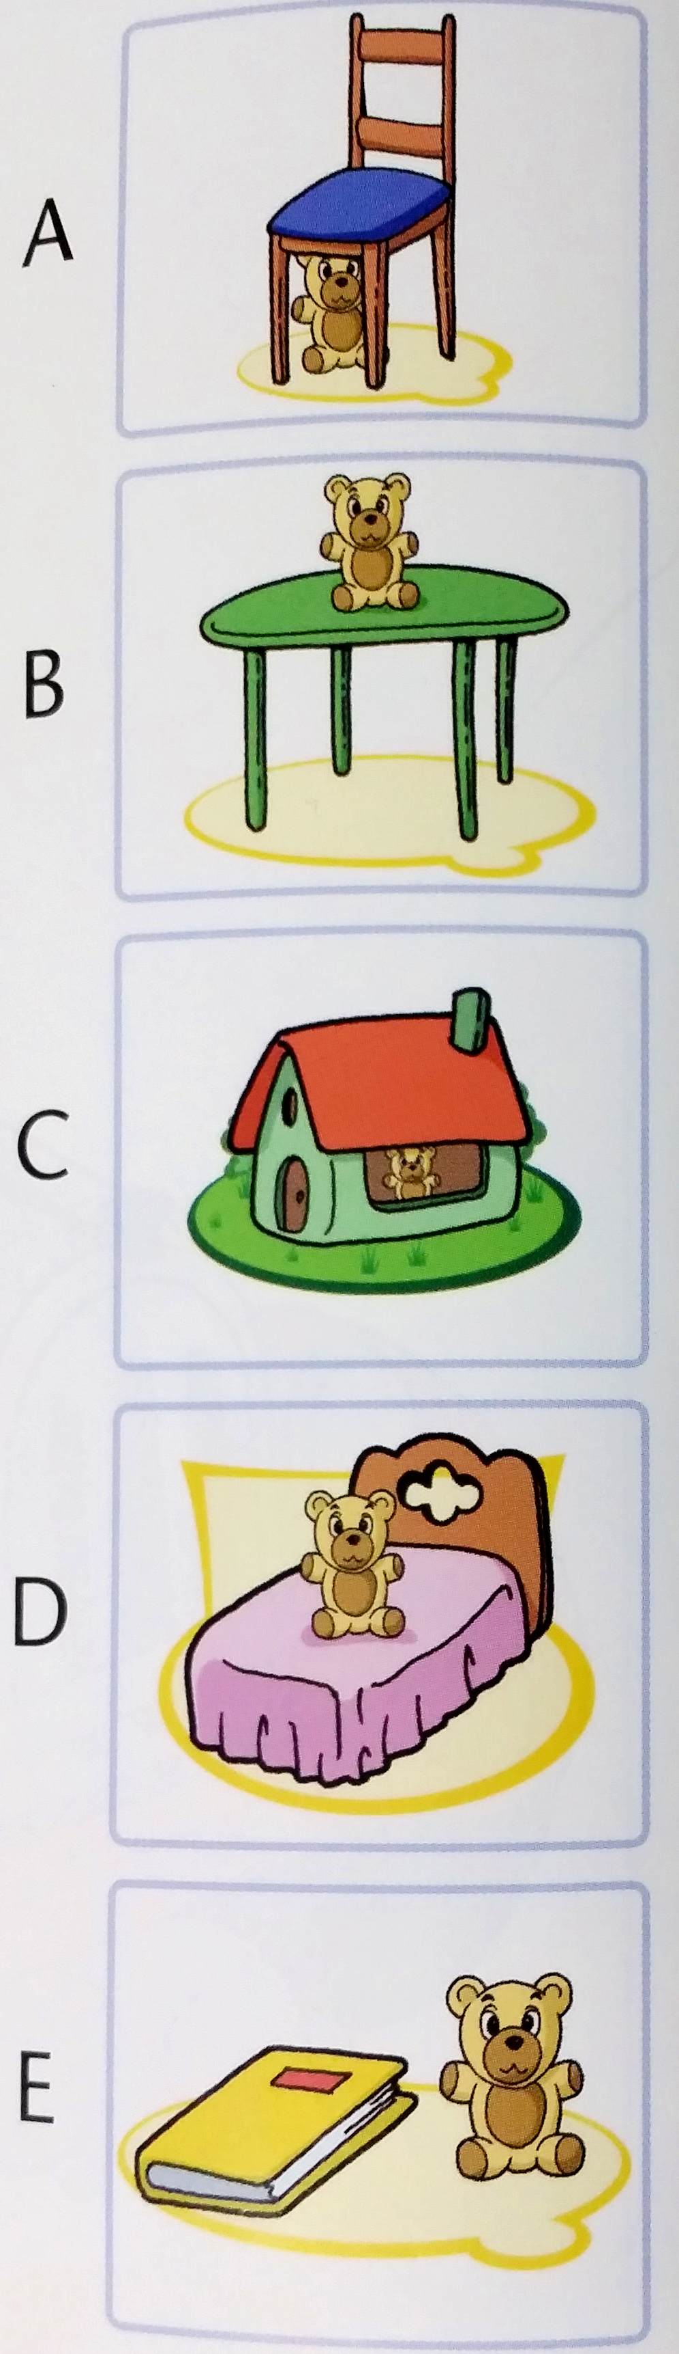

1.on the table

2. in the house

3. under the chair

4.beside the book

5.on the bed

Post Activity
Materials:
Blindfold. Stuff ( marker, pen, eraser, etc) 7 pieces of chocolate
Time | Set Up | Procedure
10min | pair  or  group  work | We are going to do an activity for prepositions of place now.  I will give you a chocolate each one of you.  (Give chocolate to each students)  All you have got the chocolate now? Look at the numbers~  The student who has number 1 and 1 are pair, number 2 and 2 are pair  and 3 are three students, you work together. Ok?  This is “ Put a blindfold and find the thing!!” activity that I have mixed.  Who's going to do first? Rock, Scissor, Paper? Ok, do it.  [Put a blindfolld on one member of group and give the other group a  few moments to hide a stuff(whatever students want)  A member who put a blindfold on,she/ he need to ask yes/ no  questions to locate it (e.g. Is it on the desk?, is it beside the chair?, etc)  The one of member need to help guide him/her by giving instructions.  The winner who can find the stuff faster than the others, will have some  gifts. So set the timer first and let's do it.  ICQ: are you work indivisually?  (After finished the activity)  Well done, now you guys are good at prepositions such as in, on, under, beside. Right?  Good job!~~~~~~
Fill in the blanks~

Where are the pink dogs? They are on the car.

Where are the brown dogs? They are in the car.

Where are the gray dogs? They are under the car

Where are the whites dogs? They are beside the car
SOS ACTIVITY
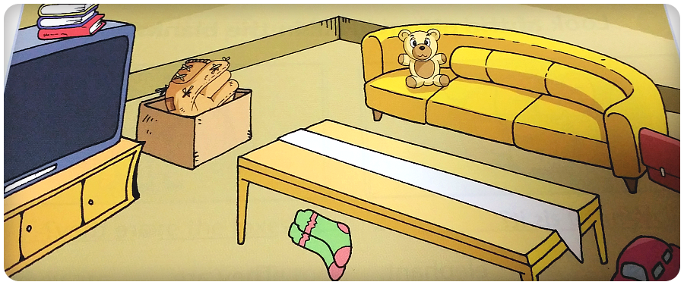

\

1.Where is teddy bear? It is ______________the sofa.
        - Where are the socks? They are _________the table.
        - Where is the bag? It is__________________the sofa.
        - Where are the books? They are _________________
        - Where is the glove? It is ________________________
        - Where is the car? It is __________________________
*Circle the correct words. *
1. (Where/What) is the dog? It's in the house
2. Where's (a cat/ the cat) ? It's on the sofa
3. Where's (the Maria/ Maria)? She's in the garden
4. Where's the book? It's (on/in) the chair.

