Listening Speaking Reading Grammar Writing

Topic:
How much/many do I need?

Instructor:  Mega | Level:  Intermediate | Students:  # 7 | Length:  30 Minutes

Materials:
- Computer with internet and a beam projector.
- Picture of ingredients in the recipes
- PPT to elicit and give examples to Ss.
- Glue, scissors, posters (blank, 2 copies), colored pencils.
- Hand-out (Ingredients) 4 copies.
- Worksheets for SOS activity 7 copies
-

Aims:
-Ss will be able to express amount of count and non-count nouns through making questions about the recipe.
- Ss will be able to read and describe a recipe by doing the task.
- I want to monitor the Ss discreetly and be a guide for the Ss to work on their own.

Language Skills:
Listening: Ss will listen to the instructions from the teacher.
Reading: Ss will read a recipe for the task
Writing: Ss will write questions in task preparation
Speaking: Ss will ask questions to the other Ss and have discussion with them.

Language Systems:
Phonology: /th/, /r/, broth, recipe
Lexis: Chorizo sausage, basmati rice, broth/stock, clove
Grammar: Quantifier
Function: Questioning, Guessing
Discourse: Discussion

Assumptions:
- Ss should have no problem asking questions to the other Ss.
- Ss should be able to follow the instruction.

Anticipated Errors and Solutions:
- Computer might not function: Use whiteboard and prints to run it.
- Ss might run out space while making the collage: Give them more papers or ask them to write on the back.

References:
http://dreamlife12.tistory.com/entry/%EC%8A%A4%ED%8E%98%EC%9D%B8-%EC%9A%94%EB%A6%AC-%EB%B9%A0%EC%97%90%EC%95%BC-%EB%A7%8C%EB%93%A4%EA%B8%B0 (Recipe for Paella)
http://olive.interest.me/Recipe/View/76?page=1 (Recipe for Paella)
http://www.just-health.net/Olive-Oil-For-Skin.html (Picture of Olive oil)
http://www.bbcgoodfood.com/glossary/garlic (Picture of garlic clove)
http://www.johnsonville.com/products/chorizo.html (Picture of Chorizo sausage)
http://www.colourbox.com/image/fresh-chicken-thigh-isolated-on-white-background-image-2369040?utm_expid=22365066-38.j3VkgN-zRgCMRMAFvmd_kg.0&utm_referrer=http%3A%2F%2Fwww.colourbox.com%2Fimage%2Fraw-chicken-thigh-image-3096135 (Picture of chicken thigh)
http://www.thereformedbroker.com/2010/04/30/shrimp-futures-soar-on-gulf-oil-spill/ (Picture of shrimp)
http://slds2.tistory.com/239 (Picture of Suzuki: Japanese seabass)
http://www.ryanphotographic.com/squid.htm (Picture of squid)
http://redwhiteandblueberries.com/2011/05/10/kitchen-basics-dicing-an-onion/ (Picture of chopped onion)
http://www.finecooking.com/recipes/chinese-chicken-broth.aspx (picture of chicken broth)
http://www.dunarbasmatirice.com/basmati-rice-wonder-grain.html (Picture of Basmati rice)
http://writingmuscle.wordpress.com/2012/07/27/the-j-of-south-africa/ (Picture of white wine)
http://www.foodrenegade.com/southwest-mussel-chowder/ (Picture of mussel)
http://en.wikipedia.org/wiki/Paella (Picture of Paella)
http://kichiwall.com/gorgeous-deseeded-sliced-tomato-wallpaper-hd/ (Picture of Paella)
http://www.bbc.co.uk/food/pea (Picture of peas)
https://www.kmart.com/community/gardensolutionscenter/hazelnut-parsley-pesto-garden-to-table-cooking/ (Picture of parsley)
http://beautybox.tistory.com/124 (Picture of lemon slices)
http://entheology.com/plants/crocus-sativus-saffron-crocus/attachment/saffron-spice/ (Picture of saffron spice)
http://www.crateandbarrel.com/copper-salt-and-pepper-mills/f43559 (picture of salt and pepper)
http://servingupfortcollins.com/midweek-mix-in-mashed-potatoes-whipped-or-smashed/ (Picture of mashed potatoes)
http://pinchmysalt.com/jasons-ultimate-manwich/ (Picture of ground beef)
http://www.mccain.com.au/products_fruitveggies_mccain-vegetable-mixes_mixed-vegetables-500g_198.aspx (Picture of mixed vegetables)
http://en.wikipedia.org/wiki/Cream_cheese (Picture of cream cheese)
http://glutendoctors.blogspot.kr/2010/10/why-i-allow-butter-on-diary-free-diet.html (Picture of butter)
http://www.kraftrecipes.com/recipes/easy-shepherds-pie-108691.aspx (Recipe of Shepherd’s pie)
http://www.grammarbank.com/support-files/quantifiers-worksheet.pdf (Worksheet for SOS activity)
http://usfusionhome.tistory.com/89 (Recipe and picture of Japchae)
http://m.lottemart.com/mobile/cate/PMWMCAT0003_New.do?CategoryID=C001001700060007 (Picture of vinegar)
http://itchylittleworld.com/2012/01/13/curry-powder/ (Picture of curry powder)
http://www.cbc.ca/news/health/how-toxic-is-sugar-1.1894262 (Picture of sugar)
http://www.tradekorea.com/sell-leads/fresh_chilli.html (Picture of red chili)
http://abcnews.go.com/Business/cocoa-shortage-worries-chocolate-lovers/story?id=21249939 (Picture of chocolate)

Pre-Task
Materials: - Picture of random recipe
- Computer with beam projector
Time | Set Up | Student Activity | Teacher Talk
5 mins | Whole class | [Review]  - Previous class, we’ve learned some of the count and non-countable nouns. If you look at the board, you would find them. Let’s have a look.  Ex Q’s) Is cheese countable or non-countable?  Ex words) Cheese (non), garlic (non), butter (non), etc  - Good job, guys! You still remembered.  [Elicit]  - Have you ever cooked something delicious before?  Ss answer -> If yes -> (Show picture of recipe)  -> Than, do you know what this is?  If no -> (show picture of recipe anyway but)  -> Who can you tell me what this is?  - Why do we use it for? And what does it have in it?  Yes!!! They have the ingredients to make some dishes.  Today, we are going to make a collage using recipe!!! Yeah!!!  Before we start, let’s take a look on some words.  Ex words) Basmati rice, Broth/stock, Bass/Suzuki, Chorizo sausage.  Ex) Basmati rice: explain by using picture of it.  CCQ: Do we eat Basmati rice in Korea? -> No

Task Preparation
Materials:
- Pictures of ingredients(2 copies for each group) 4copies
- Hand-out(Recipes) 2 copies
- Computer with beam projector.
- Picture of recipe used in the pre-task.
- 2 blank posters
Time | Set Up | Student Activity | Teacher Talk
19 mins |  | [Instruction]  Hey!!! Are you excited to make a collage? I think you do~!!  TT: Here’s how it is going to be.  1.I want you guys to make groups, group A & B  2. Here’s your recipe and printed ingredients. I didn’t bring real stuff, I don’t want to make this class messy.  2. Group A is going to have the recipe for group B and group B is going to have recipe for group A  3. You guys have to ask the other group to make a collage. Collage with the ingredients. The other group answers with the recipe which is given to them. But, you have to make the Q’s(questions) using all the ingredients from the hand-out. Ingredients on the hand-out are needed to be in the collage. On hand-out, you have more ingredients than you needed.  4. And try making Q’s using some, any, much, and many.  Here’s some example.  (show recipe of Japchae)  OK, my Qs would be like ‘is there any spinach in Japchae?  - Yes, there is some.  - No, there isn’t any.  Look at the recipe!!  If you found out that there are some spinach in the recipe, than cut it out and post it on the collage. And ask different question to check the amount of it.  Ex) Q: How much spinach do I need in Japchae?  Ans: You need a bouquet of spinach.  I will give you 7 mins to make Q’s  ICQ  What are you making?  -> Questions.  When you are making questions, what are the words you need to use? -> Some, any, much, and many.  [Time warning] 2 mins left  [Running the task]  TT: I guess you are done making Q’s.  Why don’t you start asking Q’s? Go ahead!!!  You have 10 mins to make the collage  You can move around to ask Q’s  [Monitor them to listen for errors]

Task Realization
Materials: - Picture of final result: 2 copies
- Computer with beam projector.
Time | Set Up | Student Activity | Teacher Talk
5 mins |  | [Presenting]  How was it guys? It looks great!  With the collage, can you guess what those ingredients are for?  Or can you guess the right dish from it?  Why don’t this group come to front and present your collage.  Let’s see you got them right.  Ok, that sounds great!!  (Show them the final result)  Great job guys!!!

Post Task
Materials: N/A
Time | Set Up | Student Activity | Teacher Talk
3 mins |  | [Error correction & Feedback]  During the task, what words have you use?  -> Some, any, much, and many.  Do you know what they are called?  -> They are quantifiers. It is use with countable and non-countable nouns  Here are some words. You might find it interesting.  When we talk about garlic, what do you say? 2 pieces of garlic?  Do you know there is actual word for it?  It is called ‘a clove’ so you say like ‘2 cloves of garlic’

SOS Activities

Materials: - Worksheet (7 copies)

Time | Set Up | Student Activity | Teacher Talk
3 mins | Pair work | [Instruction]  Ask Ss: what words have you used?  - Ss > Quantifier or words like ‘many’, ‘much’, ‘some’, ‘any’  TT: We are going to some practices with the worksheet. Try on your own first. After you are done, share it with your partner to see if you got the same answer.

Attachments

1. Pictures of ingredients

2. Worksheet for SOS activity

3. Recipes for the collage(Group A & B)

Basmati rice
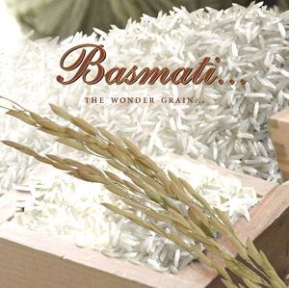

Butter
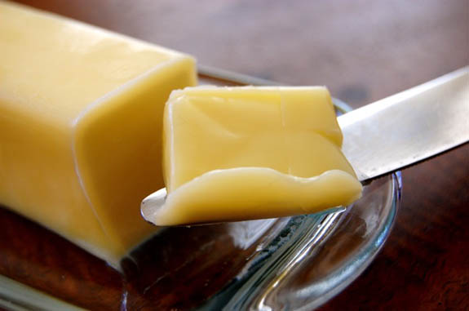

Bouquet of parsley
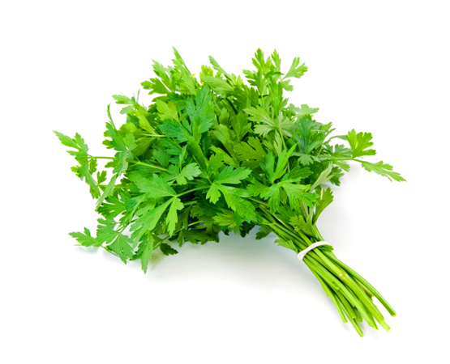

Chicken Broth/Stock
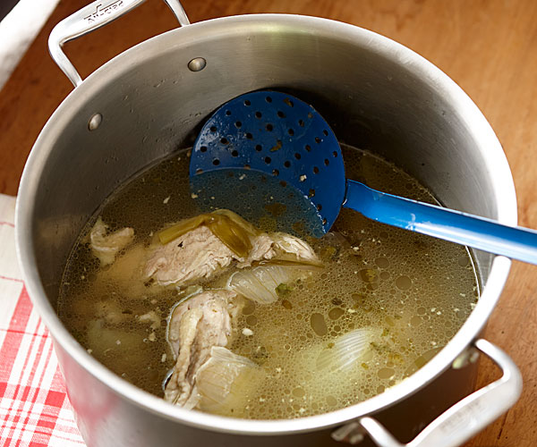

Chicken thigh
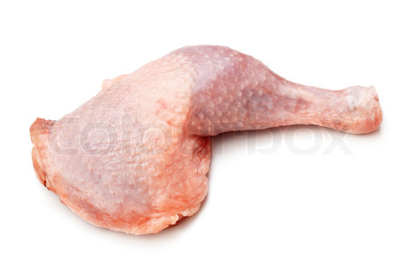

Chorizo Sausage
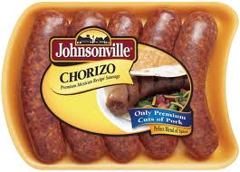

Salt and Pepper
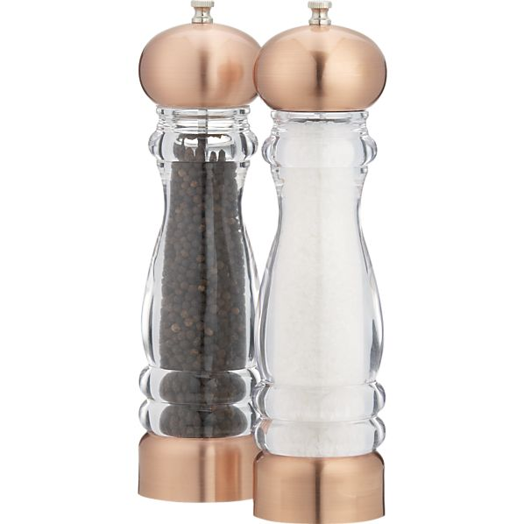

Garlic(clove)
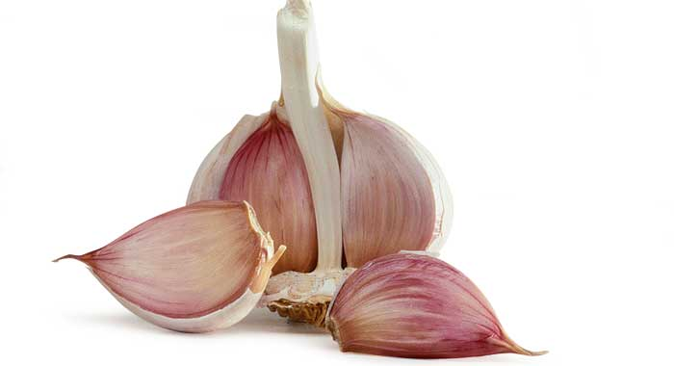

Grounded beef
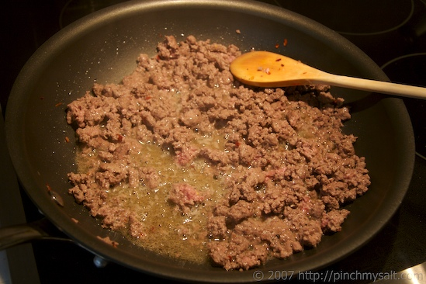

Recipe of Japchae
Lemon Slices
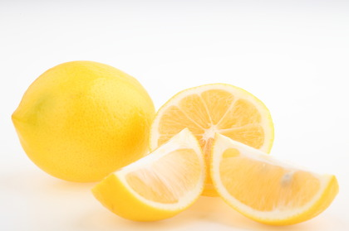

Mashed potatoes
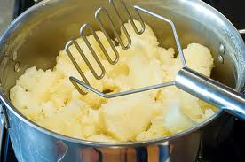

Mixed vegetables
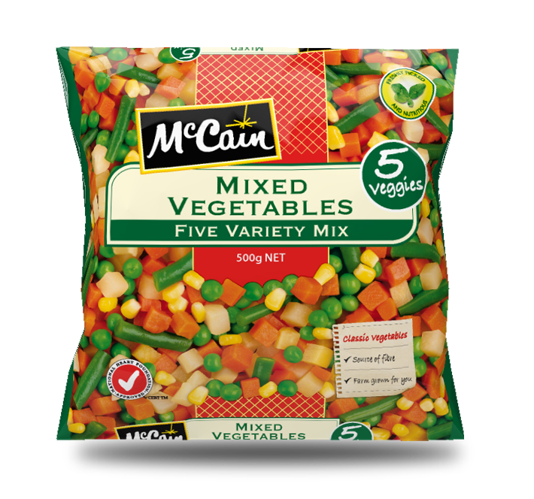

Mussels
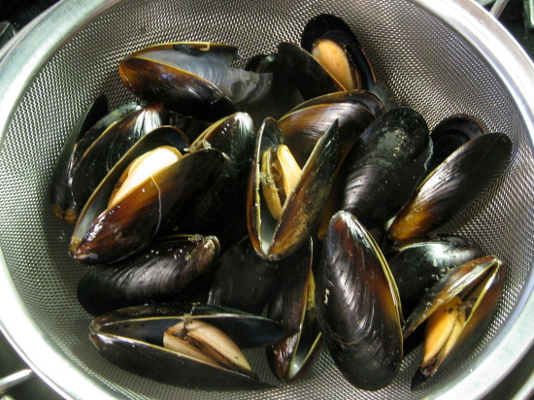
Olive oil
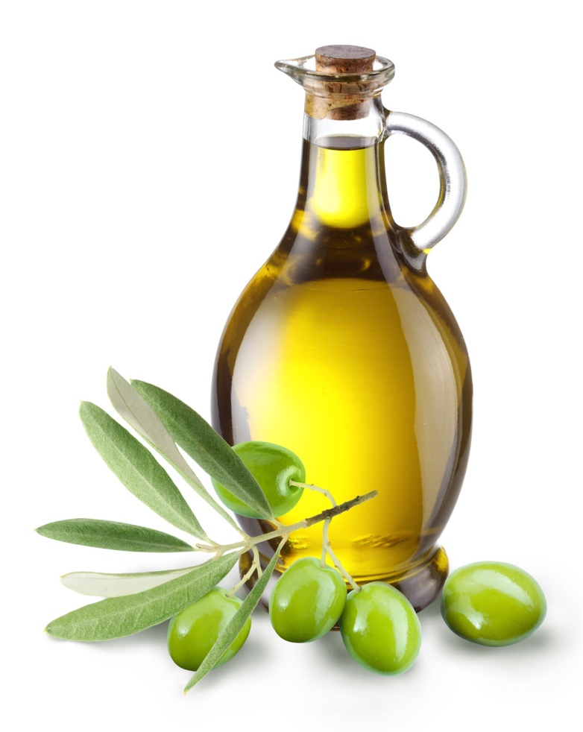
Onions(chopped)
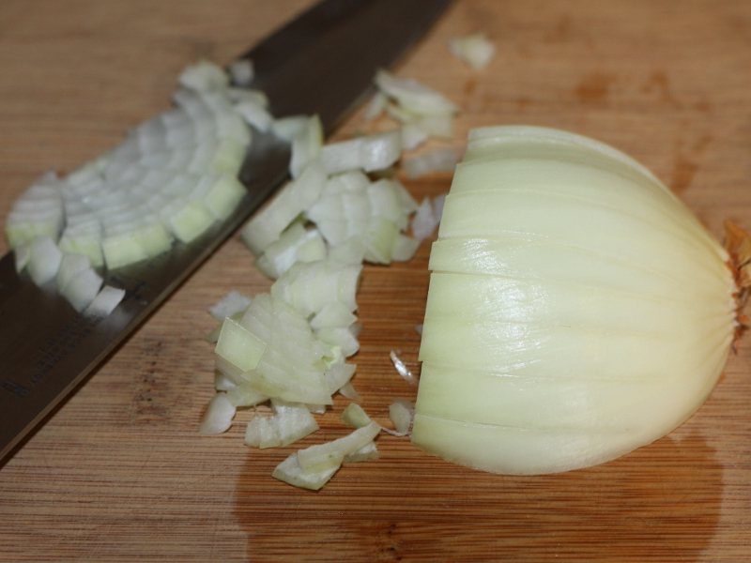
Peas
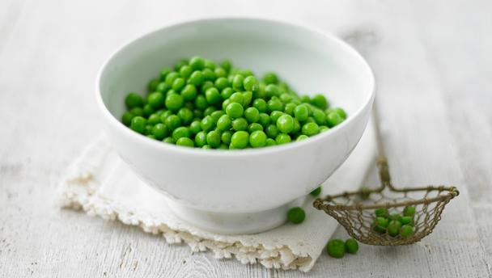

Cream cheese
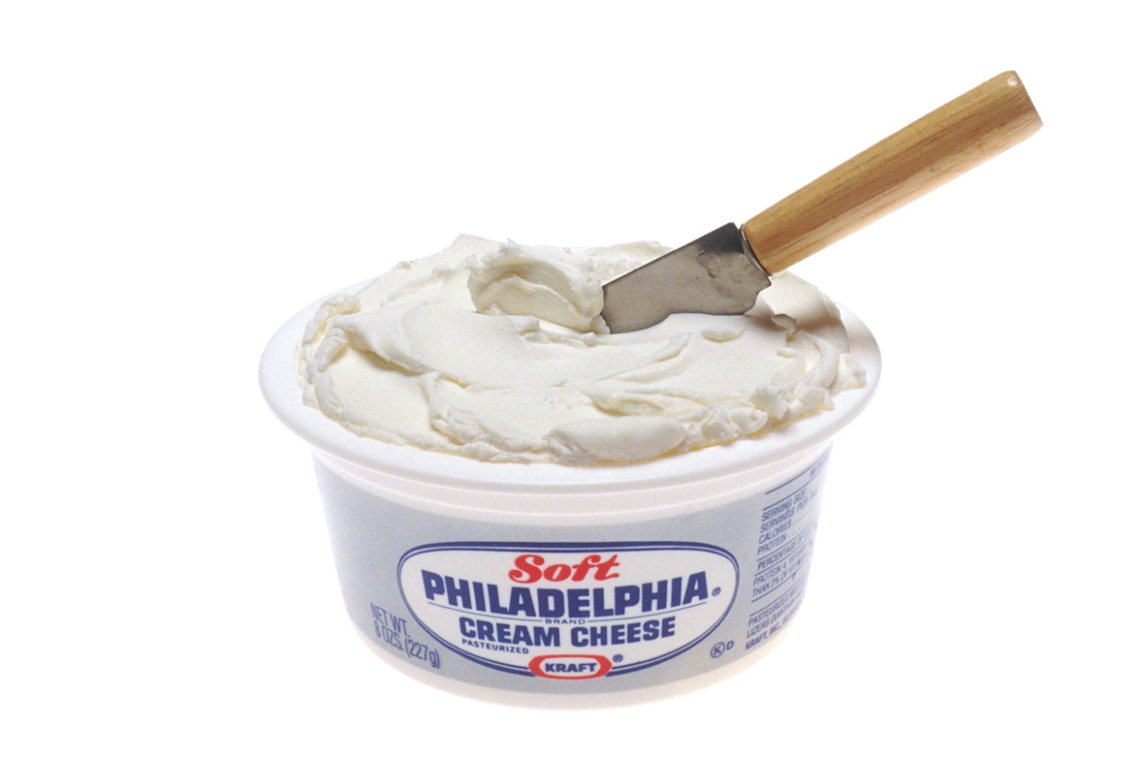

Saffron spices
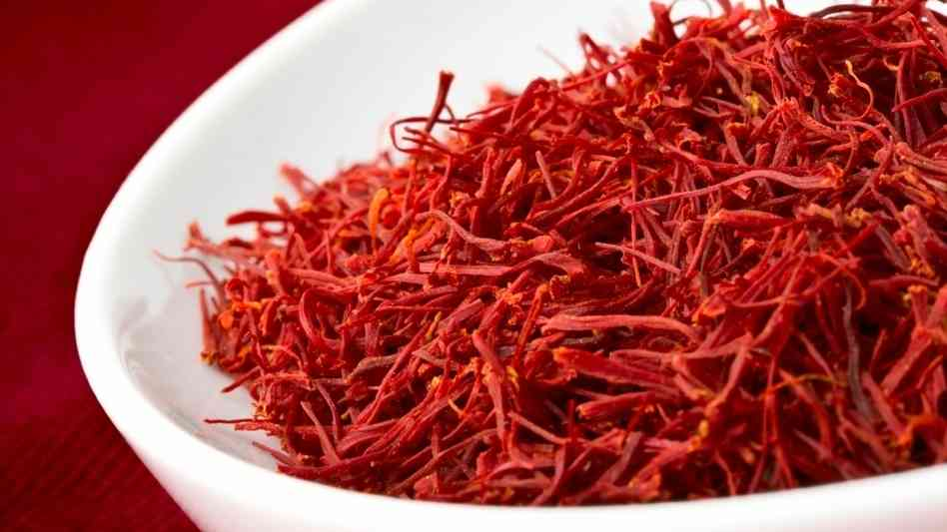

Shrimps
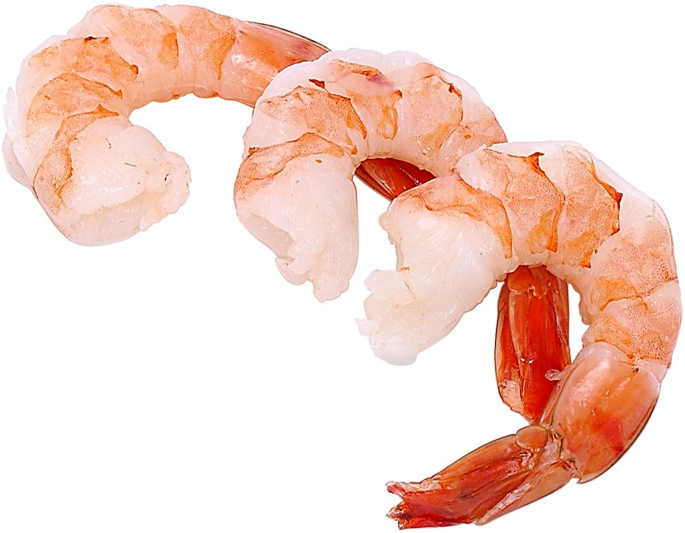

Sliced tomatoes
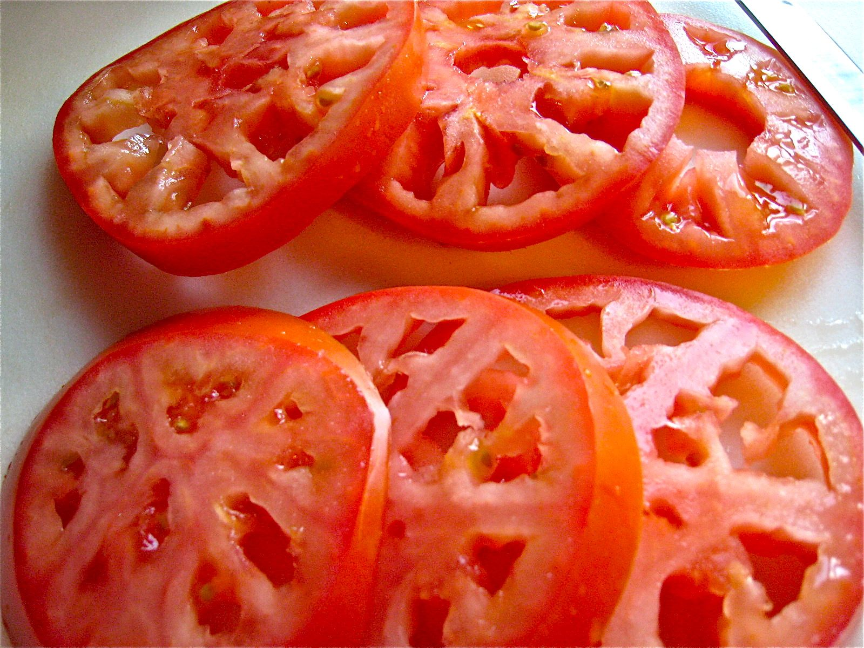

Squid
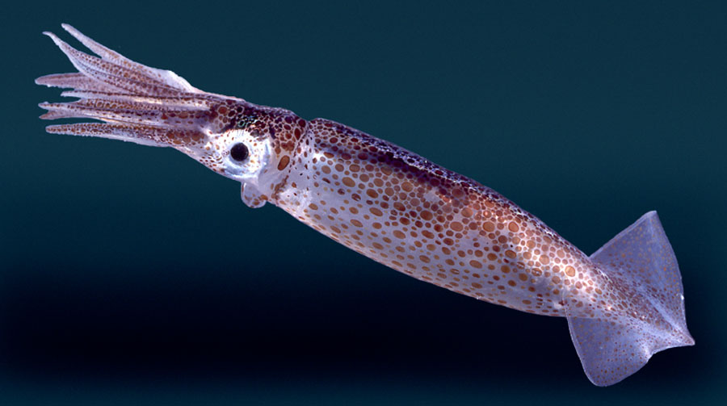

Suzuki/seabass
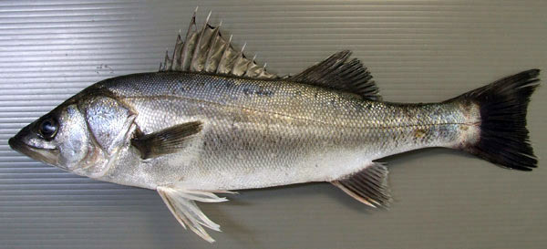

White wine
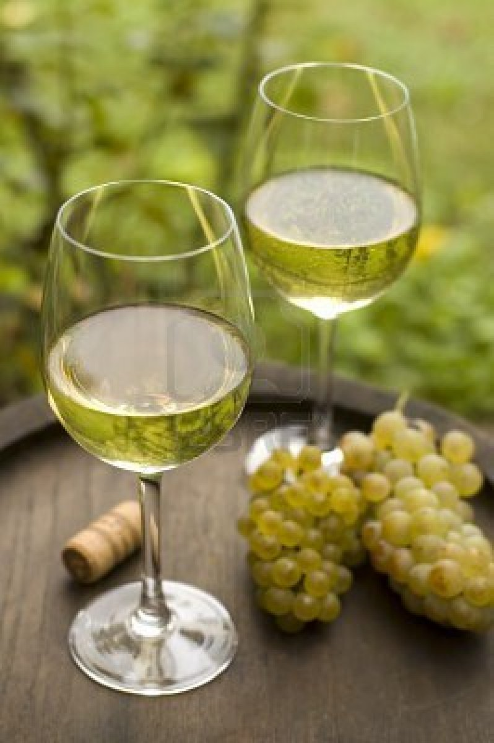

Shepherd’s pie
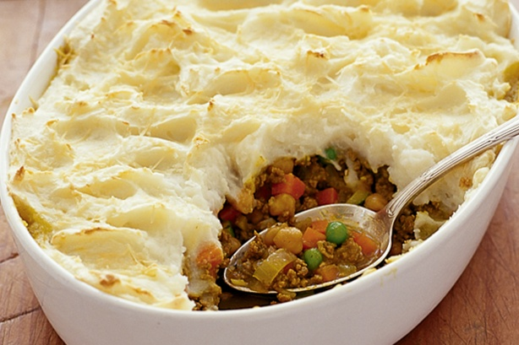
Paella
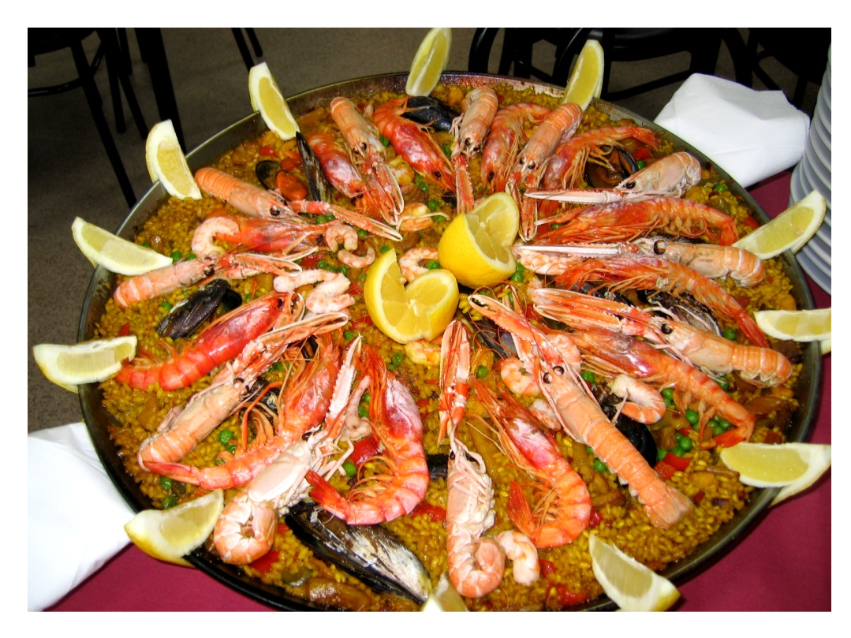

Curry powder
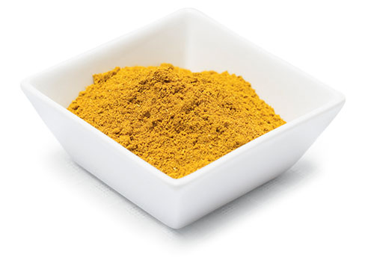

Sugar
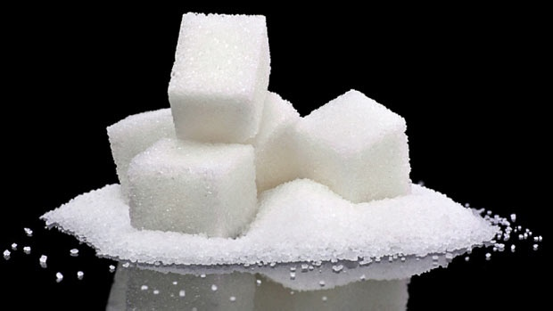
Red chili
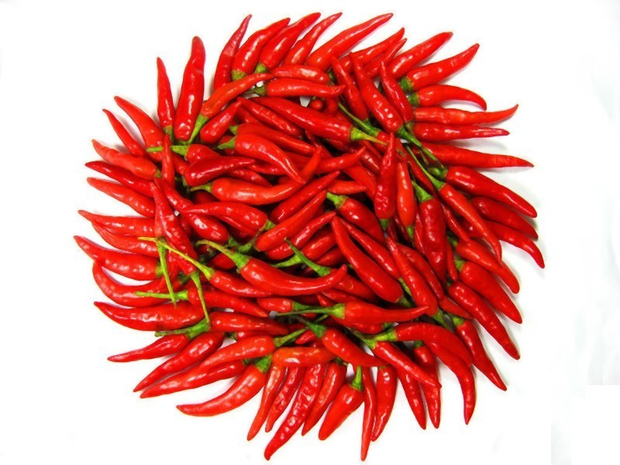

Chocolate
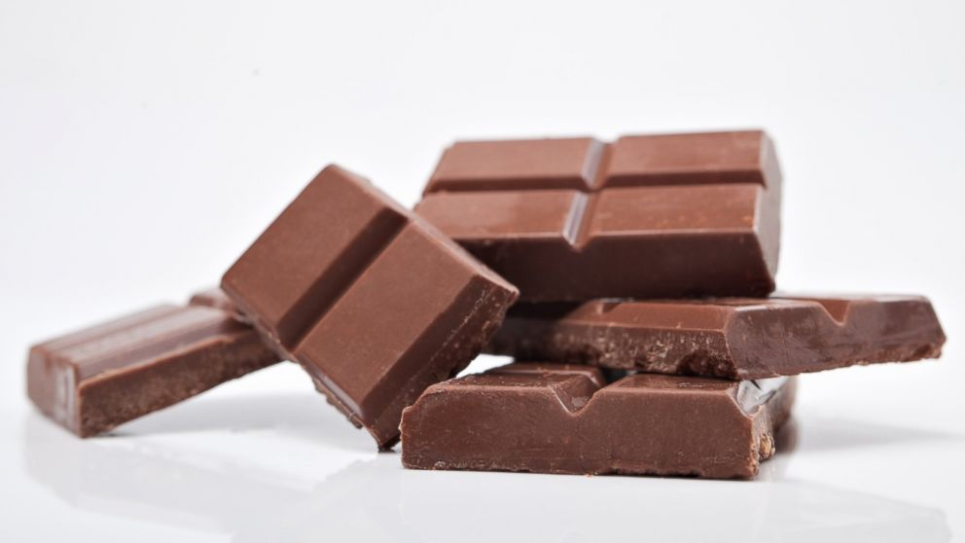

Recipe for Group A

- Olive oil (60ml)

- Garlic (2 pieces)

- Chorizo sausage (450g)

- Chicken thigh (1 piece)

- Shrimps (400g)

- Bass (250g)

- Squid (200g)

- Onions (chopped) (1)

- Chicken Broth (5 cups)

- Basmati rice (4 cups)

- White wine (125ml)

- Mussels (150g)

- Tomatoes (sliced) (200g)

- Peas (1/2 cup)

- Parsley (1 tablespoon)

- Lemons (1)

- Saffron (1 tablespoon)

- Salt (some)

- Pepper (some)
Recipe for Group B

- Hot Mashed potatoes (5, 800g)

- Sweet corn (100g)

- Butter (50g)

- Cheddar cheese (1/2 cup)

- Peas (1 cup)

- Carrot (1 cup)

- Corn (1 cup)

- Green beans (1 cup)

- Ground beef (1 kg)

- Cream cheese (1 cup)

- 2 cloves of garlic, minced

