Listening Speaking Reading Grammar Writing
Topic: My Family
Instructor:  Andy | Students Age – Competency Level  7-8 Years Old, Beginner | Number of Students:  8 | Lesson Length:  50 min
Materials:
Realia Father’s Bag, Mother’s Apron
Blank Paper
Grandfather Picture
Grandmother Picture
Father Picture
Mother Picture
Brother Picture
Practicing the Pattern Worksheet
Guitar
Some Paper
Student Map of Family
Using Song ‘Brown Bear, What Do You See?’
Brown Bear, What Do You See Lyrics.

Aims: (What students will be able to achieve by participating in the activities of the lesson.)
Ss get comfortable and interested in lesson by T presentation and attitude.
Ss will improve listening, writing, and speaking skills by making map of family, responding to teacher and describing their family in class.

Language Skills: (Lists what language skills students will be using by participating in the activities of the lesson.)
- Reading: reading their family map, sentences

- Listening: Listening to the song, to the teacher, and to the presentation of other students
- Speaking: Presenting their family map, singing the song

- Writing: making the Family map

Assumptions: (What students must already be able to do and what concepts must already be mastered before the lesson in order to achieve the aims of the lesson.)

Ss enjoy and also have fun
Ss will easily learn a pattern by practicing the pattern with T guidance
Ss have already heard the song ‘Brown bear, What do you see?’
Ss can make descriptive noun phrases of their Family with T assistance as needed

Anticipated Errors and Solutions: (What things might go wrong in the lesson and what the solution will be)
Activity takes too long; the other activity may be shortened.
Ss might be shy, teacher give encouragement.

References:

Lead-In (Warm-Up Part to activate and create interest in the lesson)
Materials:
Realia Father’s Bag, Mother’s Apron
Blank Paper

Time: | Classroom Set Up: | Student Activity and Goals: | Teacher Procedure Instructions:
1 min  2 min  2 min  3 min  3 min | Whole class  S  S  S | Greet teacher  Ss watch –become interested  Ss respond  Ss observe T and  Ss draw map  Introduce Ss Family Map | Greet students  T shows father’s bag and mother’s apron.  Ask Ss about Ss father or mother.  Hands out paper. T asks Ss to draw Ss Family map. T demonslate Family map.  T asks Ss to share. What’s your family?

Pre-Activity (Presentation Part Presenting the language structure to be covered in the lesson)

Materials:
Grandfather Picture
Grandmother Picture
Father Picture
Mother Picture
Brother Picture
Practicing the Pattern Worksheet
Time: | Classroom Set Up: | Student Activity and Goals: | Teacher Procedure Instructions:
3 min  4 min  12 min | Whole cla  S | Ss listen and repeat pattern  Ss listen then Ss read sentences using the pattern  Ss see the pictures and name the pictures and to describe pictures short noun phrases in the pattern. | T introduce stress a pattern using the pictures. The pattern goes like this (DAdadaDA) such as ‘WHAT do you SEE?  Handout, Practicing the Pattern Worksheet with sentences using DAdadaDA pattern.  Examples  - WHAT do you LIKE?  - WHERE are you GOING?  - WHERE are you FROM?  - WHAT is your NAME?  T shows pictures. Ask Ss to name and then describe the pictures in short noun phrases. T demonstrates first using the descriptions with the pattern then ask Ss to do.  Example ; show the first father picture.

Main Activity (Practice to Production Part Teacher lead practice of the language presented)
Materials: Guitar
Some Paper
Student Map of Family
Using Song ‘Brown Bear, What Do You See?’

Time: | Classroom Set Up: | Student Activity and Goals: | Teacher Procedure Instructions:
4 min  10min | Whole cla  S | Listen to song and respond about the pattern  Write description of their Family  Sing Brown bear, What do you see? the pattern. | T sing a song ‘Brown Bear, What Do You See?’ with guitar. Ask Listen to the song and describe the pattern by singing.  Ask Ss take list of their Family and make descriptive noun phrases

Post Activity (Wrap-Up Part Close the Lesson on a high note to consolidate language learned)
Materials: Guitar
Student Map of Family
Using Song ‘Brown Bear, What Do You See?’
Time: | Classroom Set Up: | Student Activity and Goals: | Teacher Procedure Instructions:
5 min  1min | Whole cla  Whole | Ss listen then join in with T  Ss say good bye | T sing along with and demonstrates using one S Family map with description.  Thanks Ss for active participation

Family Map

Practing The Pattern Worksheet

DAdadaDA

- WHAT do you LIKE?

O ㅇ ㅇ O

- WHERE are you GOING?

O ㅇ ㅇ O

- WHERE are you FROM?

O ㅇ ㅇ O

- WHAT is your NAME?

O ㅇ ㅇ O

WHAT do you SEE?

O ㅇ ㅇ O

Brown Bear, Brown Bear, What Do You See?
Brown bear, brown bear, what do you see?
I see a red bird looking at me.
Red bird, red bird, what do you see?
I see a yellow duck looking at me.
Yellow duck, yellow duck, what do you see?
I see a blue horse looking at me.
Blue horse, blue horse, what do you see?
I see a green frog looking at me.
Green frog, green frog, what do you see?
I see a purple cat looking at me.
Purple cat, purple cat, what do you see?
I see a white dog looking at me.
White dog, white dog, what do you see?
I see a black sheep looking at me.
Black sheep, black sheep, what do you see?
I see a goldfish looking at me.
Goldfish, goldfish, what do you see?
I see a teacher looking at me.
Teacher, teacher, what do you see?
I see children looking at me.
Children, children, what do you see?
We see a brown bear, a red bird, a yellow duck, a blue horse, a green frog, a purple cat,
a white dog, a black sheep, a goldfish, and a teacher looking at us.
That's what we see.

GRAND FATHER

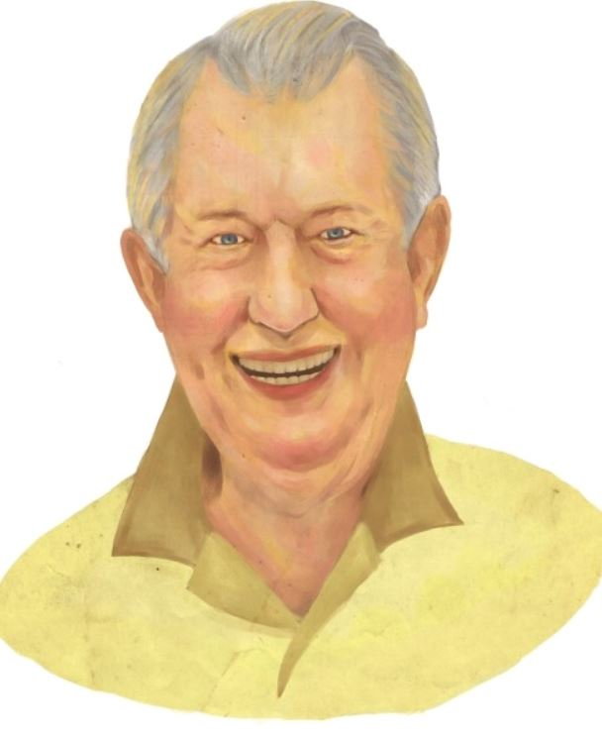

GRAND MOTHER

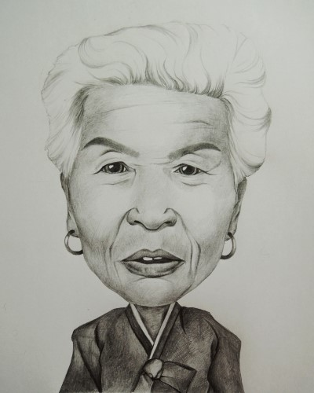

FATHER

MOTHER
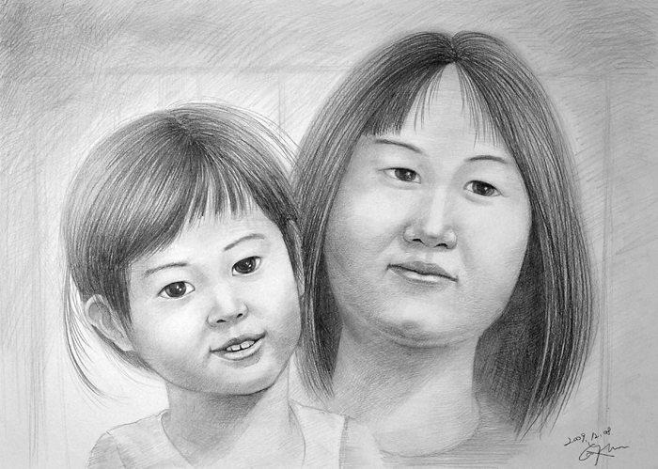

BROTHER
