Speaking
Topic: Find your True Color!

Instructor  김형원(Chloe) | Level  Intermediate | Students  7 | Length  45 Minutes

Materials
An MP3 file of “True Colors(John Legend)” and the lyrics, a big sheet to make a poster, flower work sheets, color pencils
Aims
Main aim: Ss will be able to talk about themselves and get closer to each other.
Secondary aim: Ss will get to know about the relation between colors and personalities.
Personal aim: I will try to give firm instructions and use more gestures.

Language Skills
Listening: Ss will listen to each other while interviewing each other.
Reading: Ss will read a material of the color-personality relations.
Writing: Ss will write down interviewees’ ideas and their own.
Speaking: Ss will ask and answer questions while interviewing.
Language Systems
Phonology: n/a
Lexis: (Color names and adjectives related to personality colors)
Grammar: n/a
Function: Expressing opinions, Asking questions and so on.
Discourse: Interview / Discussion / Presentation

Assumptions
Ss know each other quite well so that they can think of others’ true colors.
Ss can show their ideas and feelings with various expressions.
Anticipated Errors and Solutions
There might not be the same personality color → Switch to an individual work.

References
John Legend’s clip: http://youtu.be/SosPuPjf3W4
Information about True Colors: http://truecolorsintl.com/about-us/
Your Personality Color (reading passage):
http://www.empower-yourself-with-color-psychology.com/personality-color.html
A rose picture: http://kurtkoontz.com/wp-content/uploads/2013/11/True-Colors.jpg

Pre-Task
Materials: A video clip, slides
Time | Set Up | Student Activity | Teacher Talk
4min | Slide  Music  (lyrics)  Slide | Eliciting with True Colors (John Legend)  (Show the logo of TED talks)  Are you all familiar with TED? There have been many people on TED talks, and the speakers give speeches about topics they are interested in. A famous singer “John Legend” is one of the people. He actually does not talk at all and just sings. Let’s relax and listen to his TED talk, (or TED sing).  (Click – the lyrics)  (1minute taken for listening the song)  Lead In  (Stop the music.) I will turn it on as back ground music later on. It is a nice song, isn’t it? Did you hear the words he sang?  What do you think is the title of the song? (True Colors) That’s correct, it is True Colors.  (Click – colorful roses)

Task Preparation (1)
Materials: Work sheets, color pencils.
Time | Set Up | Student Activity | Teacher Talk
5min | Slide  Work sheets/  Color pencils  Sample  Slide  Slide  Slide | Guiding Questions  What do you think the True Colors mean? I am not the song writer but I am sure it means personality.  What do you think is your personality color? Just keep the answer in your mind. If you don’t think you have a personality color then look at the clothes you wear or the colors you choose when you decorate your room or your car. It can be one color or more, possibly. Those colors, you’re thinking, definitely reflect your personality.  We are going to figure our own true colors today. But you know, sometimes other people see us better. So first, we are going to help each other find our colors.  Today’s topic is (Click) “Find your true color!”  Instructions  Here are your first activity sheets. (Change the desk arrangement if needed.) Please pass them to the next person. Can you see a flower? Can you show your flower to everyone else?  Do the flowers have colors? No, they need to be colored.  But, you’re NOT going to color them yourselves, other people will.  There are some things to follow.  (1) Interview classmates one by one and ask them to color one of your flower’s petals with color pencils.  (2) Plus, you have to get more than 2 reasons why they choose the specific color.  (3) When you move on to the next interviewee, please try not to show the previous colors you’ve got from the first person.  (4) After you finish interviewing, color the center with the color you think is your true color.  (5) Finish your interviews and coloring in 10 minutes and get back to your seat. And get ready for another fun thing!  Demonstration (Sample)  (Show them my sample) Here is my sample. I will put it here.  ICQs  How much time do you have? 10? 15? (10 minutes)  Are you going to color all your petals by yourselves? (No, others will)  Are we coloring only the petals? (The center, too!)  Pre-teach  Here are the color options you have. Let’s learn how to read their names and see how they look. Repeat after me please.  Red/Orange/Yellow/Green/Blue/Indigo….  (Get back to the previous slide – steps/rules)

Task Realization (1)
Materials: Reading materials and discussion questions.
Time | Set Up | Student Activity | Teacher Talk
17min |  | Run the activity  ( Interviews, Presentation, Reading and discussion)  Stand up and Let’s move around. (Make sure the interview section finishes in (less than) 10 minutes.)  Let’s have a seat, everyone.  Can you introduce your flowers? Let’s take turns and present the colors you have and why they are given and what your favorite color is too.  STT (Brief Presentations)  ~~~~~~~ (Listen and monitor their speeches and check any errors.)  Prefect. Thank you for sharing everyone.

Task Preparation (2)
Materials: Work sheets, color pencils.
Time | Set Up | Student Activity | Teacher Talk
3min | Groups  (desks) | Lead In  Who have the same colors? (Get their answers)  This time, we are going to make groups of the same colors? Okay, Let’s rearrange our seats. Get together with your partners. (Help students make groups)  Instructions  Here is a reading passage for each color. (Hand them out) Read through with your partners (or by yourselves) and find anything in common! And make a poster that describes your colors. You should put your flowers too. Use the expressions and color pencils. You have 10 minutes to make your colorful posters! Oh, and if there are new vocabulary, ask your friends and research by yourself and get ready to explain when presenting.  ICQs  How much time do you have? (10 minutes.) What are you going to do with your partners/on your own? You are making a? (Poster.)

Task Realization (2)
Materials: Reading materials and discussion questions.
Time | Set Up | Student Activity | Teacher Talk
15min | Sheets/  Color pencils/  glues | Run the activity  Let’s start! (Check the time and help students if they don’t have a partner)  Time is up! Are we all done? Let’s stop and introduce our colors. Who wants to be the first??  STT (Presentation)  (Listen and check their errors)  They are different but I see some similar things between different colors as well. Let’s hang our posters on the walls.

Post Task
Materials: n/a
Time | Set Up | Student Activity | Teacher Talk
1min | n/a | I hope the activities gave you chance to know how people view you  and what kind of personality color you have.  It was so interesting for me as well to see your true colors.  Thank you for your hard work!
SOS Activities
Materials: Work sheets (True Color personality test)
Time | Set Up | Student Activity | Teacher Talk
10min |  | Well, there actually is a personality test called “True Colors.”  But it contains only 4 different colors. It will give you more simplified results. Because the previous 16 colors have many overlapped parts,  I would like you to try this test individually and make sure you have the same results.  (Let them take the test individually and hand out the result sheets when they are done.)  What color are you? Let’s take turns and briefly talk about the results...

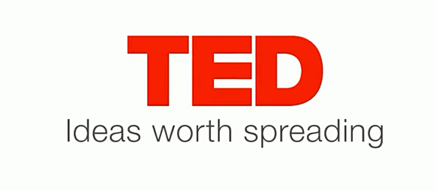

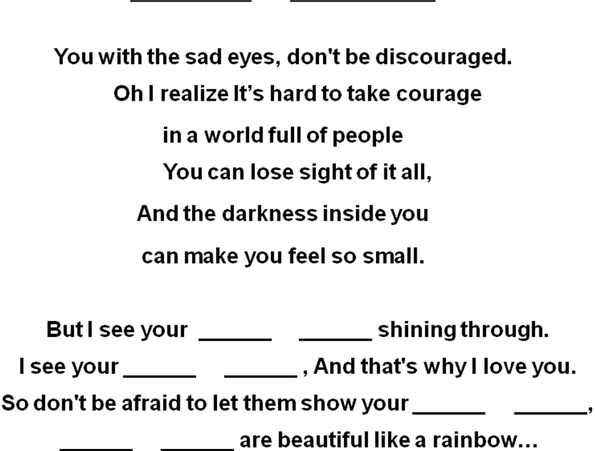

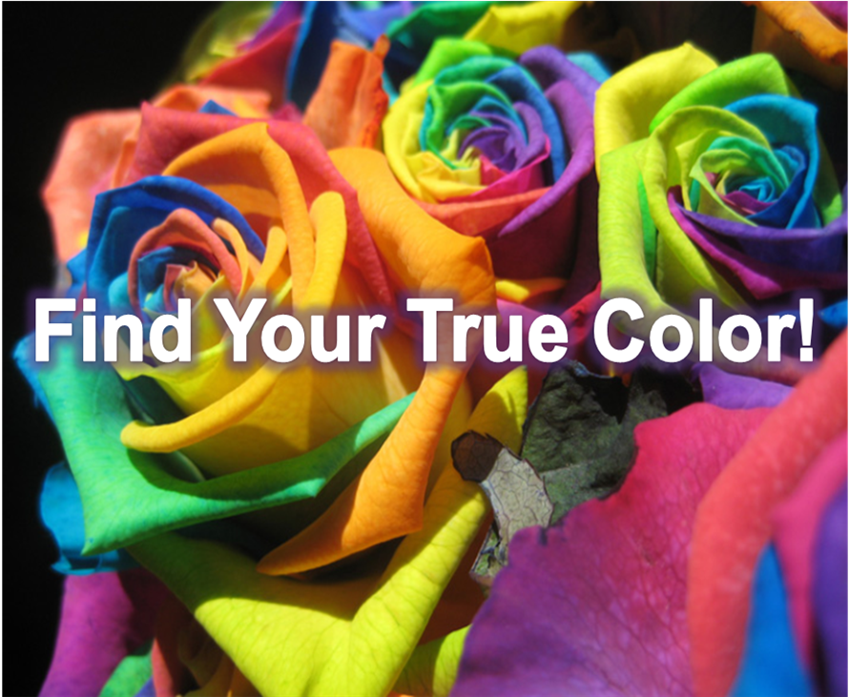
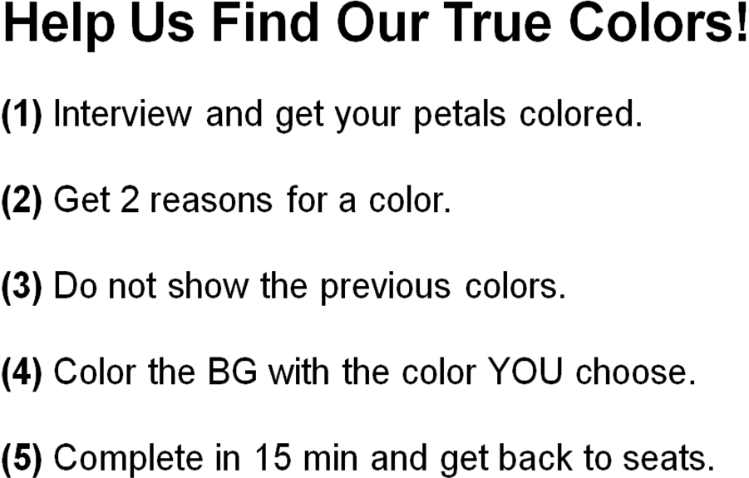
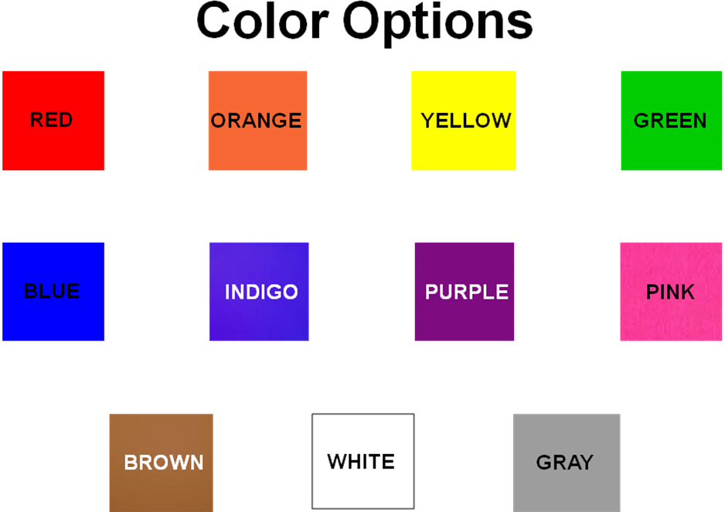

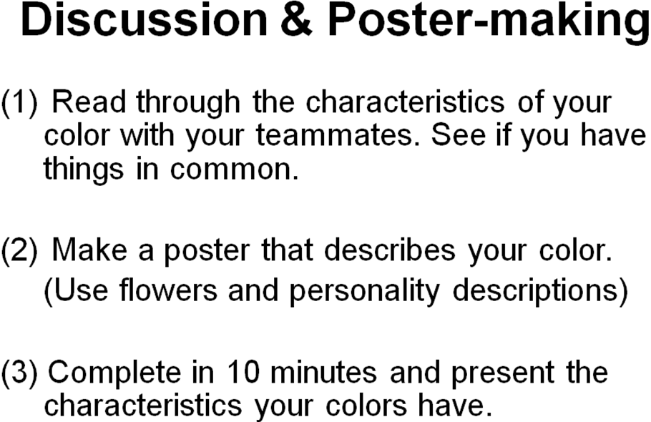

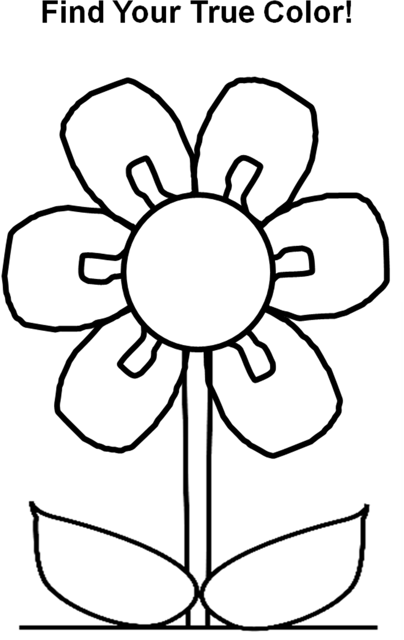
If your personality color is RED, you must be…
- Extrovert and
- Action-oriented and physically active
- Ambitious and competitive
- Optimistic and courageous
- Enthusiastic and aggressive
- Impulsive and in a hurry
- Bored easily

If your personality color is ORANGE, you must be…
- Warm and friendly
- Sociable and generally agreeable
- Free and not wanting to be tied
- Unpredictable sometimes
- Determined
- Optimistic

If your personality color is YELLOW, you must be…
- Cheerful and fun to be with
- Creative
- Critical of yourself and others
- Analyzing
- Selective with friends
- Independent
- Stubborn
- Trying to hide your emotions
- Spontaneous
- Impulsive sometimes

If your personality color is GREEN, you must be…
- Practical and down-to-earth
- Stable and well-balanced
- Generous and compassionate
- Caring and nurturing to others
- Intelligent and learning
- Loyal to friend and where you belong
- Bored with details
- Jealousy
- Community-minded
- An observer, not a risk-taker

If your personality color is BLUE, you must be…
- Conservative
- Reliable and trustworthy
- Not impulsive and always think before speaking
- Genuine and sincere
- Responsible
- Sensitive to the needs of others
- Sociable but closer to your own group
- Rigid and stubborn
- Spiritual and religious
- Thirsty for knowledge and wisdom

If your personality color is INDIGO, you must be…
- Honest
- Understanding and compassionate
- Inflexible about your life pattern
- Conscientious and reliable
- Hungry for the meaning of life
- Introspective
- Intuitive
- Into justice, law and order
- Addictive to work or other things
- Intolerable sometimes

If your personality color is PURPLE, you must be…
- Sensitive
- Compassionate
- Understanding and supportive
- Charismatic and alluring
- Idealistic and often impractical
- Good at judging characters of people
- Secretive so even your friends don’t know you well
- Very intuitive and spiritual

If your personality color is PINK, you must be…
- Loving, kind and generous
- Sensitive to the needs of others
- Friendly and approachable
- Feminine and can be like an immature girl at times.
- Calm and non-violent

If your personality color is BROWN, you must be…
- Honest, down-to-earth and wholesome
- Steady, reliable and quietly confident
- Friendly and approachable
- Genuine and sincere
- Loyal and trustworthy to friends
- Warm and supportive
- Hard-working and serious
- Frugal
- Uncomfortable about losing control

If your personality color is WHITE, you must be…
- Positive and optimistic
- Well-balanced and sensible
- Cautious, practical and careful with money
- Confident and self-assured mostly
- Wishing to create simplicity in life
- Wanting to give a perfect impression to others

If your personality color is GRAY, you must be…
- Neutral about life and indifferent
- Practical and calm
- Looking for rest and gap from the chaotic outside world
- Indecisive and lacking confidence.
- Pessimistic
- Seeking a contented life and peace

