**Name:__________**

**A**



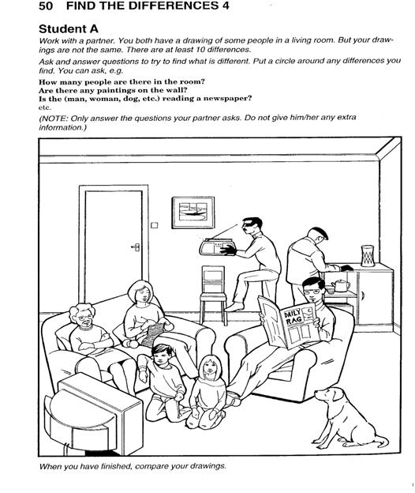

**Name:__________**

**B**



