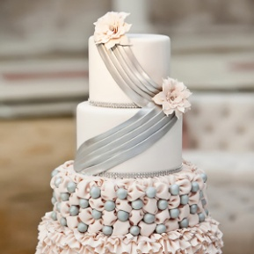
Name :______________

* Guide Lines

1) Introduce yourself and greet the other person.
2) Ask some questions to make small talk (see appendix A below)
3) Tell your gossip, using the sentence stems to start with (appendix B below)
4) Listen to the other person’s gossip and react (appendix C below)

Appendix A: Questions to make small talk at a wedding
Are you a friend of the bride or the groom?
What do you do then? (informal, asking about work)
Have you known the bride/groom long?
It’s a lovely wedding isn’t it?
I don’t think we’ve met, my name is…
Isn’t it a beautiful day for a wedding?
Doesn’t the bride look wonderful?

Appendix B: Sentence stems for a surprising aspect or a secret
I shouldn’t really say this but…
I know this isn’t the time to talk about it, but…
Did you know that…
You may not believe this but…
Well, I heard that…
Please don’t tell anyone I told you…
Somebody told me that…

Appendix C: Reacting to surprising news
Really!
No way!
I can’t believe it!
You’re kidding!
That’s terrible!

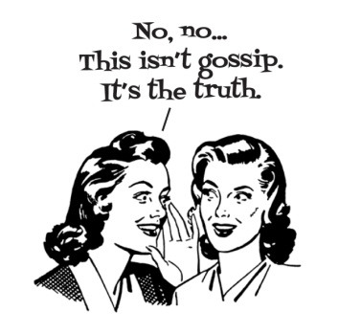
Name:___________

- Gossip you know

- Gossips the others know

Name | Role | Gossip
Sam | A friend of the bride’s | The bride worked as a dancer in a famous nightclub.
Name :________

- Gossip Ranking

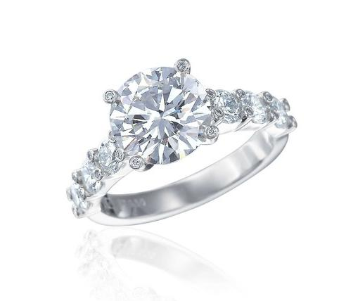
You are Sam Williams. You are a friend of the bride’s. You are a hairdresser. You know that the bride worked as a dancer in a famous nightclub.

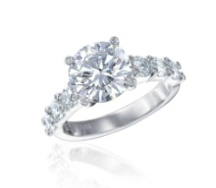
You are Jennifer Andrews, the maid of honor. You have known the bride for fifteen years. You work as a model. You know that the bride was secretly engaged to your brother for many years but they broke up.
You are Ann Marie Meller. You are a friend of the bride’s mother. You are a widow (your husband died two years ago). You have heard that the bride’s father has a secret girlfriend, a young woman from the city which invited to the party too.
You are Kylie Griffith. You are a friend of the groom’s. You are the owner of a well-know nightclub. You know that the groom has had LOTS of girlfriends and he likes to go to nightclubs. He met his bride at one!

You are Mrs. Emily Watson. You are the groom’s godmother. You are retired. You love your godson (the groom) very much, but you are worried he has a drinking problem!

You are Peter Donovsky. You are a business associate of the bride’s father. You don’t trust the groom or anybody in his family. In your opinion, they are all dishonest.
You are Debbie Harris a friend of the bride’s father (You are actually his secret girlfriend, but don’t tell anyone!) You are a dance instructor. You know that the bride went to university only because her father paid a lot of money!

You are Charlie Richards, the best man. You work at a bank in the city.

You know that the groom had problems with the law and has been arrested at least once!

