Reading Lesson Plan
Title: Making Outcasts

Instructor:  Torah | Level:  intermediate | Students:  8 | Length:  40 minutes

Materials:
- Picture 1~12
- White board & Marker
- 10 pieces of paper
- an apron
- 8 copies of worksheets for the main idea
- 8 copies of worksheets for details
- 8 copies of articles
- 8 copies of paper for homework

Aims:
∙Students will learn key words and figure out them by playing a game in pre-activity.
∙Students will comprehend the main idea by skimming the article.
∙Students will improve scanning skills by the course to answer worksheet for details.
∙Students will create the new stories of the picture by discussion and presentation.

Language Skills:
1) Listening: Listening to other students’ presentation
2) Speaking: describing the pictures of post-activity
3) Reading: Reading the article and worksheets
4) Writing: Writing the main idea of worksheet

Language Systems:
1) Lexis : The use of ‘go beyond’ ‘no longer’ ‘covered with’
2) Grammar : How to use ‘have + p.p’
3) Discourse : Interaction with their own group through post-activity.

Assumptions about Students:
1) Students are interested in the topic
2) Students are not familiar with their teacher’s teaching method
3) Students can understand the content of the article.
4) Most of students are good, but don’t respond immediately

Possible Problems and Solutions:
1) If some students are shy when they present, I will encourage them to do it.
2) If time is not enough, I’ll let students present their work within short limit time during post-activity
3) If some students finish each task earlier, I’ll give them some questions about the topic.
4) If students are not interested in the topic, I will try to raise their interest.

References:
∙http://www.segye.com/content/html/2011/01/26/20110126001316.html
∙http://xfinity.comcast.net/blogs/tv/2009/07/01/fancast-movie-of-the-week-modify/
∙Longman Dictionary of English Language and Culture
∙Longman Read and Think 2
∙http://adigaskell.org/2012/09/15/when-being-an-outcast-can-be-a-positive-thing/ ∙http://muchadoaboutdating.com/blog/i-cant-break-up-with-people/desperate-girl-in-love-grabs-unwilling-man/
∙http://www.pinterest.com/pin/473652085779412745/
∙http://unknownskywalker.tumblr.com/post/247872203/go-beyond
∙http://www.cgshelf.com/motion_tweening.php
∙http://www.bryanboy.com/bryanboy_le_superstar_fab/2010/11/vogue-paris-tribute-to-jocelyn-wildenstein-awful-plastic-surgery.html
∙http://www.gettyimages.com/detail/news-photo/erik-sprague-showing-off-his-reptilian-scale-tattoos-filed-news-photo/50555822

Lead-in:
Materials: picture 1~2, board, marker
Time | Set Up | Procedure
1 min | Whole Class | ∙Greeting  Good afternoon, everyone. How are you today? (students answer) Good. I’ve never been better. Thanks. Let’s start if you are ready.  ∙Lead-in  Let me show one picture before class. Look at this side of the picture. (show p1 to students) Do you know who he is? Yes, right. He is a comedian, you know. How about this side? Do you know who? Hard to believe, both are the same man. What happened to him? Can you guess today’s topic? Right. Today We are going to talk about “plastic surgery”. But do you think that’s all? Look at the other picture. (show p2 to students) What about this? Surprisingly, he had plastic surgery, too. Yes, today we are going to talk about this kind of plastic surgery.(Write ‘Making Outcasts’ on the board)

Pre-activity:
Materials: picture 3~7, some pieces of paper, an apron
Time | Set Up | Procedure
3 mins  4 mins  7 mins | Whole Class  Whole Class  Group | ∙Pre-teaching  Before reading, let’s check 5 key vocabularies. I will show 5 pictures to you.  (p3) Look at the first picture of them. What do you think of it? Does he look bullied? Yes, right. He isn’t in the rest of society. Look at this picture carefully. He is painted in black and white, different from others. They cast him out for being a little different. We can call him ‘outcast’. Can you say what it is? (Ss answer) Yes, you can see the word in the title on the board.  (put p3 on the board)  (p4) Look at the next picture. Can you use photo-shop? If you use this program, you can guess this word easily. She is changed her position. She is modified her position. Second word is ‘modify’ which means change. What is the word? (Ss answer) Good.  (put p4 on the board)  (p5) Before next word, do you know what ‘scale’ means? (Ss answer) Yes, right. But in this article you can know another meaning of scale. (show p5 to Students) What can you see? We can see legs covered with scale-shaped tattoo. Scale is covered with outer body of fish, snakes, dragons, and so on.  (put p5 on the board)  (p6) Do you think it is beautiful or attractive? It seems to go beyond the standard of beauty. It goes beyond the standard of beauty. Can you guess what ‘go beyond’ means? Look at the picture. (show p6) The shark needs to be in the picture. But it goes beyond the picture. Can you guess? ‘Go beyond’ means more than is needed. (Put p6 on the board)  (p7) Look at the last picture. The last word is ‘desperate’. Its synonym is ‘earnest’ or ‘urgent’ Look at her. She is falling in love. But she looks as if she loves him in earnest, urgent or desperate situation.  (Put p7 on the board)  ∙Pre-Activity  Well, We know these 5 key vocabularies now. So let me give you time to make sure them.  Instruction  First, we are going to make 2 groups. And then, I give each group each 5 pieces of paper which are written each word. When each group gets 5 pieces, members can write how the other group should describe the word on one piece of paper. You will write them for the other group, not yours. After finishing writing, you are supposed to put 5 pieces in this pocket. (show an apron) After each member of a group takes out one piece of paper from the pocket, she describes the word by the rule written on the paper. You can write down the rules for 3 minutes and you can describe the word for 10 seconds. Please don’t guess the answer. You can get the one chance to say the answer each paper to keep you from guessing answers. If time is over, or you guess an answer, out!  Demonstration  For example, look at this. I have a piece of paper written ‘go beyond’. Then, for the opponent, I write…’with gesture’. And put this paper in the pocket of the other group. Later, if you take out this paper, you should describe the word by only ‘gesture’ within 10 seconds. Right?  CCQ  1. What are you going to do first? (writing rules for the other group) and after put paper in it? (taking out some paper and describing)  2. How much time do you have during writing rules? (3 minutes) and during describing? (each 10 seconds)  3. Are you working individually or group? (Group)  Ok, now, begin! Please first make a group with the people near you.  (Teacher wears an apron and times)  Feedback  Good Job! Was it fun? I hope so.

Main Activity:
Material: worksheets for main idea, worksheets for details, article
Time | Set Up | Procedure
2 mins  6 mins  1 mins  6 mins | individually  Whole Class  individually | Skimming for the Main Idea  Instruction  We are ready for the article. I will hand out worksheet and an article. And then you are going to read the article individually thinking about the 5 questions of worksheet. I would like you to read the article quickly for main idea for 4 minutes.  Demonstration  (show a worksheet of the main idea)  Look at number 1 of a worksheet. What does the title tell you about the writer’s attitude? (show the paper of article) For this question, you will focus on the article and the title.  CCQ  1. What are you going to do? (Answer in the worksheet)  2. How much time do you have? (4 minutes)  3. Are you working individually or in group? (individually)  Hand out worksheet and Article  Ok, let’s begin.  Monitor  (While checking the article and worksheet, monitor students. Walk around and time how long it takes)  30 seconds left. You don’t have to write too long sentences.  Checking answers  Are you done? Ok, let’s check the answers. First, No.1. AAA, What is your answer of no 1? (answer) Do you agree with her? Good. Next, BBB, What is your answer of no 2? (answer) Do you agree with her, guys? Good. Last, CCC, what is yours of no 3? (answer) Do you agree with him? Good.  Feedback  Wow, nice job. Everyone had good answers!  Scanning for the Details  Instruction  Now, I am going to give another worksheet for the article. You can have 4 minutes to choose the best answer. Let’s make groups of 2. Get together with the student near you. You should scan the article for your worksheet for 4 minutes  Demonstration  Look at no 1 of worksheet together. (show worksheet) Some people remove the lower ribs to….You can find the information of this answer by scanning the article.  CCQ  1. What are you going to do? (choose the best answer)  2. How much time do you have? (4 minutes)  3. Are you working individually or in group? (in a group)  Hand out worksheet  Ok, let’s begin.  Monitor  (walk around and monitor)  Checking answers  You are done. Let’s check. DDD, What is the best answer of no 1? (answer) Do you agree everyone? (get one student to answer each number over and over)  Feedback  You are great! Thank you for your good answer.

Post-activity:
Materials: 5 pictures, board & marker, worksheet for homework
Time | Set Up | Procedure
3 mins  6 mins  3 mins | Whole Class  Group  Whole Class | Production : Discussion and Presenting  Instruction  According to this article, the reason for extreme plastic surgery is a mental problem that should be treated by psychiatrists. It is neither simple addiction nor failure. We can discuss this problem. First we can keep this form as a group. I am going to give each picture of plastic surgery to each group. After each group is offered that picture, one member is supposed to be a plastic surgeon, and the other is a psychiatrist. You can discuss a picture, and then present it as doctors. You can have 4 minutes for discussion.  Demonstration  For example, look at this picture again. (show p8)  As a plastic surgeon, I can talk that she had her eyes torn extremely, cheeks inserted something like silicone, philtrum between her nose and lips narrowed to look like a cat. As a psychiatrist, I can talk that she always thought her husband loved his cats, not wife. So she decided to modify her face like a cat because wanted to be loved by her husband. She was love-starved.  CCQ  1. What are you going to do? (discuss and present)  2. How much time do you have for discussion? (4 minutes)  3. Are you working individually or in group? (group)  Hand out 4 pictures  Let’s begin!  Monitor  (Walking around students and writing homework on the board)  30 seconds left.  Presentation  Time’s up. Let’s start your presentation with this group. (Students give presentation. Teachers listens to it and take notes on Students’ errors)  Feedback  (correct errors)  You are much better that I thought!  ∙Giving Homework  Instruction  Today we got some desperate view of plastic surgery, tattooing and others. But is that all? I’d like you to look at it from various angles. For this, please visit a health clinic, doctor’s office or website and find some information. Read the materials and consider how ideas of safety, health or danger are shown in the text and pictures. And fill in the paper I will give you. You are supposed to report what you find to next class.  Demonstration  Look at this. (show the table for homework) You can look at five Ws. You have to put your ideas into five Ws on this paper.  CCQ  1. What are you going to do? (writing what you find and report)  2. By What way are you going to write your homework? (five Ws)  3. When is it due? (next class)  Closing  Today we read one article. I am a little afraid that you might have the negative view of plastic surgery. Clearly, too much water drowned the miller.  Thank you for your participation.  Bye

Appendix
★Pre teaching vocabulary game

How to describe “outcast” |  | How to describe “outcast”
How to describe “desperate” |  | How to describe “desperate”
How to describe “go beyond” |  | How to describe “go beyond”
How to describe “scale” |  | How to describe “scale”
How to describe “modify” |  | How to describe “modify”

Picture 1
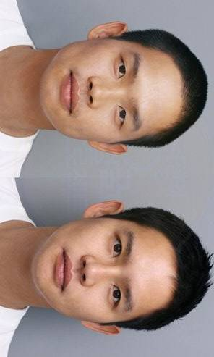
Picture 2
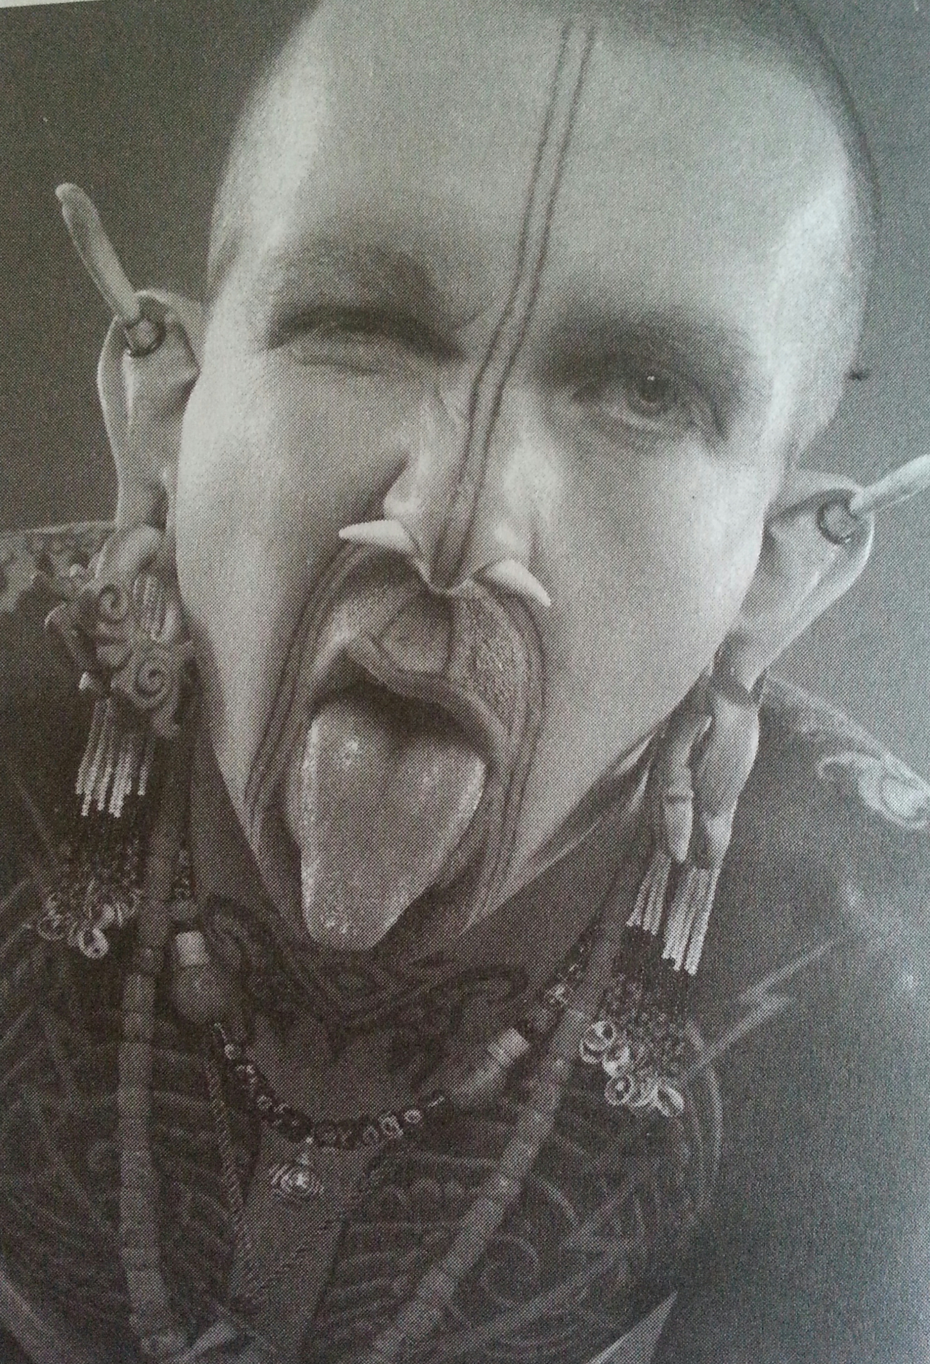
Picture 3

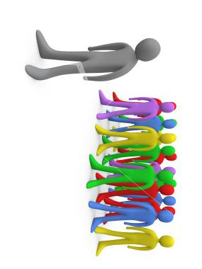
Picture 4
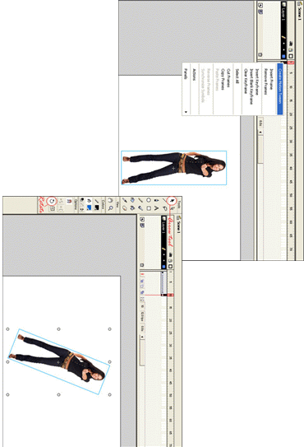

Picture 5

Picture 6
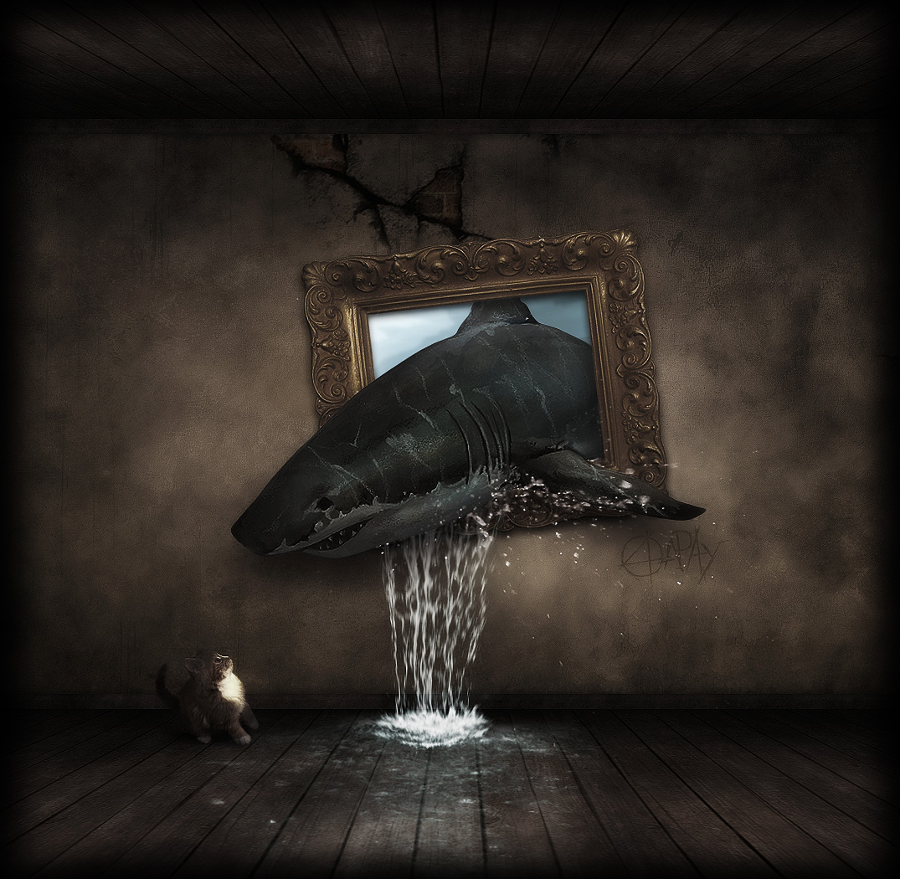

Picture 7


Picture 8
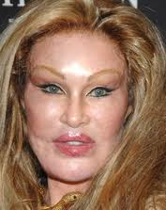

Picture 9
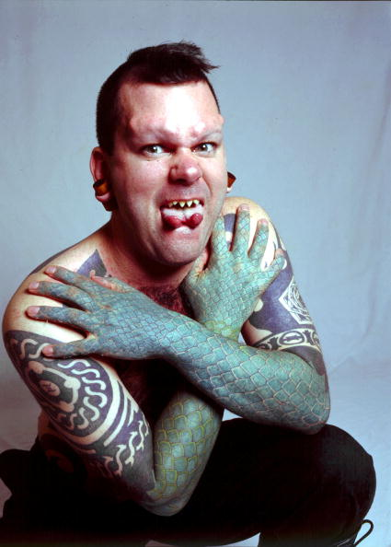

Picture 10


Picture 11
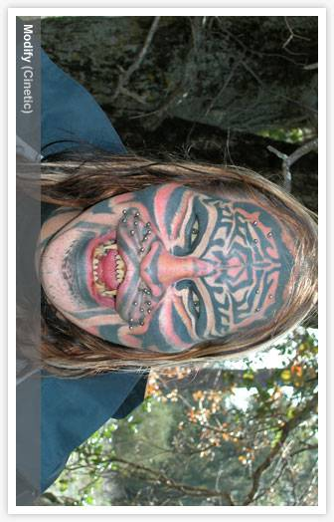
Picture 12
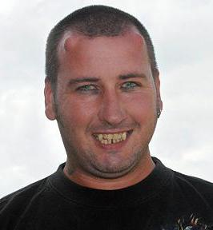

Questions for Main Idea

1. What does the title tell you about the writer’s attitude?

2. Why did the ancient Egyptians practice plastic surgery?

3. What is ‘lizard people’?

4. Write down your own answer about the question in this article, ‘what is wrong with such outcasts’?

5. In what ways can you permanently change your appearance?

Questions for Details

★Choose the best answer.

1. Some people remove the lower ribs to .
a. become shorter
b. make their social position lower
c. make the world better
d. get thinner and thinner waist

2. Plastic surgery .
a. was first used to help people with wounds and burns
b. was invented to make people look like animals
c. uses various kinds of plastic, such as shopping bags
d. can be done by anyone at home in the kitchen

3. Some people may get plastic surgery to .
a. pierce their teeth
b. make themselves unhappy
c. make themselves look more like animals
d. increase their weight

4. The author of Making Outcasts probably feels .
a. most plastic surgery makes you look better
b. law should govern the practice of plastic surgery
c. no one wants to look like a cat
d. many new kinds of plastic surgery are possible

5. The phrase treated by psychiatrists, not surgeons suggests .
a. people have many choices of doctors
b. people may have problems with their minds, not their looks
c. psychiatrists offer people more treats
d. people may not know about their choice of doctors

Post-Activity
Name
Who
When
Where
What
Why
Your opinion about your homework

Making Outcasts

Most people think that plastic surgery is quite new, but it’s not. As far back as three thousand years ago, the ancient Egyptians practiced a simple form of plastic surgery, taking skin from one part of the body to repair wounds and burns on another part. Of course, these operations were done for medical reasons, not just because people wanted to look different. Now plastic surgery has become more common and operations to change the shape of one’s eyes or nose or even removing the lower ribs to make one’s waist smaller are quite common.

But sadly, plastic surgeons have gone past these ideas; healing or creating beauty is no longer enough. Many people want to be ugly or, at the very least, less human. In particular, people have had many other kinds of operations for the purpose of modifying their faces and bodies to make them more animal-like. One man has had horns inserted into his skull. Many so-called “lizard people” have had their tongues split and scales tattooed onto their skin. One woman has had multiple operations to make her look like a cat. She has had hair inserted into her face to make her look like she has cat whiskers. Some have added long artificial teeth to make them look more like dogs. Other people have gone beyond different kinds of tattoos to getting their entire bodies covered with what look like fish scales or even fur.

The question that needs to be asked is not, What is possible? The important question is, What is wrong with such outcasts? There are two answers: they lack self-respect and they have a desperate need for attention. They should be treated by psychiatrists, not plastic surgeons. There are limits to the benefits of plastic surgery. We already have a society that doesn’t want to look old. We should beware of a society that no longer wants to look human.

(318 words)

