Listening
Topic: The rose

Instructor:  Hae-Jin Yang(Cindy) | Level:  Intermediate | Students:  12 | Length:  50 Minutes

Materials:
*Visuals of new vocabularies, The pictures of roses (Realia)
*Real reed
*Wall chart
*Cloze answer sheets for each student.
*Blank paper for writing poem.
*Computer (with connected internet) with projector.
*Crosswords worksheet.
*Grammar worksheet.

Aims:
Main aim: Ss will be improved their listening skill by guessing difficult words to hear such as linking sound words.
Secondary aim: Ss will be able to make sentences by using relative pronouns.
Tertiary aim: By using the famous song, student will enjoy when they approach English.
Personal aim: I want to improve teaching skills by using eliciting.

Language Skills:
Listening: Ss will listen to the Video Clip and dictate.
Reading: Ss will understand the meaning of each sentence. And they also will learn the form of poem.
Speaking: Ss will discuss about hidden meaning.
Writing: Ss will write their own poem.

Language Systems:
Phonology: long vowel ‘ee’
Lexis: razor, reed, bleed, be afraid of something.
Grammar: Relative pronouns.
Function: Inventing new vocabularies and describing the background of words.
Discourse: Discussing the song and creating poem.

Assumptions:
Students have done a dictation before.
Students are old enough to understand the meaning of love.
Students are interested in learning pop-songs.

Anticipated Errors and Solutions:
*If the student have difficulty in writing their own poem about the rose, let them change topic they want to write or have them just write sentences including the word ‘rose’.
*If the computer doesn’t work well, teachers will sing the song by themselves.

References:

Movie Clip : http://www.youtube.com/watch?v=VTCQBuYhq_s
http://www.youtube.com/watch?v=zxSTzSEiZ2c
Pictures
The meaning of rose color
http://www.google.co.kr/search?q=meaning+of+reso&newwindow=1&safe=active&biw=838&bih=683&source=lnms&tbm=isch&sa=X&ei=E7ShU9WnPNiVuASqvICADA&ved=0CAYQ_AUoAQ#newwindow=1&q=meaning+of+rose&safe=active&tbm=isch&facrc=_&imgdii=_&imgrc=4HItLcPFlEWb3M%253A%3BwUo3L5jFD7pgGM%3Bhttp%253A%252F%252Fjustfab.wpengine.netdna-cdn.com%252Fwp-content%252Fuploads%252F2013%252F06%252FMeaningOfRoseColors.jpg%3Bhttp%253A%252F%252Fblog.justfab.com%252F2013%252F06%252Fstop-and-smell-the-roses-the-meaning-of-rose-colors%252F%3B600%3B1200
Rose
http://www.glitterfy.com/graphics/rose/
razor
http://www.google.co.kr/search?q=meaning+of+reso&newwindow=1&safe=active&biw=838&bih=683&source=lnms&tbm=isch&sa=X&ei=E7ShU9WnPNiVuASqvICADA&ved=0CAYQ_AUoAQ#newwindow=1&q=razor&safe=active&tbm=isch&facrc=_&imgdii=_&imgrc=JuCbyRBfuCEUVM%253A%3B8W20PbLNN8DBXM%3Bhttp%253A%252F%252Fimg.thrfun.com%252Fimg%252F011%252F557%252Frazor_blade_s.jpg%3Bhttp%253A%252F%252Fwww.thriftyfun.com%252Ftf%252FOrganizing%252FAdvice%252FStoring-Razor-Blades.html%3B300%3B316
drown
http://www.google.co.kr/search?q=meaning+of+reso&newwindow=1&safe=active&biw=838&bih=683&source=lnms&tbm=isch&sa=X&ei=E7ShU9WnPNiVuASqvICADA&ved=0CAYQ_AUoAQ#newwindow=1&q=drown&safe=active&tbm=isch&facrc=_&imgdii=_&imgrc=Zdp_LFTlMph9iM%253A%3Bjjzkwxtcf54PPM%3Bhttp%253A%252F%252Fimages.rapgenius.com%252F90rx5ctvggg4mb5helana9vsx.700x700x1.jpg%3Bhttp%253A%252F%252Frock.rapgenius.com%252F2362095%252FVeil-of-maya-its-not-safe-to-swim-today%252FExhale-blood-push-them-down-and-exhale-water-push-them-down-and-exhale-blood%3B700%3B700
reed
http://www.google.co.kr/search?q=meaning+of+reso&newwindow=1&safe=active&biw=838&bih=683&source=lnms&tbm=isch&sa=X&ei=E7ShU9WnPNiVuASqvICADA&ved=0CAYQ_AUoAQ#newwindow=1&q=Reed&safe=active&tbm=isch&facrc=_&imgdii=_&imgrc=Ll7bDo50WRcjMM%253A%3Bwb04A-Q3YD18tM%3Bhttp%253A%252F%252F2.bp.blogspot.com%252F-8GnDq_nxtBU%252FTwhcJtWNSaI%252FAAAAAAAAAJk%252FLLwAP5Nz_ZA%252Fs1600%252Fphrag_e.jpg%3Bhttp%253A%252F%252Fcharwoodfarm.blogspot.com%252F2011%252F12%252Freed-warbling.html%3B1067%3B1600
bleed
http://www.google.co.kr/search?q=meaning+of+reso&newwindow=1&safe=active&biw=838&bih=683&source=lnms&tbm=isch&sa=X&ei=E7ShU9WnPNiVuASqvICADA&ved=0CAYQ_AUoAQ#newwindow=1&q=bleed+finger&safe=active&tbm=isch&facrc=_&imgdii=_&imgrc=g1E3FWdNxogUgM%253A%3BtcMjULJvVqpzVM%3Bhttp%253A%252F%252Fmckenzielcantwell.com%252Fwp-content%252Fuploads%252F2014%252F02%252Ffinger-prick.jpg%3Bhttp%253A%252F%252Fmckenzielcantwell.com%252Fbleeding%252F%3B1280%3B720
Relative pronoun worksheet
http://www.pinterest.com/sawsenabid5/relative-pronouns-quiz/

Lead-In
Materials:
Pictures of Roses and a video clip
Blank paper
Time | Set Up | Procedure
8min | Whole class  Pair  work | Lead in by asking students’ personal experience.  Greetings  Hi, Guys! How are you today?  Guiding Questions  Have you ever received some roses as a gift?  Do you know the meaning of roses by the color?  Motivate  Let’s take a look at the pictures of roses and try to guess the meaning of each colors of the rose.(see attached)  Prepare two handouts with the meaning of the roses and without it.  First, give student the handout without meaning, let them try to guess the meaning with partner, and ask their opinion.  Second, give the handout including meanings.  Elicit  Can you find out the words related with the pictures of this movie clip while you are watching?  http://www.youtube.com/watch?v=zxSTzSEiZ2c
,

Pre-Activity
Materials:
Computer with connected internet, grammar worksheet (see attached), visuals for key vocabulary(see attached), blank paper(see attached). Crossword game.

Time | Set Up | Procedure
3min | Whole class | Warm up  Let the student answer the crossword puzzle with the new keywords.  Instructions  Fill out the blanks after you read the definitions for each number.  Demonstration  Ask a volunteer to write the first word on the board before they start the crossword puzzle.  ICQs  Can you cut the paper with razor?  Is the bleed kind of plant?  Run the Activity  Let’s find out the words that have same vowels with your pairs.  Let’s find out the sentences that have opposite meaning with your group.  Pre- teach by writing the words on the board and following these steps.  Elicit : “Razor”  Have you ever seen the thin sharp blade using for disposable razor?  That’s right.  Elicit : “Reed”  What is this? ( by using real reed)  CCQ : What else can you use flower without looking at it?  Elicit : “Be afraid of”  Do you have anything you are afraid of?  CCQ : Please share your experience that you were afraid of?
8min | Pair  work

Main Activity
Materials:
Blank worksheet, grammar worksheet, wall chart
Time | Set Up | Procedure
10min | Individual  Group  work | First Activity (Q&A)  Give instructions and Run the Activity  Now, We are going to listen to the song and fill out each blank.  http://www.youtube.com/watch?v=VTCQBuYhq_s  Elicit  Do you apprehend what are the meaning of each words we’ve learn?  CCQ  Do you know what you have to focus on carefully while you are listening?  Asking Comprehension checking Questions:  What other people think about the love?  If you want to learn dancing, What should you do?  If you want to have the chance, what should you do?  Imagine what will happen in the spring after the long winter?  (Sharing the answers with others in the group)  Second activity  Elicit  Question: Why do we learn grammar through this song?  An expected answer: In order to improve reading and translate skills.  Demonstration  Explain the relative pronoun with example sentences on wall chart.  (See attached)  Give instruction and worksheet activities.  Instruction  Divide into 3 groups.  The team which completes the answers in advance will be the winner.  Fill out the answers in worksheet and check the answers with teacher.  Teacher’s role  Monitor the students discreetly and help them.  Run the Activity  (Watch again and do the cloze answer sheet activity)  Did you guys fill in all the blanks? (repeat it if not) Okay then who’d like to tell us the answers?  Checking answers with teacher.  Finally, Let’s sing this song all together.
11min | Individual  Group  Activity  Whole  Class

Post Activity
Materials:
Blank paper
Time | Set Up | Procedure
10min | In group | Motivation  Well done, guys. Have you ever written poem? Which poems do you like the best? You can also be a poet.  Instructions  Write a poem about roses. But if you want, you can change the topic or just write the sentences about the rose.  ICQs  Do you know the rules of writing poem?  Have you ever learned about rhyming?  The rhyme is the words which have very similar sound.  Now, Let’s try to find out a part of rhyme of this song.  Run the Activity  Wait and see they are writing well enough and help them if they make a mistake.  Okay , who would like to share your poem with us?  (Take turns and listen to the reader)  Close  Thank you for your participation and hope you had much fun

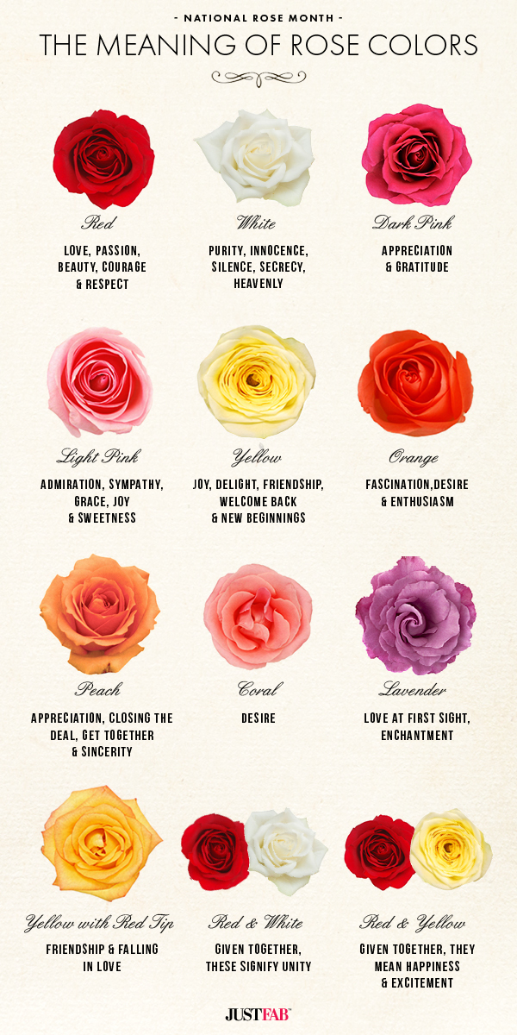

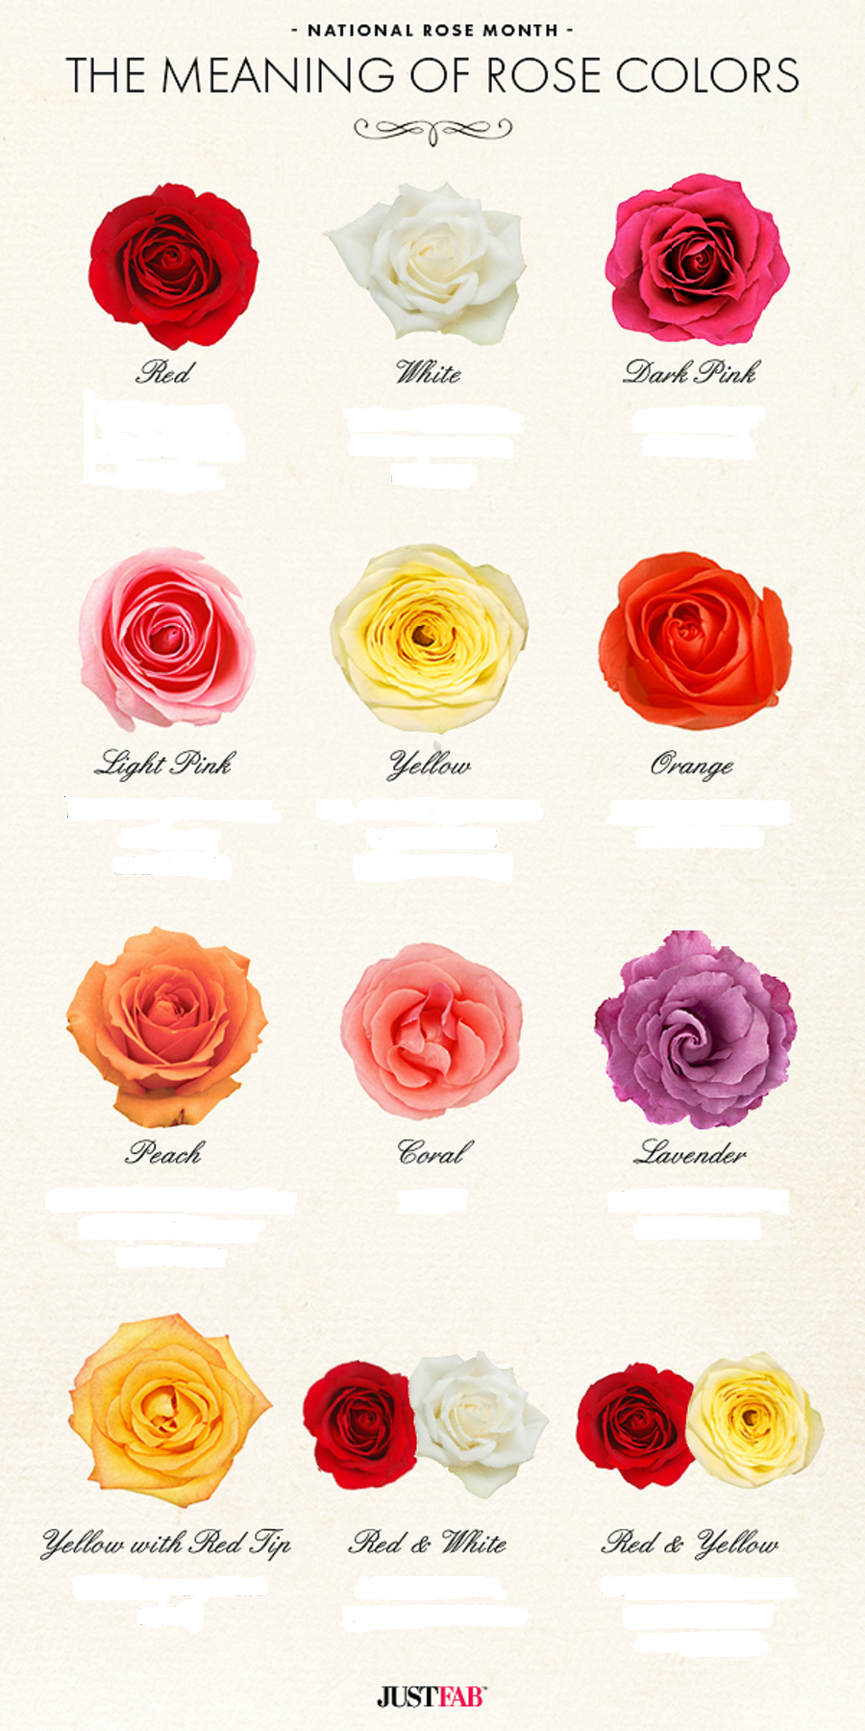

Write your Poem



Visual Aids
Razor | Drown
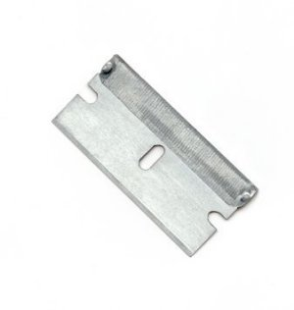 | 
Reed | Bleed
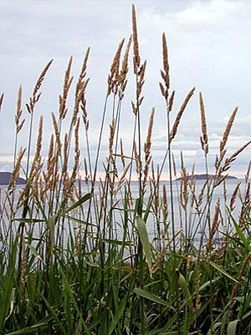 | 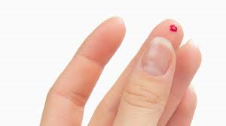

Wall Chart
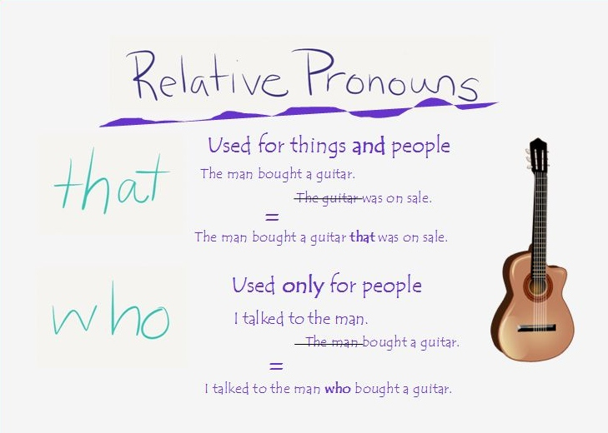

Cloze words
The rose -West life
Some say love ( ) is a river that ( ) the ( ) ( ).
Some say love it is a ( ) that ( ) your ( ) to ( ).

Some say love it is a ( ), an endless, ( ) need
I say love it is a flower, and you it's ( ) ( ).

It's the heart afraid of ( ) that never ( ) to ( )
It's the dream afraid of ( )that never ( ) the ( )

It's the one who ( ) ( ) ( ), who cannot ( ) ( ) ( )
And the ( ) afraid of ( ) that ( ) learns to ( ).

When the night ( ) ( ) too lonely and the ( ) has been too long.
And you ( ) that love is ( ) for the lucky and the strong.

Just remember in the ( ) ( ) ( )the ( )snow
( )the seed that with the ( ) ( )in the spring, becomes the rose.

The rose <West life>
Some say love it is a river that drowns the tender reed.
Some say love it is a razor that leaves your soul to bleed.
Some say love it is a hunger, an endless, aching need
I say love it is a flower, and you it's only seed.
It's the heart afraid of breaking that never learns to dance
It's the dream afraid of waking that never takes the chance
It's the one who won't be taken, who cannot seem to give
And the soul afraid of dying that never learns to live.
When the night has been too lonely and the road has been too long.
And you think that love is only for the lucky and the strong.
Just remember in the winter far beneath the bitter snow lies the seed that with the sun's love, in the spring, becomes the rose.



