Reading

Topic: Healthy Eating

Instructor:  Sue Kim | Level:  Upper Intermediate | Students:  12 | Length:  25 Minutes

Materials:

- T & F sticks for each groups (see attached)
For 3 groups;
3 copies of the T/F signs, 6 wooden sticks (or straws), tapes to attach the sticks on the T/F signs
- 1 copy of Material #1 (T/F Questions) for the teacher (see attached)
- A computer hooked up to a projector
- Ppt slides #1 & #2 to be displayed through a projector (see attached)
- 12 copies of worksheet #1 (word matching) (see attached)
- 6 copies of worksheet #2 (comprehension Q.) (1 copy for each pairs) (see attached)
- 12 copies of reading text (see attached)
- 3 copies of Worksheet #3 (1 copy for each group) (see attached)

Aims:

Main Aims:
- Students will practice their skimming and scanning skills.
- Students will use bottom up reading skills by going through the keywords in advance and skimming the reading text.
- Students will use top down reading skills and get details by scanning the reading text and answering the guiding questions.
Secondary Aims:
- Ss will be familiar with vocabularies used in the reading context by previewing the words through T/F activity and also by confirming their guess of the meanings through word matching task.
- Ss will be able to enhance the speaking skills by actively participating in the pair/group discussion.
Personal Aim:
- I want to improve my instructions by implementing various activities while I deliver them

Language Skills:

- Reading: Ss should use their skimming (bottom up) skills when they first read the text by previewing the keywords before reading. Ss should use scanning (top down) skills when they read the text again.
- Listening: Ss should listen to the instructions & guiding questions from the teacher.
- Speaking: Ss should speak to their peers while working in groups and discuss. They should debate on a statement given.
- Writing: Ss should write the answers to complete the comprehension questions.

Language Systems:

- Phonology: Sounding out the keywords in proper pronunciation
- Lexis: plump, obsessed, eating disorders, obese, diabetes
- Grammar: Present tense used on the reading text. Students will use simple present tense to describe general facts.
- Function: Describing facts and insisting their ideas while debate activities
- Discourse: Discussing opinions in groups

Assumptions:

- Ss know how to skim and scan
- Ss are adults and are able to express their ideas in English

Anticipated Errors and Solutions:

- Ss might take longer time than expected in doing their worksheets. Keep monitoring and help them in a whole class to finish all together.
- Ss might not be enthusiastic in answering a whole class questions. Designate a student to answer.
- When doing the post activity (debate) all the Ss in a group might have same ideas. Designate and divide the team into pros and cons or let the Ss discuss about the pros and cons together.
- Projector might malfunction. Show them the printed materials or use the whiteboard to show the keywords.

References:

Reading text: Active English Discussion Book 2, Unit 15 Healthy Diet by Andrew Finch published by Pearson Longman

for T/F statements #1~6:
Background Information of Healthy Diet on p.95
for T/F statements #7 Top 10 countries celebrating female obesity:
http://www.toptenz.net/top-10-countries-celebrating-female-obesity.php
for T/F statement #8
http://www.koreatimes.co.kr/www/news/biz/2014/01/335_105665.html

Images used for Fijian women then and now
Then: http://www.forumbiodiversity.com/showthread.php/27288-The-different-Faces-of-Nigeria/page31
Now: http://missosology.info/forum/viewtopic.php?f=6&t=145953

Lead-In
Materials: N/A

Time | Set Up | Procedure
3min | Whole  Class | Lead in by eliciting students’ interest and knowledge about their healthy diet.  Good afternoon everyone.  Elicit  Did you all have lunch?  What did you have for lunch?  Do you think it was a healthy meal?  Pick some students to ask about their lunch.  Guiding Questions/Elicit  How often do you think about your health these days?  Do you want to be healthy?  How hard do you try to be healthy?  When and where do you mostly get motivated?  How often do you exercise?  Motivation/Transition  Let’s play a little game and find out how much you are aware of the facts in living healthy lives.

Pre-Activity
Materials:

- T & F sticks for each groups
For 3 groups;
3 copies of the T/F signs, 6 wooden sticks (or straws), tapes to attach the sticks on the T/F signs
- 1 copy of Material #1 (T/F Questions) for the teacher (see attached)

Time | Set Up | Procedure
7min | Group work | Warm-up: Play True or False about some background information  Instructions:  Divide the class into 3 groups  Hand out T & F sticks for each group.  I am going to read out a sentence  And in each group, talk about the statement whether it is true or false. I will give you 5 seconds for each statement.  After I count down from 5, raise your stick that says T for true and F for False.  ICQ  Which stick do you raise if the statement is True?  Which stick do you raise for False?  How many seconds do you have for making your decision?  Run the Activity  Read each sentences from material #1 (see attached)  Go over the statements and if needed, elicit some meanings of the vocabularies in the statement those are also used in the reading text  Encourage Ss to guess the meaning of words and make sure they understood every word in a sentence.  Example:  #5. In USA, men suffer from eating disorders more than women do.  Elicit  What does eating disorder mean?  When we suffer from something, is it a good thing?  Try to think about the difference between eating in order and eating in disorder.  Give hints: It is a disease related to eating.  Yes, it means diseases which cause people to starve themselves.  CCQ  Do you think men suffer from eating disorders more than women do?  Finish the game and go on to the main activity

Main Activity
Materials:

- A computer hooked up to a projector
- Ppt slides #1 & #2 to be displayed through a projector (see attached)
- A copy of worksheet #1 (word matching) for each student (see attached)
- A copy of worksheet #2 (comprehension Q.) for each pairs (see attached)
- A copy of reading material sheet for each student (see attached)

Time | Set Up | Procedure
2min  2 min  1min  7min | Indiv/  Work  Whole  Class  Indiv/  Work  Pair  Work | Let’s quickly go over the keywords that we have discussed while the T/F activity.  You won’t have any difficulties with the words now.  Distribute worksheet #1 for each students  You will have 2 minutes for finishing this worksheet.  After 2 minutes, go over the answers with the whole class.  Motivation  Before reading the material, let’s look at the slides together.  Ppt slide #1 (see attached) hooked up to a projector  Motivate  I will show you two pictures of a Fijian woman then and now.  Try to think about the reason of what made the change in their looks.  display slide #2 (see attached)  Display the keywords in sequence.  These are some words from the reading context.  Elicit  Can you get the idea what the reading is about by looking at these words?  Reading Practice I (Skim)  Let’s quickly read the material individually.  I’ll give you 30 seconds.  After 30 seconds ask what the reading was about.  What would be the good title for this passage?  Reading Practice II (Scan)  Display 2 questions in sequence.  Now let’s think of these 2 questions while reading  Guiding Questions  What problems can obesity lead to?  What is a healthy way of losing weight and stay healthy?  After Reading;  Now in pairs, discuss and write down the answers on your worksheet and also compare your titles with your partner and write down the title on your sheets.  Worksheet #2 (Comprehension Questions)  Literal  - What problems can obesity lead to?  - What is the best way to lose weight and stay healthy?  Interpretive (Implied)  - Why are people around the world obsessed with unrealistic body figures?  - Why aren’t people exercising much?  Applied  Discuss and think of some ideas of giving some good advice to obese people to make them become healthier  What are some important rules to keep?

Post Activity
Materials:

- Worksheet #3 (see attached)
Time | Set Up | Procedure
3min | Group  work | Debate activity  Distribute a sheet of worksheet #3 for each group  Write the sentence on the board  ‘TV ads for junk food should be banned’  Elicit  Do you all agree with this statement?  What kind of side effects does a TV ad for junk foods have?  Do all junk food have negative effects?  Instructions  In each group we are going to do a short debate on TV ads for junk  foods. Talk about your ideas and use the worksheet to make notes  of your ideas. You have 3 minutes for this activity.  Make sure there are both pros and cons in each group.  Designate the students if needed.  Run the activity  Teacher keeps monitoring and managing time.  Close: congratulate the students on a job well done.  SOS: Give some more time on their current debate topic or give another statement about ‘going on a diet is unhealthy and dangerous’

Material #1

True or False statements for teacher’s reference.

- Breakfast is the most important meal of the day. (T)
- Low-fat foods can be fattening. (T)
- Chicken nuggets contain twice as much fat as hamburgers (T)
- Low-fat, high-calcium dairy foods may burn off fat (T)
- In USA, men suffer from eating disorders more than women do. (F)
-> 7 million women and 1 million men in USA suffer from eating disorders.
*Eating disorders: diseases which cause people to starve themselves.

- Fruit juices are always good for health. (F)
- They can contain more sugar than the standard amounts.
- There is a country that plump and chubby body is the height of beauty. (T)
- According to the research, some island countries like Samoa, Tahiti or
Jamaica, plump and curvy body is the height of beauty.
- Men are more overweight and obese in Korea than women. (T)
- According to the obesity chart from Korea Institute for Health and social affairs, men rated 36.2% obesity rate while women rated 26.3

T & F sign for the sticks used for True or False activity
Print this and cut out the shapes. Place a wooden chopstick on the back using a piece of tape to make a stick

Worksheet #1

Match the words in the box with the definitions below.
Write the letter in the bracket next to each definition.

- Fijians b. plump c. obsessed d. eating-disorder
e. irony f. obese g. junk food h. diabetes

- A sugar disorder in humans ( )
- Chubby; round ( )
- Dependent; devoted to; hooked on ( )
- Diseases which cause people to starve themselves ( )
- Food which has little nutritional value ( )
- People who live in Fiji, in the Pacific Ocean ( )
- Strange result; unexpected result ( )
- Very fat; extremely overweight ( )
Worksheet #1 ANSWERS

Match the words in the box with the definitions below.
Write the letter in the bracket next to each definition.

- Fijians b. plump c. obsessed d. eating-disorder
e. irony f. obese g. junk food h. diabetes

- A sugar disorder in humans ( h )
- Chubby; round ( b )
- Dependent; devoted to; hooked on ( c )
- Diseases which cause people to starve themselves ( d )
- Food which has little nutritional value ( g )
- People who live in Fiji, in the Pacific Ocean ( b )
- Strange result; unexpected result ( e )
- Very fat; extremely overweight ( f )
A copy of Powerpoint slides
#1 Fijian women then and now


Slide #2
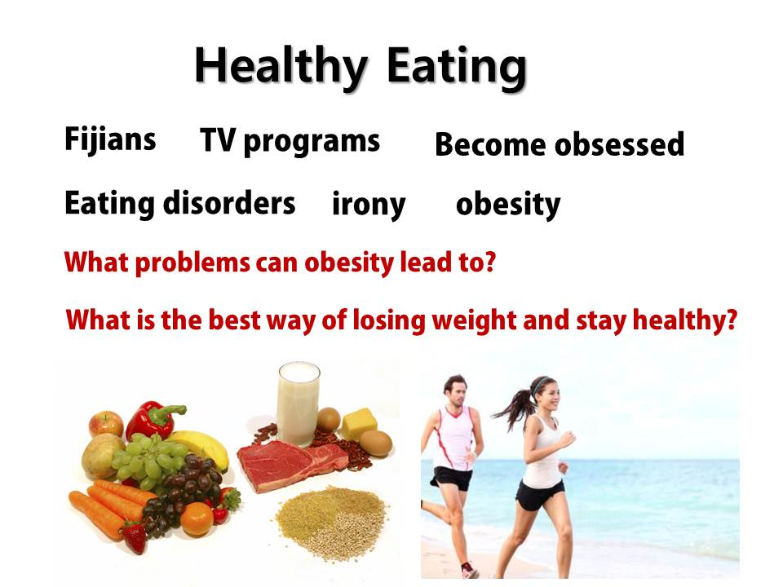



________________________

Fijians used to think that a plump, curvy body was the height of beauty. That was before TV came to the island, in 1955. Now, as a result of watching programs mainly from the USA, 3 out of every 4 teenage girls in Fiji think they are too fat. Our society has become obsessed with food and dieting, and many people have eating disorders as a result. Typical sufferers are hard-working perfectionists. They want to be as good as they can and for some unknown reason, they think that the way to do this is to lose weight.

The irony is that- according to The World Health Organization (WHO)-there are 1 billion overweight people and 300 million obese people in the world. One reason is that people are eating more fatty food and sugary food. Another is that they are not getting as much exercise as they used to.

One third of the average American diet consists of junk food: soft drinks, sweets, high-calorie desserts, and salty snacks. These increase obesity and can lead to diabetes, heart disease and even cancer. TV ads for junk food are part of the problem, with their unrealistically thin women and muscular men. They are much more frequent than ads for nutritious foods and they often target children.

Losing weight isn’t just about eating less. It’s about eating and drinking healthy foods: fresh grains, vegetables, fruits, water and milk. And don’t forget to exercise: jogging, swimming, cycling -anything is OK! Even a 30-minute walk each day will give your heart the exercise it needs.

Worksheet #2

Comprehension check questions.
Read the questions and write the answers below.

- What problems can obesity lead to?

___________________________________________________________
- What is a healthy way of losing weight and stay healthy?

___________________________________________________________
- Why are people around the world obsessed with unrealistic body figures?
___________________________________________________________
- Why aren’t people exercising much?
___________________________________________________________
- Discuss and think of some ideas of giving some good advice to obese people to make them become healthier.
___________________________________________________________
___________________________________________________________
___________________________________________________________
___________________________________________________________

Comprehension check questions.(Answers)

- What is a healthy way of losing weight and stay healthy?
It is about eating and drinking healthy foods and exercising.
- What problems can obesity lead to?
It can lead to diabetes, heart disease and even cancer.
- Why aren’t people exercising much?
People are getting used to convenient lives and it makes people lazy. (opinions may vary)
- Discuss and think of some ideas of giving some good advice to obese people to make them become healthier.
Increase vegetables and fruits to their diet plan, exercise, walk if available, see doctor to have health check regularly... etc.

Worksheet #3
Debate the statement together in groups.

TV ads for junk food should be banned.
Advantages | Disadvantages

