Seven Sisters Country Park

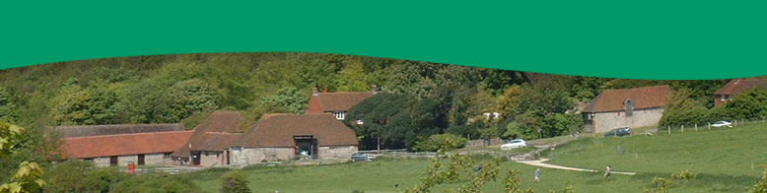

Situated in the South Downs National Park, the Seven Sisters Country Park comprises 280 hectares of chalk cliffs, meandering river valley and open chalk grassland. It is a popular place for a number of outdoor activities including walking, birdwatching, cycling and canoeing.The Country Park is named after the famous Seven Sisters that form part of the chalk cliffs on the Sussex Heritage Coast, one of Britain's finest unspoilt coastlines.
Seven Sisters Country Park offers an area of open countryside for visitors to enjoy quiet, informal recreation. It is a very important site and is managed to ensure that a balance is maintained between conservation and recreation. There are a set of byelaws to help and guide you during your visit to the Country Park.
Please ensure that you read and follow any signage and instructions. Cycling is only permitted on the valley floor of the Park, and in the Forest on bridleways and tracks.
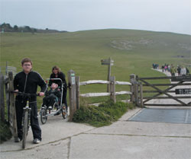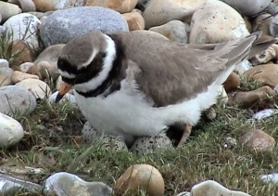

Other suggestions:
• Catch a few fish from the beach if you're lucky!
• Walk to the beach along the easy access trail.
• Enjoy all scenery, especially the great views from the top of the Seven Sisters cliffs and hillsides
• Check out the great wildlife including wading birds on the beach and at the lagoon, flowers and butterflies on the hillsides, and the fascinating underwater world of the rockpools at low tide

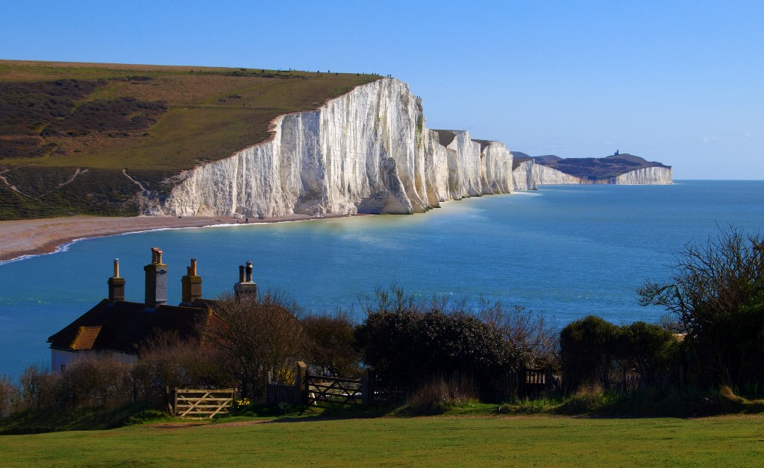

Please DO
- Take your litter home
- Pick up after your dog
- Follow the site bylaws
- Follow the Countryside Code

Please DO NOT
- DO NOT fish anywhere other than the beach - this includes the meanders and the riverbanks
- DO NOT let your dogs approach sheep and cattle as this can cause harm to your dog or the animals
- DO NOT have fires or barbecues anywhere on the Park
- DO NOT camp or put up a tent anywhere on the Park
- DO NOT cycle anywhere apart from the valley floor
- DO NOT pick any flowers - leave them for others to enjoy

Vocabulary worksheet

Match the words 1-10 with an appropriate meaning from the list a-j underneath.

1) chalk
2) cliff
3) meander
4) riverbank
5) conservation
6) byelaw
7) signage
8) bridleway
9) wade
10) rockpool

a) land along the edge of a river
b) saving and protecting the environment
c) trails for equestrians, hikers and cyclists
d) a type of soft white rock. You can use small pieces of it for writing or drawing with.
e) small pool between rocks on the edge of the sea
f) plodge
g) a high area of land with a very steep side
h) design or use of signs and symbols to communicate a message to a specific group
i) rule made by a local authority and which applies only in their area
j) it has a lot of bends

Worksheet (Short Answer Questions)

- What is the Seven Sisters Country Park comprised of?

- Where is the Park situated in?

- What kind of activities can you do at the Park?

- Where is the name the Seven Sisters Country Park originated from?

- Are you allowed to cycle anywhere in the Park?

- Where should you throw away the trash?

- What kind of wildlife are you able to see at the Park?

Worksheet (Speaking Activity)

Read the following dialogues in pairs and find what Sam and his dad won’t be able to do.

Dad : Sam, are you ready to go?
Sam : Is Rex coming? (Rex is their dog)
Dad : Of course.
Sam : Should I bring his lead?
Dad : No I think he’s fine. He needs some exercise and he loves to chase the sheep around.
Sam : Can I bring binoculars?
Dad : Sure. Don’t forget your new model aircraft. It’ll be so fun to fly your new aircraft.
Sam : What about the tent dad? Are we staying overnight?
Dad : Probably not but after fishing, if we get tired, we might stay overnight. But bring the tent anyway. Oh, pack your swimming trunk.
Sam : Yes! I love swimming. Are we going to dive and catch some fish?
Dad : If you’re lucky!
Sam : What’s that in that corner?
Dad : Oh, it’s my guitar.
Sam : I’ve never seen you playing the guitar?
Dad : I used to play a lot when I was younger. I’ll bring it and see if I still have the tunes.
Sam : Are we going to eat there?
Dad : It’ll be fun to fish at night with the camp fire beside and I’m hoping for a barbeque.
Sam : Exciting! Let’s go!! Is mom coming too?
Dad : No, she’s not feeling so well. We can bring back home some wild flowers for her. I’m sure she’ll like them.

Answer Sheet for the Instructor

Vocabulary worksheet

Match the words 1-10 with an appropriate meaning from the list a-j underneath.

1) chalk d
2) cliff g
3) meander j
4) riverbank a
5) conservation b
6) byelaw i
7) signage h
8) bridleway c
9) wade f
10) rockpool e

a) land along the edge of a river
b) saving and protecting the environment
c) trails for equestrians, hikers and cyclists
d) a type of soft white rock. You can use small pieces of it for writing or drawing with.
e) small pool between rocks on the edge of the sea
f) plodge
g) a high area of land with a very steep side
h) design or use of signs and symbols to communicate a message to a specific group
i) rule made by a local authority and which applies only in their area
j) it has a lot of bends

Worksheet (Short Answer Questions)
1. What is the Seven Sisters Country Park comprised of?
280 hectares of chalk cliffs, meandering river valley and open chalk grassland
2. Where is the Park situated in?
South Downs National Park, in the UK.
3. What kind of activities can you do at the Park?
walking, birdwatching, cycling and canoeing
4. Where is the name the Seven Sisters Country Park originated from?
named after the famous Seven Sisters that form part of the chalk cliffs on the Sussex Heritage Coast
5. Are you allowed to cycle anywhere in the Park?
Cycling is only permitted on the valley floor of the Park, and in the Forest on bridleways and tracks.
6. Where should you throw away the trash?
Take it home
7. What kind of wildlife are you able to see at the Park?
wading birds on the beach and at the lagoon, flowers and butterflies on the hillsides, and the fascinating underwater world of the rockpools at low tide

Read the following dialogues in pairs and find what Sam and his dad won’t be able to do.

Dad : Sam, are you ready to go?
Sam : Is Rex coming? (Rex is their dog)
Dad : Of course.
Sam : Should I bring his lead?
Dad : No I think he’s fine. He needs some exercise and he loves to follow the sheep around.
No person shall cause or suffer any dog or animal belonging to him or in his charge to enter or remain in the Park unless such dog or other animal be and continue to be under proper control, and be effectively restrained from causing annoyance to any person and from worrying or disturbing any animal or bird.
Sam : Can I bring binoculars?
Dad : Sure. Don’t forget your new model aircraft. It’ll be so fun to fly your new aircraft.
No person shall in the Park fly any model aircraft driven by the combustion of petrol vapour or of any other substance
Sam : What about the tent dad? Are we staying overnight?
DO NOT camp or put up a tent anywhere on the Park
Dad : Probably not but after fishing, if we get tired, we might stay overnight. But bring the tent anyway. Oh, pack your swimming trunk.
Sam : Yes! I love swimming. Are we going to dive and catch some fish?
Dad : If you’re lucky!
Sam : What’s that in that corner?
Dad : Oh, it’s my guitar.
Sam : I’ve never seen you playing the guitar?
Dad : I used to play a lot when I was younger. I’ll bring it and see if I still have the tunes.
No person shall in the Park give or take in any musical performance or hold any entertainment to the annoyance of other persons using the Park
Sam : Are we going to eat there?
Dad : It’ll be fun to fish at night with the camp fire beside and I’m hoping for a barbeque.
DO NOT have fires or barbecues anywhere on the Park
Sam : Exciting! Let’s go!! Is mom coming too?
Dad : No, she’s not feeling so well. We can bring back home some wild flowers for her. I’m sure she’ll like them.
DO NOT pick any flowers - leave them for others to enjoy

