Listening Speaking Reading Grammar Writing
Topic:
Lemon

Instructor:  Shawn Kim | Level:  Intermediate | Students:  12 | Length:  25 Minutes

Materials:
- Computer connected to a projector
- PowerPoint slides with following contents
    - Photo of a lemon
    - Advertisement with blurred text
    - Target vocabularies
    - Lemon Law in Michigan
    - Etymology of Brands for SOS activity
- 13 copies of advertisement
- 13 copies of advertising copy (stapled together with advertisement)
- 13 copies of Question Worksheet
- 13 copies of Lemon Law in Michigan Cloze Worksheet

Aims:
Main Aims:
- Students will be able to find details quickly by scanning the copy and solving Question Worksheet.
- Students will be able to find main idea quickly by skimming the copy and coming up with 1 sentence stating the main idea.
Secondary Aim:
- Students will guess and learn what the other meaning the fruit “lemon” has in the ad by understanding the main idea. (along with “plum”)
- Student will learn related vocabularies in the ad.
Personal Aim:
- I want to develop my skills to present topic in a more interesting way.

Language Skills:
Reading
- Students will practice scanning and skimming the ad copy.
- Students will thoroughly read the ad to find the key sentence.
- Students will read 2 worksheets.
Listening
- Students will listen to teacher’s lecture/instructions and each other’s opinions.
Speaking
- Students will speak to answer to guiding questions and discuss in groups and share ideas.
Writing
- Students will write 1 sentence to state the main idea.
Language Systems:
Lexis
- Windshield, tote up, depreciate, pluck, leave a bad/bitter/sour taste in your mouth, plum
Function
- Explaining, justifying, suggesting
Discourse
- Students will identify relationships among statement, explanation, reason and suggestion.

Assumptions:
- Students are able to scan and skim passages (have past experience).
- Students are able to guess the meanings of untaught vocabularies by context.
Anticipated Errors and Solutions:
- Students may have difficulty coming up with 1 sentence to state the main idea.
- Provide a hint that the sentence goes “Do _______ because ________.”
- Students may have difficulty finding the words “replacement” and “refund.”
- Provide a hint that they both start with an “R.”
- The projector or the computer may malfunction.
- Show printed materials
References:
Image of VW Lemon Advertisement
http://www.grandslamvw.co.za/vintage-ads/grand-slam-vw-vintage-ads-10/

Lemon Laws in Michigan (and other states)
http://www.dmv.org/mi-michigan/automotive-law/lemon-law.php

Etymology of brand names
http://www.boredpanda.com/name-origins-meanings-of-famous-brands-companies/

Lead-In (3 Min.)
Materials:
- PowerPoint slides or printed images of a lemon and the advertisement
Time | Set Up | Procedure
3 min | Whole Class | Lead in by presenting image of a lemon and of the advertisement.  Elicit  Do you like fruits?  Which fruit do you like the most?  Do you like something sour like this lemon?  [Show ad]  Do you know this car?  Do you know the company which made this car?  VW calls its own car a lemon in the ad.  Why do you think this car is called a lemon?  Can you guess?  Possible, maybe, good guess……  Motivate  This ad ran in the early 1960’s in the US, and it was a very successful advertising and became very famous.  Do you want to find out why this car is called a lemon?

Pre-Activity (3 Min.)
Materials:
- PowerPoint slides with vocabularies
Time | Set Up | Procedure
4 min | Whole Class | Pre-teaching  Before we have a close look at the ad, let’s look at some vocabularies related to the topic.  Explain “windshield”  CCQ:  What happens if you drive a car without the windshield?  Explain “depreciate”  CCQ:  I bought a brand new car last year. What would have happened to its price?  Explain “pluck”  CCQ:  If you pluck your hair every day, what will happen to your hair in the end?  You have lemons on the lemon trees. What do you have to do to eat them? You have to …… the lemons from the trees first.

Main Activity (15 min.)
Materials:
- 13 copies of advertisement stapled together with advertising copy
- 13 copies of worksheet with questions
Time | Set Up | Procedure
4 min  5 min  6 min | In Groups  In Groups  In Groups | Task 1: Scan  Put 12 students into 4 groups of 3.  Students to scan for 30 seconds and find details to answer to question worksheet.  Share answers as a whole class.  Instruction 1:  Keep your sheets turned over for now.  I’m going to give you 30 seconds to scan the ad and find details.  After scanning, you will work with your team to answer to the questions for 1 minute.  After finishing, turn over your sheets again.  ICQs:  Do you scan for details or for main idea?  How much time do you have?  Run Activity  Don’t let student read the ad until they are told to do so.  Manage time  Monitor students’ discussion and co-work on the worksheet.  Have students turn over sheets after finishing scanning.  Share answers as a whole class  Literal Questions  Covered in the question worksheet  Task 2: Skim  Students to find main idea by skimming the ad for 30 seconds.  Work in groups to come up with 1 sentence that will convey the main idea.  One student from each group comes out and writes the sentence on the board and share with the class.  Guiding Questions  In general, what is the main function of advertising?  To give information  To persuade  To give information to consumers so that they can make educated purchase decisions  Simply saying, to sell their product or service to consumers by giving them reasons to by it.  Instruction 2:  Keep your sheets turned over for now.  Now you have scanned for details.  Let’s skim for main idea this time while keeping that in mind, the main function of advertising.  Work with your group and skim for 30 seconds to find the main idea.  And in another 1 or 2 minutes, discuss in your group and come up with 1 sentence that will convey the main idea.  ICQs:  This time what do you skim for?  What do you have to come up with after finding the main idea?  Run Activity  Don’t let student read the ad until they are told to do so.  Manage time  Monitor students’ discussion and co-work on developing 1 sentence.  See if students are having difficulty and provide a hint if necessary.  Have students turn over sheets after finishing skimming.  Have 1 student from each group to write down the 1 sentence on the board and share as a whole class  Task 3: Find the Lemon  Students in groups to ready the ad carefully and identify 1 sentence in the ad that actually says the main idea.  “We pluck the lemons; you get the plums.”  And discuss as a whole class what lemon means.  Instruction 3:  In fact, there is 1 sentence already in the ad that says its main idea.  Read the copy carefully if you need, and talk to your groups briefly and find it.  Run Activity  Monitor students’ discussion for about 1 minute.  Share answers with whole class.  Interpretive Questions  - What do you think the lemon means here?  - Then what about the plum?  - Plum is used to describe a desirable thing.  - Can you guess why the word “lemon” and “plum” mean what they mean here?  - Leave a bad/bitter/sour taste in the mouth  - Hand someone a lemon (old British slang)  - In the 17th century, plum meant 1,000 pounds.  - What do you think “to tote up something” means as in “tote up 189 check points” in the copy?  - “carry out” but recently means “add up”  - What does the first sentence mean “This Volkswagen missed the boat?”  - It had a problem and so it could not be shipped out from the factory.  - Why do VW cars depreciate less than any other car?  - Cars were thoroughly inspected before sold, so they had higher standard of quality.  Applied Questions  What would you do or how would you feel if you bought a car which turned out to be a lemon?  (Transition to Post Activity)

Post Activity (4 Min.)
Materials:
- 13 copies of Cloze Worksheet
- PowerPoint slide with full text on Lemon Law in Michigan
Time | Set Up | Procedure
4 min | In Groups | Elicit  Has anyone heard about a law called “Lemon Law?”  Every state in the US has a law called Lemon Law to protect car buyers by defining when a car falls into a lemon.  How would you define a car as a lemon?  And what do you expect if you prove that your car is a lemon?  Instruction:  Quickly discuss in your group and take a guess to fill in the blanks.  Run the Activity:  Monitor students’ discussion while timing about 3 minutes.  See if they are having difficulty guessing the answers.  Provide a tip if necessary.  Share guesses as a whole class.  Show full text with answers.  Close:  Was it something new for you to know about another kind of lemon?  Hope all of you enjoyed today’s class.  Have a good lunch and see you all tomorrow!  SOS  Talk about brand name etymology.  Do you know what etymology is?  Volkswagen means “people’s car” in English.  Anyone has any etymology of any brand to share?  Starbucks, Nike, 3M, Adidas
Lemon

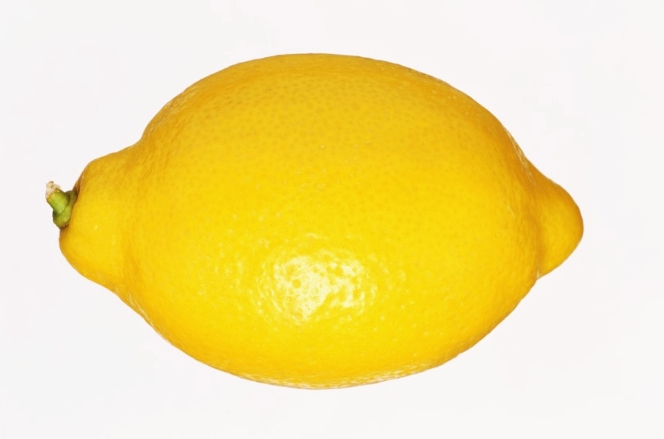
Advertisement
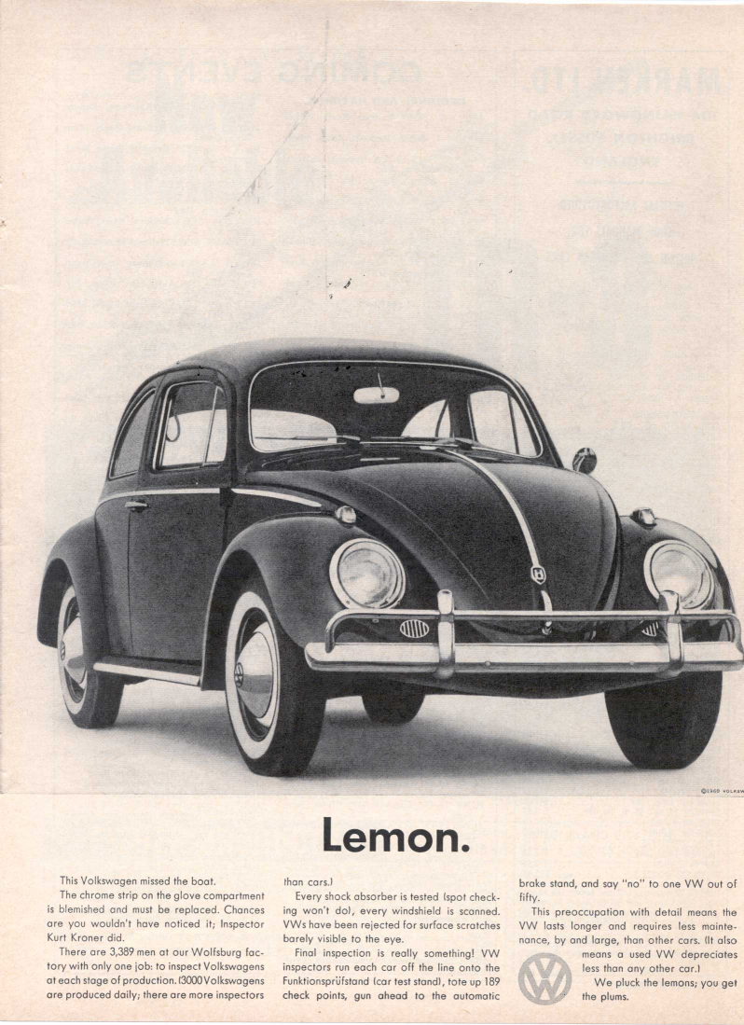
Script (Advertising Copy)
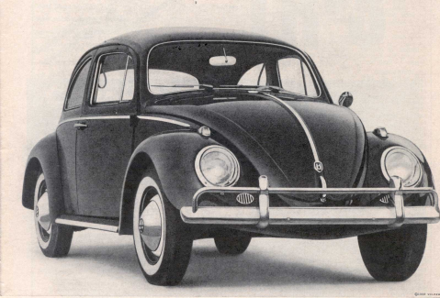
Lemon.
This Volkswagen missed the boat.
The chrome strip on the glove compartment is blemished and must be replaced. Chances are you wouldn't have noticed it; Inspector Kurt Kroner did.
There are 3,389 men of our Wolfsburg factory with only one job; to inspect Volkswagens at each stage of production. (3,000 Volkswagens are produced daily; there are more inspectors than cars.)
Every shock absorber is tested (spot checking won't do), every windshield is scanned. VWs have been rejected for surface scratches barely visible to the eye.
Final inspection is really something! VW inspectors run each car off the line onto the Funktionsprüfstand (car test stand), tote up 189 check points, gun ahead to the automatic brake stand and say "no" to one VW out of fifty.
This preoccupation with detail means the VW lasts longer and requires less maintenance, by and large, than other cars. (It also means a used VW depreciates less than any other car.)
We pluck the lemons; you get the plums.
Question Worksheet
Answer the following questions after scanning the ad for 30 seconds.

- What part of this car had a problem?

- What kind problem was it?

- What is Mr. Kroner’s job title?

- How many people in VW factory work on inspecting cars?

- How many VWs are produced a day?

- How many checkpoints are there on the car test stand?

- What is the percentage of cars failing the inspection?

Lemon Law in Michigan


What's "defective" in Michigan?
The law defines a problem vehicle as one that has been out of service for [ ] days or longer for repair or one that has been in the shop for the same repair unsuccessfully [ ] times.
You'll have a good chance to successfully use the Lemon Law if you make sure you've documented the issues you have.
If you prevail, you could be entitled to a [ ] vehicle or a [ ] of your lease payments or purchase price.

