Procession
Down the aisle just before the procession begins in a Christian ceremony, the officiant takes his or her place, with the groom to the left, and the best man to his left, facing the guests. The ushers may stand at the front, or they may start the procession as shown here, walking in pairs. They are followed by the bridesmaids. The honor attendant enters next. As another option, the ushers and bridesmaids can enter together, in pairs, with the best man and honor attendant following. If a ring bearer and a flower participate, they are the last ones down the aisle before the bride, who is escorted by her father, on his left arm. Today a bride often asks her mother to walk on her other side. In a Jewish ceremony, grandparents, the groom’s parents and the bride’s mother all join the procession. It is often led by the rabbi and cantor, who sing the prayers during the service, but they may also enter from the side and await the others at the huppah. For any ceremony it is customary for the ushers and bridesmaids to be arranged in order of height, with the shortest attendants entering first.
Christian |  | Jewish
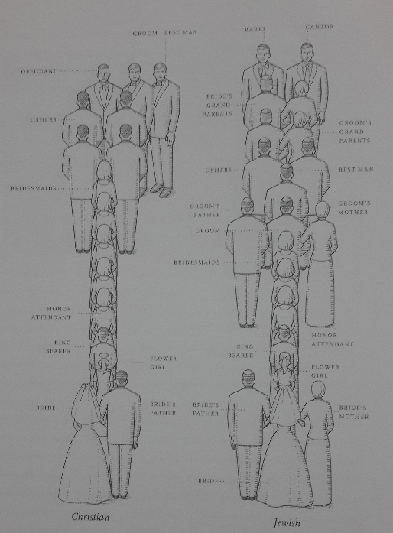
Ceremony
The formations in a Christina ceremony, as the ushers reach the altar; they usually form a diagonal line, with the first usher taking his place farthest from the groom. Bridesmaids do the same on the bride’s side. The flower girl and ring bearer stand in front of the bridesmaids and ushers. When the bride reaches the altar, her honor attendant, the groom, and the best man turn toward the officiant. Alternatively, the bride and groom can face the guests, so the officiant has his back to the guests; or the honor attendant and best man can join the lines of bridesmaids and ushers, with the bride and groom standing on either side of the officiant, facing each other. As they reach the huppah in a Jewish ceremony, ushers and bridesmaid from diagonal lines from the front poles or simply gather around the huppah. The honor attendant and best man stand next to the bride and groom under the huppah or outside it, with the bridesmaids and ushers. The bride’s and groom’s parents stand under the huppah as well. Small children can get fidgety during even the simplest ceremony, so it is perfectly acceptable for them to join their parents or take a seat on the altar once the ceremony has begun.
Christian | Jewish
