Recession
Just married in a Christian ceremony, as the musicians start the celebratory recessional music, the bride and groom turn to each other, link arms and walk briskly back up the aisle as husband . They are followed by the rest of the wedding party, also in pairs, with the women on the men’s right arms. The flower girl and the ring bearer (if they remained at the altar during the ceremony) come first, then the honor attendant and the best man, then the bridesmaids and ushers. Ushers can return to assist guests and direct them to receiving line or reception site. In a Jewish ceremony, after the newlyweds come the bride’s parents, then the groom’s parents, the flower girl and the ring bearer, the honor attendant and the best man and the bridesmaids and ushers; all are arm in arm with the women’s on the men’s left arms.

Appendix 3)
Love and Relationships Cloze  Fill in the blanks with the words in the boxes. |  |  |  |  |  |  |  | 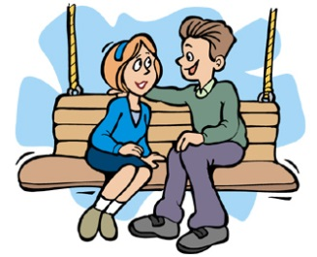
Beginning Relationships
crush |  | ask |  |  | sight |  | courage |  |  |  | blind
If you have a __________________ on someone, then you have to work up the __________________ to __________________ them out. You might also ask a friend to arrange a __________________ date. If you are lucky, it will be love at first __________________.
Dating
romantic | falls |  |  | on |  | along |  |  |  | know |  | seeing
When couples go __________________ a date, they usually go to a __________________ restaurant or café where they can get to __________________ each other better. When you start dating somebody regularly, we say that you are '__________________' somebody. If you get__________________ really well then you might become a couple. Sometimes, one person __________________ in love, which means they start to have strong feelings for the other person.
Love and Marriage
wedding | proposes |  |  | engaged |  | vows |  |  |  | ring |  | asks
When couples go out for a long time, they may decide to get __________________ . One partner, usually the man, __________________. When he proposes, he usually gives the woman a __________________ and __________________ her to marry him. They invite their friends and family to the __________________ where they say their wedding __________________.
Ending Relationships
apart | divorced |  |  | break |  | argue |  |  | heartbroken |  |  | over
Sometimes couples start to __________________ over everything. Other couples just grow __________________. And so, sometimes, couples __________________ up. If they are married, they get __________________. However, when couples split apart, often one person is __________________. In that case, the person will need some time to get __________________the relationship.

©2008 www.bogglesworldesl.com

