Listening Lesson Plan
Title: How I beat stage fright.

Instructor:  Joelle Soohyun Oh | Level:  Intermediate | Students:  9 Students | Length:  40 minutes

Materials:
• Mp3 file of “How I beat stage fright” for listening
• A computer to play the mp3 file
• 3 lead-in flashcards
• 5 flashcards for vocabulary (with synonyms)
• 5 flashcards for vocabulary game (just for the game)
• A table for the vocabulary game
• 10 copies of Main Idea worksheet (one for the teacher)
• 10 copies of Detailed Idea worksheet (one for the teacher)
• 4 copies of Production Task worksheet (one for the teacher)
• 3 papers for the production task
• 3 sets of color pencils
• A white board and markers & eraser

Aims:
• Students will learn new vocabularies through playing a vocabulary game.
• Students will learn to comprehend the story through listening to the mp3 file.
• Students will learn to comprehend the story more thoroughly through answering questions on 2 worksheets.
• Students will learn to work together and use the words they learned through production task.

Language Skills:
• Listening: Students will listen to the mp3 file of a singer-song writer who beats stage fright.
• Reading: Students will read sentences on the worksheets to solve the problems.
• Speaking: Students will speak during class to answer teacher’s questions and to work on the production task.
• Writing: Students will write on the worksheets to answer questions.

Language Systems:
• Phonology: Students will have to pronounce words when playing vocabulary game.
• Function: Students will have to find the correct word for a blank in sentences when playing vocabulary game.
• Discourse: Students will discuss on the production task question to produce a specific outcome.

Assumptions about Students:
• Students will be interested in the topic because they all have the goals to become teachers.
• Students will be focused when playing vocabulary game because they have to think on functional level.
• Students will be able to answer questions on the worksheets after listening to the mp3 files.
• 3 students are enough for a group for production task.

Possible Problems and Solutions:
• Students might not be able to understand the sentences when playing vocabulary game, so read the sentences slowly when the students are having a hard time.
• Students might not be able to comprehend easily, let them know that they should do their best.
• For the main idea worksheet, students might not be able to answer questions in detail. Let them know that they should do their best.

References:
• Video Clip of “How I beat stage fright”: http://www.ted.com/talks/joe_kowan_how_i_beat_stage_fright
• Transcript of “How I beat stage fright”: http://www.ted.com/talks/joe_kowan_how_i_beat_stage_fright/transcript
• Official website of Joe Kowan, a.k.a., J-Krafty: http://www.craftygangsta.com/

Presentation
*Materials: White Board, Markers, Eraser, 3 Flashcards for lead in.
Time | Set Up | Procedure
1 Min | Whole Class | Greetings  Hello class, how are you today? It is really hot and humid outside isn’t it? Drink lots of water and stay healthy! Let’s get started.  Lead in  Look what I have here. (Take out the 3 flashcards already prepared.)  I am going to show you 3 pictures. By looking at these pictures, try to guess today’s class’s topic.  Look at the first picture. (picture of stage) What is this? What do you do here?  Look at the second picture. (picture of people cheering for a singer) What’s happening here? Who is that person on stage? Is he shy? Is he brave?  This is the last picture, who is it and what is he doing? (picture of a singer-songwriter singing on stage) Is he shy when he is on stage?  Can you guess the topic for our lesson today?  That’s right, today’s topic is “How I beat stage fright.” We will listen to a story of a singer-songwriter who overcame stage fright. (write the topic on the board)

Pre-activity: pre-teaching vocabulary
*Materials: 5 flashcards for pre-teaching, 5 flashcards for the vocabulary game, a table, a white board, a white board marker, a white board eraser
Time | Set Up | Procedure
3 Min  5 Min | Whole Class  Whole Class | Pre-teaching vocabulary  Before we listen to the story of the singer-songwriter, let’s learn 5 important words that will help you understand the story better.  Do you know the word “Irrational?” Can anyone tell me? (give the students a chance) That’s right. The synonym for irrational is “unreasonable”. For example, we can say “Irrational fear came over me” which means that fear that cannot be explained came over him/her.  Do you know the meaning of “Convulse”? Can anyone tell me?  They synonym for convulse is “to shake” uncontrollably. For example if someone is convulsing with fear, that person is shaking uncontrollably.  Do you know the meaning of “Embrace”? Can anybody guess?  The synonym for embrace is to accept something. For example, if someone embraces a problem, that means that person accepts and acknowledges the problem.  Do you know the meaning of the word “Fess”? The synonym for fess is admit. The word fess is usually used as ‘Fess up to something’. ‘Fess up to’, these three words go together most of the times. For example, if you fess up to a problem, it means that you admit the problem and stop denying.  Lastly, do you know the meaning of “Belt”? Yes I know, belt is the one that you wear with your pants but this is a verb. The synonym for belt is “to sing” out loud. It is usually used as “belt out a song/tune”. For example, if someone belts out a tune, it means that person sang the tune out loud.  Pre-activity (Vocabulary game for a quick review)  Now with the 5 words we have learned. We are going to play a vocabulary game for a quick review. Are you ready? Alright.  Instruction  First, can everyone stand up and gather around this table?  (students move and gather around the table, while students are doing that, place the 5 flashcards on the table, write students’ names on the board)  Alright. I have placed 5 flashcards of the words we have just learned.  I am going to read random sentences to you. One sentence will have one blank. You have to listen carefully and pick the best word that will be suitable for the blank. After you pick the word flashcard, you have to re-read the sentence using that word and put it back on the table. On the board, I have your names written down to check the number of words that you get write. 2 students with the most number of correct answers will get a prize at the end of the game. Remember, you have to be quick and pick up the word because you have competitors around you!  Demonstration  I will quickly show you how it is done. For example I will now read a sentence with a blank. You have to guess quickly. (read the sentence) The answer for the blank is “embrace”. The person who picked up the flashcard with the word “Embrace” will get a check and I will write that down on the board next to that person’s name. Okay?  CCQ  What do you have to do when I read a sentence with a blank?  If you know the answer, do you have to pick up the flashcard slowly or fast?  After picking up the flashcard, what do you have to do? (2 things)  Feedback  Well done, everyone did a great job. How was it? Was it easy or too hard? I hope you enjoyed it.

Practice: Main idea activity worksheet, detailed idea activity worksheet
*Materials: 10 copies of Main Idea worksheet (one for the teacher), 10 copies of Detailed Idea worksheet, computer, mp3 file
Time | Set Up | Procedure
2 Min  6 Min  2 Min  2 Min  5 Min  2 Min | Whole Class  Whole Class  Whole Class  Whole Class  Whole Class  Whole Class | Main Activity (Main idea activity-worksheet)  Instruction  Now we are going to listen to the story of the singer-songwriter who overcame stage fright. The speech lasts for about 5 minutes. While listening, you have to answer the questions on the worksheet I will be handing out to you in a few seconds. Some questions need to be answered in detail so do your best. If you don’t understand some things in the speech, don’t worry about it and do your best. I will give you an extra minute to finish after listening so you have 6 minutes to answer all the questions and you will be working individually.  Demonstration  (Show the students the worksheet and quickly go around the classroom)  This is how the worksheet looks like. Let’s have a look at the example question together. (point to the question) It says “What did the speaker overcome?”, and you have to listen carefully for the answer in the speech.  CCQ  1. What are you supposed to do? (Answer the questions on the worksheet)  2. How much time do you have? (6 minutes)  3 Are you working in groups or individually? (individually)  Good. Let me now hand out the worksheets.  Hand out worksheets  Monitor  Are you ready? I will play the speech now. (Press the play button. While the students are listening and answering questions, walk around the classroom and monitor quietly. After the listening part is done, give an extra minute to finish.)  Check Answers  Let’s check answers. Who wants to share the answer for number one? That’s right. Does everyone agree with the answer? Okay good. (Same thing goes for all the questions.)  Feedback  Great job everyone. You are doing really well today. Excellent.  Detailed Activity (Detailed idea activity-worksheet)  Instruction  Now we are going to listen to the speech one more time. As you know the speech lasts for about 5 minutes. While listening, you have to work on 2 worksheets stapled together. One has multiple choice questions and the other has true or false questions. I won’t be giving you an extra minute this time because it is simpler than the last worksheet. So you have 5 minutes to finish both worksheets (while listening) and you will be working individually.  Demonstration  (Show the students the worksheet and quickly go around the classroom)  This is how the 1st worksheet looks like. Let’s have a look at the example question for the multiple choice worksheet together. (point to the question) It says “What did the speaker overcome?” and below, there are 3 choices. You have to circle 1 correct answer like this. Also let’s have a look at the example question for the true or false worksheet together. This is how the worksheet looks like. (point to the question) It says “The speaker did not overcome stage fright and never performed again for the rest of his life.” If you think this statement is true, circle T, and if you think it is false, circle F.  CCQ  1. What are you supposed to do? (Answer multiple choice questions and true or false questions on 2 worksheets)  2. How much time do you have? (5 minutes for both worksheets)  3 Are you working in groups or individually? (individually)  Good. Let me now hand out the worksheets.  Hand out worksheets  Monitor  Are you ready? I will play the speech now. (Press the play button. While the students are listening and answering questions, walk around the classroom and monitor quietly.)  Check Answers  Let’s check answers. Who wants to share the answer for number one? That’s right. Does everyone agree with the answer? Okay good. (Same thing goes for all the questions.)  Feedback  Great job everyone. How are you feeling? You guys are awesome today.

Production: post-activity
*Materials: 4 copies of Production Task worksheet (one for the teacher), 3 papers, 3 sets of color pencils
Time | Set Up | Procedure
1 Min  5 Min  3 Min  2 Min  1 Min | Whole Class  3 Groups  of 3  3 Groups  of 3  Whole Class  Whole Class | Production Activity (Post Activity)  Instruction  Now you are going to work in a group of 3 (quickly divide the students into 3 groups of 3 while saying this). In your group, talk about your experience in overcoming a stage fright. It can be anything. One person has to tell one experience at least. Out of all the experiences of team members, choose the most interesting one and draw pictures together to present to the class. You have 5 minutes to prepare and 1 minute to present your findings. You can pick one person as a speaker. I will hand out the guidelines.  Demonstration  For example, if your group decided to present one experience in overcoming a stage fright at a speech contest, you have to draw a picture of the contest and the person. With the picture, one person from your group will come out to the front and present your story.  CCQ  1. What are you supposed to do? (draw pictures of an experience in overcoming stage fright)  2. How much time do you have? (5 minutes for group work, 1 minute to present)  3 Are you working in groups or individually? (groups of 3)  Good.  Hand out worksheets  Monitor  Begin. Remember that you don’t have much time so drawings can be simple. (While students are working together, walk around the classroom and monitor quietly. Help them if help is necessary.)  Presentation in front of the class  Okay it’s time for presentation. We will go around this way. Remember, one group has 1 minute to present. (groups will present, do not make any comments while presenting and make notes about the student’s mistakes and what could be better.)  Feedback  (Give advice and correct errors)  Great job everyone.  Giving Home Work  Instruction  For our next class, you have to write a short essay on your experience in overcoming stage fright. It must be about 500 words in length. There is no format so you can choose your format. Extra points will be given if you use words we have learned today in class.  Demonstration  For example, if you want to write about your experience in stage fright at a dance performance, write anything about it in 500 words.  CCQ  1. What are you supposed to do? (write an essay on an experience in overcoming stage fright)  2. How many words should the essay be? Is there a format? (500 words, no format)  3. When is it due? (next class)  Closing  Well done everyone you were all fantastic today. See you next class. Class dismissed!

APPENDIX
How I beat stage fright – Joe Kowan Script
0:11 I have stage fright. I've always had stage fright, and not just a little bit, it's a big bit. And it didn't even matter until I was 27. That's when I started writing songs, and even then I only played them for myself. Just knowing my roommates were in the same house made me uncomfortable.
0:29 But after a couple of years, just writing songs wasn't enough. I had all these stories and ideas, and I wanted to share them with people, but physiologically, I couldn't do it. I had this irrational fear. But the more I wrote, and the more I practiced, the more I wanted to perform.
0:44 So on the week of my 30th birthday, I decided I was going to go to this local open mic, and put this fear behind me. Well, when I got there, it was packed. There were like 20 people there. (Laughter) And they all looked angry. But I took a deep breath, and I signed up to play, and I felt pretty good.
1:05 Pretty good, until about 10 minutes before my turn, when my whole body rebelled, and this wave of anxiety just washed over me. Now, when you experience fear, your sympathetic nervous system kicks in. So you have a rush of adrenaline, your heart rate increases, your breathing gets faster. Next your non-essential systems start to shut down, like digestion. (Laughter) So your mouth gets dry, and blood is routed away from your extremities, so your fingers don't work anymore. Your pupils dilate, your muscles contract, your Spidey sense tingles, basically your whole body is trigger-happy. (Laughter) That condition is not conducive to performing folk music. (Laughter) I mean, your nervous system is an idiot. Really? Two hundred thousand years of human evolution, and it still can't tell the difference between a saber tooth tiger and 20 folksingers on a Tuesday night open mic? (Laughter) I have never been more terrified -- until now. (Laughter and cheers)
2:14 So then it was my turn, and somehow, I get myself onto the stage, I start my song, I open my mouth to sing the first line, and this completely horrible vibrato -- you know, when your voice wavers -- comes streaming out. And this is not the good kind of vibrato, like an opera singer has, this is my whole body just convulsing with fear. I mean, it's a nightmare. I'm embarrassed, the audience is clearly uncomfortable, they're focused on my discomfort. It was so bad. But that was my first real experience as a solo singer-songwriter.
2:46 And something good did happen -- I had the tiniest little glimpse of that audience connection that I was hoping for. And I wanted more. But I knew I had to get past this nervousness.
2:55 That night I promised myself: I would go back every week until I wasn't nervous anymore. And I did. I went back every single week, and sure enough, week after week, it didn't get any better. The same thing happened every week. (Laughter) I couldn't shake it.
3:13 And that's when I had an epiphany. And I remember it really well, because I don't have a lot of epiphanies. (Laughter) All I had to do. That only seems authentic when I have stage fright, and the more nervous I was, the better the song would be. Easy, so I started writing a song about having stage fright. First, fessing up to the problem, the physical manifestations, how I would feel, how the listener might feel. And then accounting for things like my shaky voice, and I knew I would be singing about a half-octave higher than normal, because I was nervous. By having a song that explained what was happening to me, while it was happening, that gave the audience permission to think about it. They didn't have to feel bad for me because I was nervous, they could experience that with me, and we were all one big happy, nervous, uncomfortable family. (Laughter)
4:05 By thinking about my audience, by embracing and exploiting my problem, I was able to take something that was blocking my progress, and turn it into something that was essential for my success. And having the stage fright song let me get past that biggest issue right in the beginning of a performance. And then I could move on, and play the rest of my songs with just a little bit more ease. And eventually, over time, I didn't have to play the stage fright song at all. Except for when I was really nervous, like now. (Laughter)
4:39 Would it be okay if I played the stage fright song for you? (Applause)
4:51 Can I have a sip of water? (Music) Thank you.
5:06 ♫ I'm not joking, you know, ♫ ♫ this stage fright is real. ♫ ♫ And if I'm up here trembling and singing, ♫♫ well, you'll know how I feel. ♫ ♫ And the mistake I'd be making, ♫ ♫ the tremolo caused by my whole body shaking. ♫ ♫ As you sit there feeling embarrassed for me, ♫ ♫ well, you don't have to be. ♫ ♫ Well, maybe just a little bit. ♫ (Laughter) ♫ And maybe I'll try to imagine you all without clothes. ♫ ♫ But singing in front of all naked strangers scares me more than anyone knows. ♫ ♫ Not to discuss this at length, ♫ ♫ but my body image was never my strength. ♫ ♫ So frankly, I wish that you all would get dressed, ♫ ♫ I mean, you're not even really naked. ♫ ♫ And I'm the one with the problem. ♫ ♫ And you tell me, don't worry so much, you'll be great. ♫ ♫ But I'm the one living with me ♫ ♫ and I know how I get. ♫ ♫ Your advice is gentle but late. ♫ ♫ If not just a bit patronizing. ♫ ♫ And that sarcastic tone doesn't help me when I sing. ♫ ♫ But we shouldn't talk about these things right now, ♫ ♫ really, I'm up on stage, and you're in the crowd. Hi. ♫ ♫ And I'm not making fun of unnurtured, irrrational fear, ♫ ♫ and if I wasn't ready to face this, ♫ ♫ I sure as hell wouldn't be here. ♫ ♫ But if I belt one note out clearly, ♫ ♫ you'll know I'm recovering slowly but surely. ♫ ♫ And maybe next week, I'll set my guitar ringin' ♫ ♫ my voice clear as water, and everyone singin'. ♫ ♫ But probably I'll just get up and start groovin', ♫ ♫ my vocal cords movin', ♫ ♫ at speeds slightly faster than sound. ♫ (Applause)

Lead-in Picture Flashcards (they will be printed in A4 size for class)



Pre-Teaching Vocabulary Flash Cards (they will be printed in A4 size for class)
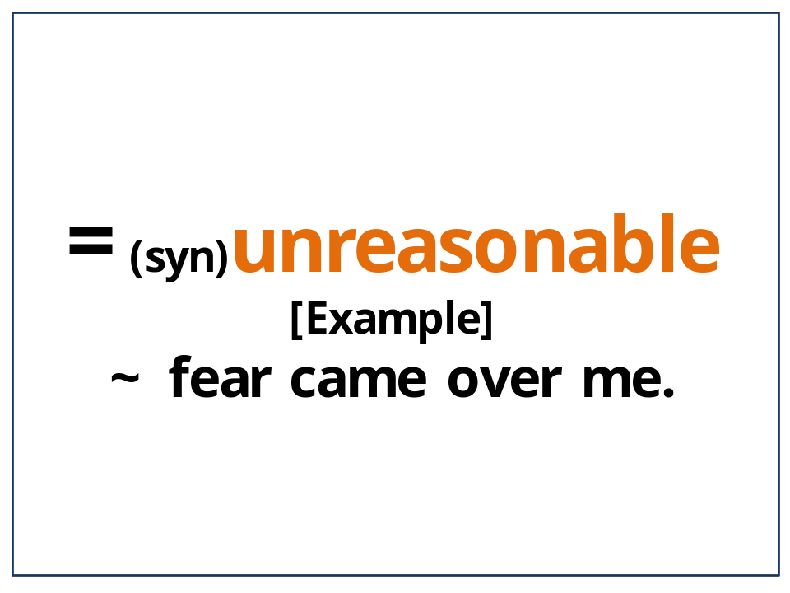

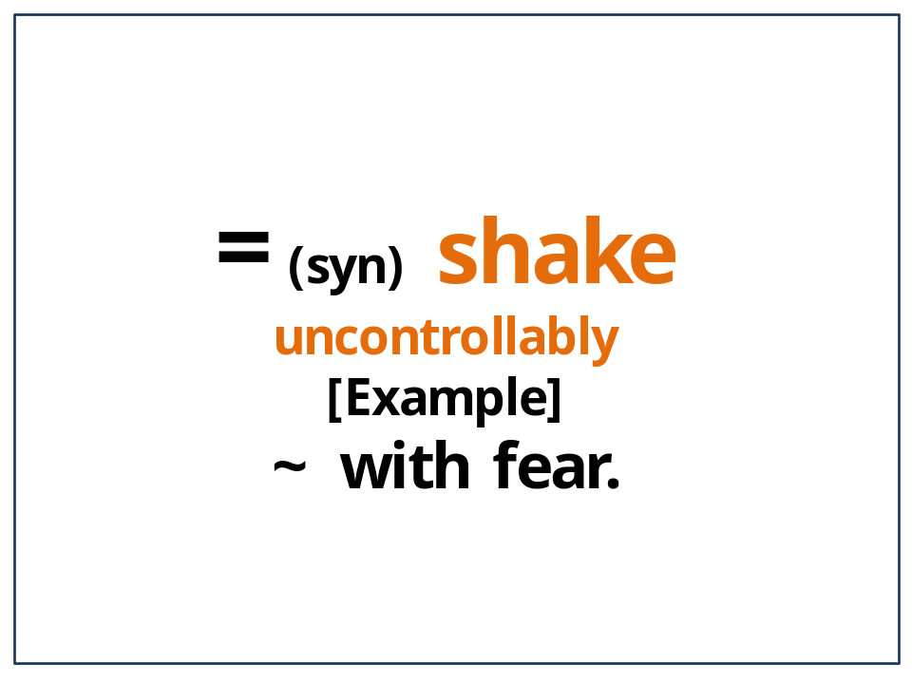

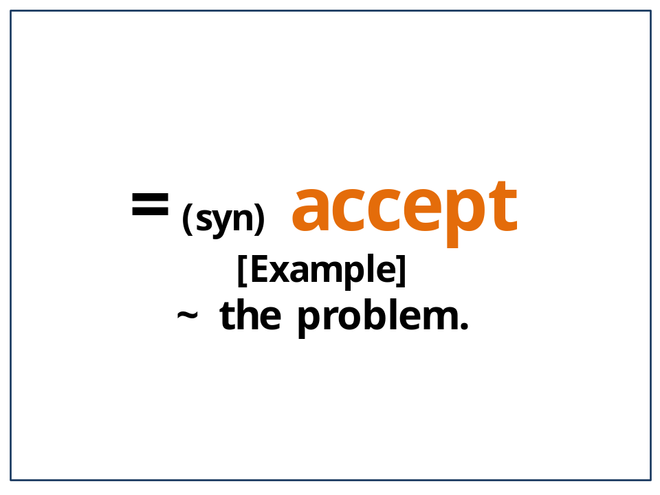

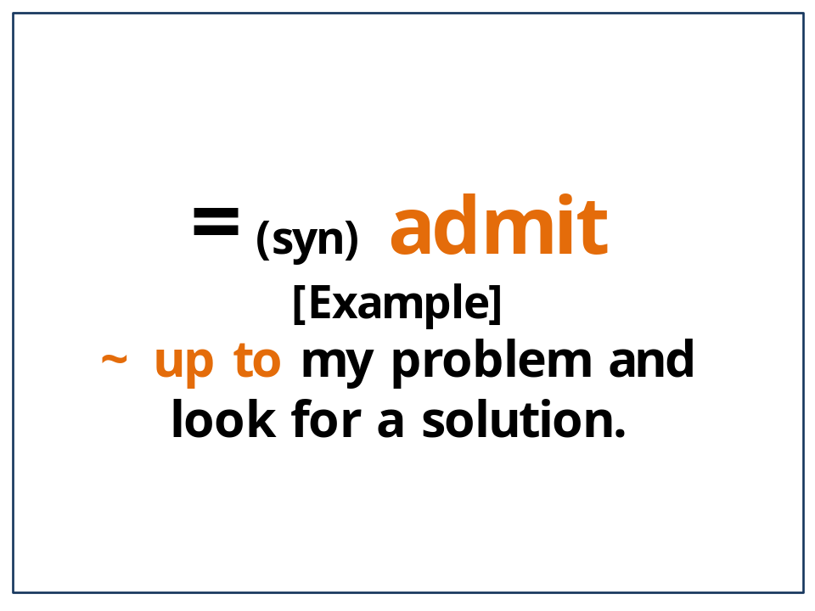

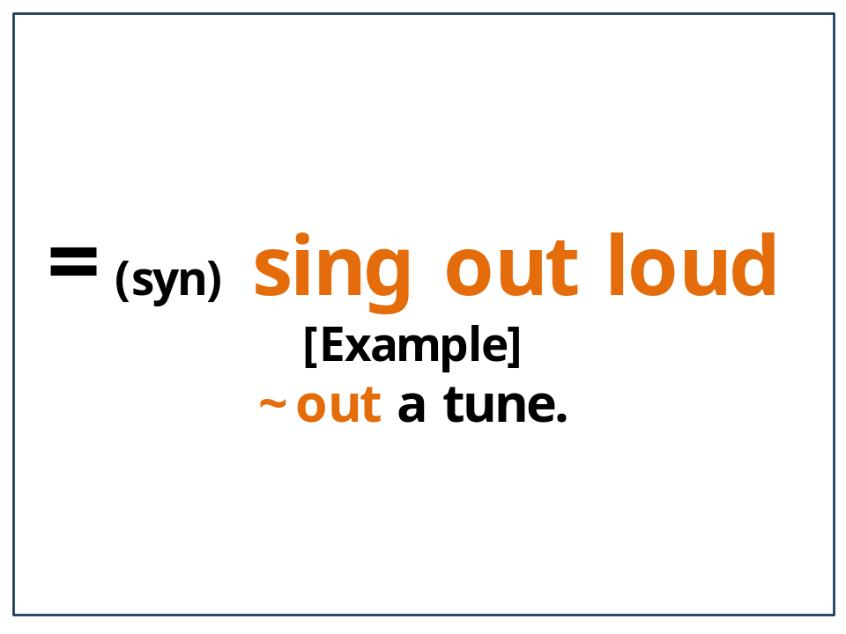

Activity #1 Vocabulary Game (they will be printed in A4 size for class)

Directions & Sentences for the vocabulary game
Directions
The students will be guided to stand around a table.
There on the table will be 5 big flashcards of all the words they pre-learned.
The teacher will read random sentences leaving the main word blank and the students will quickly guess what the word would be (in the blank) and pick up the correct flashcard quickly.
The teacher will write names of students on the board and check the number of words they guess right.
2 students with the most checks will receive a prize-lollipop.

- [Example Sentences]
- 1. She (embraced) her test scores and decided to study harder next time.
- 2. He was so furious when his roommate picked on him with (irrational) reasons.
Irrational
- 1. My wife was being so (irrational) when we were having a fight about the laundry.
- 2. This (irrational) fear came over me when I stood up on the stage.
- 3. I called my teacher because I thought my test score was so (irrational).
Convulse
- 1. A violent shiver (convulsed) him.
- 2. His whole body (convulsed) with nervousness before the performance.
- 3. When she saw the burglar, her whole body (convulsed) with fear.
Embrace
- 1. It is unlikely that such countries will (embrace) capitalist ideas.
- 2. He (embraced) her shortcomings and loved her just as she was.
- 3. He could not (embrace) his problems and went crazy.
Fess
- 1. It’s time for the President to (fess) up to his wrongdoings.
- 2. You have to (fess) up to the errors and correct immediately to save time.
- 3. He has to (fess) up to the fact that he lost 100$ in Las Vegas.
Belt
- Nobody can (belt) out a tune like she can.
- The band was (belting) out songs from the 1940s.
- He could not (belt) out the song because of his nervousness.

Vocabulary Game Flash Cards (they will be printed in A4 size for class)
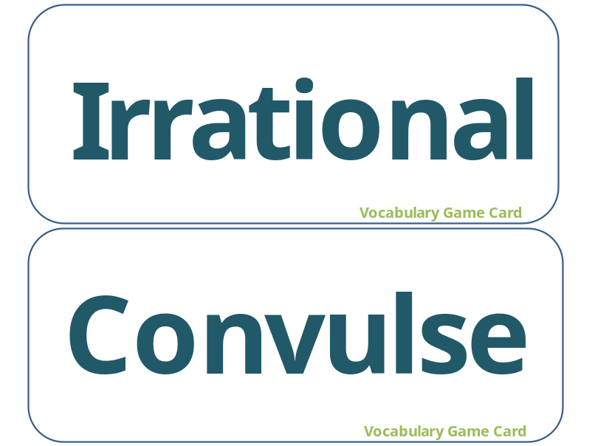
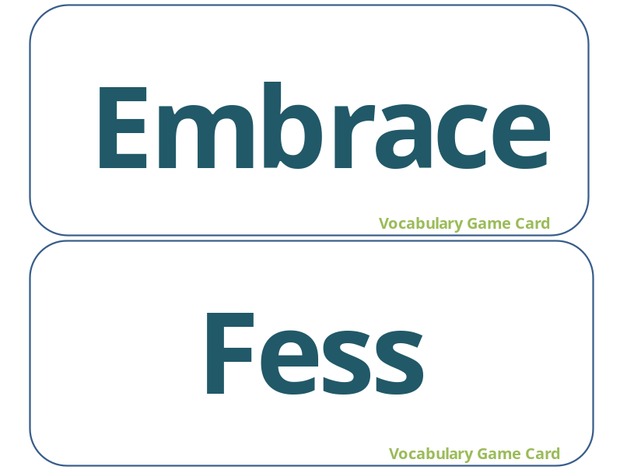

Activity #2 Main Idea Worksheet (they will be printed in A4 size for class)
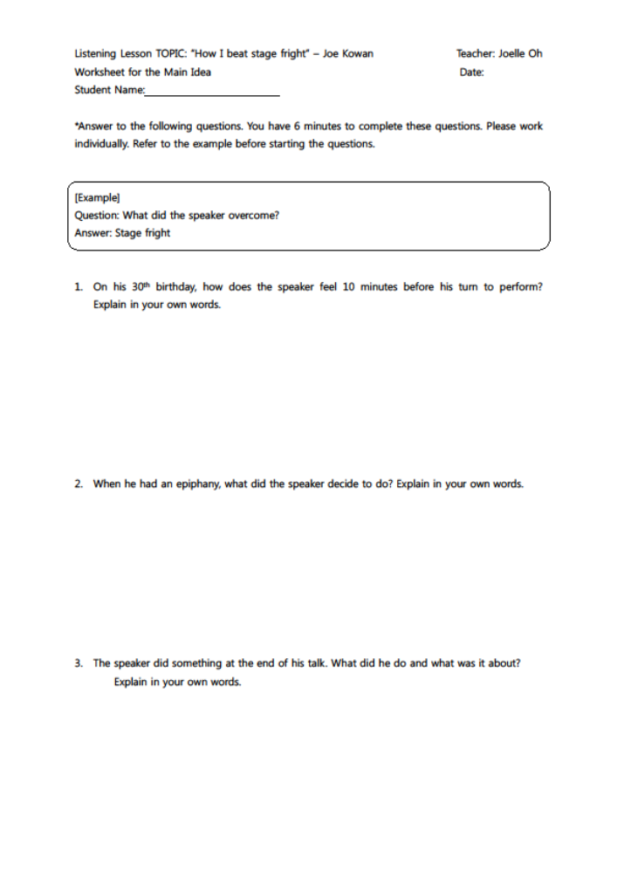
Activity #3Detailed Idea Worksheet
(2 pages - they will be printed in A4 size for class)
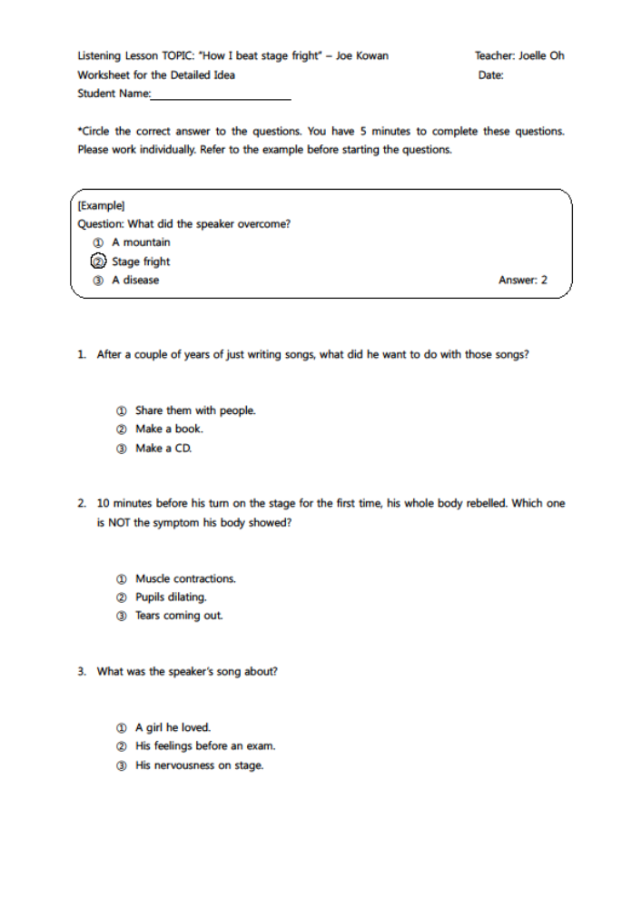
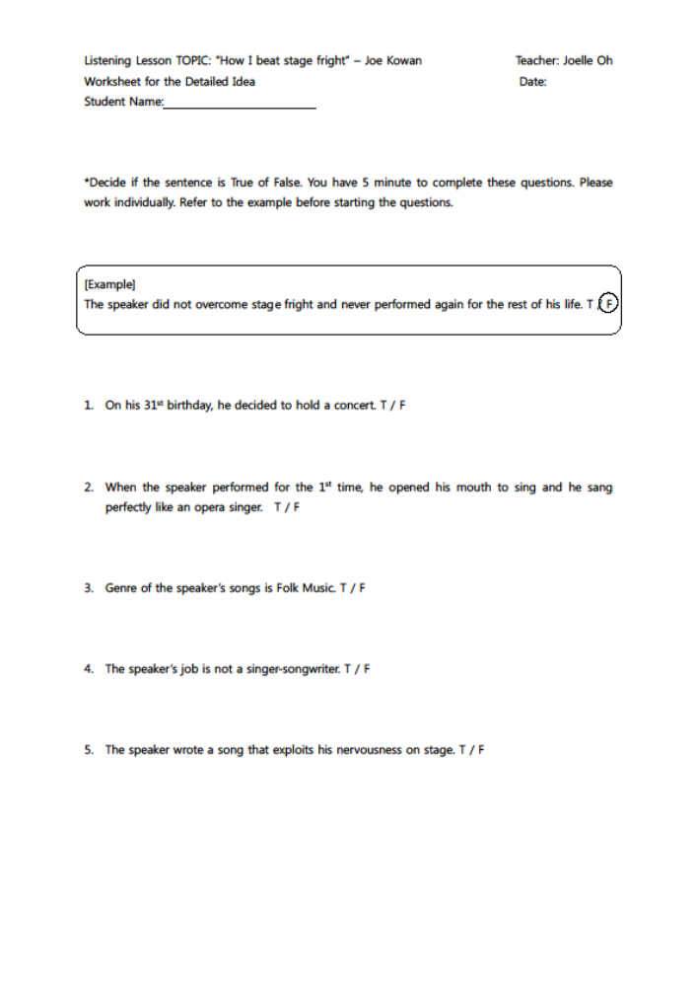

Activity #4 Production Task Worksheet
(they will be printed in A4 size for class)


