v
Listening Speaking Reading Grammar Writing
Topic: Appearance
Instructor: Jinny | Level: Pre-Intermediate | Students: 8 | Length: 50 Minutes
materials:
Pictures
Picture 1 “Snow white”,
Picture 2“Snow White And The Huntsman”,
Picture 3 “ Mirror Mirror ”
Worksheet 1 for pre-activity “Mi-ran Jang and Ji-hyun Jun”
Worksheet 2 for main activity “New snow white”
White board, markers
Aims:
- Ss can understand when they can use comparative under which situations by completing worksheet1
- Ss can know what they are learning by making new fairy tale.
- Ss can write and speak their opinions and ideas by discussing about worksheet2 “Snow White”

Language Skills:
- Listening: teacher talk, Ss talk
- Speaking: worksheet 1(Miran-Jang and Jin-hyen-Jung),worksheet 2(writing new fairy tale about Snow White), answering T
- Reading: worksheet 1,worksheet 2
- Writing: worksheet 1,worksheet 2

Language Systems:
- Phonology: drilling, making fairy tale, teacher and Ss talk
- Function: making fairy tale and presentation.
- Lexis: comparative
- Grammar syntax: s + verb/be verb + adjective+er/more/less adjective/better/worse + than
- Discourse : making new fairy tale about Snow White, responding and repeating after T
.
Assumptions:
- Ss know the pace of the course and teaching styles
- Ss know how to express their opinion in English.
- Ss know about “Snow white” fairy tale.

Anticipated Errors and Solutions:
- If Ss are confused to make comparative and superlative
>T drills same pattern and gives similar vocabularies and let Ss make comparative and superlative.
- If Ss feel difficult to make a sentence for making fairy tale.
> T encourages Ss to gives enough time to make it by themselves and lead thinking.

References:
None

Lead-In (10 min)
Materials:
Board
Markers

Time | Set Up | Student Activity | Teacher Talk
1min  5min  4min | Whole  Whole  Ss | Ss greet T  Ss listen to teacher  Ss talk their experience | Greet Ss.  T talks about my own experience.  -  Ask Ss for similar experiences and appreciates for Ss’ response.

Pre-Activity (10 min)
Materials:
Board and Markers
Worksheet 1((Miran-Jang and Jin-hyen-Jung)
Time | Set Up | Student Activity | Teacher Talk
4min  4min  2min | Whole/  Ss  whole/  Ss  Whole/  Ss | Ss listen what T says and respond  Ss respond what T says  Follow the drilling. Repeat. | T talks about Mi-ran Jang and Ji-hyun Jun  Ask Ss about them  -How do you think about Mi-ran Jang?  -What is the difference between Mi-ran Jang and Ji-hyun Jung?  T gives worksheet 1(Mi-ran Jang and Ji-hyun Jun)  T demonstrates comparative by writing on the board.  T solves worksheet1 with Ss about question  T speaks and repeats comparative with Ss  S + verb/be verb + adjective+er/more/less adjective/better/worse + than  Mi-ran Jang is stronger than Ji-hyun Jun  And then T makes one student speak.

Main Activity (20 min)
Materials:
Board and Markers
Pictures
Worksheet 2 Making Story About New Snow White
Papers, Pencils

Time | Set Up | Student Activity | Teacher Talk
5 min  10min  5min | Whole  /Ss  Group  Ss | Ss listen what T says  Ss discuss  Ss respond what T says | T Explain.  Make new fairy tale based on snow white, and present others  (T shows “Snow white” Pictures)  I will give you some words to each group. You should use these words only. Ok? Now I’m going to put 3groups and I will give you 10minutes to think.  T monitors and gives encouragement to group.  -  T gives Ss feedback and thanks Ss.

Post Activity (10 min)
Materials:
Board and Markers
Work sheet 2
Time | Set Up | Student Activity | Teacher Talk
1min  7min  2min | Whole  /Ss  Group  Whole | Ss listen what T says  Ss Present  Ss listen and say bye to T | T notices Ss enough time and prepares listening.  T listens about “Making Story New Snow White”  Close by giving Ss feedback and showing appreciation for every student.

Worksheet 1(Mi-ran Jang and Ji-hyun Jun)

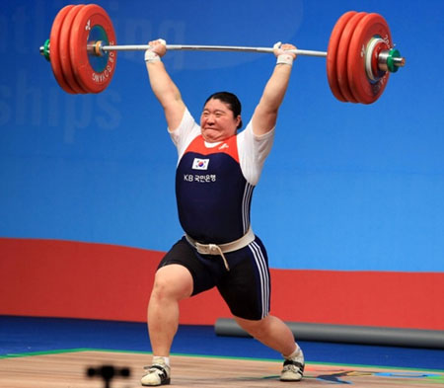
Mi-ran Jang is ______ than Ji-hyun Jun.
Mi-ran Jang is ______ than Ji-hyun Jun.
Mi-ran Jang is ______ than Ji-hyun Jun.

Keyword: Strong, Big, Heavy

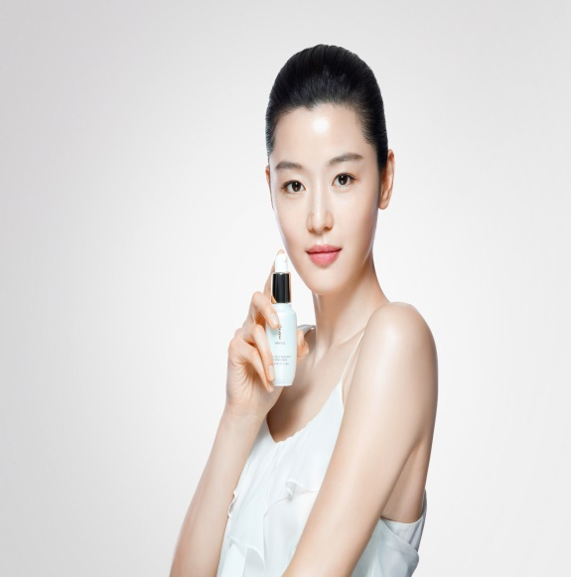
Ji-hyun Jun is ______ than Mi-ran Jang
.
Ji-hyun Jun is ______ than Mi-ran Jang
.
Ji-hyun Jun is ______ than Mi-ran Jang
.

Keyword: Pretty, Rich, Beautiful

Pictures (Snow White)

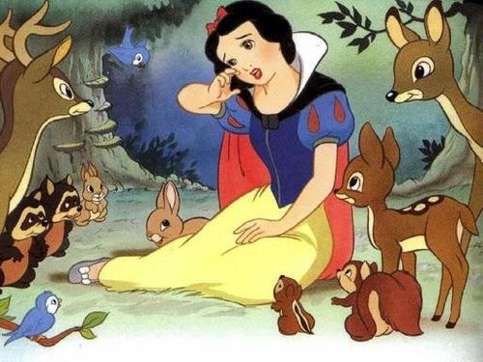

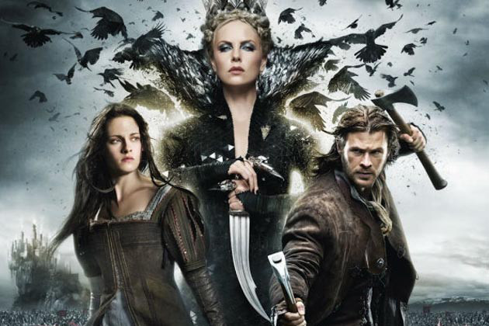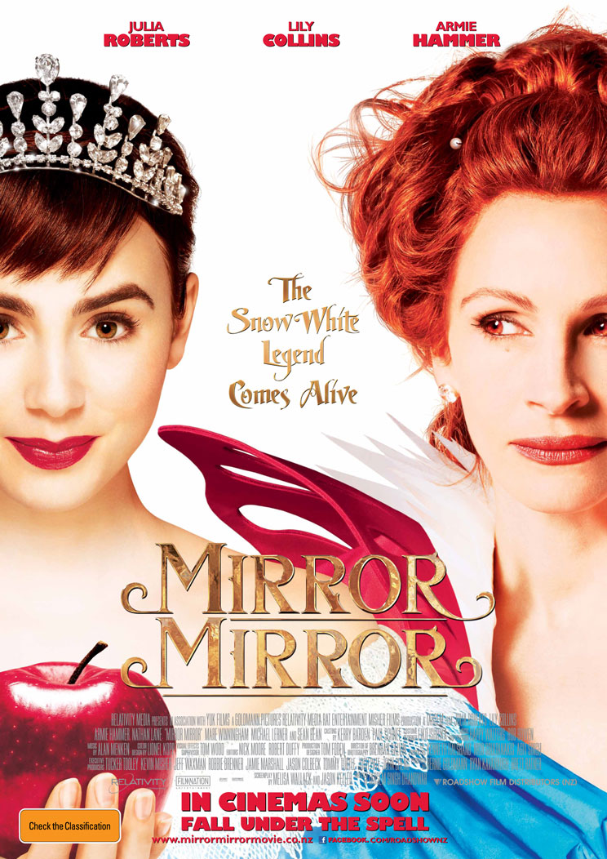
Snow White And The Huntsman (2012) Mirror Mirror (2012)

Worksheet 2(Making Story About New Snow White)

New Snow White
DATE |  | Group name
Story words (when you make new story, using these word *more than 5words)

Spicy | Wise
Fast | Big
Healthy | Expensive
Heavy | Deeply
Quietly | Creative
Beautiful | Bad
Large | Cheap
Many | Far
Easy | Small

