Grammar
Topic: Let’s have a good time with uncountable nouns.

Instructor: Faith  (Kyung Sun Hwang) | Level:  Pre- intermediate | Students:  12 | Length:  20 Minutes

Materials: PPT file
Video clips for game
Word cards and board
6 copies of uncountable nouns
Computer, Beam Projector
3 copies of comic strip attached on the board.
12 copies of worksheet.

Aims:
First aim : Ss will review the countable nouns
Ss will learn about uncountable nouns and their categories.
Second aim: Ss will develop cooperation mind through the game.
Personal aim: I want to have funny and interesting game time during the main activity.
I want to have confidence in front of adult students.
I want to keep time strictly.

Language Skills:
Reading: Reading worksheet to answer questions.
Listening: Teacher’s instructions and group conversation.
Speaking: Group conversation, Practice activities.
Writing : Worksheet answers.

Language Systems:
Phonology : N/A
Lexis: abstract, literature.
Grammar :Countable nouns and uncountable nouns
Discourse : Ask questions and answering
Function : Solving questions, stating

Assumptions:
Ss already have learned countable nouns in a previous class.
Ss might know most of vocabularies from the passages.

Anticipated Errors and Solutions:
If some of Ss don’t know the meaning of words, they can ask their classmate.
If the computer doesn’t work well, teacher can use their own lap top computer.

References:
Cat
http://wallpaper-million.com/Wallpapers/f/Cats/Small-cat-in-the-garden-wallpaper_6810.jpg
orange
https://d3nevzfk7ii3be.cloudfront.net/igi/rCjJcEgTAnWxY4Ck
oranges
http://fruitbrothers.com.au/assets/upload/data/oranges.jpg
A bird in the cage
http://dwellingintheword.files.wordpress.com/2011/02/bird-cage.jpg
Birds in the cage
Water
http://www.fengshuiweb.co.uk/wp-content/uploads/2013/03/Water-Rat-Feng-Shui.jpg
a drop of water
http://cdn.c.photoshelter.com/img-get2/I0000Nt8Jizc2.uE/fit=1000x750/Drop-of-Water.jpg

a bottle
http://i.c-b.co/is/image/Crate/AirtightGlassBottle33p75S13/$web_zoom$&/1308302307/airtight-glass-bottle.jpg
a spoon
http://upload.wikimedia.org/wikipedia/commons/3/32/Dessert_Spoon.jpg
honey
http://www.mynavigatornews.com/wp-content/uploads/2014/04/honey.jpg
salt
http://toriavey.com/images/2012/06/Salt-.jpg
a bag of flour
http://blog.cleveland.com/business/2008/08/white_lily_bag.jpg
cup
http://www.backgroundsy.com/file/large/red-coffee-cup.jpg
homo faber
http://www.digitalcounterrevolution.co.uk/wp-content/uploads/2013/07/digital-homo-faber.jpg
Chocolate
http://upload.wikimedia.org/wikipedia/commons/1/19/Cella-Chocolate-Cherries.jpg
sand
http://wisconsingeologicalsurvey.org/images/silica-sand.jpg
comic strip
http ://ishlanguage101.com/wp-content/uploads/2012/03/rst0030l.jpg

Lead-In
Materials: Comic strip
Time | Set Up | Procedure
 | 4min | Hi, guys. How are you today?  Guide Question & ICQ  Have you ever drawn cartoons or comic strip before?  What is the famous cartoon in Korea?  Motivate  Ok, here is a short comic strip which is not finished. Now please think of the test for each speech bubbles and share your ideas in your group. After that, complete their conversation.  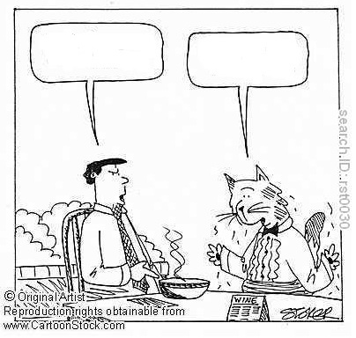  <After 2 minutes>  Good job. Everybody. Now, please show and sat your idea.  <After sharing>  Now, I want you to check the original cartoon before we start. Please tear a paper off which you drew just a moment ago.  Can you see the speech bubble? Please read their conversation together. Check the red colored letters.  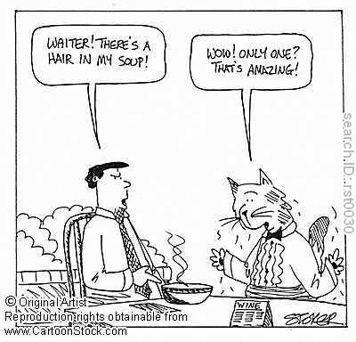  Is it possible to count hair, like a hair or two hairs?  Ok, Let’s check it later. Today, we’ll talk about it.

Pre-Activity
Materials: Word cards and board.
6 copies of uncountable nouns
Time | Set Up | Procedure
 | 1min  5min | <Review>  We already have learned countable nouns last time, right? Ok, Is there anyone who can describe the uncountable noun? Let’s look at the screen together.  <A Short review of countable nouns>  <Warm up>  Now, I will give you a piece of paper. There are some words we’ll learn today.  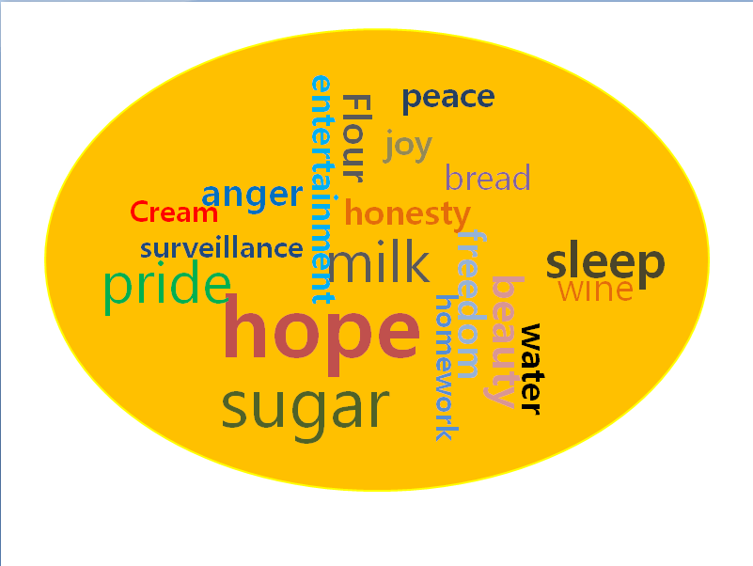  ICQ :  I want you to think about these words.  Is there any words we can count?  Can you count hope?  Can you count water without any containers?  Yes, that’s right. We can’t count liquid like water, milk…..etc.  <Divide Ss into the three groups>  Instruction  Now, look at the picture again. These words can separate into four different groups. substances, concepts, feelings….. For example, Where does water belong, food or concept? That’s right. Now, each group chose one category and come forward to put each word in the appropriate parts.  <Run activity> teacher help Ss to find words easily.  Good work, Everybody. Thanks a lot.  <Check answers >  Which words were included in substances?  Which words were included in concepts?  Which words were included in feelings and qualities?  Which words were included in activities?  CCQ :  What other words can you include for food, feelings and concept?  How can we call these kinds of nouns? Did you remember the word ‘countable’? Which word has opposite meaning of countable nouns? That’s right, ‘Un’. So, I think you already know the name of these words. What is it?  <After Ss say the answer>  That’ right. Uncountable nouns.

Main Activity
Materials: PPT file.
Computer, Beam projector.
Worksheets.
Time | Set Up | Procedure
 | 8min | Instruction  1.Recall  Yes, as you know, generally, we can count these words.  But sometimes, uncountable nouns have forms that express plural concept.  Look at the screen again.  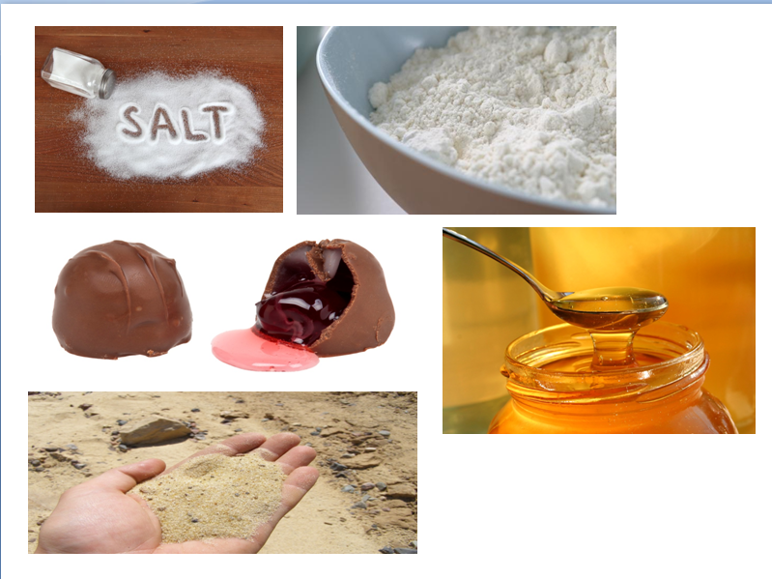  As you know there isn’t anybody who can count these things.  But, we can use tools.  Do you know how can we call the human who can use the tool in according to separate human beings from animals?    Yse, “Homo faber”. Use container like these things, bottles, spoons, cups and we’ll count water. Sugar, coffee and tea. It’s really simple.  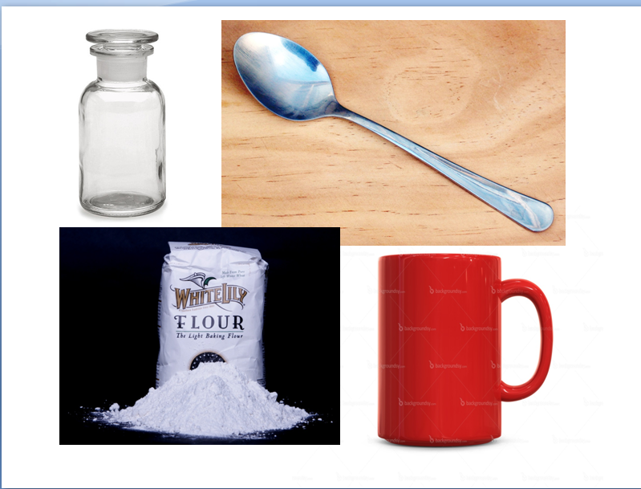  2. Reflect  Look at the next picture. Let’s make sentences which have plural meaning.  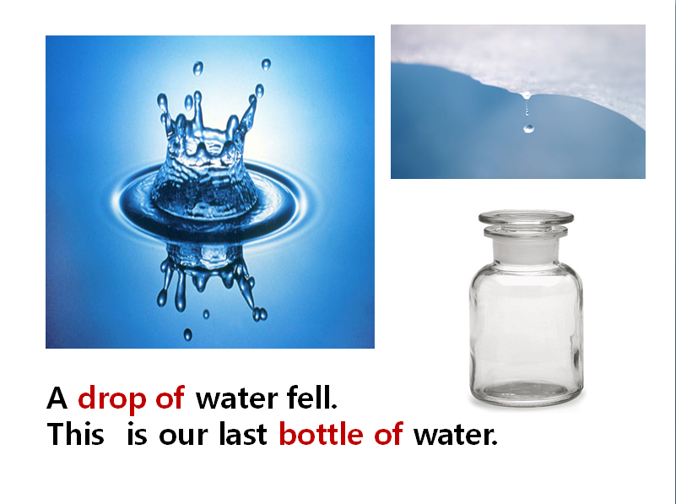  But, these expressions show us the amount of materials, not the numbers of individual objects.  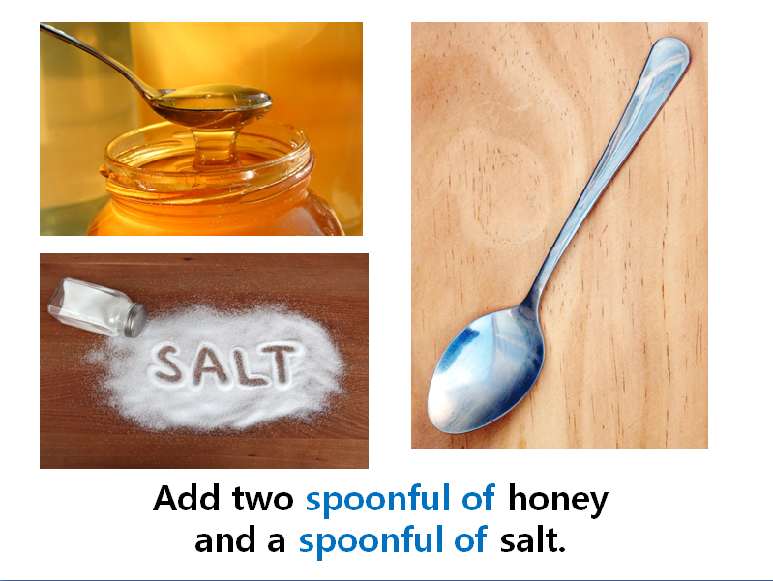  But, these expressions show us the amount of materials, not the numbers of individual objects.  3. Conclude  <After hand out>  Here are some of most common containers and quantity expressions for these uncountable nouns. Choose a right expression from the box for each uncountable noun during 1 min.  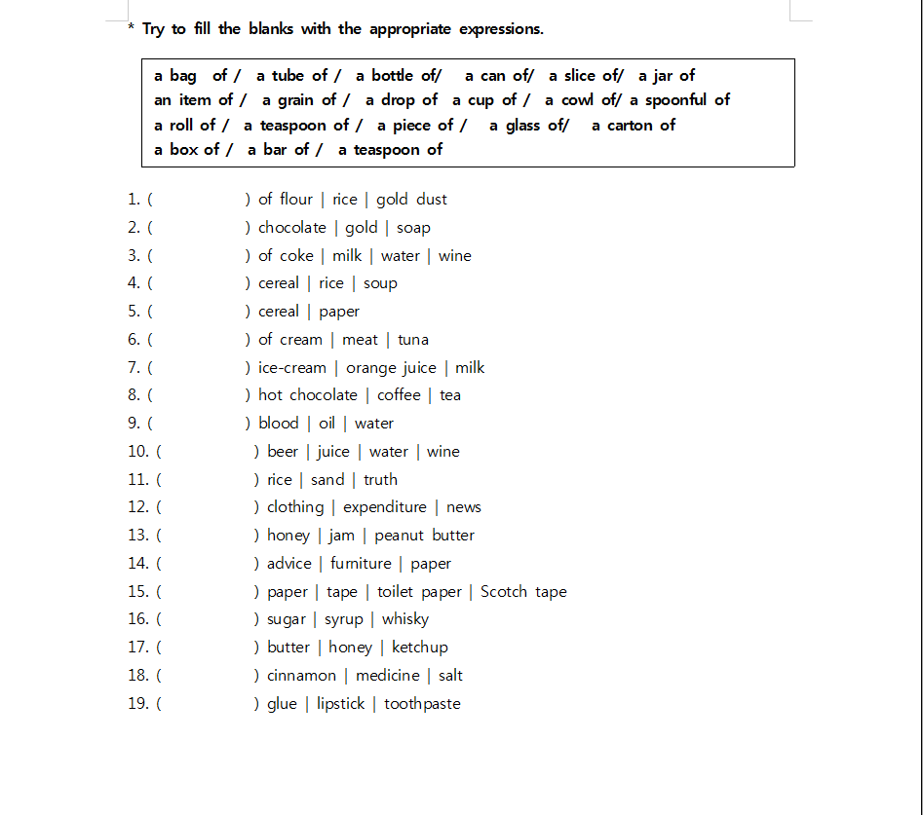  <After activity>  CCQ:  Good, now let’s check the answers together. Please say the answer for each number. Ok, ( Ss’ name), Which one is for question1.  <After the checking answers>  Wow, Excellent.  CCQ :  Now, let’s try to make sentences with the quantity expressions  What we just studied.  <watch screen with Ss>  Ok, choose one of the lists to complete the sentence.  Q 1. He dozed off after drinking a glass of beer.  Q 2. I’d like to give you a piece of advice.  If there is enough time, teacher and ask more questions.

Post Activity
Materials: Video Clips
Small presents.
Time | Set Up | Procedure
 | 7~8min | Instruction  Now, we are going to have interesting game time.  ICQ : Do you like Fs movies about heroes? Which one is the best? What kinds of Fs movie did you watch recently?  <Divide Ss into the three groups>  Now I will show you some movie trailers about the heroes.  But you should watch the screen carefully, because some words will  pass very quickly while you watch the screen.  Remember the words and unscramble them into the right order to  make a sentence as soon as possible.  Demonstration& warm up  Here is easy one for exercising.  You should shout the sentence as soon as you make.  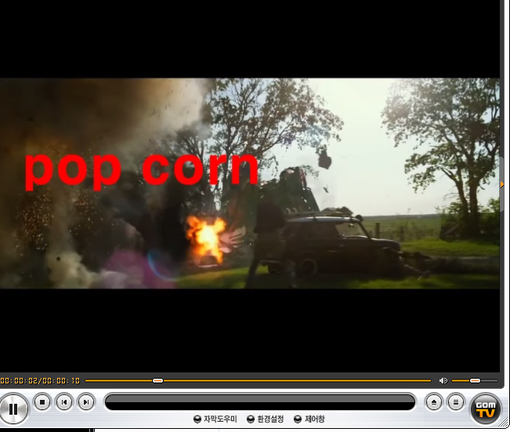  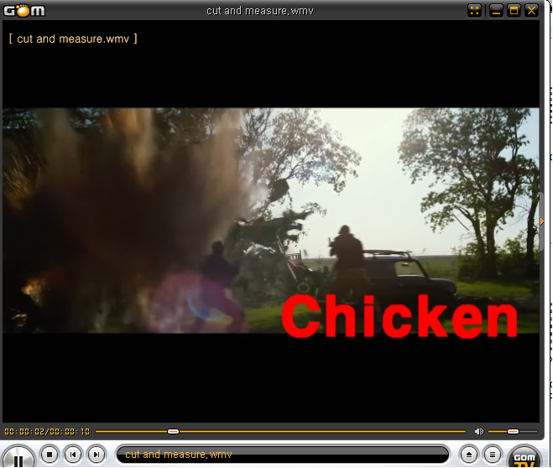  Full sentence:  I’d like to order two bags of pop corn.  Do Activity: Teacher will show the movie clip and score for each group.  Now, can you guys know how to do it? Ok, Let’s start.  Group A, please choose one of the topics.  (There will be five different topics which related with the uncountable nous we studied this class.)  Closing  (Congratulate the Ss on a work)  Now, which group recorded the highest score?  Wow, Congratulations, Group A!!!!!!  I prepare presents for everybody because you did very good job.  (Distribute presents)  Ok, that’s all for today. Thank you for joining my class. Bye~~.

* Try to fill the blanks with the appropriate expressions.
a bag of / a tube of / a bottle of/ a can of/ a slice of/ a jar of
an item of / a grain of / a drop of a cup of / a cowl of/ a spoonful of
a roll of / a teaspoon of / a piece of / a glass of/ a carton of
a box of / a bar of / a teaspoon of

1. ( ) of flour | rice | gold dust
2. ( ) chocolate | gold | soap
3. ( ) of coke | milk | water | wine
4. ( ) cereal | rice | soup
5. ( ) cereal | paper
6. ( ) of cream | meat | tuna
7. ( ) ice-cream | orange juice | milk
8. ( ) hot chocolate | coffee | tea
9. ( ) blood | oil | water
10. ( ) beer | juice | water | wine
11. ( ) rice | sand | truth
12. ( ) clothing | expenditure | news
13. ( ) honey | jam | peanut butter
14. ( ) advice | furniture | paper
15. ( ) paper | tape | toilet paper | Scotch tape
16. ( ) sugar | syrup | whisky
17. ( ) butter | honey | ketchup
18. ( ) cinnamon | medicine | salt
19. ( ) glue | lipstick | toothpaste

Comic strip

