<Appendix 1>
- paradigm
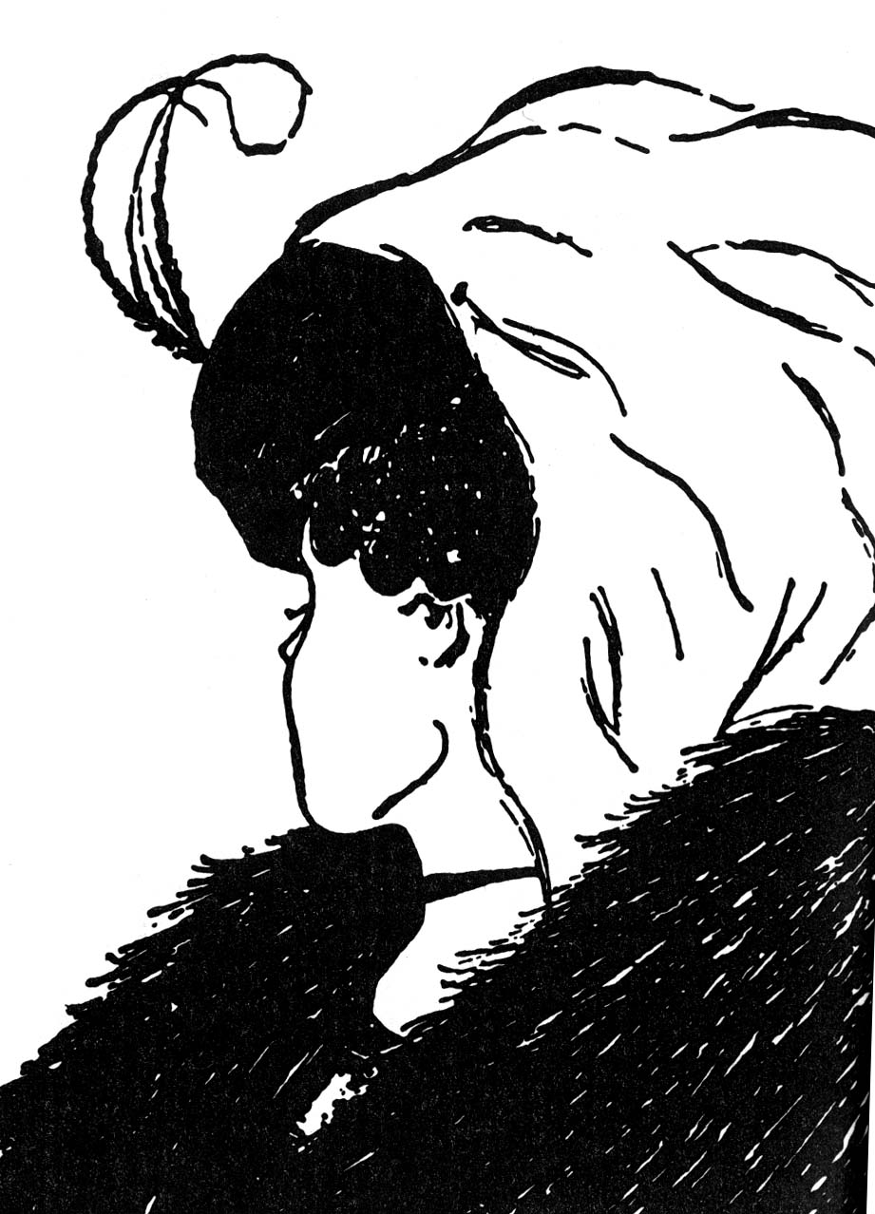

- Model of the paradigm shift. How to change the world.

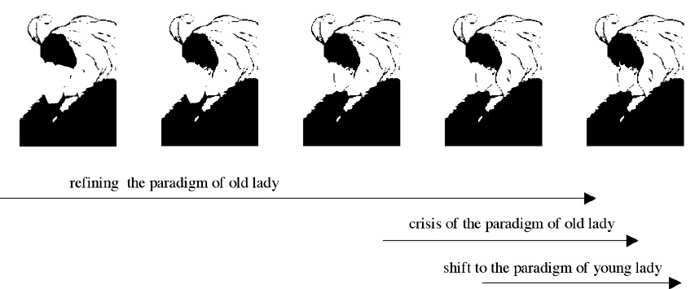

<Appendix2>

- How will you make your student initiative?

I am the victim; I blame everyone | Be Proactive
Life is a crapshoot; do NOT have a plan | Begin With the End in Mind
Who cares about first things? Live for the moment | Put First Things First
Think win-lose; I’m getting mine | Think Win/Win
First, I have something to say, then I’ll let you talk | Seek First to Understand; Then Be Understood
I work better alone; cooperating means I lose | Synergize
Wear yourself out; I don’t have time for myself | Sharpen the Saw

<Appendix 3>

- Examples of teacher’s mission statement

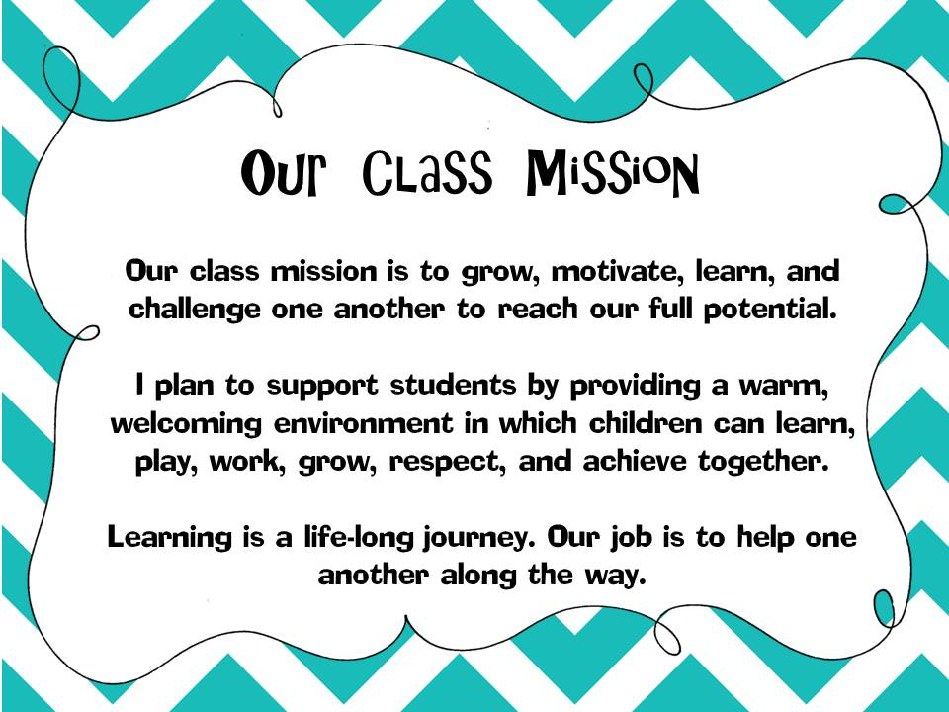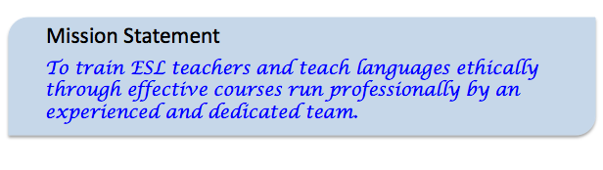
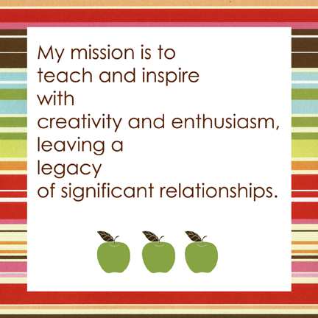

<Appendix 4>

- Paradigm of 7 habits

