Listening Speaking Reading Grammar Writing

Topic: Ranking

Instructor:  Kylie Lee | Level:  Intermediate | Students:  12 | Length:  30 Minutes

Materials:
- Pictures of various magazine covers (ex: Forbes, Times, People, Traveler, Fortune, Reader's Digest, The Economist, etc.)
- A collection of logos for various “World’s Best”/”Top 100” titles given by magazines (optional)
- A ranking list of any kind that will interest the students (ex: for a class of adults, perhaps “World’s most valuable brands” might be good for grabbing attention / for a class of young adults, “top 100 celebrities” might work better).
*These visual aids may be presented on PPT slides.
- 12 copies of <Topic List> worksheet.
- 12 copies of <Let's Rank!> worksheet
- Whiteboard & marker
- Computer connected to a projector.

Aims:
Main Aims
-Students will be able to improve oral fluency as they talk in groups to decide on the ranks and also as they present the results to the class.

-Students will be able to practice expressing opinions and supporting ideas with appropriate reasons as they discuss(in groups)/present their ranking lists..

-Students will be able to develop their interpersonal skills(negotiating/decision making/verbal communication) as they discuss in groups to come up with their final rankings.

Secondary Aims
-Students will be able to understand the difference between "ranking" and "rating" as they complete the activity.

-Students will be able to practice using superlatives (most/-est) as they discuss in groups to choose the "best" items for ranking, and also as they present their ranking results to the class.

Personal Aims
-I will try to keep track of time more effectively.

Language Skills:
Speaking
-Students will discuss in groups as they try to come up with a list of topics for ranking,
and also to complete their final rankings to present to the class.
-Students will present the rankings they came up with in groups.

Listening
-Students will listen while other groups present their rankings.
-Students will listen to the teacher's instructions.

Reading
-Students will read the instructions on the worksheet.

Writing
-Students will complete the <Ranking Exercise Worksheet>.
-Students will write the reasons for the choices they made in ranking their items.

Language Systems:

Phonology
"criteria", "ranking", "rating".

Lexis
-Students will learn the definitions of "criteria", "ranking", "rating".

Grammar
-Students will practice using superlatives (most/-est), and perhaps comparatives (less, more/-er) as they discuss with partners to complete their rankings.

Function
-Agreeing/Disagreeing
-Giving opinions
*Students will have to express themselves to agree or disagree to each other's opinions
during group discussions. Also they will have to share opinions.

Discourse
-Students will discuss in groups as they try to come up with a list of topics for ranking, and also to complete their final rankings to present to the class.

-Students will present the rankings they came up with in groups.

Assumptions:
-Students have already learned and are familiar with the use of mparatives/superlatives, but sometimes they make mistakes when applying them in everyday speech.

-Students like to read different types of magazines.

-Students are familiar with the ranking and rating systems, but they may not be certain about the differences between them.

Anticipated Errors and Solutions:
- Students may have difficulty coming up with their own topics for ranking
→ It is intended that students are not provided with any guidelines for listing the rank topics, as it will prompt them to engage in group discussion more actively. However, if it seems to be too difficult for certain groups, teacher may provide some hints and suggest topics they could consider (ex: sports, entertainment, music, literature, business, technology, education, language, etc.)

- Computer/projector may malfunction.
→ Have all the visual aids and PPT slides prepared in hard copies in advance.

References:
Magazine cover images:
https://www.google.co.kr/search?q=magazine+cover&newwindow=1&source=lnms&tbm=isch&sa=X&ei=YZ66U-XFCIarkwXziYHQAg&ved=0CAYQ_AUoAQ&biw=1280&bih=709#newwindow=1&q=magazine+cover+forbes&tbm=isch

< The World's Most Valuable Brands 2014> introduced during pre-task:
http://www.forbes.com/powerful-brands/list/

Pre-Task
Materials:
-Pictures of various magazine covers (ex: Forbes, Times, People, Traveler, Fortune, Reader's Digest, The Economist, etc.)

- A ranking list of any kind that will interest the students (ex: for a class of adults, perhaps “World’s most valuable brands” might be good for grabbing attention / for a class of young adults, “top 100 celebrities” might work better).

Time | Set Up | Student Activity | Teacher Talk
3 min. | Whole Class | *Students listen and respond to teacher’s questions.  Lead-in by presenting pictures of various magazine covers.  Get students to talk about magazines.  Guiding Questions:  Do you like reading magazines?  What kind of magazines do you enjoy reading?  Elicit:  -What kind of information can you get from magazines?  (ranking list, dos and don’ts, how-to, etc.)  -If students have difficulty guessing → Look very closely. What do these magazines have in common? (Each magazine contains a ranking list of some kind)  Motivate  As you can see, there are so many different kinds of rankings in various fields; entertainment, sports, business, tourism, etc. You can see them not only in magazines but also in newspapers, TV programs, websites, etc. Some of them are just for the sake of fun, others provide very useful information.  Let's take a look at a more specific example.  (Show <The World's Most Valuable Brands 2014> ranking on PPT slide. Reveal the title of ranking later.)  Can you guess what the list is ranking? (answer: The most valuable brands)  *Students guess.  *Teacher reveals the title of ranking (on PPT slide)  Transition  So today, our topic is 'ranking', and we are going to make up our own ranking list for some of the topics that interest us most.

Task Preparation
Materials:
-12 copies of <Topic List> worksheet.

Time | Set Up | Student Activity | Teacher Talk
2 min.  3 min.  2 min. | Whole Class  In pairs  In Pairs | We're going to get started soon, but, before we do that, I want to make sure that you are familiar with some of the key terms.  Vocabulary (rating/ranking)  Teacher: Do you know the difference between "ranking" and "rating"?  Students: (response)  Teacher: Great. So, ranking has to do with picking out the best items under a certain category, and then putting them in order. Rating, on the other hand, is more about scoring individual items (ex: giving a score out of 10) So, based on the rating results, we might probably be able to do the ranking.  CCQs  *If I say, I'd give 5 stars for the recent movie I have seen. Am I ranking it? Or rating it?  *If I say, I think the top 3 movies this season were "Maleficent", "Frozen", and "About Time". Am I ranking or rating?  Teacher: Excellent. So now, I think we're ready to move on.  -------------------------------------------------------------------------------------------  Task #1  Instructions:  In pairs, students will try to think of as many ranking topics as they can in 2 minutes. They will list down their ideas on the <Topic List> worksheet.  Teacher: In pairs, I would like you to come up with as many  ranking topics as you can for the next 2 minutes.  Be creative, it can be anything; funny, interesting,  informative, strange, etc. (Hand out worksheets)  Demonstration:  For example, some possible ranking topics are as follows:  - World’s most important human inventions  - Top 5 useful mobile applications  - Top 5 useless mobile applications  - The weirdest/strangest TV shows/movies  - Most stressful jobs  - Most annoying moments you might encounter at work  - Most important qualities to look for when choosing an apartment  - World’s most valuable brands  - World's most innovative/creative companies  *Present on a PPT slide (also provided on <Topic List> worksheet)  ICQs  Is this individual work? (pair work)  How many topics will you think of? (as many as you can)  How much time will you have? (2 min.)  Run the Activity  Monitor discreetly and make sure students are discussing with each other to complete the list.  Task #2  Instructions  From the <Topic List> they made in the previous activity, Each group(pair) will quickly decide on the 2 topics to work on for their <Ranking Activity>.  Teacher: Now you have a list of topics that interest you.  Go on and quickly choose 2 topics that you like best  with your partner. Later on, you will come up with your own  rankings for these topics. You will have 1 min.  ICQs  How many topics will you choose? (2 topics)  How much time will you have? (1min.)  Run the Activity

Task Realization
Materials:
-12 copies of <Let's Rank!> worksheet.

Time |  | Set Up | Student Activity |  |  | Teacher Talk
8 min.  10 min. |  | In pairs  Whole Class | Task #1:  Instructions  Students will discuss in pairs to come up with their top 3 list of items for the 2 topics they have chosen. They will be completing the <Let's Rank!> worksheet. While doing so, they will need to discuss and come up with their own criteria for ranking items, and think of reasons to support their choices.  Teacher: Now we are ready to move on to the ranking activity.  With your partners, you are going to come up with a top 3  list for each of the topics you have chosen. Your rankings  do not have to be true in real life. They can be based on your  opinions. But to be fair about your choices, you will need to  have clear reasons and standards. That means you need to  have some kind of a criteria for ranking your items.  Is everyone clear with the term "criteria"?  CCQs (vocabulary: "criteria")  What might be a possible criteria for choosing the top 3 restaurants in Seoul? (ex: price, quality of food, interior design, service, location, etc.)  Teacher: Great. So, when you make your top 3 lists, make sure to  talk about the criteria with your partners.  Go ahead and complete the worksheet.  I will give you 5 minutes. (Hand out worksheets)  ICQs  How many topics will you work on for the rankings? (Two topics.)  How many items will you rank for each topic? (3 items.)  Is this going to be pair work our group work? (Pair work.)  Run the Activity  Discreetly monitor. Provide help if needed.  -------------------------------------------------------------------------------------------  Task #2:  Instructions:  Each pair will come up and present their results from the ranking activity. They will introduce their topic, reveal the top 3 list they came up with, and then explain their choices with reasons.  Teacher: Okay, so everyone's completed their rankings.  Now, we are going to share the results as a class.  Since each pair has two topics, divide them up with your  partners, so every one of you will have a chance to present..  Teacher's Demonstration  My topic is < Top 5 restaurant for holding a reunion in Seoul >.  I think <Bulgogi Brothers> is the best place for holding a reunion, followed by <CPK>, and then <VIPS>.  My criteria for ranking were diversity of menu, service and price. <Bulgogi Brothers> serves all kinds of delicious Korean food and the service is great. Also, price is very reasonable. So I think it's the best. <CPK> has great menus, but they only have pizza and pasta. Also, price is more expensive than <Bulgogi Brothers>. As for <VIPS>, service is not bad, and the food quality is average. But they have a salad bar, so you can enjoy more food for a cheaper price.  Run the Activity  Take note of any errors heard during presentation.
Post Task
Materials:
-Whiteboard & marker
Time | Set Up |  |  | Student Activity |  |  | Teacher Talk
2 min. | Whole Class |  |  | Teacher: Everyone's done a great job!  Your ideas were very interesting, and insightful.  So, let's give a round of applause for everyone.  Now, before we finish, I just want to point out a few errors  that I've heard throughout the lesson.  Error Corrections  Write down any errors heard on the board, and correct them.  Close  That's it for today.
SOS Activities
Materials:
-Whiteboard and marker
Time | Set Up |  |  |  | Student Activity |  | Teacher Talk
5 min ~ | Individual,  and then,  Whole class for sharing answers. |  |  |  | Instructions:  Have students think about their response to the following discussion question individually, and then students can go around the class and share their answers.  Discussion topic  If you could be the world's top rank for one particular field, what would it be? Why?  Teacher: Okay, so today, we practiced ranking items. Before we wrap up our class today, I want us to take a moment to share each other's ideas about the following question:  (Write down the discussion topic on the board)  Take 1 minute to reflect individually, and then we will go around the class and share our answers.  Teacher's Demonstration  I would like to be number 1 at teaching English, because this is what I want to do for the rest of my life. So I want to be a respected person in the educational field.  ICQs:  Is this going to be group work? (No, individual work)  How many minutes will you have to reflect? (1 min.)
PPT Slides
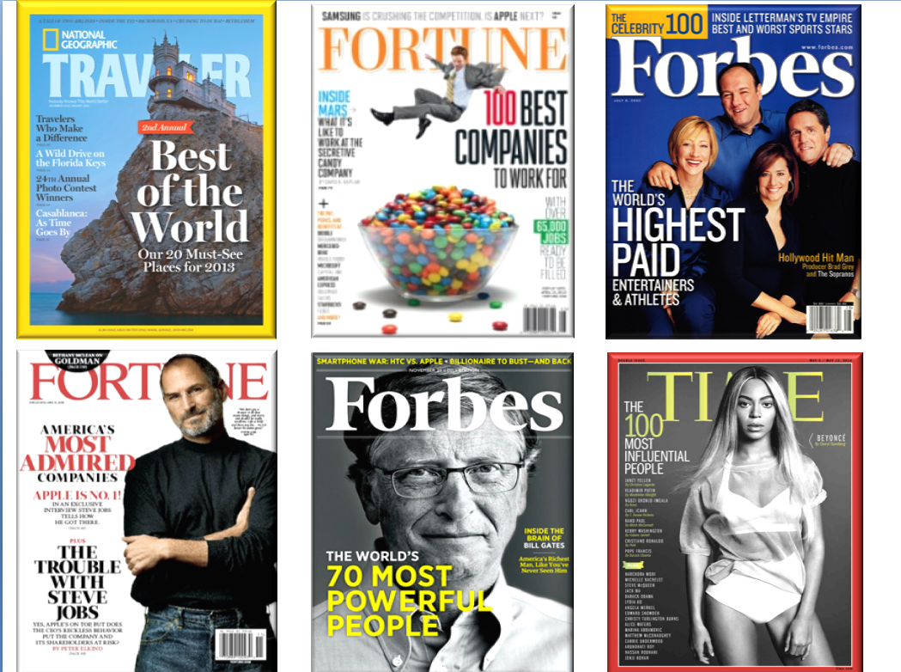
Magazine covers to show during lead-in (pre-task)


Ranking Title Examples (presented during lead-in)
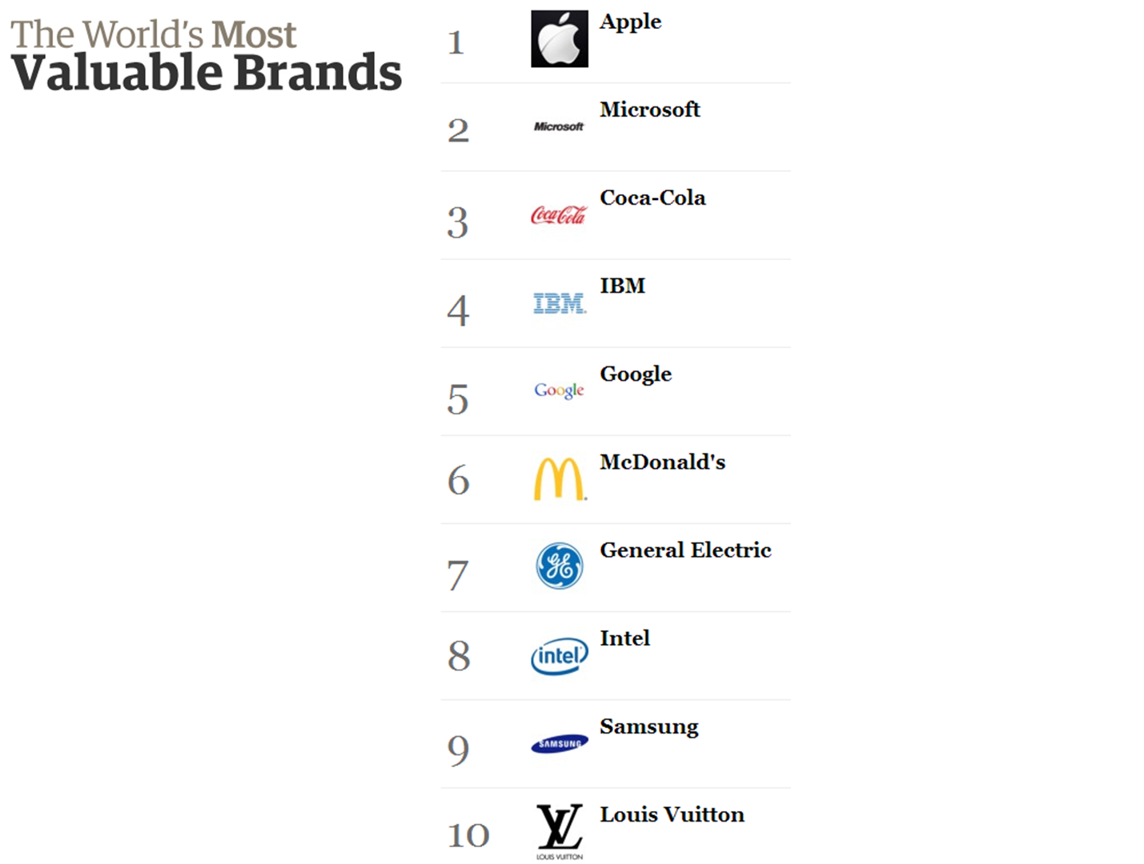
<The World's Most Valuable Brands> Example of ranking (presented during pre-task)

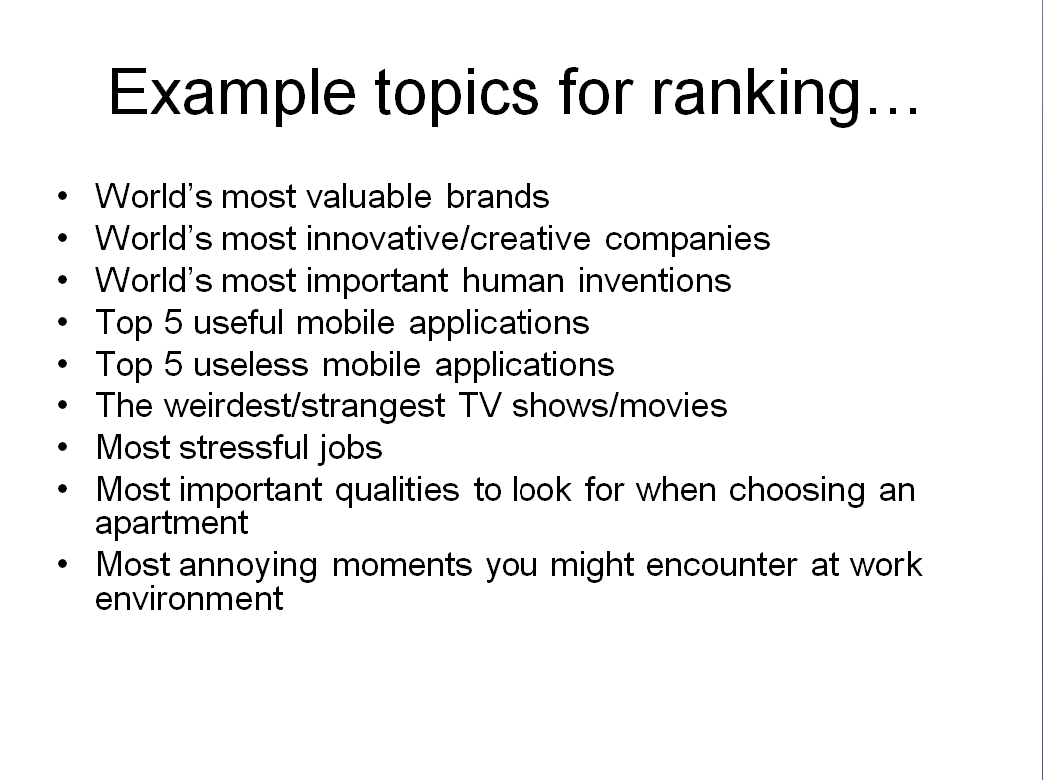
Example topics for ranking (presented during task-preparation)

Worksheet #1: <Topic List>
<TOPIC LIST>

Instructions:
Make a list of all the topics you can think of for ranking items. Be creative. It can be anything.
Examples:
- World’s most important human inventions
- Top 5 useful mobile applications
- Top 5 useless mobile applications
- The weirdest/strangest TV shows/movies
- Most stressful jobs
- Most annoying moments you might encounter at work environment
- Most important qualities to look for when choosing an apartment
- World’s most valuable brands
- World's most innovative/creative companies

Worksheet #2: <Let's Rank!>


