Role Card 1
Left brained person : devoid of charm
Right brained person : act charming

Role Card 2
Left brained person : use with words
Right brained person : use with gesture
( ex) when people show the directions~)
Role Card 3
Left brained person : check a text message several times before sending it
Right brained person : send a text message immediately

Role Card 4
Left brained person : make plans thoroughly before going on a trip
Right brained person : unplanned

Role Card 5
Left brained person : work one thing at one time
Right brained person : work several things together

Role Card 6
Left brained person : opposite of right brained person
Right brained person : feeling is more important (love at first sight)

Worksheet #1
<Interview>

- Are you more creative or rational?
- Are you good at recognizing faces or remembering names?
- Are you a subjective or objective person?
- Do you use logic or feeling?
- Are you detail oriented or big picture oriented?
- Do you use facts rules or imagination rules?
- Do you use words and language or symbols and images?
- Are you planned or unplanned before you do something?
- Which one do you like more between safe and risk?
- Are you practical or impetuous person?

 | Jess | Jenny | Karen | Andrea | Sue | Stephanie
1
2
3
4
5
6
7
8
9
10

 | Kylie | Rosie | Shawn | Christina | Jina | Faith
1
2
3
4
5
6
7
8
9
10
Worksheet #2

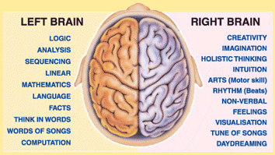

Left Brain Functions | Right Brain Functions
Uses logic  Detail oriented  Facts rule  Words & language  Present & past  Math & science  Can comprehend  Knowing  Acknowledges  Order/pattern perception  Knows object name  Reality based  Forms strategies  Practical  Safe | Uses feeling  Big picture oriented  Imagination rules  Symbols & images  Present & future  Philosophy & religion  Can “get it” (i.e. meaning)  Believes  Appreciates  Spatial perception  Knows object function  Fantasy based  Presents possibilities  Impetuous  Risk taking

- Left brain : rational
Right brain : creative

- Left brain : remembering names
Right brain : recognizing faces

- Left brain : objective
Right brain : subjective

- Left brain : logic
Right brain : feeling

- Left brain : detail oriented
Right brain : big picture oriented

- Left brain : use facts rules
Right brain : imagination rules

- Left brain : use words and language
Right brain : use symbols and images

- Left brain : planned
Right brain : unplanned

- Left brain : safe
Right brain : risk

- Left brain : practical
Right brain : impetuous

