Listening Speaking Reading √ Grammar Writing

TOPIC: Preposition of Time

Instructor:  Tracey Kim | Level:  Intermediate | Students:  12 | Length:  25min.

Materials:
- Board and Markers.
- A picture of time, Worksheets.
- Video clip.

Aims
- Main
To enable Ss to improve their grammar skills by having Ss complete the sentences using the worksheet.

- Secondary
Ss will use the tense by working with worksheets, talk about the events in the worksheets and interacting with other Ss.

- Personal
: I want to convey the lesson accurately to Ss at a proper pace.
: I want to deliver information clearly and powerfully by explicating instructions.

Language Skills
- Speaking: Ss talk about the events with the preposition of time form.
- Writing: Ss will be engaged in dictation and filling in the blank worksheets.
- Listening: Ss will listen to other Ss’ opinions to draw proper conclusion when describing the events.
- Reading: Ss will read the worksheets and events they guessed what they've seen on video.

Language Systems:
- Lexis: Preposition.
- Phonology: None to discuss.
- Grammatical: Preposition of time.
- Discourse: Words in preposition used appropriately in a sentence.
- Function: Freely describe the events in the preposition of time form.

Assumptions:
- All Ss understand the concept of preposition of time.
- All Ss have an interest toward video clip showed in the lesson.
- All Ss have an interest toward learning grammar.

SOS activity:
- To work on time management, Ss must learn preposition of time, which I may assail with questions by Ss.
- adhere to the one-third rule when Ss present and give the rest of the answers.
- Distribute the sheet of explanation paper of the concept.
- If Ss have further questions, I will answer the questions during break time.

- Time may be left before end of the 25 min.
- I will extend my explanation a little further.

References:
- California State University TESOL Program Grammar Module
- http://www.youtube.com/watch?v=GQ4uUNxO_sU (video clip)
- http://www.englishclub.com/grammar/prepositions
- http://www.teach-this.com/resources/prepositions
- http://www.eslflow.com/prepositionlessonplans.html

Lead-In
Materials:
-Whiteboard
-a Marker
Time | Set Up | Student Talk | Teacher Talk
5min. | T – Whole Class | Greeting  Answer | Greeting  Guiding Questions:  “What did you do this weekend?”  Draw up a chart into three columns.  (activities, time, place)  Eliciting:  e.g. Mina (subject to change accordingly to names), over the weekend, did you go shopping? If so, what for?  During your free time at Hyundai department store?
   | Mina | Scott | Carrie
  Went shopping? What for?
  During free time.
  At Hyundai department store?

Task preparation
Materials:
Pictures, Worksheet, Whiteboard and a Maker
Time | Set Up |  | Student Talk |  | Teacher Talk
5min | T-/W  T-/WC |  |  |  | “ Now, I’m going to show a pictures”  Showing pictures to Ss  Eliciting:  “ What does these images have in common?”  “Time”  “yes, you are correct”  Now, Pointing to the white board. (Write “for” During” “in”, in advance)  Eliciting:  “ When I say “for” During” “in”, what do you, think of?  “Prepositions”  “Good, well done”  “So, today our topic is?”  “Prepositions of Time”  “Yes, you guessed it. It’s a preposition of Time”  * hand-out the sheet.  “ please look at the first page in your work sheet, where it says preposition of time and let’s go through some of details.”  Go through the concept  CCQ  So, we used these 3 preopsitions when showing, length of time.  Instructions  “ Now I would like the class to split up into three groups of four.”  Then, I’ll go around the classroom and ask each group to pick one of the prepositions (“in”, “for”, “during”).  “With your group, I would like you guys to come-up with 2sentences using your chosen prepositions.”  Demonstration  * Write on the board,  I learned how to ride a bicycle during my summer vacation.  ICQ  "What are we going to do?"  "How much time do you have?"  "Are we doing it individually?"  You have 3minutes to prepare. Please do it as a group.”  Run the activity and Monitor  “Now time is up. I would like one Ss from each group to come up front and present.”  *one student at a time.  (group “for” first, “during” Second”, “in” third)
Task realization
Materials:
Video clip, worksheet, Board and markers
Time |  | Set Up |  | Procedure
8 min. |  | T-/WC  Ss-Ss |  | .  Each group present their work |  | * Show Ss a video  “I'm going to play a video clip. Pay special attention to subtitles in RED fonts.”  After showing the video, hand out work sheet.  Explicit Instructions  "Don't start until everyone receives a worksheet and I say begin."  Explicit ICQ  “Are you going to start before everyone receives a worksheet?"  “Are you going to start when I say begin?”  Run the activity  Monitoring. (Visiting group by group and see how they are doinging. Listen to what  they are saying)  Timing  “1min left, 30sec., 10 sec., and Times up!”  “Let’s read the complete sentence one by one”  * Time Management!  If the class doesn’t have enough time, teacher calls out the correct answers to several questions.

Post Task
Materials:
Time cue cards
Time | Set up | Student Activity | Teacher Talk
7min. | T-WC  Ss-Ss  Ss-T | Select a card and create an passive voice sentence  Unscramble | Activity 1.  Time Plucker :  “Now I would like you to get into two groups of 6.”  Rules  Ss come out one from each group and choose a card that is folded in half, so that Ss can’t see, (Cards have time written on it already) then ask Ss to show the cards to opposite side of a team.  Now let the Ss out at the front to explain to the rest of Ss in their group, only by making Gestures.  So that rest of Ss in a group can guess what is on the card.  * After each volunteer presents ask he or she what prepostion could take place.  Instructions and Demonstration.  "Now class, 2 person from each group, you'll come out and select a card. Cards that have specific time wirtten on.  You start off by showing the card to opposite team. Rests of Ss have to explain the time by making gestures, and you also should guess the preposition that fits the time written on the card. You all have 2 min to perform."  Demonstration  Teacher selects a card and demonstrates Time-plucker.  “I have a card that says 7 oclock, so, I will demonstrate this time like so.”  Make gestures wuth finger counting.  “ for the preposition that goes with 7oclock would be by 7oclock?”  Activity start  * Timing  “30 sec, 10sec., and Times up!  "Please tell what you have"  Activity 2.  Instruction  “we are going to do a role play. Make 2 dialogue, using three prespositions we learned today.”  Demonstration  “For instance, turn to the last page of your work sheet.”  There, you see three examples.  So, for first question,  A: how long have you known John?  Ask Ss, to elicit.  B: I’ve known him FOR five years now,  *Run the activity  Post Activity  "Class, since you didn't make any mistakes, let's unscramble the word 'persipotion' and finish the lesson.

SOS Activities
Materials:
Word cards, Board and markers
Time | Set Up | Student Activity | Teacher Talk
5min. | T-WC | Ss come out and write on board. | Instruction  Ss individually complete the sentences using the prepositions I taught with the given words. 1 min for preparation.  ICQ  "What are we going to do?"  "How much time do we have?"  "Are we doing it in pairs?"  Ask Ss come out and write the answer on board.


Prepositions | Use | Examples
In | In months | In July, in September
In | Year | In 1985, in 1999
In | Seasons | In summer, in the summer of 69
In | Part of the day | In the morning, in the afternoon
In | Duaration | In a minute, in two weeks
For | Period of time | For three weeks
During | Through the whole  Period of time | During the holidays
Preposition of Time.



What was in a Dialogue from video clip?!

- I met him at Christmas in December.

- I could interview him then visit Goa in summer.

- ….no, too hot may be… in autumn….

- One day in April during career week.

- In the afternoon or in the early evening.

- I’m away in Moscow for three days in April.

- …but during your school holidays I think.

- …but I’m home for two or three weeks.

- I’ll phone him during the day tomorrow. I’m free for a few hours in the morning.

10. I hadn’t seen her for months!!

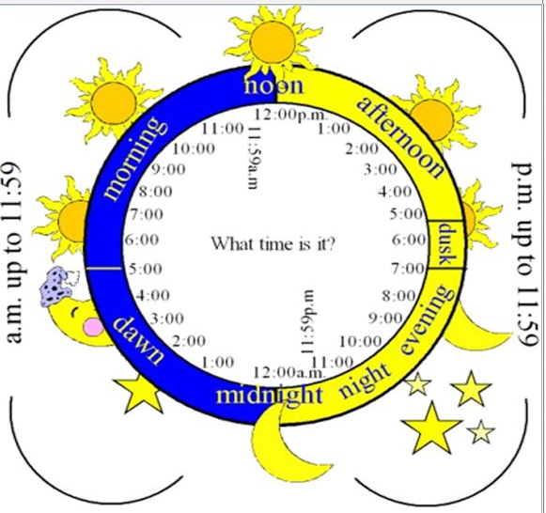

What was in a Dialogue from video clip?! (Student copy)

- I met him at Christmas _____ December. (in/at)

- I could interview him then visit Goa ______ summer. (in/in about)

- ….no, too hot may be… ______ autumn…. (in/in about)

- One day _____ April (in/at) ______ career week. (during/in about)

- _____ the afternoon or _____ the early evening. (in/at)

- I’m away ____ Moscow (in/in about) ______ three days. (for/in about)

- …but ________ your school holidays, I think. (during/in about)

- …but I’m home ______ two or three weeks. (for/in about)

- I’ll phone him ________ the day tomorrow. (during/ in about)
I’m free ______ a few hours. (for/in about)

10. I hadn’t seen her ______ months!! (for/in about)



Fun! Fun! Dialogue

A: How Long have you known John?
B: I’ve known him FOR five years now.

A: When did you meet John?
B: I first met him DURUNG my freshmen years in high school

A: When is John coming back from this trip?
B: He is coming back IN about two days.

Time is Money

Hours of a day

