Speaking Lesson Plan
Topic: Let’s be a fortuneteller.

Instructor:  Carrie Choi | Level:  intermediate | Students:  12 | Length:  30 Minutes

Materials: Computer with the Internet
Projector and Speaker
White board, Board Markers
pictures [dozens of fortune teller images]
phrases ‘will , be destined to, be born to’ and adverbs of strong possibility
Colorful cards for fortune teller

Aims Aims
- Students will be able to acquire several adverbs about strong possibility by pre-teaching.
- Students will be able to acquire a few expressions about telling a future like will, be destined to, be born to~.
- Students will be able to practice cooperative working and speaking by working in groups.
- Students will be able to understand what other students ask and to answer it by telling them their fortune.

- Personal Aims : I’d like to improve my ability to get students interested in a topic and to maximize their interaction.

Language Skills:
- Reading : Students should read a teacher’s future diary and a few examples on the
screen.
- Listening : Students should listen other students’ talk and a teacher’s instruction.
- Speaking : Students should tell their partner about his/her future by pretending
themselves to be a fortuneteller
- Writing : Students should write a-year-after future dairy by using their imagination
for homework.

Language Systems:
- Grammar : Students can use future tense when they are telling a fortune. [will~,
be born to~, be destined to ~]
- Lexis : Students can acquire several adverb expressions of strong possibility when
they are telling a fortune. [surely, certainly, definitely, unquestionably,
for certain, for sure, without doubt, possibly]
- Phonology : Students can practice how to pronoun the word with sound ‘-ly’
when they are telling a fortune.
- Function : Students can ask and answer each other based on the cards they choose.
- Discourse : Students can talk to each other about their own fortunetelling.

Assumptions:
- Students are at a pre-intermediate level, so they can listen and understand what other students say, and answer opinions with their own words.
- Some of students already know some of adverbs of possibility.
- Students already know Students know seat arrangement and time dividing.

Anticipated Errors and Solutions:
- Internet may not be able to work for a while.
→ Save the music video clip in my flesh drive in advance.
- Computer and projector may not work well
→ Print out the worksheet in advance.
- Students may not understand what to do with their partner.
→ Help them by asking ICQs.
- Students may have difficulty telling their partners about their fortune.
→ Give some example and encourage them to be able to imagine any small idea from the cards.
- Students may not be willing to talk with their partner.
→ I will listen what they are talking, as if I am another partner, I ask them what they think about my future based on the cards I choose.
Encourage them to talk to each other.
- Students may have difficulty writing their own future diary for homework.
→ Tell them any kind of imagination is good enough.

References:
Tea leaf reading [http://www.youtube.com/watch?v=VPb-Iy4pzes]
Images [http://busyteacher.org/14634-fortune-teller.html]

Pre-Task
Materials: Computer with the Internet
White board, Board Markers
Background music
Time | Set Up | Student Activity | Teacher Talk
5 min | Whole Class | Students watch the video clip and find out her job.  Students share their ideas about what a teacher asks. | Hello, here is the short video clip about a woman.  Enjoy the video, and find out what she does for a living and what we call her job.  (show the video 2:15)  What do you think she does for a living? (elicit some ideas from students)  Yes, she reads tea leaf and tells someone his or her future with tea leaf left.  So, what do we call someone like her who tells someone about their future. (elicit ‘psychic’, or’fortuneteller’ from students)

Task Preparation
Materials: Computer with the Internet
White board, Board Markers
Time | Set Up | Student Activity | Teacher Talk
2 min  3 min  2 min  3 min | Whole Class  In group  Whole Class  Whole Class | Students listen what a teacher says.  Students listen a teacher’s instruction and share their experiences with their group.  Students share their experiences.  Students listen to what a teacher say and answer actively. | Besides this kind of way, there are some other ways to tell you the future. Do you know other ways about fortunetelling? (elicit other ways from students)  (Show some pictures of fortunetelling on the screen)  Who tried visiting any kinds of fortuneteller to be told your future? Raise your hands, if you’ve ever tried it before even once. I can see most of you’ve tried before.  I want you to share your experience to be told fortunetelling, how you feel about it or it turned out they have luck guess about future, with your group.  There are 4 members in a group, and you will have 2 minutes.  ICQ  - What kinds of experience do you share?  - How many members do you have?  - How much time do you have?  I heard some interesting experiences from your group.  Who wants to share your experience? (let two or three students share their experience)  Now let’s imagine.  If you were a fortuneteller, what tense would you often use? (elicit ‘future tense’) How about verb phrases like ‘be born to’ or ‘be destined to’? Could we use these? (showing the sentences with ‘will, be born to, be destined to’ on the screen) You are born to be the best teacher in the world. (saying it with spooky voice) or you are destined to marry a good-looking, rich guy in 3 year.  Plus, we can use adverbs expressing strong possibility when you tell the fortune, can’t we?  What kinds of adverb can you use? (elicit some adverbs from students)  (Showing possible adverbs on the screen)  These are all adverbs about strong possibility. Can you read them out together? (let them read out)  Yes , when you tell someone the future, if you use these adverbs, you look an expert fortuneteller.

Task Realization
Materials: Computer with the Internet
White board, Board Markers
Flash cards [19 pieces 6copies]
Background music
Time | Set Up | Student Activity | Teacher Talk
4 min  5 min | Whole Class  In group | Students listen to a teacher’s instruction.  Students do a role play – a fortuneteller and a customer | Now, I want you to be a fortuneteller. Here are cards. I will give these to each pair. At first turn, one student will be a really good fortuneteller, and the other student will be a customer who wants to know his or her future.  After finishing your role, you will switch your roles. The student who was a customer will be a fortuneteller this time. The student who was a fortuneteller will be a customer this time.  (demonstrating with cards )  If you were a fortuneteller, you should make your cards face down. Listen to a customer’s asking first, and let them choose 5. Based on your cards, you can make up the stories and tell your customer about his or her problem or future. Whenever a customer asks a question, you should rearrange and let them pick 5.  If you were a customer, you should ask more than two questions, but any kind of question is good, but one question should include the problem you really have now. Tell a fortuneteller about your asking first, and pick 5.  (Showing short instructions to follow on the screen)  I will give you 5 minutes.  And you don’t have to be seriously taken about what you are told from a fortuneteller. It’s just for fun.  ICQ  - Are you working with group or a partner?  - How much time do you have?  - If you were a fortuneteller, which one is first, letting a customer pick 5 cards or listening his or her asking?  - How many cards does a customer pick?  - If you were a customer, do you ask only one question?  (Monitoring discreetly)

Post Task
Materials: Computer with the Internet
White board, Board Markers
Time | Set Up | Student Activity | Teacher Talk
4 min  2 min | Whole Class  Whole Class | Students share their roleplay in front of the other students.  Students listen to a teacher’s instruction and read the example on the screen. | How do you feel after you listen to your future from a fortuneteller? Who is satisfied with the result?  Okay, -----[name], Could you come up and show your roleplay? Who is a fortuneteller? Okay, so you are a customer. Let’s start playing.  (Ask other students who said they were happy with the result to come up and share.)  Everyone did good job.  Now, We are going to write our future diary. After 5 years later, what do you think you will have done?  Here is my future diary. (show the example on the screen)  Write your diary on August 12, 2018 or 2019. Pretend you do something or you are someone that time.  (Read my future diary out)  At least 5 sentences should be included in you diary.  ICQ  - How many sentences do you write at least?  - Do you write your diary for today, or for future?  Today, I’m so happy you did a excellent job!  See you tomorrow.
SOS Activities
Materials: pens and a piece of paper
Time | Set Up | Student Activity | Teacher Talk
1 min  2 min  2 min | Whole Class  Individually  Whole Class | Students listen to a teacher’s instruction  Students write their own fortunetelling.  Students share theirs. | Let’s write a fortunetelling of our own.  You will write whatever you want to be told from a fortuneteller.  That could be a solution of the problem you have now, or that could be a message of your dream coming true.  You should write at least 5 sentences in the fortunetelling message.  You will have 2 minutes.  ICQ  - How many sentences do you write at least?  - How much time do you have?  - Are you working alone or together?  (after students finish the task,)  (Let them share their own massage in front of students.)

Future diary for homework
Aug 12, 2018
I went to Everland amusement park with my son and my husband.
My husband took a day off to go a picnic.
It was too hot today that we said we should've been there on another day.
We couldn't ride on many rides, but we took lots of photos there.
I will make photobooks with those photos.
Even though it was hot and we were tired, I'm sure my son looked happy and enjoyed himself with us.
Tomorrow, I have a class for 100 students who prepare for a civil service exam.
Plus, I should finish my book to publish next month.
I'm so busy and tired, but I enjoy my life.







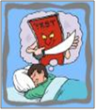



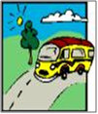






Tarrot Cards

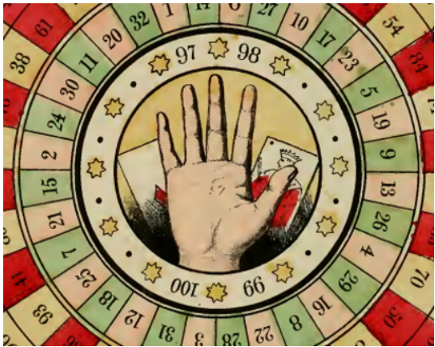
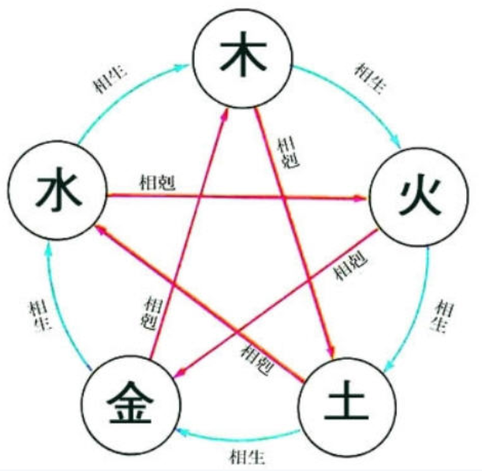
Other kinds of fortunetelling

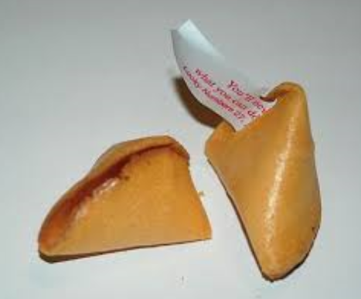
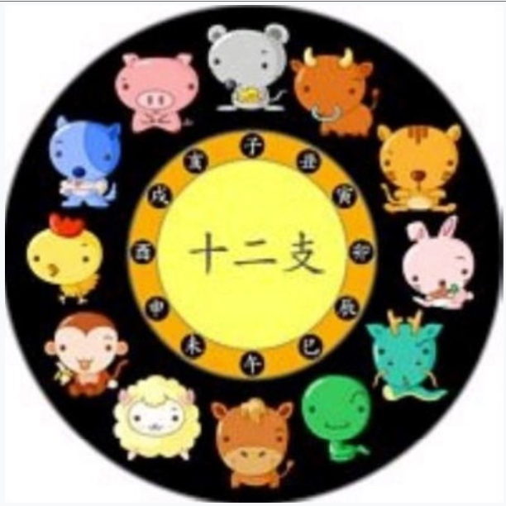
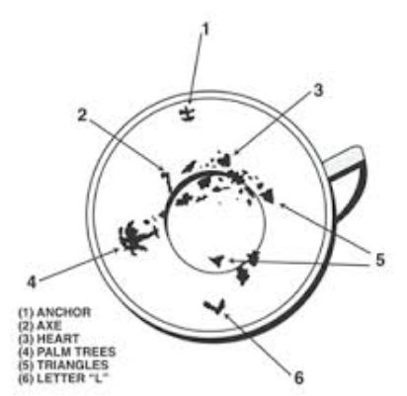


Some examples
You will be rich in your late 30s.
You are born to be the best teacher in the world.
You are destined to marry a good-looking, rich guy in 3 year
-----------------------------------------------------------------
surely / certainly / definitely / unquestionably
for sure / without doubt / possibly / for certain

instructions

a Fortuneteller
1. Arrange the card facing down.
2. Listen to a customer's asking.
3. Let them pick 5 cards.

a Customer
1. Ask a question first, and pick 5 cards
2. Ask for the advice about the problem they have now.
3. Ask more than two questions.

