Speaking Lesson Plan

Title: Career Day
INSTRUCTOR | LEVEL / AGE | STUDENTS | LENGTH
Jung Hee Hong (Jung) | Intermediate/ 16 years old | 17 | 50 mins

Materials:
Markers, white board, Job picture file, computer, projector, cable (computerprojector), Jobs Vocabulary worksheet(18 include extra), Jobs flash cards(5 include extra), Crossword puzzle(S.O.S plan)

Aims:
Students will practice speaking by talking about careers with each other.
Students will study roles of careers by discussing and explaining with each other.
Students will study new vocabulary about jobs.

Language Skills:
Speaking: Discussing with other students, answering questions during the activities (crossword-S.O.S plan, explaining about jobs)
Listening: Listening to other students, listening to the teacher’s instructions.
Reading: Reading the Job vocabulary worksheet and flash cards
Writing: Fill in the blank ( Jobs crossword worksheets )

Language Systems:
Phonology: Learning the most common phonemes in “What is your dream job?”, “I want to be a______.”
Lexis: Words in the Jobs Vocabulary Worksheet (construction worker, dentist, reporter, salesperson, mechanic, etc)
Grammar: Simple present tense
Discourse: Explaining about career roles with other students.
Functions: Explaining the role, questioning the other students about their job

Assumptions:
Students are interested in talking about jobs.
Students have some knowledge of the roles of jobs such as what a dentist does or what a model does.
Students know enough words to do the explaining exercise

Anticipated Errors and Solutions:
Students can misspell some words and the solution is to elicit rather than correcting the mistake on the spot.
Students can mismatch the word and the meaning in the Jobs Vocabulary worksheet. The solution is to ask them for the answer again rather than point out the error.

References:
Pictures - http://news.naver.com/main/read.nhn?mode=LSD&mid=sec&sid1=107&oid=076&aid=0002531957
http://news.naver.com/main/read.nhn?mode=LSD&mid=sec&sid1=102&oid=028&aid=0002249323

Notes: S.O.S Plan
Crossword puzzle –> make partner in class –> same two Crossword but it is different fill-the-blank -> one student explains another student’ blank to another student -> another student figure out the blank

Pre Task
Title: Picture description |  | Aims:  To practice describing and explaining through the picture description exercise. | Materials:  Job picture file, computer, projector
Time | Set Up | Students | Teacher
7 mins | Whole class | Students look at the pictures and think about the situation in the pictures. Then they guess the jobs that match the pictures.  Students supply the answers for the pictures. | Show the students the Job pictures file through the projector.  Make sure the answers with the students.

Notes:
Make sure all students can see the pictures.
Make sure all students understand the questions clearly.
From - http://news.naver.com/main/read.nhn?mode=LSD&mid=sec&sid1=107&oid=076&aid=0002531957

Important.. Students have to think about jobs and the roles of jobs.

Task Preparation
Title: Matching Vocabulary |  | Aims:  Students study new vocabulary by doing the Jobs Vocabulary Worksheet together. | Materials:  Jobs Vocabulary Worksheet, Whiteboard, marker
Time | Set Up | Students | Teacher
5mins  5mins | Pairs  Whole class | Students discuss the word and the meaning with their partners.  Students attempt to solve the worksheet together with their partners.  Students discuss their answers with the class. | Divide the class into pairs  Hand out Jobs Vocabulary Worksheet and ask students to match the meaning with the words.  Teacher asks the class for the answers of the Vocabulary Worksheet.

Notes:
Make sure if teacher’ instruction is clear or not
Check all students are following the class

Task Realization
Title: Job role play |  | Aims:  Students practice speaking by explaining and by talking about jobs. | Materials:  Flash cards
Time | Set Up | Students | Teacher
20mins | Groups | Put the Flash cards faced down.  Students take turns taking one card without showing the card to others.  With that card the student is going to explain about the roles of the job on the card.  Other students in the group will figure out the word.  Someone who got the right answer gets the point. | Teacher makes groups and gives flash cards.  Teacher has to give instruction clear with ‘for example’ and CCQ(“Can explainer get the cards?”, “Can explainer say the word on the card to others”)  Make sure the matching vocabulary.

Notes:
Make sure if teacher’ instruction is clear or not.
Make sure all students can follow teacher.

Post Task
Title:  Explaining student’ dream job |  | Aims:  Students can think and speech about their dream job(career) with English. | Materials:
Time | Set Up | Students | Teacher
3 mins  3 mins | Pairs  Whole class | Students talk about “What’s my dream job?” the answer with their partners.  Students learn prolonged with “want to -> wanna”  Students supply the answers for the questions. | Divide the class into pairs and instruct them to talk about the pictures.  Discuss the answers with the students.

Notes:

Job picture file (not worksheet, On the screen)

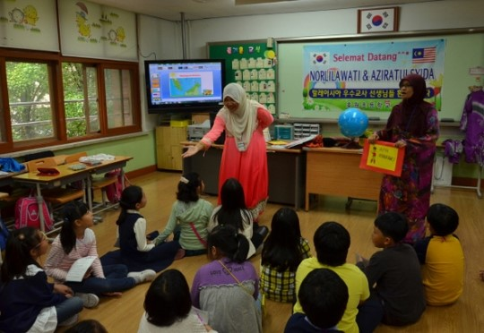

Jobs Vocabulary worksheet

[the names of the jobs] [the roles of the job]

Construction worker tells new stories

Dentist helps customers at a store

Salesperson fixes cars

Mechanic brings food to customers

Model does fashion show

Reporter build houses

Waiter is in a movie

Cashier cleans teeth

Actress cleans hotel rooms

Housekeeper takes customers’ money

Flash Cards (cut)

Construction worker | Dentist
Salesperson | Mechanic
Model | Reporter
Waiter | Cashier
Actress / Actor | Housekeeper
Dancer | Truck driver
Chef | Waiter / Waitress

S.O.S Plan----------Partner A

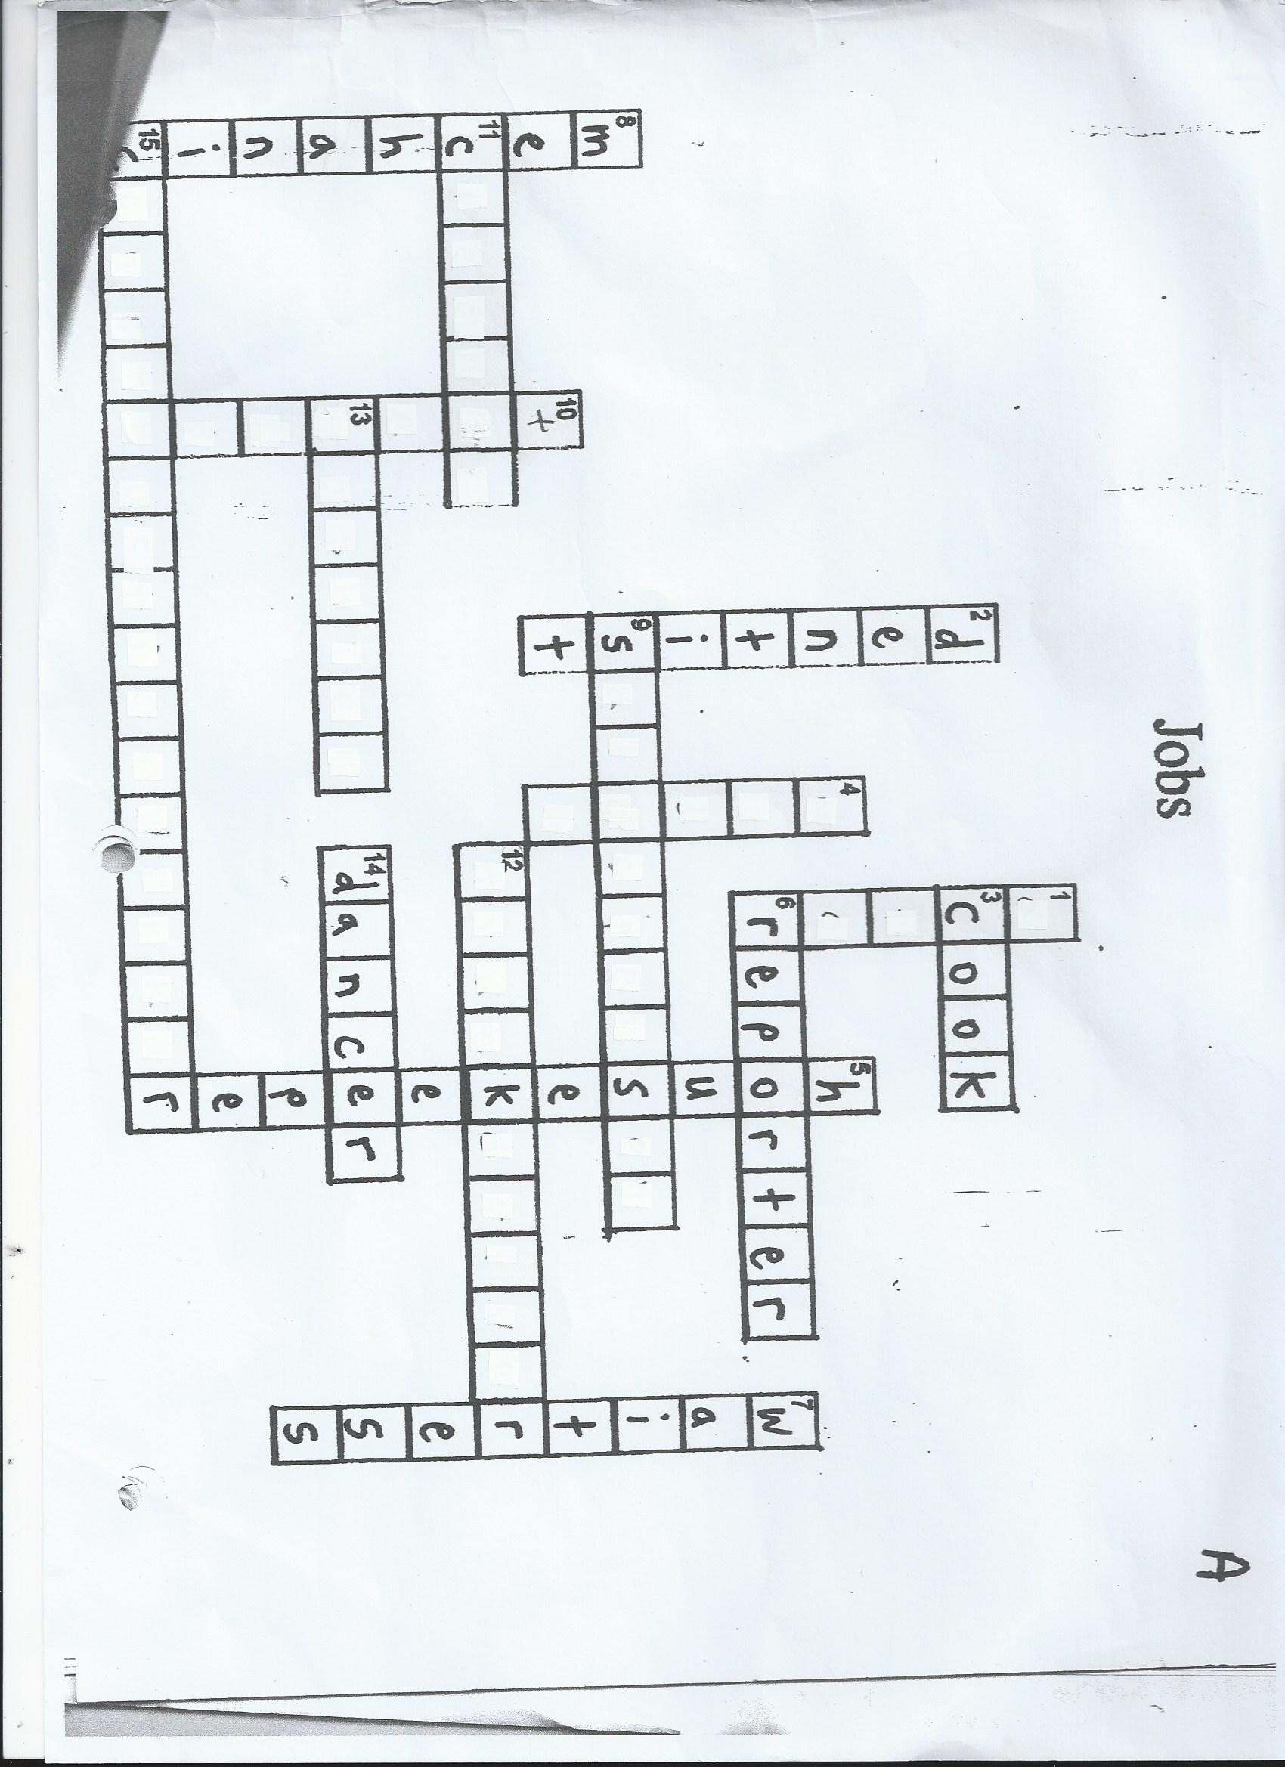

S.O.S Plan----------Partner B

