Listening Lesson Plan

Title: Become a Hero: Blood Donations Saves Lives
INSTRUCTOR | LEVEL / AGE | STUDENTS | LENGTH
Sarah Yoon | Intermediate / Elementary school, grades 5-6 | 17 | 50 mins

Materials:
“Visual aid (to pre-teach “blood”)” attachment – printed in A3 color, 1 copy
“Blood Donations: Comprehension Questions” attachment – 17 copies
“Task Realization: Blood Donation Poster Samples” attachment – printed in A4 color, laminated, 3 copies each
“Post-Task: CCQ (cut up individually and scrunch up)” – cut up and scrunched-up in non-transparent bag
Three balls numbered 1-3 – in a non-transparent bag
Three whiteboards and sets of markers
Large A3 white paper – 3, plus extra in case
Three sets of color papers
Three sets of color pens and pencils
Board and markers

Aims:
- To practice listening at a relatively natural speed, understanding the main function (i.e.: encouraging or persuading) as well as details (e.g.: numbers, figures and basic procedures) through top-down comprehension questions.
- To produce (or start work on) posters that imitate authentic material while utilizing the function of persuading and advertising to the audience to donate blood.
- To practice interpersonal negotiating skills and teamwork in spoken English

Language Skills:
Listening: Listening clip (“Blood Donations”), student interactions, teacher explanations
Speaking: Teamwork and group discussion, student participation
Reading: “Blood Donations: Comprehension Questions” worksheet, guiding questions (Pre-Task), CCQ (Post-Task)
Writing: Producing posters, answering top-down comprehension questions

Language Systems:
Phonology: (see Lexis), also listening clip
Lexis: Pre-taught key words, “donation” spelling activity (see Pre-Task), “Blood Donations: Supplementary Vocabulary” if necessary
Grammar: Induced through receptive skills (reading and listening)
Discourse: Listening clip, “Task Realization: Blood Donations Poster Samples” attachment
Functions: Persuading, advertising through listening clip and poster activity (see Task Realization)

Assumptions:
- Students already understand and can detect large numbers (thousands, millions, decimals) in English
- Students can detect a “four-step process” as comprising of four distinct progressive steps (see “Blood Donations: Script” attachment)
- Students already have basic note-taking skills

Anticipated Errors and Solutions:
- Students will not understand the term “9 point 2 million” in the listening clip. Teacher will explain that point means “decimal” and elicit the number “9,200,000.”
- Students will have difficulties writing down the four-step process described in the listening clip. Teacher will hand out “Blood Donations: Supplementary Vocabulary” (attachment) and tell students to help each other in their groups.

References:

Listening clip and lesson materials
Davis, Mrs. Smith. "Blood Donations." Randall's ESL Cyber Listening Lab. Randall's Web Sites, 2014. Web. 06 Oct. 2014.
http://www.esl-lab.com/blooddonations/blooddonations-rd1.htm
Visual aid (to pre-teach “blood”) attachment
"About Us." Malaysia Blood Donors Society. Pertubuhan Penderma Darah Malaysia (Malaysia Blood Donors Society), 2014. Web. 06 Oct. 2014. http://www.sedarahmalaysia.org/image/alg-blood-donation-jpg.jpg
“Task Realization: Blood Donation Poster Samples” attachment
"Posters of blood donation." N.p, n.d. Web. 06 Oct. 2014. http://gal2.piclab.us/key/posters%20of%20blood%20donation
"World Blood Donor Day." Media Mold. Cargo, n.d. Web. 06 Oct. 2014. http://mediamold.com/world-blood-donor-day
Curtis, Katie. “Advocacy Posters / The American Red Cross.” Khc0716's Blog. Wordpress, 29 Oct. 2010. Web. 06 Oct. 2014. http://khc0716.wordpress.com/2010/10/29/advocacy-posters-the-american-red-cross/

Notes:

There is a high possibility students will not finish the task in the “Task Realization” phase. Cut off 5 minutes before the end of class and explain that they can continue next class. The focus should be on the “Task Preparation” phase and making sure that the students have comprehended the listening clip.
- (Plan B) If printer fails and the overhead projector does not work, the teacher can dictate the comprehension questions. The teacher can also demonstrate on the board some possible samples of a blood donation poster.
- (Plan B) If the speakers or audio equipment fails, the teacher may read from the “Blood Donations: Script (Teacher’s Use Only)” attachment. Do not show the script to the students.

Pre-Task
Title:  Pre-teaching key words and guiding questions |  | Aims:  To practice and gain a grasp on pre-taught key words  To prepare for the listening task through guiding questions  To practice interpersonal negotiating skills in spoken English | Materials:  “Visual aid (to pre-teach “blood”)” attachment – printed in A3 color, 1 copy  Three balls numbered 1-3 – in a non-transparent bag
Time | Set Up | Students | Teacher
10 mins | 3 groups of 5-6 | Practice key-words. Each team has 1 min (timed) to spell each essential vocabulary.  Answer guiding questions one after the other (5 mins)  - How can you be a hero?  - Who is your hero and why?  - Would you donate blood? Why or why not?  Three teams do rock, scissors, paper (RSP) with each other.  Teacher chooses one person in the winning team and the direction. Each student in the team gets the chance to spell “donation,” one letter after another. If they lose, another team gets a chance.  The team that manages to spell the word “donation” nominates one person from another to pick a ball numbered 1-3 from teacher’s bag. That student has to answer the question corresponding to that number in three full sentences.  After the student answers the question, s/he nominates another student from another team to pick a ball. Continue until all three teams answer one question each. | Pre-teach three key words: hero, blood, donate.  - Tell a story about someone who might be a hero and elicit vocabulary (use mouthing if necessary).  - Mime about getting a cut and point to the “blood” and elicit vocabulary. Use visual aid (see attachment)  - Enact a situation where teacher “donates” money to a homeless person.  Elicit spelling for each vocabulary in teams.  Write guiding questions on the board.  Teacher tells students that they must prepare three full sentences to each question. Each student in the team must learn those three sentences.  Wrap-up Pre-Task with praise and summaries of each groups’ answers. Discuss any other answers to the guiding questions.

Notes:
Move on when all the students have understood the key words (the teacher may refer to the CCQ in the “Post-Task” phase if desired).

Task Preparation
Title:  Top-down comprehension questions |  | Aims:  To practice listening to main ideas and details using a top-down comprehension approach  To practice interpersonal negotiating skills in spoken English | Materials:  Three whiteboards and sets of markers  “Blood Donations: Comprehension Questions” attachment – 17 copies
Time | Set Up | Students | Teacher
20 mins | Retain same 3 groups of 5-6 | Stage 1: What is the speaker’s goal?  Listen to the listening clip. Discuss in groups and write down on team whiteboards. Two students from each group go to the front with their whiteboards.  Stage 2: Read comprehension questions (see attached worksheet “Blood Donations: Comprehension Questions”).  Listen to the listening clip. Teacher may repeat the listening clip in chunks for each comprehension question if required. Students should answer the worksheet individually.  Students confer in their groups to check their answers. They write the answers on their team whiteboards. Two students from each group go to the front with their whiteboards.  Review answers.  Stage 3: Write down the four-step process described in groups. Teacher may repeat parts of the clip as requested. | Stage 1: Teacher presents question. Check team whiteboards and elicit reasons. Correct answer: the speaker is trying to persuade the audience to donate blood.  Stage 2: Teacher hands out worksheet “Blood Donations: Comprehension Questions”  Repeat listening clip as often as necessary. For the worksheet, teacher may stop and start the listening clip in chunks with respect to each question.  Teacher checks team whiteboards and elicit reasons. Correct answers:  1. (C) 40,000  2. (C) 9,200,000  3. (A) they are afraid of the process  4. (C) eating food before you donate  5. (A) 56  Write on board: “40,000 blood donations are needed daily in the US” (keep on the board through “Task Realization” phase)  Write on board: “9,200,000 people donate blood yearly in the US” (keep on the board through “Task Realization” phase)  Stage 3: Teacher writes “Four-step process” on the board. Teacher tells students to write down the four-step process of blood donation described in the clip. Elicit correct answers through spoken answers. Write correct answers on the board under “Four-Step Process.” Keep these answers on the board during “Task Realization” phase.  Correct answers:  - Registering  - Getting your medical history checked  - Donating  - Having some refreshments

Notes:
Make sure the audio is loud enough for all the students to hear. If the audio equipments or speakers fail, the teacher may read from the “Blood Donations: Script (Teacher’s Use Only)” but s/he must read clearly and loudly.

Task Realization
Title:  Producing blood donation posters |  | Aims:  To produce (or at least start work on) a poster based on knowledge acquired from the listening clip  To practice writing English in the function of persuading and advertising  To practice interpersonal negotiating skills in spoken English | Materials:  “Task Realization: Blood Donation Poster Samples” attachment – printed in A4 color, laminated, 3 copies each  Large A3 white paper – 3, plus extra in case  Three sets of color papers  Three sets of color pens and pencils
Time | Set Up | Students | Teacher
15 mins | Retain same 3 groups of 5-6 | Prepare a blood donation poster in group, using information from the listening clip. The poster should seek to encourage people to donate blood.  Students must use all three key words in their posters: hero, blood, donate (or donation). | Teacher should model the task: prepare a group poster encouraging people to donate blood. Students may be creative, but they should include actual information from the listening clip.  Teacher should present “Blood Donation Poster Samples” and describe certain layout ideas (image and text), explaining what kind of information from the clip could be used. Refer to answers on the board:  - The four-step process (registering; getting your medical history checked; donating; having some refreshments)  - Comprehension questions 1: 40,000 blood donations are needed daily in the US  - Comprehension questions 2: 9,200,000 people donate blood yearly in the US  Monitor while students work on their posters.

Notes:
If students do not finish the poster in the given time, explain that they can continue next class. Cut off 5 minutes before the end of class. Request students to clean up and put their group posters (finished or not) to one side of the classroom.

Post-Task
Title:  Reviewing key words and preparation for next class |  | Aims:  To review pre-taught key words through CCQs  To understand how to prepare for the next class | Materials:  “Post-Task: CCQ (cut up individually and scrunch up)” – cut up and scrunched-up in non-transparent bag
Time | Set Up | Students | Teacher
5 mins | Retain same 3 groups of 5-6 | One student from each team picks a scrunched-up ball from teacher’s bag corresponding to one set of CCQs. The student reads it. Teacher repeats clearly and loudly as necessary. Class responds. Repeat until all three sets of CCQs have been answered.  Prepare for next class (review task):  A short summary of the listening clip, including information in the “Blood Donations: Comprehension Questions” worksheet and the four-step process. Read the summary aloud at home before coming to class. | CCQ  Set 1  - What makes someone a hero?  - What feelings do you have towards a hero?  Set 2  - Where can you find blood?  - What does blood look like?  Set 3  - What is another word for donate? (Explain the difference as necessary)  - Do you expect anything in return when you donate?  Teacher explains what to prepare for next class. Ask ICQs to check students understand what to do.  A short summary of the listening clip, including information in the “Blood Donations: Comprehension Questions” worksheet and the four-step process. Read the summary aloud at home before coming to class.

Notes:
If the blood donation posters are incomplete, teacher should explain that students can continue next class.

Worksheets, handouts and lesson materials

Blood Donations: Script (Teacher’s Use Only)

So, do you want to be a hero today? Well, there is a great need for blood donations around the world, and you can be the means of saving lives. According to the American Red Cross, over 40,000 blood donations are needed every single day in the United States alone, and without the help of volunteers like you, it is impossible to fill this need. About 9.2 million people donate every year in the US, and although approximately 38% of the population is eligible to donate, less than 10% of them actually do.
Sometimes, people don't donate out of fear, but the process is relatively simple following a four-step process: registering, getting your medical history checked, donating, and then having some refreshments. And once you donate, you have the ability to donate red blood cells every 56 days.
So, carefully consider becoming a hero today. Donate blood and you can save lives.

Visual aid (to pre-teach “blood”)

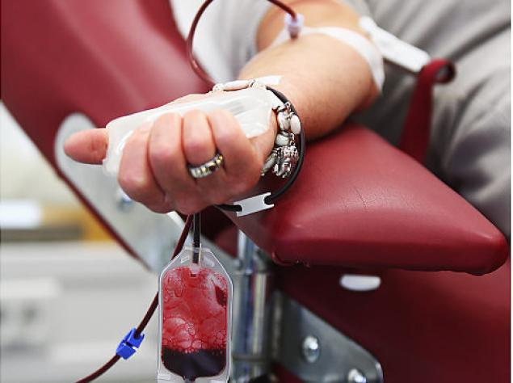

"About Us." Malaysia Blood Donors Society. Pertubuhan Penderma Darah Malaysia (Malaysia Blood Donors Society), 2014. Web. 06 Oct. 2014. http://www.sedarahmalaysia.org/image/alg-blood-donation-jpg.jpg

Blood Donations: Comprehension Questions

1. About how many blood donations are needed every day in the United States?
A. 14,000
B. 24,000
C. 40,000

2. Approximately how many people donate blood every year?
A. 92,000
B. 920,000
C. 9,200,000

3. According to the announcement, some people do not donate blood because _______.
A. they are afraid of the process
B. it isn't always convenient to schedule a time
C. they are concerned about their privacy

4. Which step for donating blood was NOT mentioned in the recording?
A. signing up for a time
B. reviewing your medical history
C. eating food before you donate

5. You can donate blood every ______ days.
A. 56
B. 66
C. 76

Blood Donations: Supplementary Vocabulary

- means (noun): way or method of doing something.
What is the best means of helping other people in the community?

- donate (verb): to give something freely.
My father always donates money and items to the homeless shelter in our area.

- eligible (adjective): having the right to do something
Children who come from low-income families are eligible to receive free lunches at school.

- register (verb): to sign up for something
How about registering to donate blood next month? It's a great way to serve the community.

- consider (verb): to think about.
I considered volunteering my time to help children learn how to read at the library, but our family moved before I had a chance.

Task Realization: Blood Donation Poster Samples

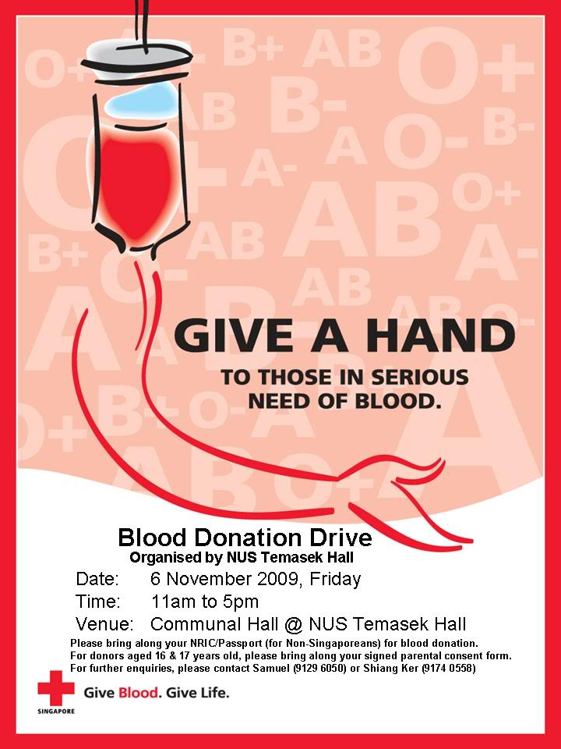
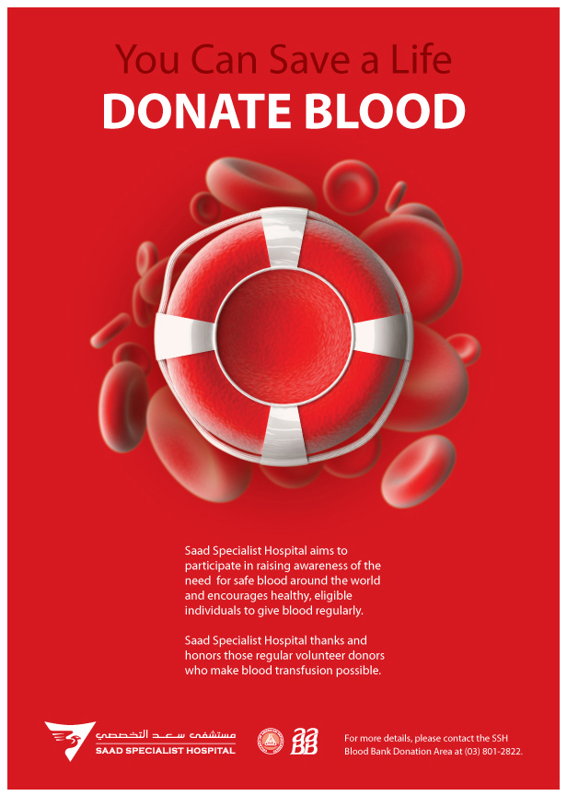

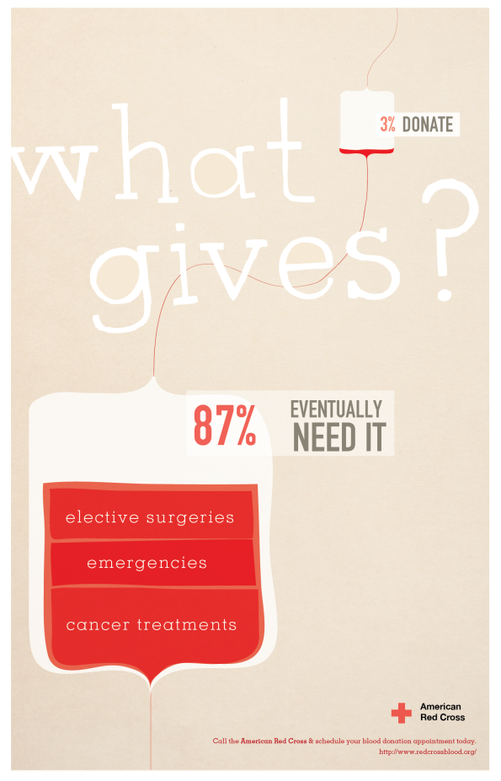

Post-Task: CCQ (cut up individually and scrunch up)

------------------------------------------------------

- What makes someone a hero?
- What feelings do you have towards a hero?

------------------------------------------------------

- Where can you find blood?
- What does blood look like?

------------------------------------------------------

- What is another word for donate?
- Do you expect anything in return when you donate?

------------------------------------------------------

