Grammar Lesson Plan

Title: My Dream House: Present Progressive (Gerund) & Going To
INSTRUCTOR | LEVEL / AGE | STUDENTS | LENGTH
Sarah Yoon | Pre-intermediate / Elementary school, grades 3-4 | 17 | 50 mins

Materials:
Separate whiteboards and marker sets – 3 sets (1 per group)
- (Plan B) A3 blank white paper – 3 sheets (1 per group)
Jaymay, “What About the Bob?” (song and music video, see References)
- (Plan B) Jaymay, “What About the Bob?” (Lyrics) and image of music video, paused at 1:23 mark (attached)
“Vocabulary Worksheet – Buildings” – 9 copies (1 per pair)
“Types of Homes” – 9 copies (1 per pair)
A4 blank paper – 9 sheets (3 per group)
Color pencils and pens – 3 sets (1 per group)
Color balls in an opaque bag – 4 colors, 5 each
- (Plan B) Balls of different types, e.g.: fruit types, numbers, etc.
Blank board game templates – 6 copies (2 per group)
Board and markers

Aims:
To practice speaking and listening in the present progressive tense through visual group activities (e.g.: picture relay, drawing and describing pictures, board games).
To practice speaking and listening in the “going to” future tense through designing and describing a dream house.
To study lexical items related to household objects and different types of houses, engaging with them through a designing a dream house activity.

Language Skills:
Listening: Song lyrics (picking up nouns), picture relay activity, teacher instructions, pairwork, group discussion and presentations
Speaking: Picture relay activity, board game activity, pairwork, group discussion, presentations and feedback
Reading: Vocabulary worksheets, board game activity
Writing: Listening lexical activity (warmer), note-taking during picture relay activity, vocabulary worksheets

Language Systems:
Grammar: Present progressive, “going to” future tense, “what about” (through warmer song)
Phonology: (see Lexis), song (warmer)
Lexis: Song lyrics (Jaymay, “What About the Bob?”), household objects (e.g.: stove, cabinet, rugs), different types of houses (e.g.: cottage, palace, hut, bungalow)
Discourse: Describing drawings (picture relay, presenting dream houses), song lyrics, task-based discussion, describing future dreams
Functions: Describing, explaining, informing

Assumptions:
- Students have a good grasp of prepositions. They can describe rooms or objects in a given space without any (or very minor) problems related to prepositional language.
- Students have fairly developed listening skills and can pick out lexical items from a rather fast-paced song (warmer).
- Students have at least minimal drawing skills and will be able to execute the drawing activity, i.e.: designing their dream house.

Anticipated Errors and Solutions:

References:

(Warmer) song and music video
Jaymay. “What About the Bob? – Official Video.” Youtube. Youtube, 26 Mar. 2012. Web. 28 Oct. 2014. http://www.youtube.com/watch?v=61QH1RxSRQY
(Lyrics) Jaymay. "What About the Bob?" Lyrics Mania. Lyrics Mania, n.d. Web. 28 Oct. 2014. http://www.lyricsmania.com/what_about_the_bob_lyrics_jaymay.html

Types of homes worksheets
R., Philip. "Vocabulary Worksheet - Buildings." iSL Collective. iSL Collective, 22 Feb. 2011. Web. 28 Oct. 2014. http://en.islcollective.com/resources/printables/worksheets_doc_docx/vocabulary_matching_worksheet_-_buildings/home-vocabulary-matching/3572
Herber. "Types of Homes." iSL Collective. iSL Collective, 22 Oct. 2013. Web. 28 Oct. 2014. http://en.islcollective.com/resources/printables/worksheets_doc_docx/types_of_homes/home-elementary-a1/60447

Blank board game template
"Blank Board Game Template." Gallery hip. Disqus, n.d. Web. 28 Oct. 2014. http://fc00.deviantart.net/fs70/i/2013/141/f/a/1510_x_1510_wheel_template_by_wheelgenius-d662zbn.png

Notes:
- Students may use the simple present tense, instead of the present progressive tense. The teacher should help scaffold the correct language using the “There is…” structure.
- Students may use the future tense “will,” instead of “going to.” The teacher should help scaffold the “going to” future tense.

Pre-Task
Title:  Song listening activity and picture relay |  | Aims:  To study lexis based on a song listening activity, with students teaching each other and using their schemata  To practice speaking in the present progressive tense (beginning with “There is…”) through a picture relay activity | Materials:  Whiteboards and markers – 1 set per group  (Plan B) A3 blank white paper – 1 per group  Jaymay, “What About the Bob?” (song)  Paused music video image, paused at 1:23 mark (see References)  (Plan B) Printed image of music video, paused at 1:23 mark
Time | Set Up | Students | Teacher
10 mins | Whole class  3 groups of 4-5 with 3 “runners” | Listening lexis activity  Students hear that they will listen to a song and must write down as many objects as they can hear. The song will be quite fast and students will only hear it once, so they have to listen well. They listen to the song and write down the objects on their given group whiteboards with markers. Students share what they have written. After this listening activity, students must erase their whiteboards.  Picture relay activity  Students appoint one “runner” in their group. This student will be shown an image of a room by the teacher and will then return to their team members and describe at least ten objects that they have seen (in 3 mins). They must use full sentences, e.g.: “There is a girl standing in a pink dress in the bottom left hand corner.” The remaining students in the team must make notes of what they hear from the runner. Team members share what they have heard the room contains.  Students are shown the full image on the whiteboard projector. Students describe what they can see in the image using the present progressive tense. | Inform the students about their purpose in the listening activity. Turn on the music. Check whiteboards for recorded lexis.  Prepare picture relay activity. Model the present progressive language they must use, e.g.: “There is a boy holding a gold ring.” Remind students that they don’t have to record every single object, as there are many – the goal is to get at least ten.  Cut off activity. Check group answers. Show the image to the entire class on the whiteboard projector – elicit descriptions in the present progressive tense. Show the entire music video if preferred.

Notes:
- (Listening lexis activity) The teacher may choose to use a big piece of paper per group, instead of whiteboards. Students may also have difficulty listening to the various nouns in the song. The teacher may choose to repeat the song if she prefers.
- (Listening lexis activity, plan B) If equipment fails, the teacher may choose to read out the lyrics instead (attached).
- (Picture relay activity) The goal is not for students to record every single object in the image, but to practice present progressive tense as much as possible. Therefore, the teacher should limit the number of objects they should describe to about ten. The teacher should help scaffold the appropriate language. For example, if a student says, “A boy holds a gold ring,” the teacher should scaffold accordingly, “There is a boy holding a gold ring.”
- (Picture relay activity, plan B) If equipment fails, the teacher may print a color copy of the image attached.

Task Preparation
Title:  Practicing different types of houses |  | Aims:  To study lexical items related to different types of houses and buildings through a matching activity  To practice the “going to” future tense through an activity related to designing a dream house | Materials:  “Vocabulary Worksheet – Buildings” – 9 copies (1 per pair)  “Types of Homes” – 9 copies (1 per pair)
Time | Set Up | Students | Teacher
10 mins | Pairs  Pairs | Lexical practice  Students practice matching lexis to building and home types. Students teach each other and discuss the answers within their groups.  Task and language modeling  Students hear they can change or move homes next week. They must describe their new dream house to their partners (using the “going to” future tense). E.g.: “There is going to be a big garden” or “There is going to be a theatre room.” They can choose whichever type of house they prefer among the list or they can make their own type of house. | Hand out worksheets. Monitor. If lexical questions arise, elicit answers. Check class answers.  Scaffold “going to” future tense.

Notes:

Task Realization
Title:  Designing and talking about a dream house |  | Aims:  To practice listening and speaking in the “going to” future tense through describing drawings of students’ dream houses and the objects they will contain  To develop speaking in the third person by reporting other students’ dream houses | Materials:  A4 blank paper – 9 sheets (3 per group)  Color pencils and pens – 1 set per group  Color balls in an opaque bag – 4 colors, 5 each
Time | Set Up | Students | Teacher
20 mins | Individual  3 groups of 5-6 | Designing dream home  Students must design their dream home. It can be whatever kind of house they imagine. Students have 5-7 mins, so they don’t need to be too detailed.  Presentations  After 5 mins, students describe their houses to their groups. After the discussion, each group presents their dream houses at the front of the class. Each student in the group takes someone else’s dream house picture and describes it. E.g.: This is Tom’s house. He’s going to live in… etc. | Model the task. Monitor. Scaffold “going to” future tense language.

Notes:

Post-Task
Title:  Present progressive board game activity |  | Aims:  To practice the present progressive tense through linking nouns and verbs in full sentences through a group board game activity  To develop interpersonal negotiation and teamwork skills through the task of designing and playing a board game activity  To practice speaking in the “going to” future tense with respect to personal real-life situations regarding what students will do following the class | Materials:  Blank board game templates – 6 copies (2 per group)
Time | Set Up | Students | Teacher
10 mins | 3 groups of 5-6  Whole class | Present progressive board game activity  Students fill in one board game template with nouns or household objects. They fill a second board game temple with verbs. Each student must roll a dice twice, one for each board game. They must say the full sentence and include it in their dream house drawing. E.g.: “ice-cream” and “jump” may be “There is an ice-cream jumping on the roof.”  Cut off 5 mins before the end of class. Students give feedback. They tell the teacher what they are “going to” do now (practicing “going to” future tense). | Hand out two board game templates to each group and instruct the in the activity. Monitor students as they use the present progressive tense to link nouns and verbs.  Elicit feedback and “going to” phrases.

Notes:
- The teacher may choose to use “spin-the-top” instead of board game templates, but these are more difficult to make and require stiff card.

Worksheets, handouts and lesson materials

Jaymay, “What About the Bob?” (Lyrics)

What about the moon
What about the car
What about the pants that drove really far
What about the sun
What about the star
What about the rugs we leave on the floor
What about the cat
What about the dog
What about the bird
What about the lire
What about the fire
What about the shake
What about the drum
What about the keys
What about my knees
What about the son
What about the daughter
Would it be for all
What about the, what about the bicycle and the heater and the furnace
What about the stove
What about the cabinet
What about the 'roo
What about the rabbit
What about the purple paint on the wall
What about the harmonica
What about the summer that's about to fall
What about the winter that's about to spring
What about the diamond set in the ring
What about the, what about the sky
What about the guy
What about the gal
What about the body
What about the bow
What about the, what about the cement floor
What about the cement floor
What about the trap door and the girl beneath the sea

Jaymay, “What About the Bob?” (Music video image)

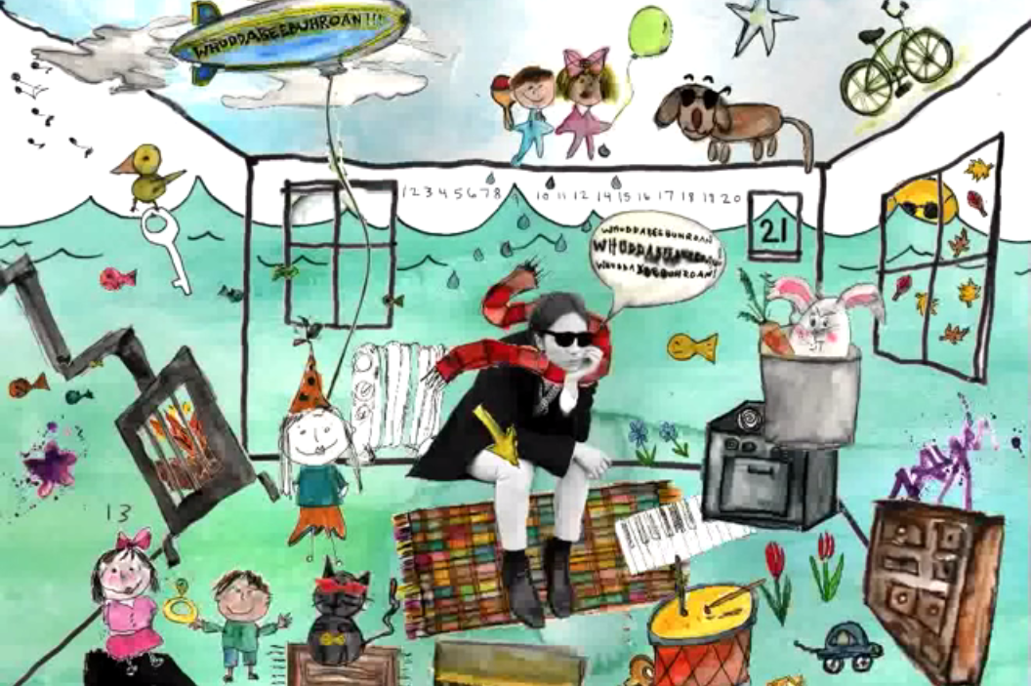

Jaymay. “What About the Bob? – Official Video.” Youtube. Youtube, 26 Mar. 2012. Web. 28 Oct. 2014. http://www.youtube.com/watch?v=61QH1RxSRQY

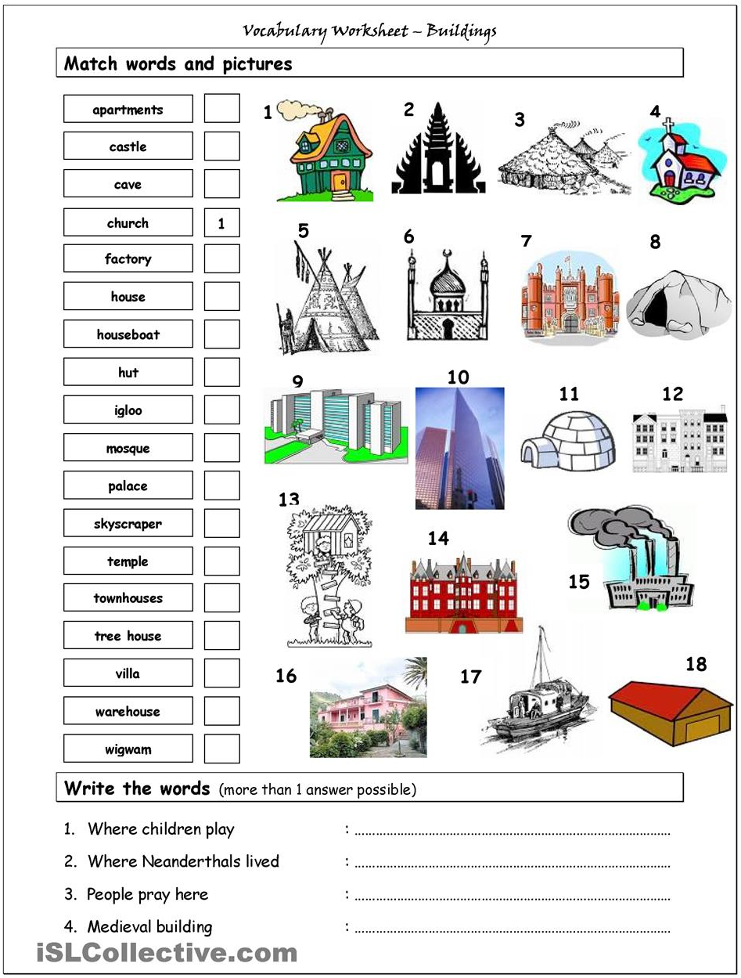

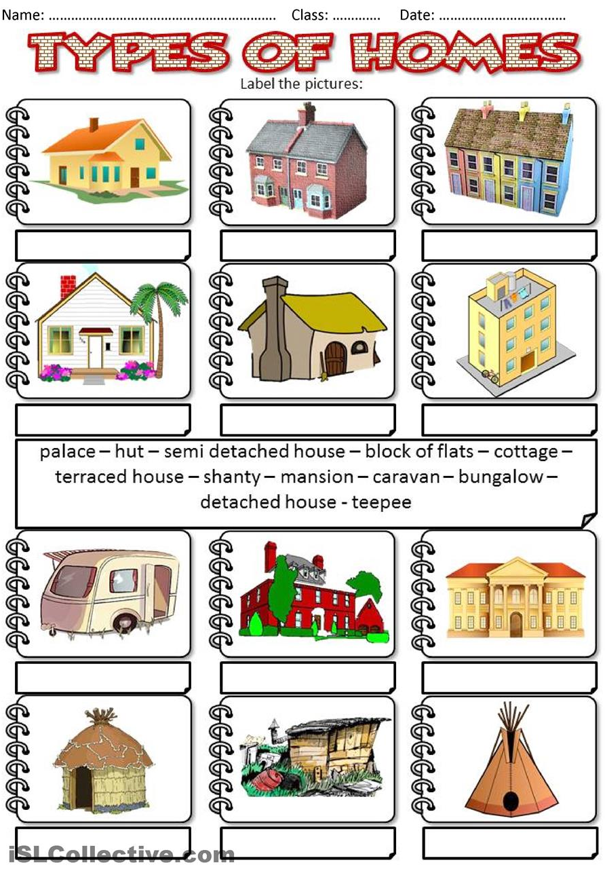

Blank board game template

