Listening Lesson Plan

Cheetahs Run the Fastest

Instructor:
Lee Go Woun
Level: Intermediate
Students: 6
Length: 40 minutes

Materials:
Picture of people with different heights, animals
Worksheets : 6 worksheet of filling in the blanks & notebook of the students + student book 6 worksheet of questions for the dialogue

Aims:
SWBAT distinguish between adjectives that take + er form (fast+er=faster) and others that take more+ adjective form (more beautiful) by listening to the song, the dialogue and writing about their families.
SWBAT list the names of some animals including birds and compare them as well as some adjectives, their synonyms and opposites through dialogues and eliciting.

Language Skills:
Reading: Read the song’s lyrics & the dialogue that contain comparatives and superlatives.
Writing: filling the blanks and write about their families
Listening: Listen to the teacher’s instructions, the song and the dialogue
Speaking: Share sentences containing comparatives and superlatives with the class

Language Systems:
Grammar: learn to formulate comparatives and superlatives via the song and the dialogue
Function: learn how comparatives change according to the subject of the sentence. A lion is faster than a zebra and slower than a cheetah.
Discourse: learn how comparatives change according to sentences they are in. A cheetah is the fastest in the jungle but it is slower than a car …
Lexis: learning new vocabulary about animals & forms of comparatives& superlatives
Phonology: listening to the forms of comparatives and superlatives

Assumptions:
Students can already express their ideas in English.
Students know the teacher’s style of teaching and the pace of the class.

Anticipated Errors and Solutions:
-The students may still be confused about when to use adjective + er or more+_ adjective. The teacher will give more examples and elicit some from other students.
-The post activity may finish earlier than expected. The teacher will ask students to elaborate more on their sentences.
-If time is short, reduce the number of students sharing their opinions.

References:
Jenny Oh et al. (2006) CHESS Student Book, UNIT5: Descriptive Talk.

Lead-In
Materials: picture of characters with different heights & board & markers
Time  3 minutes | Set Up  T-S  S-T  S-S  Ss are seated in a horseshoe  seating arrangement.  Ss tell about what they did on the weekend | Procedure:  T begins by smiling and making eye contact, waiting until Ss are quiet and ready to begin, or may use an attention-getting technique.  T: “Welcome to our class. How are you, today? Let’s get  started. Look at this picture. What do you see?”  Ss responds and T confirms or corrects. T puts the visual  aid in view where it will stay for the remainder of the  lesson, unless it is used for further discussion/checking.  T: “Today, we will talk about animals. We will also  learn about comparatives and superlatives”  T writes the topic and language points on the board.  Ok. Good. On the weekend, I saw a movie with my  younger sister. I have a shorter hair but she has bigger  eyes. The movie was the funniest among the ones I saw  this month. I couldn’t stop laughing. What about you?  What did you do on the weekend?

Pre-Activity
Materials: pictures of animals, board, markers
Time  5 minutes  5 mins |  | Set Up  S-S  Seated in pairs  Elicit : ugly is the opposite of beautiful + the synonym of beautiful : pretty + attractive | Procedure:  I will show you some pictures of some animals. Tell me which is faster than the other. Teacher shows a picture of a rabbit . What is this? ( A rabbit). Then, T shows a picture of a turtle. What is this? (A turtle). Good. Then who is faster a rabbit or a turtle? Tell me the whole sentence( A rabbit is faster than a turtle) Excellent.  Now who can tell me what is the name of this bird? ( A swan). What about this? (A koala). Then who is more beautiful a swan or a koala? (A swan) Very good. Please keep in mind that we say more beautiful not beautifuler. Do you know other adjectives than have the same meaning as beautiful? ( attractive , pretty) very good. Can we say prettier ?  CCQ: What is faster? A turtle or a rabbit? ( A rabbit )  What is the slowest ? A turtle or a snail? ( A snail )  Lexis: Eliciting the words.  We have seen that slow is the opposite of fast. Can you tell me the opposite of beautiful? Ugly. Write it on the board.  Write on the board : A is ugly, B is uglier, C is the ugliest  What about the synonym of beautiful? ( pretty and attractive) .
Main Activity
Materials: CD player , CD , worksheet 1 ( fill in the blanks) , board, board markers + student book worksheet 2 : questions about the dialogue
Time  4mins  4 mins  3 mins  10 mins | Individual work  Listen to the song and memorize the name of the fastest animal and the most beautiful one.  Listen to the song and fill in the blanks : Individual work  Listen to the  dialogue and answer the questions + write the sentence that contains the comparative and superlative form with partner |  | Procedure:  Activity 1  Now you will listen to a song where you have to pick up  The name of some animals. Try to memorize the name of  the fastest animal and the most beautiful one. You will  listen once. It is an individual work.  ICQ: What are you going to do ?  Check answers  Now you will listen for the second time. This time you will  Listen and fill in the blanks. ( Distribute the worksheet2).  I will play it once. We will check the answers when the  Song finishes.  ICQ: Are you going to listen to the song twice? No.  Are we going to answer before the song finishes? No  T: “Time’s up.”  Check answers: Pick one person per answer. T gives  explains the answers: why faster but not more fast and  why more beautiful and not beautifuler because the  latter has more syllables ( chunk the word).  CCQ: What do zebras, lions and cheetahs have in  common? They run fast  Which bird is the most beautiful? A swan.  Which bird is the least beautiful? A canary.  Activity 2 :  Now we will listen to a dialogue. There will be two  animals.  Before that, read these questions that I gave you (worksheet #2)and try to answer them when we finish listening to the dialogue. I will Play it twice. Work with your partner ( T gestures to the partners). Don’t forget to write at least one sentence that contains comparatives and superlatives in your notebook.  ICQ: How many sentences are you going to write?  At least one.  Are you going to work alone? No  Check the answers while looking at the student book
Post Activity
Materials: Notebook + board+ markers
4 mins  2 mins | Individual:  Write about family members using comparatives and superlatives. Teacher demonstrates first.  The students read the answers and the teacher corrects. |  | Now you will write about your family member. I will give you 4 minutes. Try to write at least 4 sentences. Work alone. I will start first.  I have a younger sister. She is taller than me. She has bigger eyes and a longer neck.  ICQ: How many times do you have? 4 mins.  Do you work with your partner?  While the students are writing, the teacher monitors the students.  1 more minute left.  Time is over.  Very good everyone.  What did we learn today? Superlatives and comparatives and names of animals…  Is a swan beatifuler than a parraot? No a swan is more beautiful than a parrot.  I s a snail more fast than a rabbit? No a rabbit is faster than a rabbit.  Excellent job everyone. Class dismissed.  SOS activities: if the last activity finishes earlier than planned, ask more questions to check their understanding of the comparative and superlative structures.
Picture showing people with different heights :
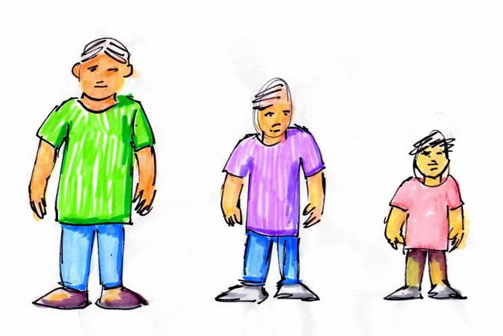

Pictures with animals :

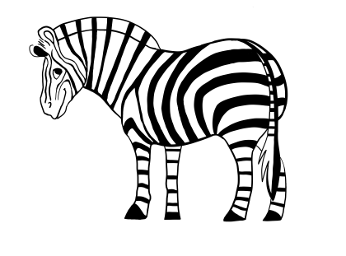

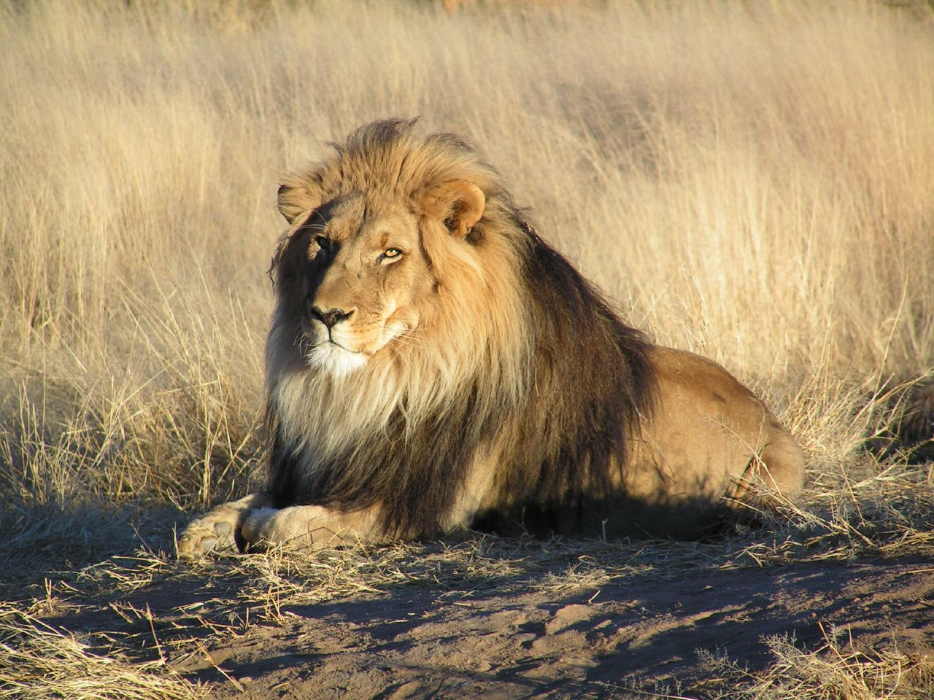

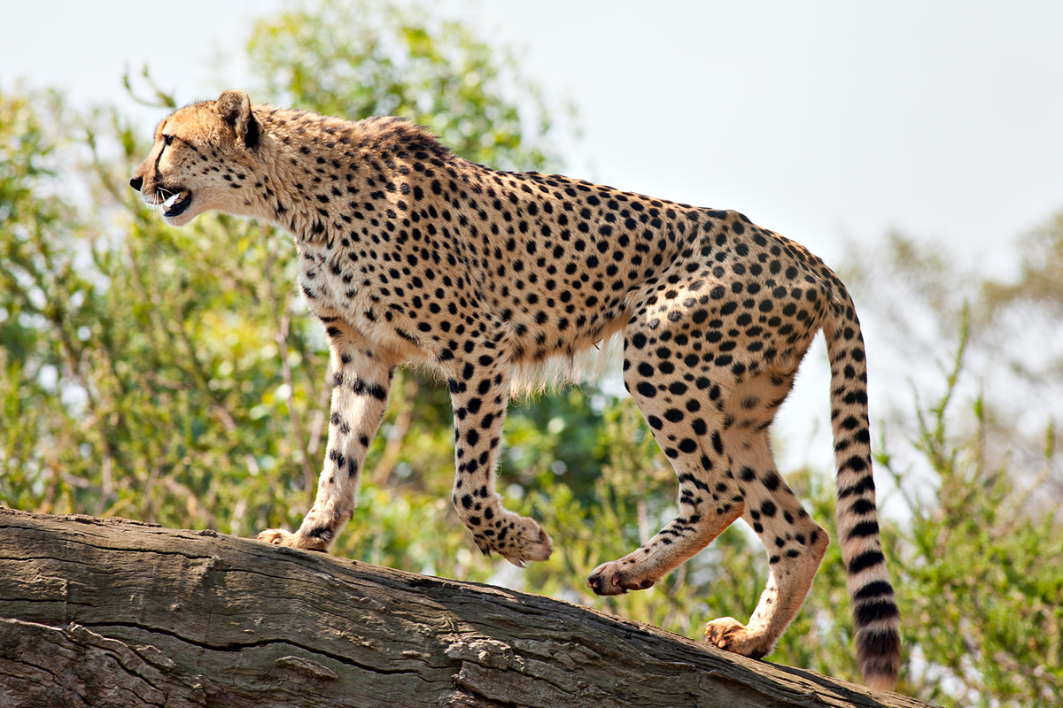

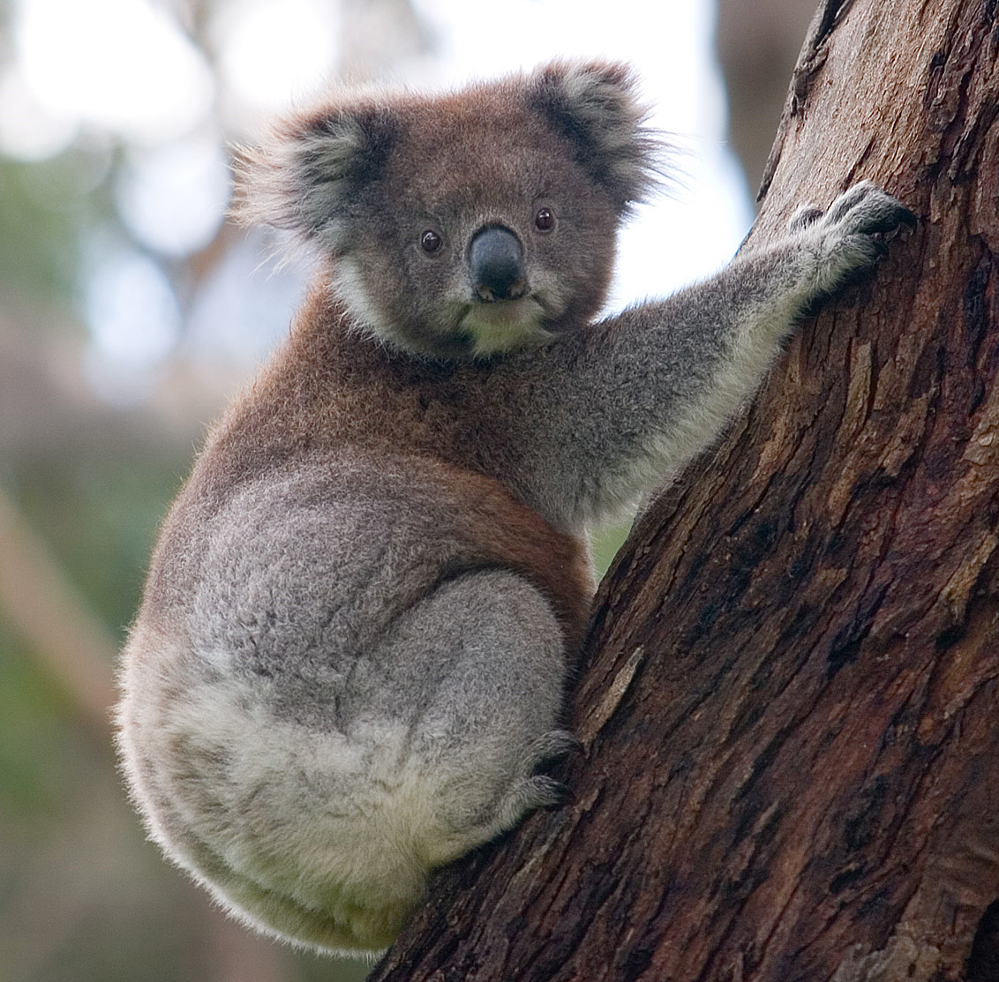

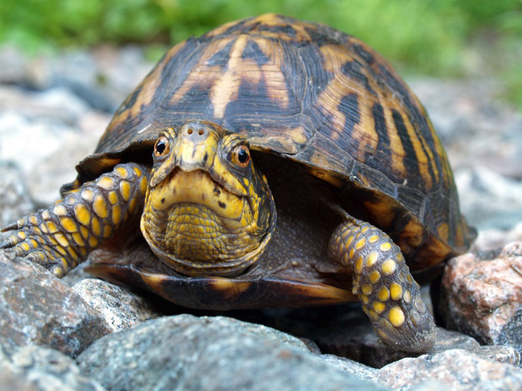

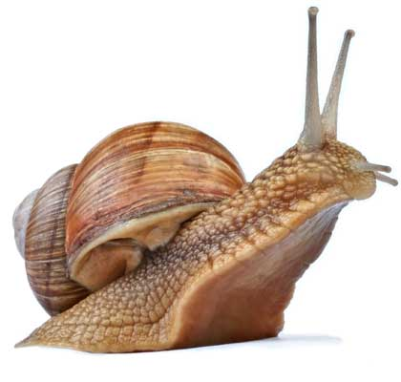

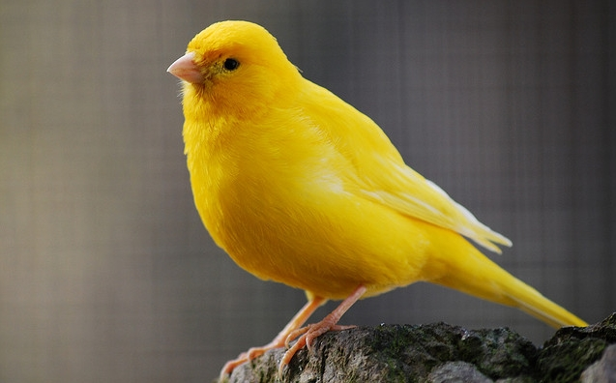

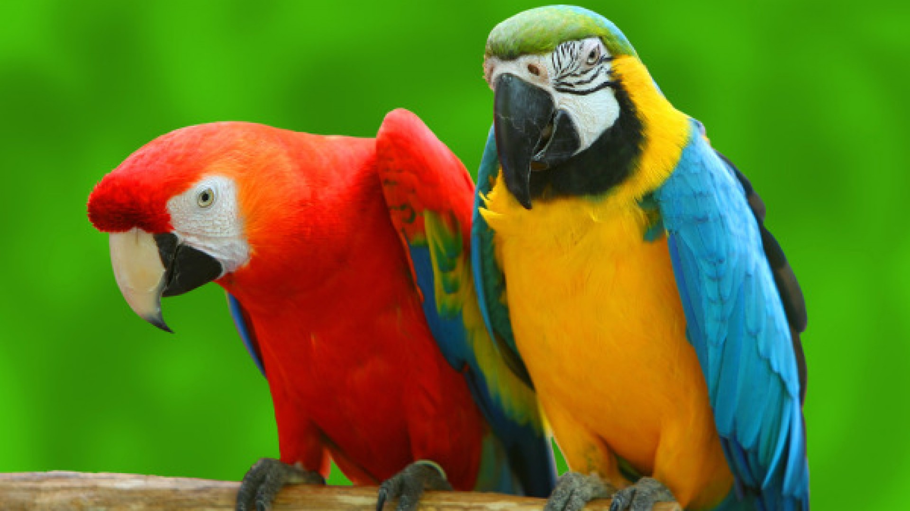



The song : Animals

Which animal is fast ?
A zebra is fast .
A lion is faster
A cheetah is the fastest

Which animal is slow?
A koala is slow.
A turtle is slower.
A snail is the slowest .
They move slowly.

Which bird is beautiful?
A canary is beautiful.
A parrot is more beautiful.
A swan is the most beautiful.
They fly beautifully

Worksheet 1 : Fill in the blanks with the appropriate word.

Which animal is ?
A zebra is fast.
A is faster.
A cheetah is ………….
They run fast.

Which animal is ………..?
A koala is slow.
A ……….. is slower
A snail is …………….
They move slowly.

Which animal is ……………..?
A ………. is beautiful.
A ………… is more beautiful.
A swan is ……………….
They fly beautifully.

Dialogue: A favor

Ms. Hedgehog: Hello,MS. Rabbit. Can you do me a favor?
Ms. Rabbit: Sure , what is it ?
Ms. Hedgehog: Can you take this lunch box to the prettiest girl at school?
Ms. Rabbit: The prettiest one? It must be Rosa Rabbit.
Ms. Hedgehog: Oh, no! Not Rosa. She is prettier than Rosa. She always smiles happily .
Ms. Rabbit: Smiles happily? Then it must be Dina deer.
Ms. Hedgehog: Not Dina! She is prettier than Dina. She also moves gracefully.
Ms. Rabbit: Which animal is prettier than Dina?
Ms. Hedgehog: My girl! She is the prettiest, and the most attractive one in school.
Ms. Rabbit: You mean Heddy Hedgehog. Oh my goodness!

Worksheet 2 : The questions about the dialogue

1-Who gives the lunch box to Ms. Rabbit?
-
2-Where does Ms. Rabbit have to take the lunch box to?
-
3-Who does Ms. Rabbit have to give the lunch box to?
-
4- Who does Ms. Rabbit think is the prettiest girl ?
-
5- Who does Ms. Hedgehog think is the prettiest girl?
-
6- Does Ms. Rabbit think Heddy is pretty?
-
7- Write the sentence that contains the comparative and superlative form in your notebook .

