Speaking Lesson Plan

Title : Where do you like to travel? Would you recommend any places to other students?
INSTRUCTOR |  | LEVEL / AGE | No of STUDENTS |  | LENGTH
Esther Hyun Joo Park |  | Pre - Intermediate / 24-30 | 18 |  | 50 mins

Materials:
- 18 Find someone who work sheets
- White board, markers and eraser
- List of cities and countries
- Poster, color pens, color paper
- 18 evaluation sheets
- Ping pong ball
Aims:
      - To help students to make and give a presentation of recommending and study how to organize presentation through practicing within a group
      - To practice language using 5W and H through group discussion and to be able to describe about different countries and places they have been traveled and share ideas with groups.
      - To practice writing to improve productive skills to reproduce and generate language learned today into words and sentences by understanding assignment.

Language Skills:
Speaking: Group discussion, answering questions to guide questions and ICQ, Presentation
Listening: listening an instruction, group response, teacher’s question and elicitation
Reading: Reading a passage, read vocabularies, comprehensive questions
Writing: write down all the answers for CCQ, guide questions, comprehensive questions, make vocabulary books using sentences

Language Systems:
Phonology: Practicing presentation,
Lexis: Evaluation, attract, procedure
Discourse: Speaking of experiences about travelling and making a presentation
Functions: describing, expressing likes, criticizing, Explaining, evaluating, suggesting, wishing, planning, organizing
Grammar: Using present perfect tense, future tense

Assumptions:
- Students are able to talk about different countries in English.
- Students are able to describe their experience of travelling.
- Students know how to play find someone who…

Anticipated Errors and Solutions:
- Students may find difficult to give presentations in front of a class
→ Present by a group, everyone takes turn, evaluate themselves to realize how to make a good presentation

References:
http://www.pinterest.com/pin/246572148319173690/
http://www.state.gov/misc/list/

Notes:

Pre Task
Title:  Find someone who….. |  | Aims:  To help students to warm up about general idea of travelling |  | Materials:  18 Find someone who work sheets
Time | Set Up | Students |  | Teacher
5 mins  1  mins | A whole class | Students go around the class room and do worksheets  Answer guide question  - Where is the place most of people have been except Seoul?  - What do you think this activity about? |  | Greet students.  Hand out work sheets  Ask guide questions  Ask students if they have any questions and pause

Notes:
Get students attention before start the next activity.

Task Preparation
Title:  This place is famous for……….. (TABOO Game) |  | Aims:  To practice students speaking by playing Taboo about different countries of improving describing vocabularies | Materials:  White board, markers and eraser, list of cities and countries
Time | Set Up | Students | Teacher
1  Mins  5  Mins | Whole class but a group competition | Listen to an instruction  - One person from each group comes in front of the board.  - Tell a student a country or a place (2 each)  - A explainer group has a priority to call out answer first but if they are wrong then the other groups can have chances to guess what it is  - The group of the most answer wins  ** cannot tell its capital city **  Instruction questions  - What shouldn’t you say?  Do activities – silence / listening  Students ask question before the next activity | Give an instruction  Give chunk instructions .  Give countries or city name to Students in front  Ask students if they have any questions and pause

Notes:

Task Realization
Title:  I recommend you to visit …………… |  | Aims:  To feel friendly to generate language of recommending using 5W and H and making a presentation  - To share idea within a group and cooperatively work together using English |  | Materials:  Poster, color pens, color paper
Time | Set Up | Students |  | Teacher
2  mins  15  mins  14  mins | In a group | Students listens carefully about the instructions  - Students will talk with their groups about their tour experiences. .  - Chose one of the best tours of a group and recommend to other groups to go travelling in the future.  - Make it out of a poster using 5W and H.( for Who, Where to go, When is the best time, What should you do, Why do you recommend this place, How to get there)  - Evaluate other group’s work  - Group presentation for 3 mins and preparing time for 15minutes  Answer instruction questions  - What should you discuss with your group?  - What should be included in a poster?  - How many minutes for preparing time and presentation?  Prepare for a presentation  Chose which group to go first (using a Ping-Pong ball, whoever gets highest # goes first and as its order)  Presentation starts  Presentation finishes  Students ask question before the next activity |  | Give an instruction  Ask Instruction checking questions  Chose which group to go first  Stop after 3 mins  Monitor discreetly while they do questions  Ask students if they have any questions and pause
Notes:

Post Task or Production
Title:  Where do you want to go next? |  | Aims:  To evaluate students by themselves of their speaking and improve their presentation skills  - To develop writing skills using 5W and H to describe where they would like to travel in the future | Materials:  18 evaluation sheets
Time | Set Up | Students | Teacher
4  Mins  2  mins | In a group | Go over evaluation sheets together  Students answer the Questions:  Answer questions  - What is the most important thing when you make a presentation? ( in a poster )  - What is the most important thing when you do this kind of presentation (recommending)?  - How would you like to improve your presentation next?  For homework students write 3 paragraphs about a place where they want to visit next time based on the other groups’ recommendation using 5W and H. Due next class  - Where was the best place that attracts you to plan to travel next time?  Answer instruction questions  - What is the assignment about?  - Why do you have to do assignment?  - When is it due?  Allow students to ask question before finish the lesson  Give round of applause to everyone and themselves | Go over evaluation sheets  Elicit ‘ 5W and H’  Assign homework  Ask Instruction checking questions for assignments.  Ask if they have any questions and pause  Encourage students  Dismiss the class

Notes: Make sure Students know why they need to do assignment

Worksheets, handouts and lesson materials
FIND SOME ONE WHO
Has been to Paris   | Has been to Australia   | Has been to Barcelona  
Has been to California  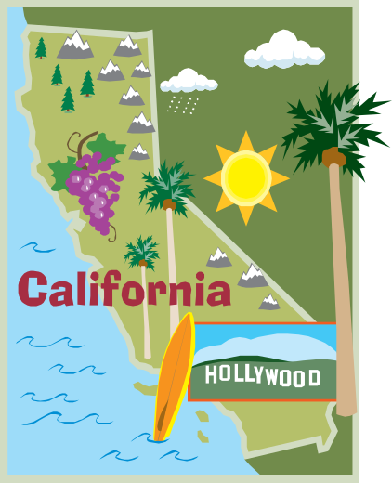 | Has been to Thailand   | Has been to HongKong  
Has been to New Zealand  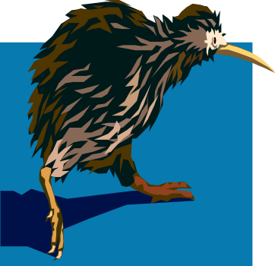 | Has been to Venice  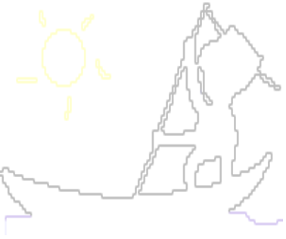 | Has been Philippines  
Has been to New York   | Has been to Seattle   | Has been to Malaysia  
Has been to Seoul  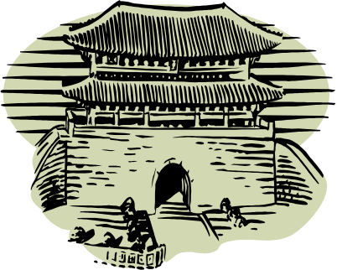 | Has been to Busan  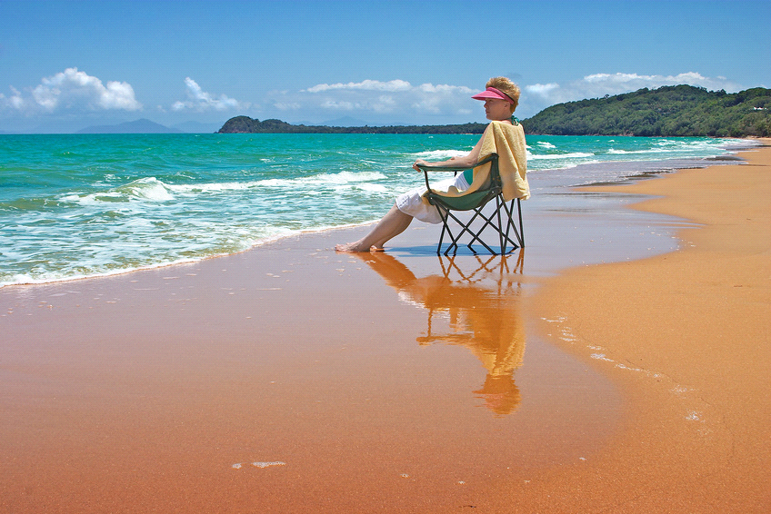 | Has been to Jeju Isaland  
Has been to Austria   | Has been to Saudi Arabia  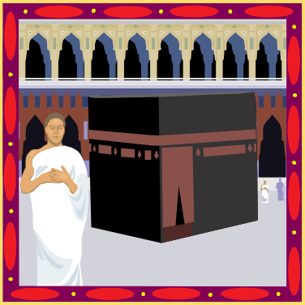 | Has been to Canada  

Peers Evaluation form
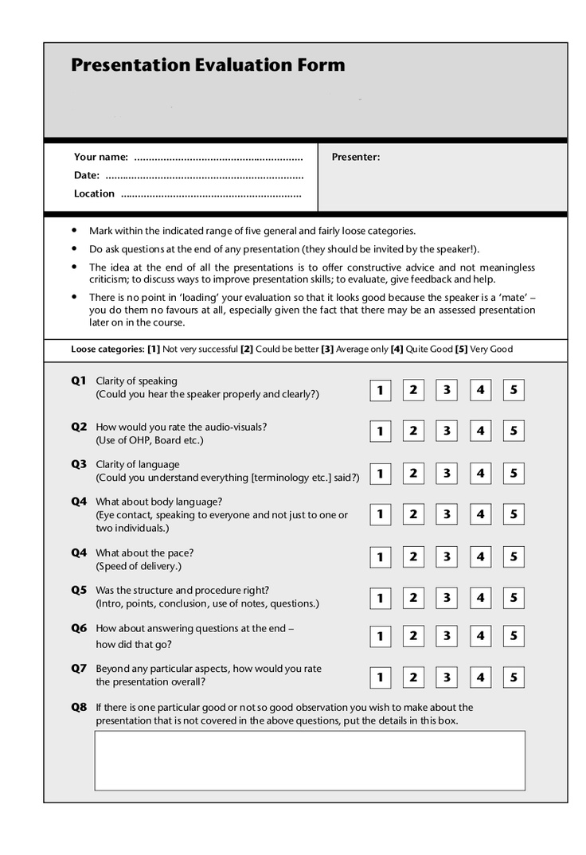
List of TABOO Activity

Seattle | London | Melbourne | Vancouver
France | United Arab Emirates | South Africa | Russia
Beijing | Brazil | Colombia | Thailand
Egypt | Santorini | Belgium | Spain
Mexico | Venice | Sydney | Norway

