Reading Lesson Plan

Topic: Occupations/Jobs
INSTRUCTOR | LEVEL / AGE | STUDENTS | LENGTH
MinHee Huh (Ellie) | Elementary / 6-10 | 18 | 50 minutes

Materials:
White board and markers
Jobs Flashcards1 / Worksheets1: Job Descriptions (18)
Jobs Flashcards2 / Worksheets2: Job Word Search (18)
Job Description Cards (18)

Aims:
To recognize common jobs/occupations in real life
To analyze new vocabulary
To improve speaking and listening ability by sharing ideas in a group

Language Skills:
Reading: Read short job description
Speaking: Answer the questions and group discussion
Listening: Listen teacher’s instruction / Interact with group members
Writing: Write the list of jobs and worksheets

Language Systems:
Discourse: Discuss in a group what do you want to be in the future / Imagine what does he/she do
Functions: Describing or explaining each job / Questioning and answering each questions
Phonology: Correct pronunciation of vocabulary words (architect, athlete, chef, doctor, solider)
Lexis: Jobs/occupations vocabulary (actor, architect, artist, astronaut, athlete, chef, dentist, doctor, farmer, janitor, mail carrier, mechanic, miner, musician, nurse, pilot, police officer, reporter, scientist, solider, teacher, vet)
Grammar: Simple present tense

Assumptions:
Students already know jobs/occupation vocabulary.

Anticipated Errors and Solutions:
Students may not know the definition of the words.
- Use dictionary and find its definition by themselves (Do not tell the definition)
Students may not know many job titles.
- Mime and describe and then elicit the words

References:
http://bogglesworldesl.com/job_worksheets.htm

Notes:
If no one answer and explain the flashcard in task preparation,
- Ask students what does your father/mother do
If there is no time to review,
- Cut wrap-up activity in post task

Pre Task
Title:  What do you want to be? |  | Aims:  To practice students to speak by group discussion and get closer to the topic, jobs/occupations | Materials:  Paper, pencil  White Board, Markers
Time | Set Up | Students | Teacher
1min.  1min.  3mins. | Individual  Group of 3or4 | Answer the question:  - What do you want to be when you grow up?  List occupations/jobs and write on the board. | Greeting  Ask questions

Notes:
N/A

Task Preparation
Title:  What does he/she do? |  | Aims:  To introduce new vocabulary (jobs/occupations) | Materials:  Jobs Flashcards1  Worksheets1: Job Descriptions (18)  Jobs Flashcards2  Worksheets2: Job Word Search (18)
Time | Set Up | Students | Teacher
3mins.  2mins.  3mins.  2mins. | Whole class  Group of 3or4  Whole class  Group of 3or4 | Explain each flashcards  Worksheets1: Job Descriptions (18)  - Match the jobs with their descriptions  Explain each flashcards  Worksheets2: Job Word Search (18) | Show the Jobs Flashcards1  Give out the Worksheets1: Job Descriptions (18) and explain an instruction.  Show the Jobs Flashcards2  Give out the Worksheets2: Job Word Search (18) and explain an instruction.

Notes:
If a class has enough time, do Job Word Search worksheet2 (If don’t, do not have to do).

Task Realization
Title:  Guess who? |  | Aims:  To read a job description and help to understand how to play fun activity  To ask and answer the yes/no questions | Materials:  Job Description Cards (18)
Time | Set Up | Students | Teacher
3mins  22mins | Individual | Give each student a card and read a description for his/her job (do not show it to anyone). Each student should recognize a job in the card (what does he/she do, where does he/she work at, how does he/she do for his/her job), etc.).  A student come to the front and other students can only ask Yes or No questions and guess what is his/her job. | Give an instruction

Notes:

If student does not get any idea of his/her job (on the card), he/she can search and find the definition of it.

Post Task
Title:  What’s this? |  | Aims:  To improve students’ knowledge about jobs/occupations | Materials:  White Board, Markers
Time | Set Up | Students | Teacher
1min  8mins | Whole class | Wrap-up activity: on the board write the new vocabulary ith the letters in the wrong order, (for example, L I P T O (pilot)). Students must rearrange the letters to form the correct word.  Explain what he/she does for each job. | Review what we learned today.  Give an instruction

Notes:

N/A

Worksheets, handouts and lesson materials
- Jobs Flashcards1

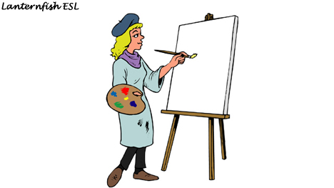   | 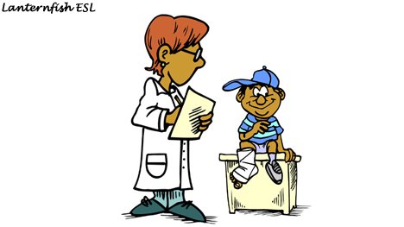   | 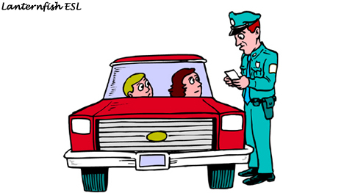  
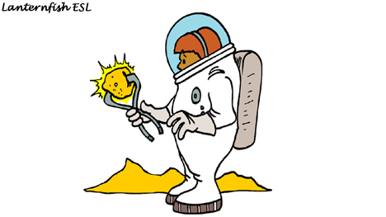   | 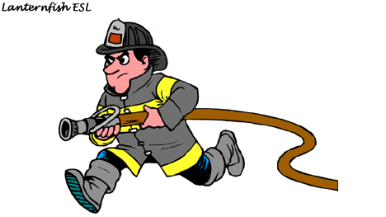   | 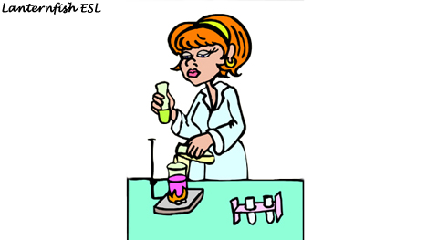  
   | 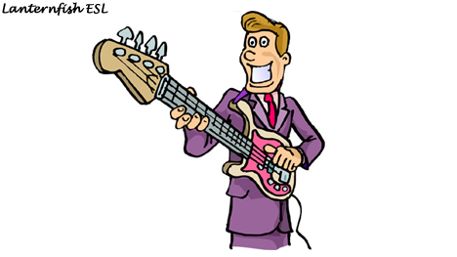   | 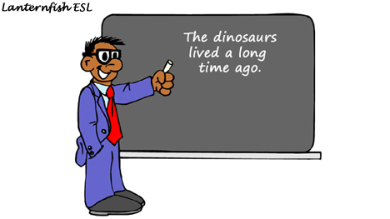  
   | 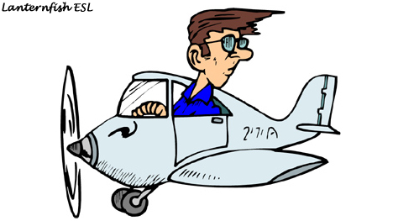   | 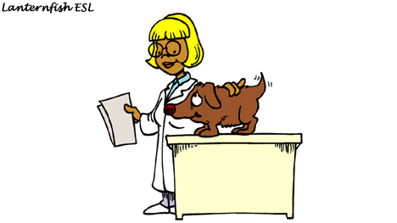  

- Worksheets1: Job Descriptions (18)

 |  |  |  | 
 |  |  |  | 
 |  |  |  | 

- Jobs Flashcards2

   | 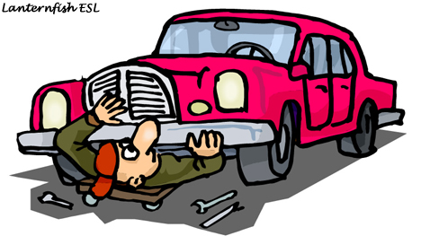   | 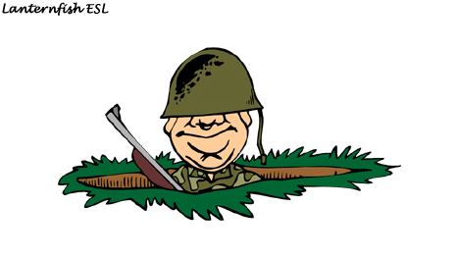  
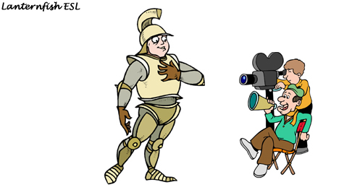   | 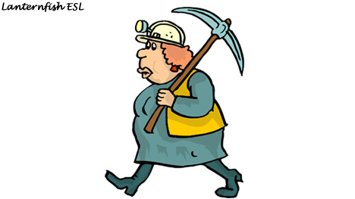   |   
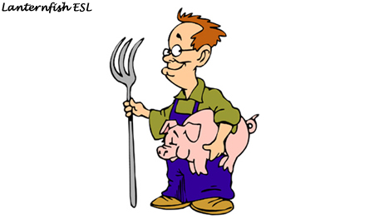   |    | 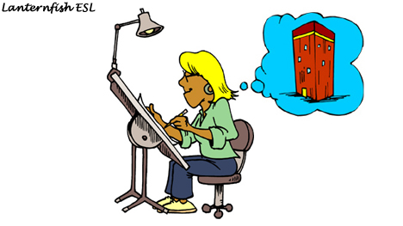  
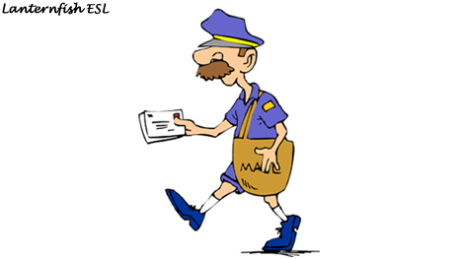   |    | 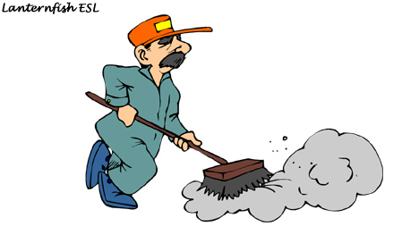  

- Worksheets2: Job Word Search (18)

Jobs Word  Search:  Find the word in the list below in the grid to the right.  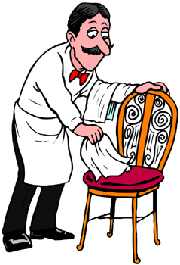 | 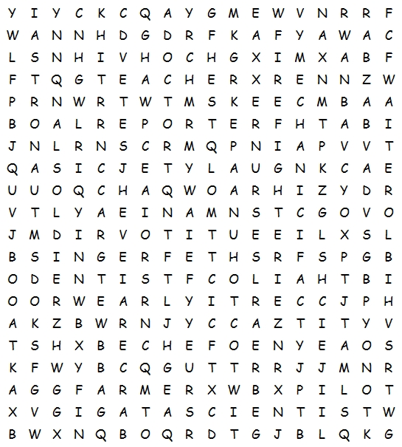
actor  architect  artist  astronaut  athlete  chef | dentist  doctor  farmer  firefighter  janitor  mechanic | miner  musician  nurse  pilot  police officer  reporter | scientist  singer  soldier  teacher  vet  waiter

- Job Description Cards (18)

Farmer  A person who grows crops and raise animals | Doctor  A person who helps them get well when people get sick | Police officer  A person who maintains order and protect the citizens
Firefighter  A person who rescues people and buildings from fire | Pilot  A person who flies passengers on short or long flights | Chef  A person who prepares delicious food for you to eat
Mechanic  A person who repairs vehicles when they are damaged | Vet  A person who treats disease and injuries of animals | Waiter  A person who takes orders and serve food and drinks at tables
Artist  A person who creates original piece of art work | Solider  A person who works on a ship or ocean going vessel | Actor  A person who acts in a play or movie
Architect  A person who designs buildings | Miner  A person who works digging minerals (coal, gold, etc.) out of the ground | Nurse  A person who takes care of patients
Teacher  A person who helps students learn various subjects | Musician  A person who plays a musical instrument | Scientist  A person who is specialized in science especially one of the natural sciences.

