Reading Lesson Plan

Title: THANK YOU M’AM
INSTRUCTOR |  |  |  | LEVEL / AGE | STUDENTS |  | LENGTH
Youngwoun Oh (Anna) |  |  |  | Pre intermediate / 20~25 | 18 |  | 50 mins

Materials:
White board and makers
Three kinds of work sheets and copies (18): ‘THANK YOU M’AM1’, ‘THANK YOU M’AM2’, ‘”THANK YOU M’AM2” BY LANGSTON HUGHES’

Aims:
To be able to familiar with useful expressions in the short story such as ‘to get a bite to eat’, ‘get through with’, ‘latch onto’ and ‘been there done that.’
To practice catching main ideas of each paragraph through skimming and list it up in chronological orders.
To be able to answer the questions based on the specific information taken from scanning.
To practice speaking by discussing with group members

Language Skills
Reading: short story “Thank You M’am” using skimming and scanning, work sheet
Listening: teacher’s instruction, group members’ opinion
Speaking: discussing with group members
Writing: writing answers on work sheet

Language Systems
Phonology: pronunciation of Africa-American English like ain’t and yes’m.
Lexis: to get a bite to eat, get through with, latch onto and been there done that
Grammar: tag question
Discourse: conversation between main characters in short story, discussion in groups
Functions: summery, sharing idea, answering questions

Assumptions:
Ss know about the author, Langston Hughes who is a representative of Harlem Renaissance. (19C)
Ss know what is skinning and scanning.

Anticipated Errors and Solutions:

References:
“Thank You M’am” by Langston Hughes/ Kari Sayers, 『Views and Values』

Notes:

Pre Task
Title:  Useful expressions |  |  | Aims:  To be able to familiar with useful expressions in the short story such as ‘to get a bite to eat’, ‘get through with’, ‘latch onto’ and ‘been there done that |  |  | Materials:  Work sheet ‘THANK YOU M’AM1’  White board and board markers
Time | Set Up |  | Students |  |  | Teacher
6mins | Groups  (4 members) |  | - Ss talk about the meaning of expressions in ‘Useful expressions’ section in work sheet and write down in on the paper. (3mins)  - Each group write down the meaning they think on the board so that other groups can share each other’s schema.(2mins) |  |  | Give instruction  (little talk, write in the board)  Monitor

Notes:
- In case Ss having trouble in guessing the meaning, T can give them sample sentences bellow to help them understand.
-Do you want to stop somewhere to get a bite to eat?
-When will you get through with the finishing touches? Or I just got through with my homework.
-A: I was really frustrated when I was jobless for three months.
B: Oh, Yeah, been there myself.
- After Ss write down the meaning on the board, T simply check the results and move to next.
Checking here is just for getting Ss know what difference is there.

Task Preparation
Title:  Chronological orders |  |  | Aims:  To practice catching main ideas of each paragraph through skimming and list it up in chronological orders. |  |  | Materials:  Work sheet ‘THANK YOU M’AM1’
Time | Set Up |  | Students |  |  | Teacher
7mins | Groups  (4 members) |  | - Ss skim each 4 paragraphs in work sheet 1.(1min)  - Ss list the paragraphs up in chronological order through discussing with group members.(3mins)  - Each groups present their order and check it with quick summery.(2mins) |  |  | Give instruction  (skim, little talk)  Monitor  Check the order

Notes:
1. Ss figure out the outline through skimming so that they get ready to read the rest of story and answer questions.
2. Summery for each paragraph
A) She decided to take him home.
B) He lied and tried to run.
C) He tries to steal her purse.
D) She dragged him at home.
3. Order: C – B – A – D

Task Realization
Title:  Scan and answer |  |  | Aims:  To be able to answer the questions based on the specific information taken from scanning. |  |  | Materials:  Work sheet ‘THANK YOU M’AM2’ and ‘”THANK YOU M’AM2” BY LANGSTON HUGHES’
Time |  | Set Up | Students |  |  | Teacher
30mins |  | Groups  (4 members) | - This time Ss read the story using scanning.(2mins)  - Discuss with group members and answer questions 1-5 in work sheet 2. (16mins)  - Present their idea to class.(8mins) |  |  | Give instruction  (scan, little talk and answer, present)  Monitor  Get Ss present

Notes:

Post Task
Title:  Think more |  |  | Aims:  To think more about the story related with proverb “It takes a village to raise a child.” |  |  | Materials:  Work sheet ‘THANK YOU M’AM2’
Time | Set Up |  | Students |  |  | Teacher
7mins | Groups  (4 members) |  | - Ss talk about the meaning of proverb itself and in related with story. (2mins)  - Present their idea to class.(3mins)  H.W  -Write a short essay about experience they had related to the proverb.  -Use at least 3 expressions from ‘Useful expressions’.  -Due day: tomorrow  (Half page of A4, point 11) |  |  | Give instruction  (little talk and answer, present)  Monitor  Get Ss present  Give Ss homework

Notes:
For homework, if Ss have no experience with the proverb, they can choose other one they want.

“THANK YOU M’AM” 1

Useful Expressions
- To get a bite to eat:
2. Get through with:
3. Latch onto:
4. Been there done that:

Chronological orders
List each paragraph up in chronological orders
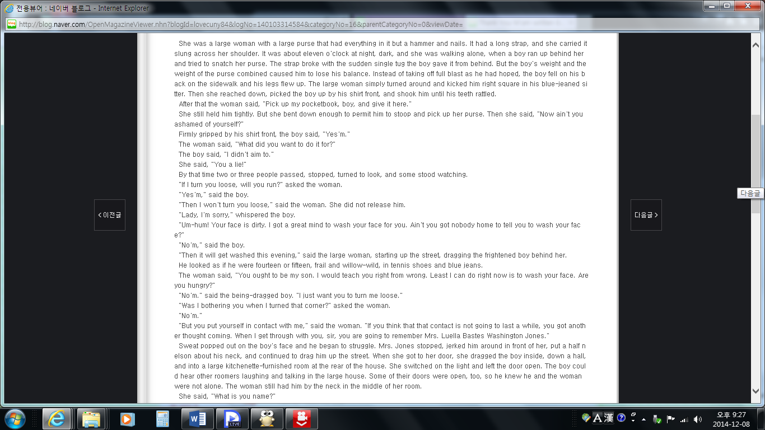
=>

“THANK YOU M’AM” 2

Question
- Why did Roger try to steal Mrs. Jones’s purse?

- Before he leaves, how much money did Mrs. Jones give Roger?

- Why are Mrs. Jones and Roger out on the street at eleven o’clock at night?

- Although Roger has tried to steal her purse, Mrs. Jones drags the boy home with her. Why doesn’t she call the police?

- Have you ever met anyone who impacts on your life like Mrs. Jones? Who was it? And how that person impacts your life?

Think more!
There is the African proverb “It takes a village to raise a child.” What does it mean? How does this saying relate to the story and Mrs. Jones’s role in Roger’s life?
Explain the proverb | Connect to the story

“THANK YOU M’AM” BY LANGSTON HUGHES

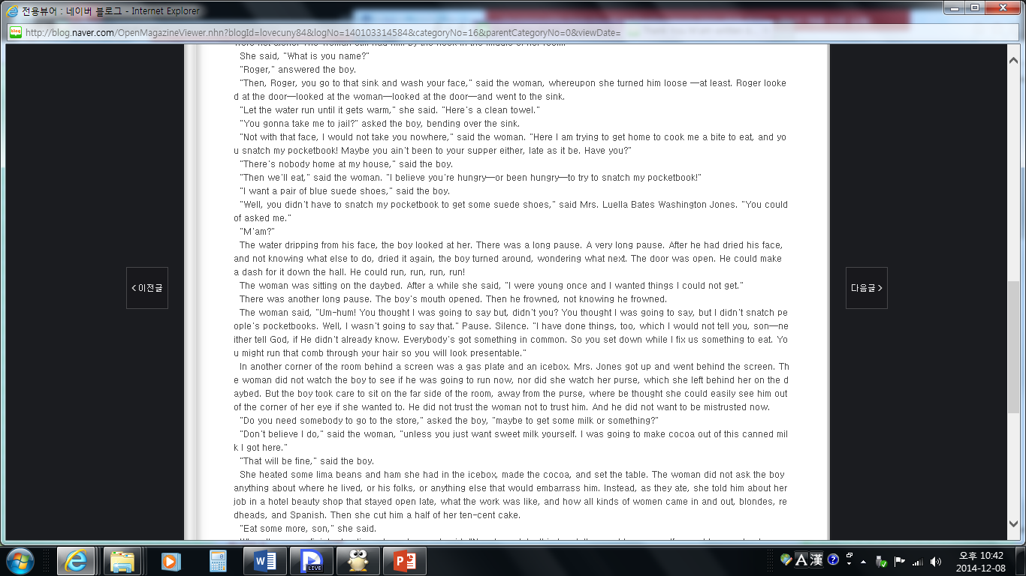
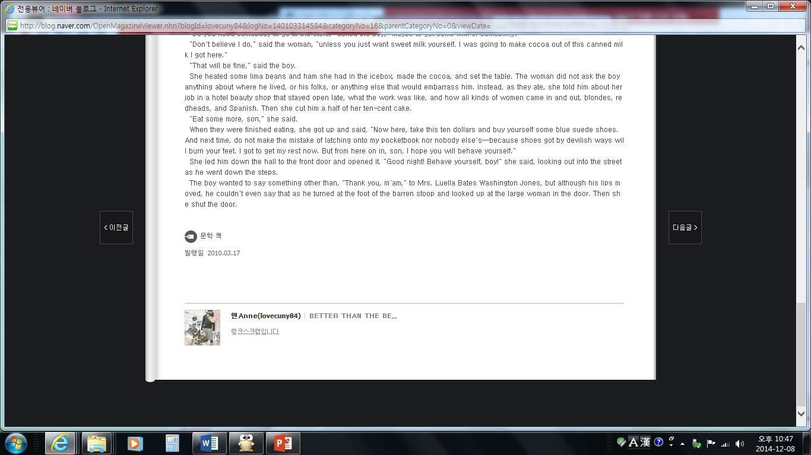

“THANK YOU M’AM” 1
(Answer sheet for T)
Useful Expressions
1. To get a bite to eat: to eat something
2. Get through with: to finish, to teach a lesson
3. Latch onto: to become attached to something
4. Been there done that: to do same thing before

Chronological orders
List each paragraph up in chronological orders
=> C - B – A – D

“THANK YOU M’AM” 2

(Answer sheet for T)

Question
- Why did Roger try to steal Mrs. Jones’s purse?
=> To buy a pair of blue suede shoes
- Before he leaves, how much money did Mrs. Jones give Roger?
=> Ten dollars
- Why are Mrs. Jones and Roger out on the street at eleven o’clock at night?
=> She works hard for a living, whereas he steals for a living.
- Although Roger has tried to steal her purse, Mrs. Jones drags the boy home with her. Why doesn’t she call the police?
=> She thought she had a better way of teaching him a lesion. Instead of punishment, he needed love, care, and kindness. (She noticed that nobody is there around him.)
- Have you ever met anyone who impacts on your life like Mrs. Jones? Who was it? And how that person impacts your life?
=> Depends on Ss

Think more!
There is the African proverb “It takes a village to raise a child.” What does it mean? How does this saying relate to the story and Mrs. Jones’s role in Roger’s life?
Explain the proverb | Connect to the story
A child can grow properly when people all joined.  *village: neighbors, teachers, elders | Roger is an orphan. A child can develop with people’s concern, though a child doesn’t have relationship with them.

