Reading Lesson Plan

Title: What kind of person are you?
INSTRUCTOR | LEVEL / AGE | STUDENTS | LENGTH
Erica | Pre-intermediate / Adult | 7 | 50 mins

Materials:
● White board, magnets, markers, eraser
● Vocabulary worksheets (7 copies / extra 3 copies)
● Fill in the quiz (7 copies / extra 3 copies)
● Reading article(7 copies / extra 3 copies)

Aims:

● Students learn the meaning of “Party animal”, “Culture vulture”, “Couch potato”

● Students know the personality type and improve reading comprehension.

● Students increase vocabulary.

Language Skills:
● Reading: Students read the article and worksheet.
● Listening: Students listen to the teacher’s instructions and each other’s opinions while discussing.
● Speaking: Students answer the questions and share ideas.
● Writing: Students write the answers on the worksheets.

Language Systems:
● Phonology: Recognizing the words that were used in the reading article
● Lexis: “party animal”, “culture vulture”, “couch potato”
● Discourse: Discussing / sharing ideas about the reading article with groups
● Functions: Guessing and sharing and expressing the ideas.
● Grammar: Present tense

Assumptions:
● Students are unfamiliar with the word (“party animal”, “culture vulture”, “couch potato”)
● Students understand about the article.
● Students are comfortable with group discussion / pair work.

Anticipated Errors and Solutions:
● Some students may have a hard time finding meaning of words.
→ Explain the meanings individually or pairs.
● Students’ might finish their activities early.
→ Follow SOS plan.

References:

Notes: If students finish the activity early I’ll do SOS activity
Solving some short riddles : Group work- Ss read a short riddle and guess what it is. Ss discuss with their group and share the idea.

Warmer
Title:  Talk about personal likes and dislikes |  | Aims:  To introduce the idea of what we are going to learn today. | Materials:
Time | Set Up | Students | Teacher
6  mins | Whole class | ● Greeting to teacher and classmates.   Eliciting  Q: What do you usually do on the weekend or free time?  Q: Are you an early-morning person or night person?  Q: Do you like outdoor activity or indoor activity? | Procedure:   Greeting  T: Hi class. How are you today?   Eliciting   Introducing topic  T: Today we’re going to check your personality type.

Notes:

Task Preparation
Title:  Can you guess the meaning of words? |  | Aims:  To learn the meaning of “party animal”, “culture vulture”, “couch potato” | Materials:  White board, markers, eraser, magnets, vocabulary worksheets, fill in the quiz worksheet
Time | Set Up | Students | Teacher
3  mins  4  mins | Pairs  Individually | ● Make the pairs   Ss look through the worksheets and discuss each other   ICQs  Q: How much time do we have?  Q: Are you going to work alone or in pair?   Ss talk about the meaning of the words  (“party animal”, “culture vulture”, “couch potato”)   Ss fill in the quiz   Compare the results and discuss it with your partner | Instructions:  T: Before the activity, let’s check the vocabularies.   Make the pairs   Distribute worksheets  T: Please look through the paper and guess what the meaning of these words and discuss each other.  I’ll give you 2 minutes   ICQs   Write the words on the board  T: Can you guess the meaning?  (“party animal”, “culture vulture”, “couch potato”)   Distribute worksheet(fill in the quiz)  T: I think you can understand the exact meaning of these words after you fill in the quiz.  I’ll give you 2 minutes   Compare the results

Notes: Make sure all students are following the class

Task Realization
Title:  What kind of person are you? |  |  | Aims:  To know the personality type and improve reading comprehension. | Materials:  Reading article worksheets
Time | Set Up |  | Students | Teacher
10  mins | Group |  | ● Divide into small discussion groups   Read the article and answer the questions  Q: Is each person a “party animal”, a “culture vulture”, a “couch potato”?  Q: What do Nobu and Lola like doing?  Q: What do they dislike doing? | Instruction:   Divide into small discussion groups   Distribute reading article   Read the article and answer the questions   Monitoring  - Looking around to check whether they are doing right  - Check language errors  - Check time.

Notes:

Post Task
Title:  Summarizing the lesson today. |  |  | Aims:  To increase vocabulary | Materials:  White board, markers, eraser
Time | Set Up |  | Students | Teacher
7  mins | Whole class |  | ● Summarizing  Q: This person likes staying in, eating, and watching TV  ______________  Q: This person likes going out, dancing, and meeting friends.  ______________  Q: This person likes reading and going to museums and art galleries.  ______________ | ● Summarizing  - Conclusion:  So much for today. Thank you.
SOS activity
Time |  | Set up | Students |  | Teacher
5  mins |  | Group | Solving some short riddles  - Ss read a short riddle and guess what it is.  - Ss discuss with their group and share the idea. |  | Teacher prepare some short riddles

Worksheets, handouts and lesson materials
<Vocabulary worksheet>
Pair work

1. “party animal”

2. “culture vulture”

3. “couch potato”

< Fill in the quiz >
What kind of person are you?

- Check the best answer. ★Result: _________

①It’s your birthday. Do you…
- A go out with friends?
- B have dinner at a restaurant with friends?
- C get a DVD and pizza?
②It’s a sunny weekend. Do you…
- A have a picnic with family and friends?
- B visit another city?
- C read a magazine at home?
③It’s your lunch break at work. Do you…
- A go to the gym?
- B go to lunch with friends?
- C have a sandwich at your desk?
④It’s your summer vacation. Do you…
- A go out at night?
- B go sightseeing?
- C lie on the beach?
⑤You go shopping on vacation. Do you buy…
- A some clothes for the evening?
- B a book about the place you’re in?
- C ice cream?
<Results>
Mostly “A”s:
You’re a real party animal and fun to be with.
Don’t forget to stop and rest sometimes!
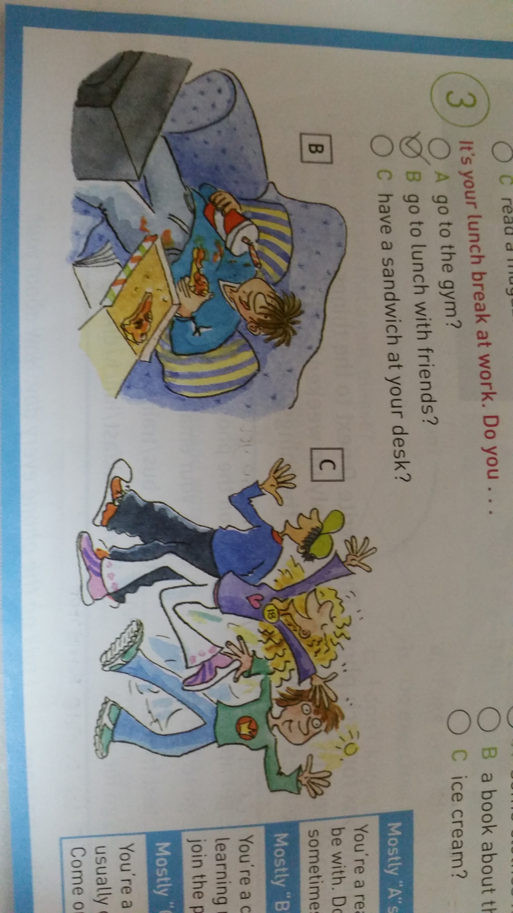

Mostly “B”s:
You’re a culture vulture and like learning new things.
Don’t forget to join the party sometimes!
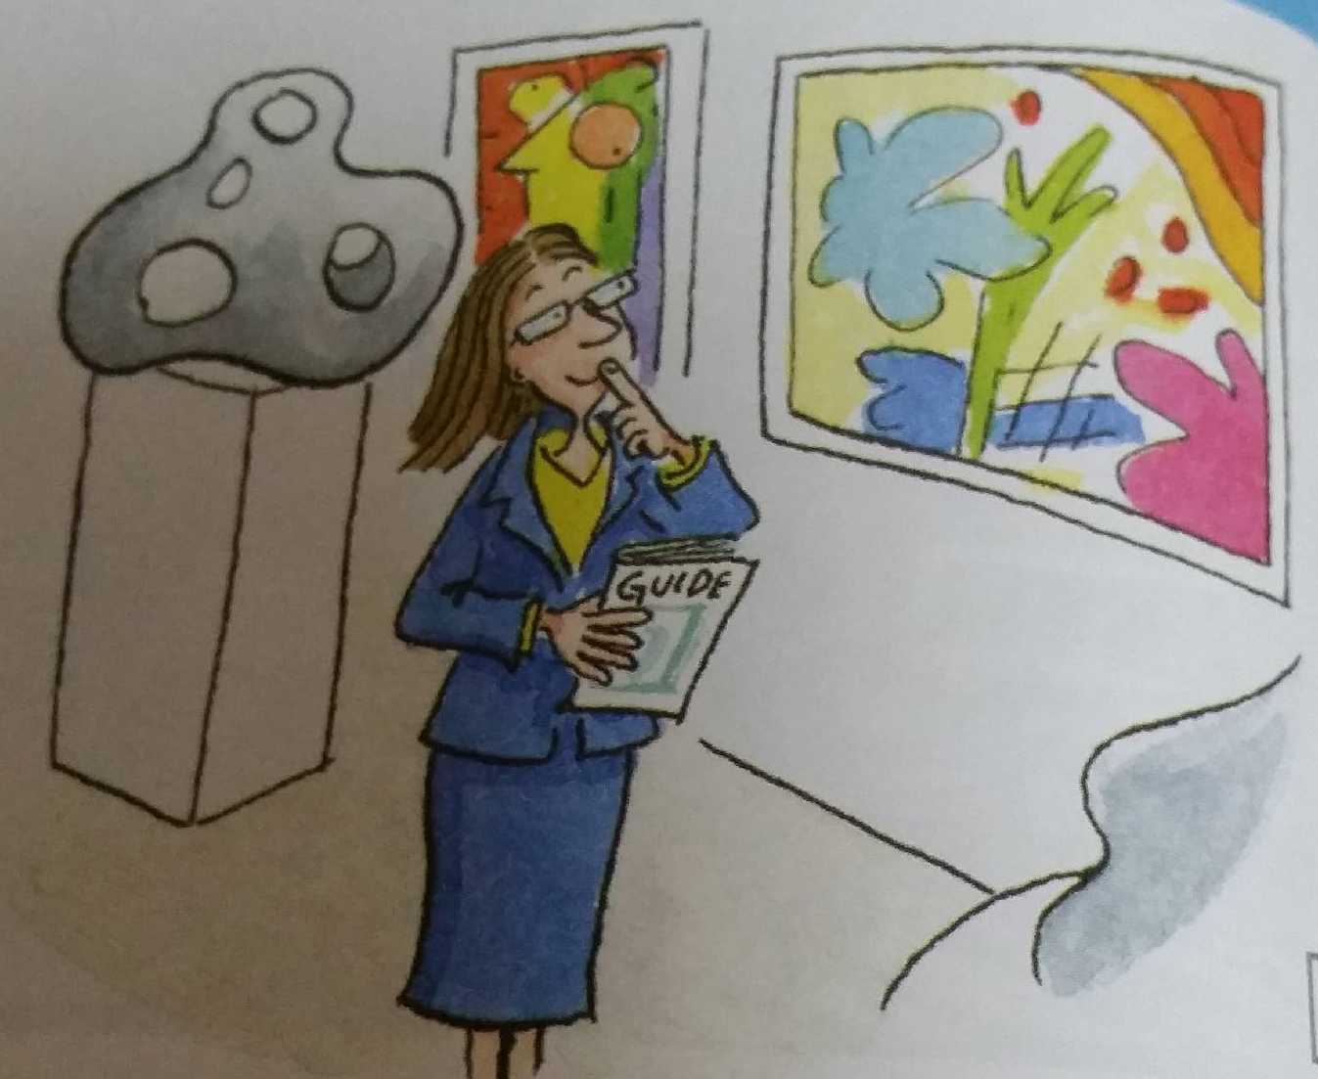

Mostly “B”s:
You’re a total couch potato and are usually on the sofa, doing nothing. Come on ~ get up and join the fun!

<Reading article>
I don’t like getting up early on weekends, so I usually sleep in sometimes until 10:30! I love to big ball of ramen on Saturday mornings. I can’t stand going to the gym, but I sometimes go for a walk in the afternoon. I like going to the park and just lying on the grass and doing nothing. I’m not into going out on Saturday night. Ii stay in and talk on the phone and watch TV.
Nobu Suzuki, Tokyo, Japan

I really hate doing nothing, so I get up early on Saturdays and start the day by texting friends. I really like to meet friends for breakfast, so I catch a bus into town. After breakfast, my friends and I sometimes go to an art gallery. I’m into most kinds of art, so I don’t mind which gallery we go to. I do different things on Saturday nights. I sometimes have dinner with friends, or I stay home and read.
Lola Gutierrez, Mexico City, Mexico

Answer the questions.

Q: Is each person a “party animal”, a “culture vulture”, a “couch potato”?

Q: What do Nobu and Lola like doing?

Q: What do they dislike doing?

