Grammar Lesson Plan

Title: I am doing!
INSTRUCTOR | LEVEL / AGE | STUDENTS | LENGTH
Nuri Nam | elementary/ 10 | 18 | 50 mins

Materials:
- A white board and markers.
- Visual aid – is doing (#1) (18copies)
- Word flash card Staff (#1-1) (1copies)
- Vocabulary work sheet (#2) (18copies)
- Board game staff (#3) (5copies)
- White board staff (1copies)
- Dice (5)

Aims:
- To improve students’ grammar knowledge through various activities.
- To practice vocabulary and ing form for main activity.
- To improve students’ speaking skill through group activity.

Language Skills:
Reading: Reading work sheet.
Speaking: group talking, speak before classmate, answering the questions
Listening: classmates’ interaction, teacher’s talking
Writing: worksheets

Language Systems:
Phonology: Pronunciation of run and learn.
Lexis: struggle, associated
Grammar: present continuous.(I am swimming, I am sleeping, I am eating etc)
Discourse: given situation story, communication with others, telling their situation.
Functions: explaining, classifying, inquiring, reporting

Assumptions:
- All student have their own dictionary.
- Students already have their own group.

Anticipated Errors and Solutions:
- Students don’t know the word which is relevant with the given situation.
- Let them search the dictionary the words they don’t know and explain each other.
- Student may not be able to pronounce some word
- Teacher can help them with that vocabulary.

References
http://www.activeennis.ie/facilities/active-ennis-leisure-complex/
http://blog.helpwithmusic.com/top-ten-lasting-benefits-piano-playing-child/
http://childparenting.about.com/od/nutrition/a/Sugar-And-Kids-How-To-Cut-Down-On-How-Much-They-Eat.htm
http://www.hollyrilinger.com/sleep/
http://lewisroom20.blogspot.kr/2014/10/signing-club.html
http://zealhk.com/whats-new/
http://cityofwatsonville.org/city-of-watsonville/water-quality-report-2013
https://www.jennyhadfield.com/training-plans/zero-to-running/
http://www.psychalive.org/whats-wrong-with-kids-watching-tv/
http://www.mrwallpaper.com/Cycling-Sunrise-Art-wallpaper/

Notes:
- If the worksheet didn’t print not enough, students can share it.

Pre Task
Title: what are they doing?  Picture activity |  | Aims:  To get some basic knowledge through picture activity.  - To warm up the student before starting main activity. | Materials:  - A white board and markers  - Visual aid – is doing (#1)  - Word flash card Staff (#1-1)
Time | Set Up | Students | Teacher
5mins  4mins | Whole class | - Students find the memo which is already hidden by teacher.  - And attach that memo to the picture which is relevant with the word.  - Through the additional flash card, practice the present continuous form. | - Before starting the class teacher need to hide the memo in the classroom.  - Greeting  - Show them additional flash card

Notes:
- If there is a student who doesn’t understand well, let other student help their teammate.

Task Preparation
Title: Let’s practice vocab!  new vocabulary. Pre- teaching |  | Aims:  - To practice vocabularies and ing form for main activity through worksheet. | Materials:  - A white board and marker  - Vocabulary work sheet (#2)
Time | Set Up | Students | Teacher
6mins  3mins | 5group of 3-4  Whole class | - Solve the Vocabulary work sheet (#2) with their group  - If they don’t know the meaning of the word, they can use their own dictionary.  - Share their answer with whole class. | - Give Vocabulary work sheet (#2)  - Ask them to teach each other  - Check the answer

Notes:
- If there is a student who don’t bring his/her dictionary, let them share with their partner.

Task Realization
Title: board game!!  Group talking.  Fun activity. |  | Aims:  To practice present continuous through board game activity.  - To improve the skill that express their own opinion. | Materials:  - White board and mark  - Board game staff (#3)  - Dice (5)  - white board staff
Time | Set Up | Students | Teacher
16mins  11mins | 5group of 3-4  Whole class. | - Play the board game as a group.  - Instruction  - Roll the dice  - Go ahead with the dice number.  - Make a sentence which is expressing the picture.  - Check the answer and if it is correct, student can stay. But if is wrong, they should go back where they were before.  - When the student stay the smile mark, they should answer for teammate’s action.  - Who first reach the end win!  - Choose one (probably the one is winner!) among the team. And go a front.  - They are representative of their team.  - And play the board game with whole class.  - When they stay, they need to answer seeing team mate’s action with ing form.(using white board staff) | - Give them the board game sheet and instruction.  - Monitor and prepare next work.  - Draw board game on the whiteboard  - Give the instruction.

Notes:
- If they are not able to understand the activity well, let them ask to the teacher again or explain each other.

Post Task
Title: Let’s review!  Review, CCQ |  | Aims:  To review new vocabulary and present continuous through CCQ  - To prepare the next class and make sure it through ICQ | Materials:  - White board and marker
Time | Set Up | Students | Teacher
5mins  2mins | Whole class | - Answer the questions.  - What am I doing? (ask with action)  - What am I doing? (ask with another action)  - Homework : No homework, but just know what we are going to do tomorrow. | - Ask them CCQ  - Explain what they need to prepare for the next class. And make sure the students understand through ICQ.

Notes:
- Let the student to do their left work, if they couldn’t complete yet.

Visual aid – is doing (#1)




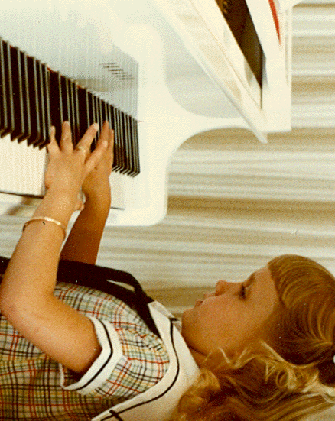

Word flash card staff (#1-1)
Swim She swims.
She is swimming.
Play
She plays the piano.
She is playing the piano.
Eat They eat.
They are eating.
Sleep
He sleeps.
He is sleeping.

Vocabulary work sheet (#2)
make ing form using given word.
Dance----- > Dancing
Sing----- >
Hike----- >
Drink----- >
Jump----- >
Run----- >
Ski----- >
Cook----- >
Watch----- >
Cycle----- >
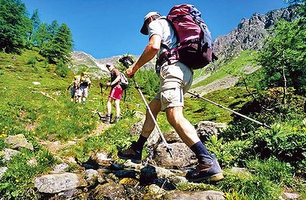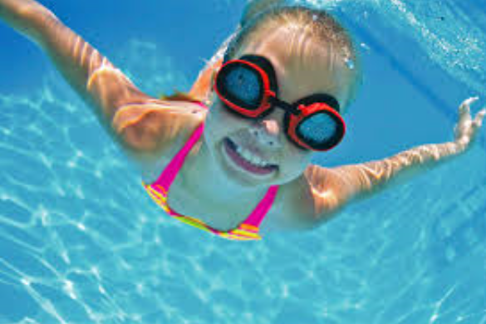
Board game staff (#3)
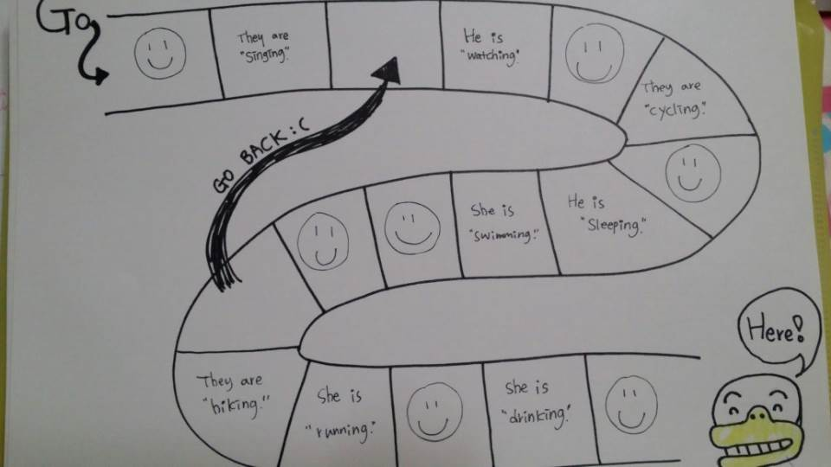
White board staff
- Dancing
- Jumping
- Skiing
- Cooking
- Talking
- Drinking
- Singing

