<Pictures for Pre-task>

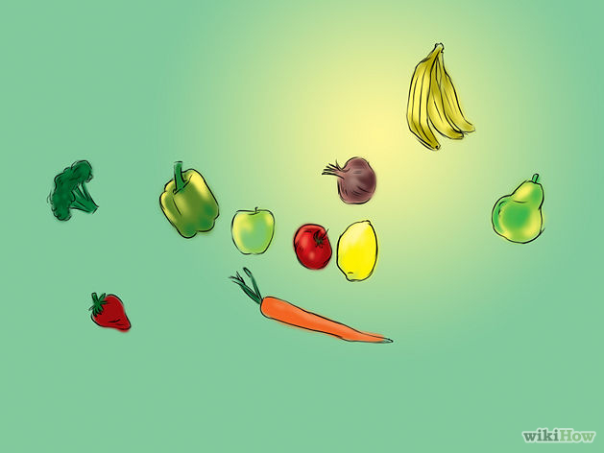

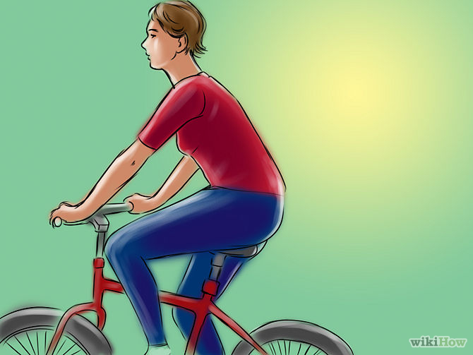
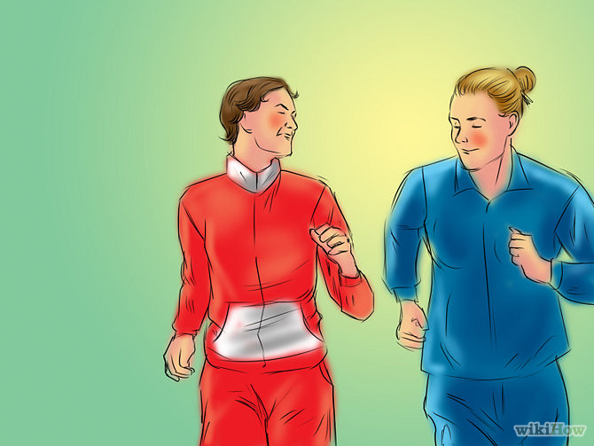
<Listening Script>

Ever wondered about changing your life for the better? Do you want a healthier and fitter lifestyle? Today, I’m going to provide you with several opportunities to create a better living for yourself. If you want to catch well-being and hot body at the same time, all you have to do would be to just follow these simple steps.
First, Begin eating breakfast, even if it is something small. This will prevent you from over-eating later when you become hungry. Furthermore, it activates and determines metabolism and digestion of the day. A good breakfast to stave off eating more later on has a protein source and a grain source, and maybe fruit.
Next, Get an exercise-buddy. If you have a friend, ask them to join in with you or motivate you. He/She can be your jogging buddy, gym buddy, or cooking friend. If you happen to have no friends that are interested, try making a club. A lot of people want to get healthy, but are just too scared to do it themselves. With this club you can discuss exercises for each other and new recipes. You can even have a day when you all make a recipe and eat.
Last, Know when you need a snack and what kind. You can have snacks, or small meals in between your meals, but be sure it is healthy: nuts, low-fat yogurt, protein rich peanut butter, raw vegetables, whole grains and fresh fruit instead of dried.

- Guiding Questions examples
- Do you usually eat breakfast in the morning?
- Do you have friends who like doing exercise?
- How often do you eat junk-foods or snacks in oneday?

< Format of Summarizing & Organizing>
< Handouts for note-taking in task-realization>

Main Idea : __________________________________________.

Reason 1 : ___________________________________________.
Supporting detail 1 : ______________________________________________.
Supporting detail 2 : ______________________________________________.

Reason 2 : ___________________________________________.
Supporting detail 1 : ______________________________________________.
Supporting detail 2 : ______________________________________________.

Reason 3 : ___________________________________________.
Supporting detail 1 : ______________________________________________.
Supporting detail 2 : ______________________________________________.

