<Article1>

Children go for smartphones
The rules say that you can play World of Warcraft at the age of 12, open your Facebook account when you turn 13, drive when you turn 18 (well, in most of the countries), but what is the right age for the first mobile phone?
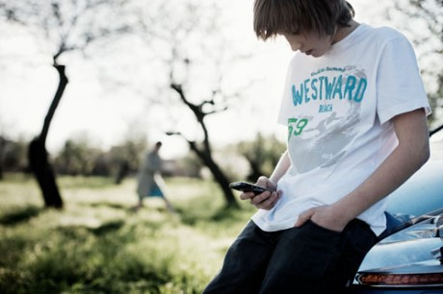
We can debate about it, but parents have already decided. Close to half of Danish children get their first phone by the time they turn 8, while almost everyone has it at the age of 10, shows a recent survey. More than a half of them wear a smartphone in the pocket. The survey initiated by Telenor and conducted by Userneeds Danmarkspanel was conducted in Denmark, among 1015 parents with children aged 7-12.

Helps parents keep kids safe
Mobile phone makes it possible to stay in touch with your kids at any time. Appreciated by parents, it is a clear number one reason when parents decide to get a mobile phone to their children. Just being able to call their little ones when they are late, is what as many as 88 % see as the major advantage when the youngest family members carry their own mobile.
No wonder then, that almost half of the interviewed sees as the biggest challenge the situation when the phone stays forgotten at home, or when children don’t answer their calls. Parents like to be able to reach their kids at any time and appreciate the feeling of control that mobile phone gives them.

Mum’s old phone is not good enough
The kids who are now about to get their first phone were born in 2004, when we (born in 20the century) were amazed with the slim shaped, clam shell phones with two screens, thinking that it must be the top of mobile phone evolution. The very same year Apple launched 1st generation of iPod Mini. Growing up with advanced devices, those who are about to get their first mobile today want more than an old keyboard phone, and they know how to use it.
For six of 10 kids, the first mobile phone is also a brand new one and just as often – a smartphone. That should not come as a big surprise in the Danish market, where the smartphone penetration is 50 %. That’s probably why parents see as an advantage that mobile phone helps their children to take part in today’s digital world (42% of interviewed).
«Smartphone is a good tool for kids that in addition to calls and messaging can be used to play and learn. Children are learning quickly and are able to use the possibilities of smartphones,” says Mattias Ringqvist, Chief Marketing Officer (CMO) Consumer in Telenor Denmark.
Three of four kids use their phone for gaming, while every fourth surfs the Internet. Still, the phone is first and foremost used to call parents – says 95 % of interviewed.

Enabling safe use
When choosing the subscription for their kids, parents’ decision is driven by the need for cost control and safety; fathers being a bit more concerned with the first one, while mothers put safety on top.
Today it is possible to choose tariff plans adjusted to children, with filters blocking access to inappropriate content and limited usage.
Telenor’s Mattias Ringqvist recommends parents to choose these tariff plans and avoid unpleasant surprises. Another good advice is to define clear rules on when and how the phones should be used, so both children and parents can with less worries, enjoy the benefits of being connected.

<Article 2>

Kids Who Sleep Near Their Smartphones Get Less Shuteye, Study Says

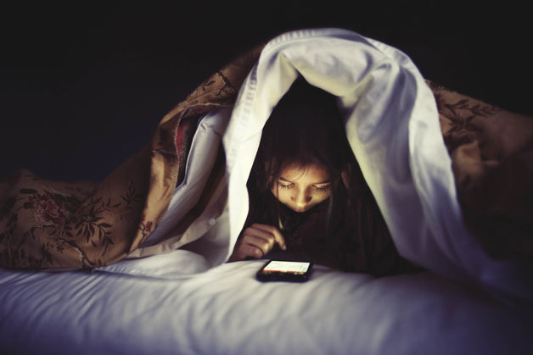
Children who slept in the same room as small screens such as smartphones got almost 21 fewer minutes of shuteye a night than those who didn’t, according to research published today in the journal Pediatrics.
Children who slept in the same room as small screens such as smartphones got almost 21 fewer minutes of shuteye a night than those who didn’t, according to research published today in the journal Pediatrics.
Gave your kids smartphones for the holidays? You might want to reconsider their bedtime. Children who slept in the same room as small screens such as smartphones got almost 21 fewer minutes of shuteye a night than those who didn’t, according to research published today by the journal Pediatrics. The two age groups studied -- about 9 years old and 12 years old -- also reported significantly less regular sleep with a phone nearby, possibly due to the buzz of text messages and Snapchats.
The paper joins a growing body of research finding that gadgets correspond to shorter, more fitful nights, as well as other health issues such as weight gain. As one study found last month, adults who used glowing e-readers before bed had worse sleep and more drowsiness than those with printed books. The evidence suggests that bright, blinking screens are affecting our biological timekeeper, the circadian clock.
While the Pediatrics study didn’t conclude that phones cause sleep deprivation, its lead author, Jennifer Falbe, said the case for clamping down on kids’ screen time is gaining strength.
Recent findings “caution against unrestricted access to media in children’s bedrooms,” Falbe, a researcher at the University of California at Berkeley, said in a phone interview. “The risks associated with shorter sleep duration and poorer sleep quality would include reduced academic performance, behavioral problems, possibly an increased risk for weight gain and possibly negative impacts on immunity.”

Circadian Rhythms
The human body uses light and darkness to influence circadian rhythms, the physical, mental and behavioral changes in a 24-hour cycle. The brain’s internal clock uses the amount of light to determine when to produce more melatonin, a hormone that brings on sleepiness. Charles A. Czeisler, a professor of sleep medicine at Harvard Medical School, estimates that since the advent of electricity-powered light, people’s internal sleep triggers have been pushed back six hours.
The study in Pediatrics, funded by the U.S. Centers for Disease Control and Prevention and the National Institutes of Health, surveyed more than 2,000 fourth- and seventh-graders in Massachusetts as part of a broader investigation into obesity in children. The majority of kids surveyed slept with a small screen by their side.
The 21 minutes lost with smaller screens exceeded the 18 minutes given up by children who slept in a room with a TV. Since small devices are held closer to the face, they may delay the release of melatonin more than TV light, the researchers said.
TV and video games were also associated with less sleep. Seventy-five percent of kids in the study said they slept in a room with a TV. Each hour of TV- or DVD-viewing a day corresponded with almost four fewer minutes of sleep, compared with five fewer minutes for gamers.

