★Lesson Plan Template Task Based Lesson (Listening)
Title : “I’m ~ing… .”
Instructor  : Hailey | Level  : Pre-intermediate | Students  : 6 | Length  :40min

Materials
- mp3 file : A song titled “Lemon tree” (Fool’s Garden)
- Worksheet #1 (6 copies each)
- Picture cards
- Computer, projector, speaker
- Picture #1, #2
- White Board & board marker

Aims & Goals
- Ss will be able to improve listen skill by listening to pop-song, teacher’s words (during the picture card game) and group mates’ words (during discussion).
- Ss will be able to use the present progressive form especially , “I’m ~ing … .” by making some sentences.

Language Skills
- Listening : Ss will listen to the song titled “Lemon tree” by the mp3 file.
Ss will listen to teacher’s words during the picture card game.
- Reading : Ss will read the lyric on the worksheet #1.
- Writing : Ss will write the lyric on the worksheet #1.
- Speaking : Ss will talk with teacher about right answer of worksheet #1.
Ss will compare to other classmates about what they heard while the song titled “Lemon tree” was playing. (based on worksheet #1)
Language System
- Phonology : pronunciation “th” (e.g. nothing, another, everything)
- Lexis : wonder, isolation
- Function : Q&A, Discussing, Presentation
- Grammar : making some sentences in the present progressive form (especially , “I’m ~ing … .”)
- Discourse : Q&A (T-Ss), Comparing and discussion with group works. (S-S)

Assumptions
- Students can understand all of my words and make simple sentences.
- Students are middle school students in pre-intermediate level.
- Students already knew how to set up the class and run by a group of 6 students. (2groups)
- Students lately learnt ‘the present progressive form’.
- Students have never heard the song “Lemon tree”.

Anticipated Problems | Solution
- If a computer doesn’t work and the mp3 file can’t be played, | → Teacher play the song by using T’s own  cell phone & speaker.
- If a projector doesn’t work and teacher can’t show the pictures for eliciting, | → Teacher show the pictures by T’s i-pad.  (T already downloaded them to T’s i-pad.)
- If students finish activity early, | → Teacher lets student sing the song together.

references
(picture#1)http://food.ndtv.com/ingredient/lemon-701101
(picture#2)http://anyasgarden.com/blog/ask-the-perfumer-32413-meyer-lemon-organoleptic-info-and-giveaway/meyer-lemon-tree-big/
(Lemon tree on worksheet#1)
http://1.bp.blogspot.com/ keDJ5k53HtI/TbkSq5CFNEI/AAAAAAAAACQ/Xcg9TiY0q1c/s1600/lemon_tree.jpg
(picture card#1) http://hidrateh2o.com/2014/07/15/need-energy-drink-water/

Lead - In
Materials : None
Time | Set up | Student Activity and goals | Teacher talk (procedure)
30sec | Whole class | Ss greet T  Ss answer freely  (Ss : Yes!) | Greeting  “Hello, everyone. How are you today?”  “Thank you for your attendances. I hope all of you enjoy today’s class. Then, are you ready to start?”  “Ok, good.”

Pre - activity
Materials : Projector and computer for present
Picture#1, Picture#2
White board , board marker
Time | Set up | Student Activity and goals | Teacher talk (procedure)
2min  2min | whole class  whole class | Ss answer the elicited Qs  Ss see the picture #1  Ss see the picture #2  Ss listen to instruction  Ss answer the ICQ | Eliciting  “Do you like fruits?”  “What fruits do you like?”  (Ss answer freely.)  “Then, do you like lemon?”  “Have you ever seen a lemon tree?”  (Ss answer “yes, I have” or “No, I haven’t.)  “Where did you see that?”  “What color was it?”  “Ok, great.”  Instruction  “I want to introduce one of my favorite pop-songs. Its title is “Lemon tree”. Today, you can learn how to use the present progressive form especially , “I’m ~ing … .” through this song.  (Write “I’m ~ing… .” on the top of the white board)  ICQ  “Today, what will you learn about?”  “Great.”

Main Activity
Materials : Computer, Speaker, mp3 file(“Lemon tree”), Picture cards#1~#20
Time | Set up | Student Activity and goals | Teacher talk (procedure)
5min  1min  4min | whole class  whole class  individually | Ss listen to instruction  Ss answer the CCQ and ICQ  Ss listen to the song and count the number of expression “I’m ~ing … .”  (Ss : “13times”, “14times”, or “15times”)  Ss listen to instruction  Ss answer the ICQ  Ss listen to the song one more time and do their tasks | 1. Listening the song  &  Paying attending to “I’m ~ing… .” forms.  Instruction  “At first, I will play this music for you just once from start to finish. Then, you have to count how many time have you listened to expressions of ‘I’m ~ing.’ in this song. Count the number of it.”  CCQ  “What is the title of this song?”  ICQ  “How many times can you listen to it?”  “What do you have to count?”  “Ok, you understood well. Then let me play it.”  (Play the song by computer)  monitoring  While the students are listening the song, stand behind the students and look around. If some students do not concentrate on the activity, tell them “Try to count.”  After the music,  “How many times you listened to expression ‘I’m ~ing…’ ?”  “Good job, everybody.  The answer is… ‘14times’!”  Instruction  “Now, I’ll play the music once again. This time, you have to listen carefully and fill in the blanks being careful ‘I’m ~ing … .’ forms.”  “Do it yourself, not discuss each other.”  I’ll ask you something to listen.  ICQ  “What are you going to do?”  “Will you do it with your classmates?”  (Distribute worksheet#1)  “Are you ready to start?”  “Do your best. Start!”  (Play the song by computer)

1min  30sec  3min  3min  1min  7min | whole class  each group  whole class  whole class  whole class | Ss listen to instruction  Maybe,  (Ss : No./Not yet.)  (Ss : Yes.)  Ss answer the ICQ  Ss compare their answers with group mates  & discuss  (Group activity)  Ss check the answers and correct  Ss listen to how to do activity  Ss answer the ICQ  (Ss : Ok, I see.)  Ss choose the correct card | 2. Discussion  &  Checking the answers  Instruction  (After the music,)  “Did you fill out all the blank spaces?”  “Then, do you need group activity?”  “Compare with tasks of other group mates. And find out what you missed. You can fill in the blanks together. I’ll give you 3minutes to discussion.”  ICQ  “What will you discuss about?”  “With whom?” With me?”  “How much time do you have for this activity?”  “Start to discuss! Go, go, go!!”  Monitoring  While the students discuss, stand behind the students and whether they are doing activity appropriately or not. Ask students “Do you need any help?” If they need some help, help them to discuss actively.  Timing  1minute, 30seconds, 10seconds, and time’s up!  “Ok, then, let’s check the answers together.”  Tell Ss correct answers from blank 1 to blank 14. If some Ss want to know how to spell some words, write them on the board.  (Ask Ss what they think first, and then notify correct answers)  3. Playing the picture card game  Instruction  “Now, we are going to play the picture card game. I’ll tell you how to play it. I’ll show you two picture cards and speak a sentence to you then you have to choose a correct card corresponding teacher’s words and point it.”  “Then, I’ll ask you something to listen.”  ICQ  “When I show you some picture cards, then what should you do?”  Demonstration  I’ll show you one example.  (show 2 cards and read a sentence.  And pick up a correct picture card.)  “Great, are you ready?”  (Show Ss 20 picture cards)

Post activity
Materials : picture cards#1~#20
Time | Set up | Student Activity and goals | Teacher talk (procedure)
1min  5min  4min | whole class  whole class  whole class | Ss listen to how to do activity  Ss answer the ICQ & CCQ  Ss make sentences corresponding each picture cards and speak them out  Ss tell their opinion with the class | (After the game,)  “Well done, everyone.”  “Now let’s speak out all of sentences. You should tell me what he or she doing. But, remember that you should make the sentences through only “I’m ~ing… .” forms. Do not say “He or she is ~ing… .”  ICQ  “What are you going to do?”  CCQ  (Pick up the picture card #1)  “If I say “She is drinking water.” am I right?”  “Then, what should I say?”  “You listened very well. Good job.”  (make Ss speak out the correct sentences showing all of picture cards)  3. Feedback  “You did a good job. That is the end of our lesson for now. After school, you’d better listen to the song “Lemon tree” and sing along it. I hope you enjoy it.”  “I’ll give some questions to you.”  “What do you think of today’s activity?”  “Today, we learnt by mainly listening music. Did you enjoy it? What its advantages are?”  “Then, what its disadvantages are?”  “I’m pleased you enjoy today’s lesson. Thank you for your participation.”

SOS Activity
Materials : Computer, speaker
Time | Set up | Student Activity | Teacher talk (procedure)
 | Whole class | Ss watch the video clip | Instruction  “We have the rest time. So, let’s watch a music video clip of ‘Lemon tree’ on You tube.”  (Play the video clip)  http://www.youtube.com/watch?v=bCDIt50hRDs

picture#1
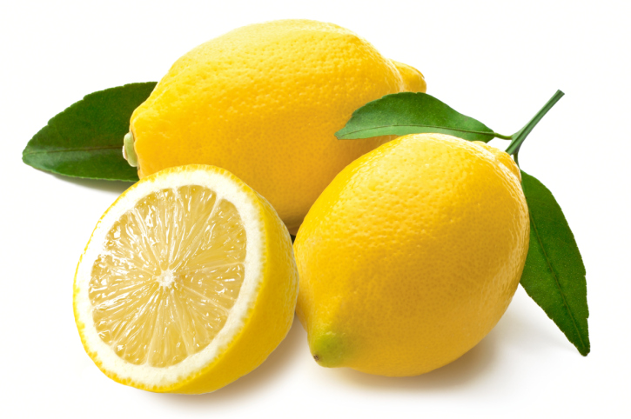

picture#2
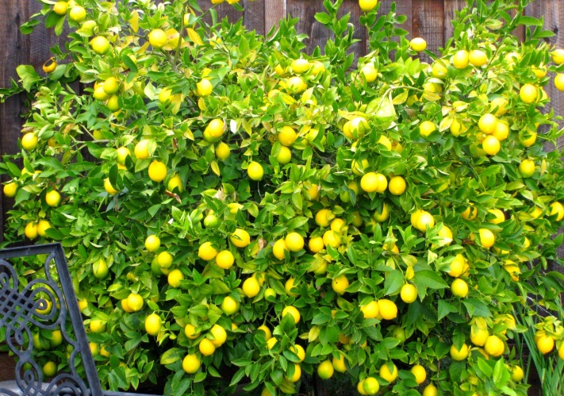

Picture card#1
http://hidrateh2o.com/2014/07/15/need-energy-drink-water/

worksheet#1

name : ( )

♬ Fill in the blanks listening “Lemon tree” ♬

I’m 1) here in the boring room  It’s just yellow rainy Sunday afternoon  I’m 2) my time  I got nothing to do  I’m 3) around  I’m 4) for you  But nothing ever happens and I wonder  I’m 5) around in my car  I’m 6) too fast  I’m 7) too far  I’d like to change my point of view  I feel so lonely  I’m 8) for you  But nothing ever happens and I wonder  I wonder how I wonder why  Yesterday you told me  about the blue blue sky  And all that I can see  is just yellow lemon-tree  I’m 9) my head up and down  I’m 10) turning turning turning turning around  And all that I can see  is just yellow lemon-tree  Sing, dah da da da da dee da da...  I’m 11) here I miss the power  I’d like to go out taking a shower  But there`s a heavy cloud inside my head  I feel so tired Put myself into bed  Where nothing ever happens and I wonder | Isolation is not good for me  Isolation  I don`t want to sit on the lemon-tree  I’m 12) around in the desert of joy  Baby anyhow I`ll get another toy  And everything will happen  and you`ll wonder  I wonder how I wonder why  Yesterday you told me  about the blue blue sky  And all that I can see  is just yellow lemon-tree  I’m 13) my head up and down  I’m 14) turning turning turning  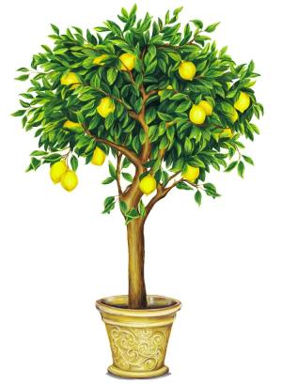  turning around  And all that I can see  is just yellow lemon-tree  Yellow, wonder, wonder  I wonder how I wonder why  Yesterday you told me  about the blue blue sky  And all that I can see,  and all that I can see,  and all that I can see  Is just a yellow lemon-tree

