TITLE | In-flight service
INSTRUCTOR |  |  |  | Ss’ LEVEL | AGE GROUP | No of Ss | LENGTH
Gwen |  |  |  |  | 20~23 | 8 | 50

MATERIALS

- White board & markers./ Laptop, Ipad & speaker. / A downloaded dialogue listening file./ 4 sheets of blank A4 size papers./ Soft and hard copies of 2 pictures./ 4 worksheets of papers for the preparation task./ Pens or pencils./ A script of the dialogue in hard copy./ 8 worksheets of papers for the homework.

AIMS 1. |  | To practise listening to fast-paced real-life speech and to figure out the situation from practical dialogue.
2. |  | To learn and practise vocabularies and experssions about in-flight service and situation.
3. |  | To practise speaking by discussing and role-playing in pairs/group members.

LANGUAGE SKILLS
Listening |  |  | ESL Podcast dialogue about the in-flight service.
Speaking |  |  | Explaining to the classmate for 'Hot Seat' activity. Pairs disussing and answering to the guiding, literal, interpretive and applied questions regarding the podcast dialogue. Pairs role playing and ' Timeout Q&A Relay Racing' activity.
Reading |  |  | Written words on whiteboard while 'Hot Seat' activity and written keywords & sentences of listening dialogue on papers/worksheets.
Writing |  |  | Writing down/dictating key words and sentences from a podcast on papares/worksheets.
LANGUAGE SYSTEMS
Phonology |  |  | Practising intonation & rhythm of new vocabularies and sentences.
Lexis |  |  | Practising practical vocabularies about in-flght service. (e.g. have, out of, call button, complimentary, turbulence, air sickness bag, meal service…)
Grammar |  |  | Past, present and future sentence. (e.g. I was asleep…, We only have the Bean Salad left…, I’ll take that…)  Using correct verb against the object. (e.g. We are no a pencil. vs We don’t have a pencil.)
Discourse |  |  | Practising how to get an in-flight service.
Functions |  |  | Practising the formal way of requesting. (e.g. Could I have, I'll have, What do you have?...)

ASSUMPTIONS

- Ss have experienced in flight trip.

- Ss know what flight attendants do for passengers and what services they can have during the flight.

- Ss can speak and write in English but not very accurately.

- Ss know how to play the guessing word activity, 'Hot Seat'.

- Ss know the greeting rules in classroom.

ANTICIPATED GRAMMATICAL ERRORS AND SOLUTIONS

- Ss may not be able to use 'have' correctly. And T speaks again the same sentence in correct way after student's speaking.

: We are not any more Baked Chicken. -> We don't have any more of the Baked Chicken.

- Ss may not be able to use 'will' . And T speaks it correctly again and emphasize 'will' word after student speaking.

: I have a diet soda. -> I will have a diet soda.

REFERENCES

- Listening dialogue : ESL Podcat, script by Dr. Lucy Tse (https://www.eslpod.com)

- Guessing the word activity: 'Hot Seat' activity by Callum Robertson in website 'BBC Counsil- TeachingEnglish' ( https://www.teachingenglish.org.uk/language-assistant/games/hot-seat )

- Timeout Q&A Relay Racing activity : “Andrew’s Games Goldmine.” website 'Reach To Teach' ( www.reachtoteachrecruiting.com )
- The 1st picture to show. : Google image by Wikipedia about flight attendant.
( http://upload.wikimedia.org/wikipedia/commons/6/64/Germanwings_-_Service.jpg)

- The worksheet to show the 2nd picture : Google image by w.carn.com news
( http://cdn.feeyo.com/news/140603/1406031205102.jpg )

NOTES

<Plan B>

-If any machinary problem is occurred for turning on the dialogue, a teacher will read the hard copy of it instead.

<Cut-off plan>

- Pls refer to alternative plan in each part of taks.

<SOS acitivity>

- Biting your tail.

- Brain storming what service/happenings at the airport.

- Brain storming to make Ss own story of in-flight service for h.w.

PRETASK TITLE |  |  | Hot Hot Seat, let's guess the words.
AIMS |  |  |  | MATERIALS
-To practise explaining and describing the meaning of the words.  -To elicit the 'airplane' in the end. |  |  |  | -Whiteboard & markers
TIME | SET UP | STUDENTS |  |  | TEACHER
1 |  | - Ss are greeting with teacher. |  |  | Greeting to Ss.
1 |  | - Ss are greeting in pairs as same as above. |  |  | Monitoring Ss.
8 |  | <Hot Seat Activity>  1. Ss make a team in two groups and move their chairs & desks accordingly as teacher's instruction and pick one person from each team to sean on the chair which is in front of the white board.  2. Ss see the written word on the board and explain to the representive to guess the word.  3. The representive person has to speak loudly guessed word to hear all Ss clearly. |  |  | - Instruction Ss to do the activity.  - Setting up the whiteboard.  - Writing the target word on board.  ; associated words to 'airplain'  - Writing the winner's word in each part on board.  - Managing the number of target words against the assigned time.
1 |  | 1. Ss see all written words they worked on the board as per teacher's request.  2. Ss guess and answer to the below answer.  (T) What can you guess from these words?  3. Ss ask some questions to get a clue from teacher if they don't guess the word easily. |  |  | - Instruction.  - Eliciting the word 'airplane' from Ss in one or few questions.  - Using a facial expression on Ss's answers.  - Writing 'airplane' in the box of the board.

NOTES

*** USE ENGLISH ONLY***

- Both teacher and Ss.

[About a greeting time]

- There are classroom rules for greeting as below and Ss already know.

1. The one of Ss has to ask a question to teacher. (e.g. How are you? What did you do yesterday/weekend/last night? How was your holiday?...etc.)

2. Ss has to have a greeting to a different friend in every class.

[ About an activity 'Hot Seat']

1. Ss already know how to play this activity.

2. Target words to get Ss guess.- associated words to 'airplaine'

- bird, machine, luggage, travel, seat belts, land on, take off, DHL, boarding, pilot… etc.

3. The number of presenting word should be managed considering the designated time for this activity.

4. Procedure

*** Whiteboard set-up***

- Draw a vertical line in the middle of the whiteboard. And insert a word box in the middle of vertical line. See the reference in below.

- In the box, write the word which Ss has to guess.

- Each one part will be a section for each team. Winner's words will be written in each team's part.

• First, split your class into different teams (two is best, but if you have a large class, any number could be used).

• Sit the students facing the board.

• Then take an empty chair - one for each team - and put it at the front of the class, facing the team members. These chairs are the 'hot seats'

• Then get one member from each team to come up and sit in that chair, so they are facing their team-mates and have their back to the board.

• As the teacher, have a list of vocabulary items that you want to use in this game.

• Take the first word from that list and write it clearly on the board.

• The aim of the game is for the students in the teams to describe that word, using synonyms, antonyms, definitions etc. to their team mate who is in the hot seat - that person can't see the word!

• The student in the hot seat listens to their team mates and tries to guess the word.

• The first hot seat student to say the word wins a point for their team.

• Then change the students over, with a new member of each team taking their place in their team's hot seat.

• Then write the next word…

[About an elicting 'airplane']

- If Ss feel hard to guess the word and there is no time to lead it more, give a clue in one of them as below.

1. Give the first letter to Ss.

2. Use a blank line as per the word's letters.

e.g. _ _ _ _ _ _ _ _

3. Present a visual movement like showing the some scences- taking off, landing on or flying.

*** Reference drawing for the board preparation.

TASK PREPARATION TITLE |  |  | The happenings and the kind of service of in-flight.
AIMS |  |  |  | MATERIALS
- To learn vocabularies about in-flight materials, service and situation.  - To get Ss ready to listen to the dialogue. |  |  |  | - Whiteboard & markers.  - Ipad, soft copy & hard copies of 2 pictures which are in-flight scene & the moment of conversation between flight attendant and a passenger.  - 4 worksheets of papers.
TIME | SET UP | STUDENTS |  |  | TEACHER
5 |  | 1. Ss see a picture of in-flight scene.  2. Ss answer the teacher's questions as below. (e.g. flight attendant, chairs, seat-belt sign, smoking sign, screen, a cup of water, having a meal… etc.)  (T) What can you see in this picture?  (Ss) e.g. flight attendant, chairs, seat-belt sign, smoking sign, screen, a cup of water, having a meal… etc.  (T) Are those meals and sodas are complimentary for passengers?  3. Ss ask the meaning of 'complimentary' and try to guess its meaning.  4. Ss listen to the same question from teacher.  (T) Are those meals and sodas are free for passengers?  5. Ss understand the meaning of the word.  6. The one of Ss ask how does it spell the word.  7. Ss guess the word from teacher's slow pronounciation and speak out the each of spell together.  8. Some of Ss write the word on their note.  9. Ss continuously answer the teachers following question as below.  (T) When this seat-belt sign is on?  (Ss) e.g. When the airplain is unstable, Too windy weather… etc.  10. Ss listen to teacher's feed back and see the blank under lines for letters on the board to guess the word of 'turbulence' .  11. Ss learn the word and some of are writing down the word.  12. Ss answer the question in below.  (T) What kind of service can we have in-flight?  (Ss) e.g. drinking, meal service, newspaper, pillow, blanket…etc.  (T) What if there are some menu or sodas out of in the cabin, what will you do?  (Ss) e.g. No eat, choose another menu…etc. |  |  | - Showing a picture of in-flight scene to Ss.  - Asking questions.  - Eliciting words to get ready to listen the dialogue.  - Drawing under lines of 'Turbulence' letters on the board.  - Explaining the meaning.  - Pointing out some materials in the picture.  - Pronouncing a word slowly to have Ss know the spell of it.
5 |  | 1. Ss make a group in pairs as per teacher's instruction.  2. Ss receive a hand-out from teacher.  3. Ss see the picture of worksheet roughly with their partners and listen to the teacher's questions in sequence as below and answer them accordingly.  (T) Who are these two people in this picture?  (Ss) e.g. flight attendant, cabin crew, customer, passenger…  (T) What are they doing now?  (Ss) e.g. talking, asking to flight attendant, requesting…etc.  (T) How can we call the flight attendant in-flight?  (Ss) e.g. Excuse me, raising hand, push the call button…etc.  4. Ss discuss what they're talking in the picture and write down 1 or 2 things on the worksheet with a partner within 3 mins as per tearcher's instruction.  (T) Talk with your partner and write down on the worksheet 1 or 2 things what customer is asking to the flight attendant.  5. After 3 min Ss hear the bell sound of finish.  6. Ss tell their ideas to the class what they discussed by each team.  7. Ss listen to the person who is speaking. |  |  | - Instruction to make Ss in pairs.  - Giving a worksheet to each team.  - Asking questions.  - Ringing the bell.

NOTES

*** USE ENGLISH ONLY***

- Both teacher and Ss.

[Words Ss have to know before listening]

- call button, flight attendant, complimentary, turbulence, out of…

[Alternative]

- If the Ipad doesn't work to show a picture to Ss, use a hard copy of it and show around to Ss and hold it in center of your chest.

- If Ss don't understand the expression of 'out of', ask questions in different way to get Ss know the meaning of 'out of'.

(T) What if there are some menus or sodas out of in the cabin, what will you do?

-> (T) What if the cabin crew doesn't have some menu or sodas, what will you do?

- If the time goes fast unexpectedly, skip the worksheet activity. And just show the picture and let Ss speak their mind freely instead.

TASK REALISATION TITLE |  |  | Requesting in-flight service.
AIMS |  |  |  | MATERIALS
-To listen to the fast-paced real-life speech and to figure out the situation from practical dialogue.  -To practise the formal way of questions. |  |  |  | - Laptop & speaker.  - A downloaded dialogue listening file.  - 4 sheets of blank A4 size papers.  - Pens or pencils.  - A script of the dialogue in hard copy.
TIME | SET UP | STUDENTS |  |  | TEACHER
5 |  | <While listening>  1. Ss receive the one sheet of A4 paper for each team from teacher.  2. Ss listen to teacher's instruction about what they are going to do while they're listening to a dialogue.  3. Ss listen to the dialogue.  4. Ss write down on key words in order of situation from the dialogue in pairs while they're listening to.  5. Ss listen to teacher's another instruction.  6. Ss listen to the dialogue again.  7. The one person of each group dictate the flight attendant speaking and the others write the passenger's while they're listening to.  8. Ss listen to the dialogue in third time. |  |  | - Getting ready to turn on the dialogue in the laptop.  - Instruction the tasks about what ss are doing while listening.  - Giving the hand-out the papers to Ss.  - Turning on the dialogue.
10 |  | <After listening>  1. Ss write down a keyword in order on the whiteboard.  2. Ss see teacher is marking/matching the key word and liesten the teacher's explaination.  3. Ss answer the question to the below questions based on what they dictated and listened.  (T) Literal questions  How the flight attendant came to the passenger?  What did the cabin crew said first ?  What did the passenger wanted to?  ………………… as a sequence.  (T) Interpretive questions  What will the passenger say to the cabin crew at the last sentence?  How the man was acting when he is saying 'what's that?'  Does the man has to pay for the water?  What do you think what was he doing when she said ' Make sure your seabelt is fastened.' ?  (T) Applied  What will you drink if there is no water in the cabin, too?  What else you can ask to the flight attendant for your convenience? |  |  | - Instruction to make Ss write down the key words on the board.  - Asking question.- literal, interpretive, applied.
8 |  | <Role-play activity>  1. Ss do a role play with their partner based on the dialog within 8 minutes.  2. Each one of Ss has 4 min. per role.  3. Ss can follow as per the dialogue or adjust the situation as their own.  4. Ss have corrected by Ss when they make some mistake on grammars or words. |  |  | - Instruction Ss to have a role playing with their partners.  - Mornitoring and correcting on errors.  - Guiding them to use & practice formal way of questions.

NOTES

*** USE ENGLISH ONLY***

- Both teacher and Ss.

[Correcting point]

- Ss may not be able to use 'have' correctly. And T speaks again the same sentence again in correct way after student's speaking.

: We are not any more Baked Chicken. -> We don't have any more of the Baked Chicken.

- Ss may not be able to use 'will'. And T speaks it correctly again and emphasize 'will' word after student speaking.

: I have a diet soda. -> I will have a diet soda.

[Alternative]

-If Ss feel the podcast speaking is too fast to catch the words, sentences from the dialogue, turn on the slow version of it.

-If any machinary problem is occurred for turning on the dialogue, a teacher will read the hard copy of it instead.

-If the time is running out, skip the applied questions or reduce the time of role playing.

POST TASK TITLE |  |  | Timeout Q & A Relay Racing.
AIMS |  |  |  | MATERIALS
To practise the words, sentences, questions, answers about in-flight service converstaion through a fun learning activity. |  |  |  | - A stop watch.  - 8 worksheets of papers.  - Whiteboard & markers.
TIME | SET UP | STUDENTS |  |  | TEACHER
1 |  | <Activity instruction>  - Ss listen to teacher's instruction about an acitivity called 'Timeout Q & A Relay Racing activity'.  - Two Ss come to the front and make a big circle including teacher.  - Other Ss watch a demonstration of the acitivity  - All Ss get together in an one big circle excluding teacher.  - Ss know all each person has to ask or question while they're holding a stop watch.  - Ss have to play a role as a flight attendant or passenger when they're doing based on the lecture.  (e.g.) T. What can I do for you?  player1. I feel cold, can I have a blanket?  payer2. Sorry, We're out of it.  player3. Ok, Could I get a meal service?  ……………………………etc.  - Ss have to finish one round within 4 mins.  - Ss will get a prize if they finish one round in time.  - Ss are ready to start the acitivity. |  |  | - Instruction to do the acitivty.  - Ordering in chunks.  - Making a demonstration with 2 Ss.
4 |  | <Timeout Q & A Relay Racing activity>  - A starter receives a stop watch from teacher.  - A starter push the start button on a watch.  - Ss run the race by clock wise.  - A student answers the question or give a question to the right side person once s/he gets a stopwatch from him/her.  - Once the one's task is finished, pass the stop watch to the right side person.  - When the time is up, the stop watch makes a sound.  - If Ss complete the mission in time, teacher gives a prize to them. (e.g. points, snacks...etc.) |  |  | - Watching Ss.  - Mornitoring.  - Giving a prize.
1 |  | - Ss receive the worksheet from teacher.  - Ss listen to the instruction of the homework.  - Ss answer the question to check the homework.  (T) What will you do on this worksheet?  When will you bring this?  - Ss see teacher is writing about the H.W on the board.  - Ss listen to teacher's ending speech of the class. |  |  | - Passing the worksheets for homework to Ss.  - Instruction for H.W.  - ICQ for H.W.  - Writing about H.W on the board.

NOTES

*** USE ENGLISH ONLY***

- Both teacher and Ss.

[Alternative]

- If there is no time to do an activity, let Ss do the worksheet instead. For homework, Ss write their own situation dialogue based on the script.

- If there is plenty time of to do an acitivity, let Ss do a few times.

[About an 'Timeout Q&A Relay Racing activity']

1. It's based on a team ball relay as below.

2. Giving a time limitation to Ss with a stopwatch.

3. After a student finish his/her task(questioning or answering), s/he has to hand over it to the right side of person.

4. Reference

TEAM BALL RELAY POP

Two teams of six. Five are in a line. The sixth child faces her team members. There is a distance of about two to three meters between them. Let's say your teaching the children, "How are you?" The team leader says, "How are you?" and throws the ball to the first child who answers "I'm fine, thank you" and throws the ball back. The first child squats on the floor while the team leader repeats the question and throws the ball to the second child. That child answer and throws the ball back. When the last child throws the ball back the team leader squats. The first team to finish wins. This is a good game to play when teaching the "Look" book of American cram classes.
<The 1st picture to show>

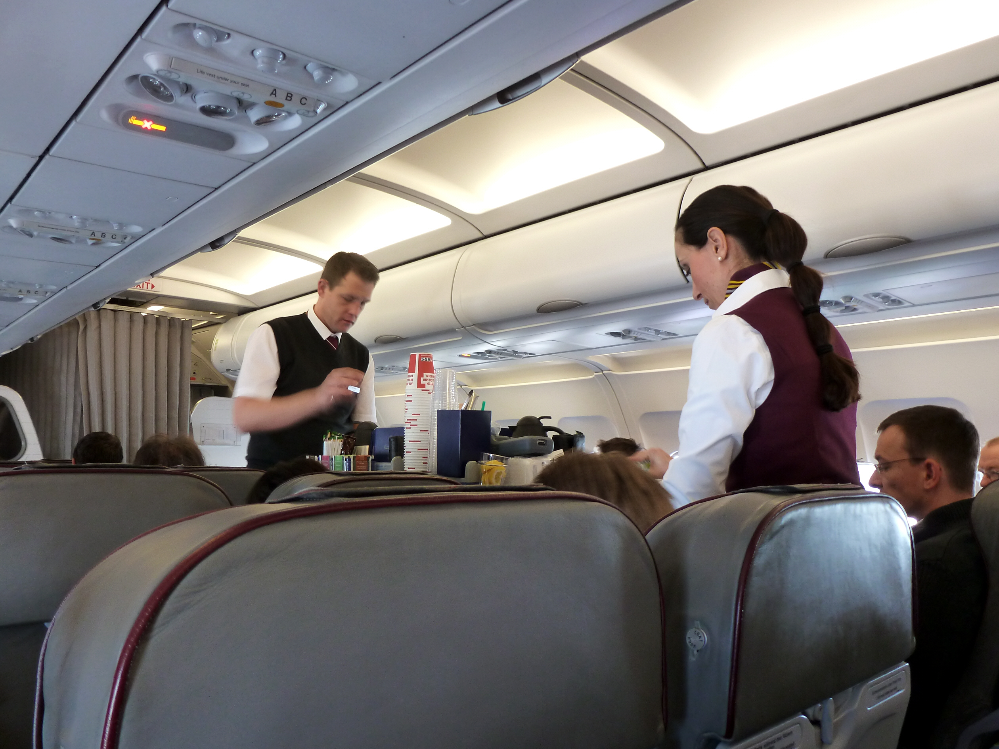

Let’s guess the conversation!!!

- LOOK AT THIS PICTURE.
- DISCUSS AND TALK WITH YOUR FRINED WHAT THEY’RE TALKING.
- WRITE DOWN THE CASES IN BELOW BLANK AREA.

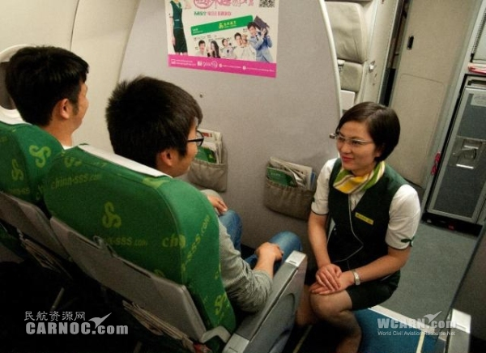

CASE.1

CASE.2

CASE.3

<The Script of Listening dialogue>
ESL Podcast - Getting In-Flight Service

I pushed the call button to get the attention of the flight attendant.
Flight attendant: Yes? What can I do for you?
Hal: It’s very cold in the cabin. Is it possible to get a blanket?
Flight attendant: We’re out of blankets, but here’s a pillow.
Hal: Okay, thanks. I was asleep during the meal service. Could I get a meal?
Flight attendant: We don’t have any more of the Baked Chicken. We only have the Bean Salad left.
Hal: Oh, okay, I’ll take that. Could I also get a drink?
Flight attendant: What would you like?
Hal: What do you have?
Flight attendant: The complimentary drinks are listed in our in-flight magazine. Beer, wine, and other cocktails are $4.
Hal: I’ll have a diet soda.
Flight attendant: We’re out of diet soda.
Hal: How about just some water? What’s that?
Flight attendant: That’s turbulence. Make sure your seatbelt is fastened.
Hal: Could I get an airsickness bag, please?
Flight attendant: I’m sorry, but we’re out of those, too.

<The Script of Listening dialogue>
ESL Podcast - Getting In-Flight Service

Let’s fill the blanks.

I pushed the call button to get the attention of the flight attendant.
W : Yes? What can I do for you?
M : It’s very cold in the cabin. Is it possible to get a blanket?
W : We’re out of blankets, but here’s a pillow.
M : Okay, thanks. I was asleep during the meal service. Could I get a meal?
W : We don’t have any more of the Baked Chicken. We only have the Bean Salad left.
M : Oh, okay, I’ll take that. Could I also get a drink?
W : What would you like?
M : What do you have?
W : The complimentary drinks are listed in our in-flight magazine. Beer, wine, and other cocktails are $4.
M : I’ll have a diet soda.
W : We’re out of diet soda.
M : How about just some water? What’s that?
W : That’s turbulence. Make sure your seatbelt is fastened.
M : Could I get an airsickness bag, please?
W : I’m sorry, but we’re out of those, too.

