TITLE | An Unlucky Winner.
INSTRUCTOR |  |  |  | Ss’ LEVEL | AGE GROUP | No of Ss | LENGTH
Won Won Young Lee |  |  |  |  | 19-25 | 8 | 50

MATERIALS

White board, marker, projector, computer, 8 copies of the article, 8 copies of vocabulary sheet, 2 copies of mixed-up sentence work sheet, 2 copies of crossword, 2 copies of comprehension question, 1 lottery ticket, pictures of liquor, store, clerk, rich so on.
AIMS 1. |  | Ss will practice reading comprehension skills through guessing the title of the article, answering from comprehensive questions, solving crossword puzzle, and unscarmble the sentence.
2. |  | Ss will practice how to read fast and fluently by getting familiar with different reading strategies such as skimming, scanning, extensive, and intensive. Reading the article to get the main idea, guess the topic, and look for a specific answer to the comprehensive questions.
3. |  | Ss will practice speaking and listening ability by sharing ideas in a pair or group.

LANGUAGE SKILLS
Listening |  |  | Ss will listen to each other in a group and the teacher's speaking.
Speaking |  |  | Ss will discuss in a pair or in a group to share their own experiences, focus on getting the main idea or guessing the topic from the article, solving the crossword puzzle, and unscrambling the mixed-up sentence exercise.
Reading |  |  | Ss will read the article, comprehension questions, the crossword puzzle, and the mixed-up sentence exercise.
Writing |  |  | Ss will write to fill in the crossword puzzle and unscramble the sentences.
LANGUAGE SYSTEMS
Phonology |  |  | Vocaulary such as lottery, liquor, store, clerk, million, mega, worth.
Lexis |  |  | See Phonology.
Grammar |  |  | Past Simple, future in the past (e.g. was going to).
Discourse |  |  | The article.
Functions |  |  | Expressing excitement, yelling, regretting, planning.

ASSUMPTIONS

Ss might have experienced buying a lottery ticket in the past.
Ss are used to working individually, pairs and groups.
Ss may be motivated to read and work in a group to win to get the free lottery ticket.

ANTICIPATED GRAMMATICAL ERRORS AND SOLUTIONS

Ss will make grammatical mistakes when they try to speak in a group. T will monitor them carefully and take notes instead of correct them immediately. T will mention their common grammatical errors at the end of the class.

REFERENCES

http://www.rong-chang.com/ne/es/es013.htm

http://www.rong-chang.com/ne/emx/ne_mx01301.htm

http://www.rong-chang.com/ne/ecross/ne_cross013.htm

NOTES

Ss may find many unfamilliar vocabulary words. T should ask ss to circle the words and their group members can figure them out from context or use their dictionary ultimately.

Ss may take longer than expected to complete the task or there may not be enough time to complete the lesson. T should assign the post activity as a homework assignment.
Some ss may not actively participate in the group discussions. T should encourage reluctant ss by asking their opinion of what other ss are saying.

Plan B: get ss to role-play from the text.

SOS activity: Play Pictionary, one person draws on the board while the rest have to guess what it is. Everyone should get a turn to draw.

PRETASK TITLE |  |  | What kind of ticket is this?
AIMS |  |  |  | MATERIALS
To get ss to be interested in the topic, discuss of a key theme, create clear link between topic of the text and ss' own experiences.  To guide ss to focus on new vocabulary that will come in the text. |  |  |  | White board, marker, lottery ticket, pictures of luxury items mansion, cars, yacht, pictures of some vocabulary words such as rich, million, liquor,store, clerk, tax.
TIME | SET UP | STUDENTS |  |  | TEACHER
1 |  | Greeting |  |  | Greeting
1 |  | Presenting the pictures of luxury items.  <elicit>  Vocabulary words such as boat, big house, car, rich.  Presenting the lottery ticket.  <elicit>  What kind of ticket is this?  Why do pp buy it? |  |  | Introduction and lead-in
2  1 | Whole class | Brain storming and guiding questions.  Have you ever bought a lottery ticket?  What would you do if you won the lottery?  What would you buy if you won the lottery?  What's your plan?  <ICQ>  Are you supposed to work in a pair? or alone?  <CCQ>  What do you have to talk about with your partner?  Presenting their ideas to class. |  |  | Guiding question and monitor.  <ICQ>  <CCQ>  Sharing ss ideas.
1 |  | Pre-teaching words such as rich, liquor, store, clerk.  <Elicit> liquor, liquor store, clerk.  Party, celebrate.  What would pp do when they are happy?  Liquor store  What items would pp bring to a party to have fun?  Clerk.  What do pp call a preson who works at the store? |  |  | Pre-teaching vocabulary and elicit.

NOTES

T should activate and create interest in the lesson by showing them a real lottery ticket that winnning group will achieve from later class activity.

T should draw attention from ss so that what they will be reading in class might be something that relates to their own lives or experiences.

T should carefully monitor and judge which vocabulary words T will pre-teach after how ss respond from first luxury items shown in the lesson.

T should show pictures of words after ss answer correctly making sure they fully understand the meaning of words they elicited from them.

TASK PREPARATION TITLE |  |  | Can you guess what the topic of the article might be?
AIMS |  |  |  | MATERIALS
Ss will practice different reading style such as skimming, scanning, extensive and intensive reading of the article to guess what the topic might be, main idea, what happened to the character, and specific information from the text. |  |  |  | White board, marker, 8 copies of the article.
TIME | SET UP | STUDENTS |  |  | TEACHER
.30  1  1 | pair  whole | Focus on fast reading for gist(skimming),  Guess the title?.  Read the article for 30 seconds initially,  <ICQ>  How much time ss have given to read the article?  What do you do when T says 'Stop'?  <CCQ>  What ss must to do when they read the article?  Talk about the key words or topics in pair.  Present their opinions. |  |  | Presenting to ss how to skim.  <ICQ>  <CCQ>  Monitor.  Sharing ideas.
.30  1  1 | Pair  Whole | Focus on fast reading to locate specific information(scanning).  Talk about how much the main character won?  <ICQ>  How much time ss have given to read the article?  <CCQ>  What information that ss must to look for when they read the article?  Talk about how much the main character won the lottery in pairs.  Present their opinions. |  |  | Presenting ss how to scan.  <ICQ>  <CCQ>  Monitor.  Sharing ideas.
1  1  1 | Pair  Whole | Focus on meaning (general idea, extensive reading)  What is main event in the text?  <ICQ>  How much time ss have given to read this time?  <CCQ>  What should ss to look for when they read?  Talk about what was main event from the text in pairs.  Present their ideas. |  |  | Presenting extensive reading.  <ICQ>  <CCQ>  Monitor.  Sharing ideas.
2  1 | Whole | Focus on meaning (more intensive comprehensive understanding)  Pay attention to finer points of detail.  Ask ss to cirlce new words and have them figure out from the context.  <ICQ>  How much time ss have given to read this time?  <CCQ>  What should ss to do when they read?  Teach new vocabulary words.  <elicit>  Mega,  What’s another word for a million?  Worth  (e g. The watch is worth 20 dollars.) |  |  | Presenting intensive reading.  Teach new words.  <elicit>

NOTES

T should present skim, scan, extensive and intensive reading to ss as a fun experimental method, not a test or threat, so ss can participate in the tasks comfortably.
(T shouln't confuse ss by telling what the 4 reading styles are, just let ss to feel the differences.)
Introduce to ss that it's not essential to understand every word to read passage, help ss to understand that practicing some different reading techniqies in English may be very useful to them.
Be careful not to stress ss reading with integrating comprehension checks, tests and exercises.
Let ss read, enjoy, and move on, rather than read every detail of the text.

TASK REALISATION TITLE |  |  | Work on a comprehension questions sheet and solving the crossword puzzle.
AIMS |  |  |  | MATERIALS
To help ss to understand the deeper meaning of the article by answering comprehension questions and solving crossword puzzle in a group. |  |  |  | White board, marker, 2 copies of comprehension questions, 2 copies of crossword puzzle.
TIME | SET UP | STUDENTS |  |  | TEACHER
7 |  | Hand out the comprehesion question sheets.  See ss can answer the questions.  Comprehension questions.  1. Who won the lottey in the beginning of the story?  2. What are the items that Sammy was going to buy after he won the lottery?  3. Where did Sammy take his lottery ticket to?  4. What would the clerk do after he ran out of the store?  5. Was Sammy poor before he won the lottery?  6. Does Sammy like to drink?  7. Is Sammy talkative person or shy person?  8. Do you think the clerk went back to liquor store and continue working?  9. Would you show your lottery ticket to a stranger after you won?  Discuss in groups.  See if ss can guess the title?  Present 4 different kinds of title, let ss pick.  1. Winning a Lottery is great.  2. A Happy Winner.  3. The Finder is the Keeper.  4. An Unlucky Winner. |  |  | Presenting comprehesion questions and monitor.  Present 4 possible titles and monitor.
1 |  | Gather the ideas together with class. |  |  | Gathering Ideas and feed back.
15 |  | Solving the crossword puzzle.  Discussion in groups.  <ICQ>  Are you supposed to work alone? or in a group?  Who will have a lottery ticket?  <CCQ>  What do you do in group? |  |  | Presenting crossword and monitor.  <ICQ>  <CCQ>
1 |  | a winning group will get a lottery ticket as a reward. |  |  | Praise

NOTES

Ss may find many unfamilliar vocabulary words. T should ask ss to circle the words and their group members can figure them out from context or use their dictionary ultimately.

T should mention the dreaming part beforehand, is the most fun part of the life, not the actual stuff that we are getting.

T also should mention if the winning group gets the free lottery ticket, ask them politly to share it with their group that's if the free ticket has the winning number on it.

POST TASK TITLE |  |  | Unscramble the sentences.
AIMS |  |  |  | MATERIALS
To help ss to understand text clearly by the unscrambling key words activity and be familiar with structure of sentences inductively.  Ss will get used to using grammatical form, the future in the past(eg was going to) when they put themselves into the main chacter's situation. |  |  |  | White board, marker, 2 copies of mixed-up sentence work sheet.
TIME | SET UP | STUDENTS |  |  | TEACHER
1 |  | Unscramble sentences.  Present the work sheet  <elicit>  What kind of activity they will have to do?  Unscramble.  Putting words in a correct order.  Demonstrate. (eg pretty she is.)  <ICQ>  Do you have to work alone? or in a group?  <CCQ>  What do you have to do? |  |  | Presenting mixed-up sentences.  <Elicit>  <ICQ>  <CCQ>
5 |  | Discussion and share their ideas with class. |  |  | Gathering ideas.
1  2 | pairs | Grammar study.  <elicit>  What were you going to do?  If you are Sammy, main character from the text,  What were you going to do? using the grammatical form the future in the past (eg was going to).  <ICQ>  What do you have to say? Asking a question? or talking about your plan?  <CCQ>  What kind of grammar form do you need to use when you talk about your plan?  Work in a pair. |  |  | Presenting grammar form.  <ICQ>  <CCQ>  Monitor.
1 |  | Share the ideas with class.  Feed back  Home work,  Class dismiss, |  |  | Gathering ideas and closing.

NOTES

If ss have hard time to unscramble words, T should guide them with the first words of the sentences.

Ss may take longer than expected to complete the task or there may not be enough time to complete the lesson. T should cut off the grammar activity and assign it as a homework assignment.










Sammy won the lottery. He was so happy. He jumped up and down. “I won the lottery! I’m rich! Life is great!” he yelled.
He checked the numbers on line again: 2, 22, 3, 33, 4, and 44. Yes, those were the winning numbers. Yes, those were the numbers on his ticket. The mega number was 44. The mega number on his ticket was 44. He was so rich! His ticket was worth $41 million before taxes.
He was going to buy a new house. He was going to buy a new car. He was going to buy a new boat. Oh, life was so great!
He took his ticket to the liquor store. He showed it to the clerk. “I won! I won! He told the clerk. The clerk checked the numbers. “You won! You won!” he said. Then the clerk ran out of the store with Sammy’s ticket.

Vocabulary

boat
clerk
jump
liquor
lottery
million
number
store
taxes
ticket
worth

Comprehension questions

1. Who won the lottey in the beginning of the story?

2. What are the items that Sammy was going to buy after he won the lottery?

3. Where did Sammy take his lottery ticket to?

4. What would the clerk do after he ran out of the store?

5. Was Sammy poor before he won the lottery?

6. Does Sammy like to drink?

7. Is Sammy talkative person or shy person?

8. Do you think the clerk went back to liquor store and continue working?

9. Would you show your lottery ticket to a stranger after you won?

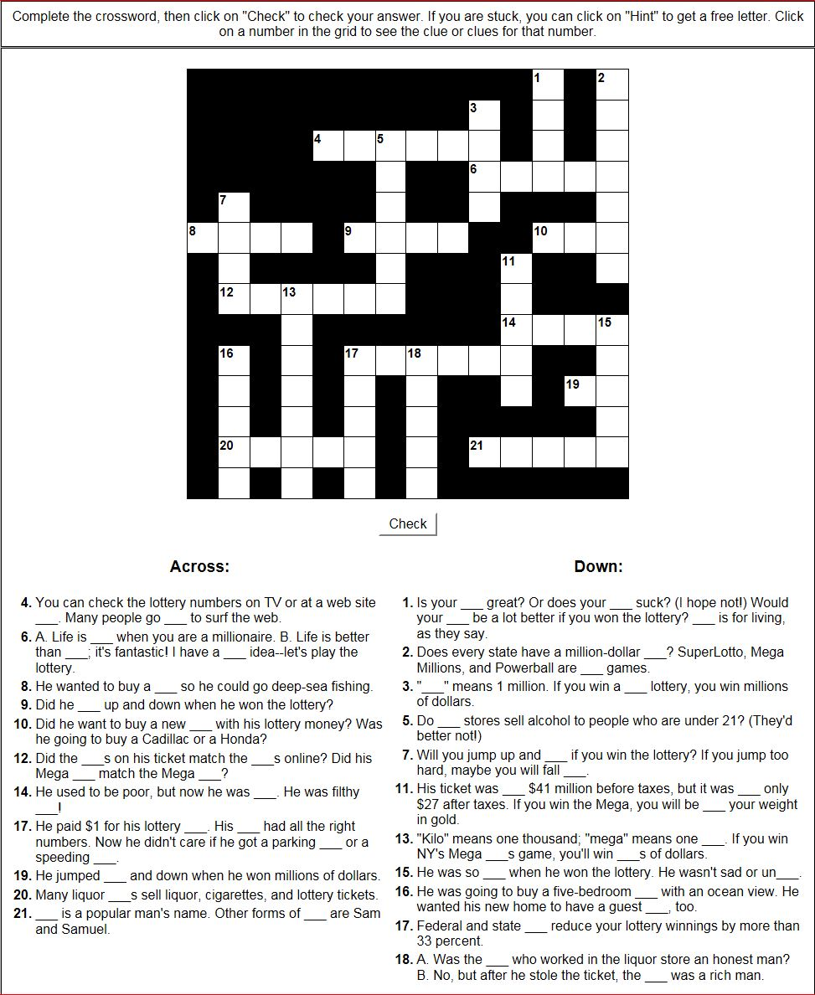

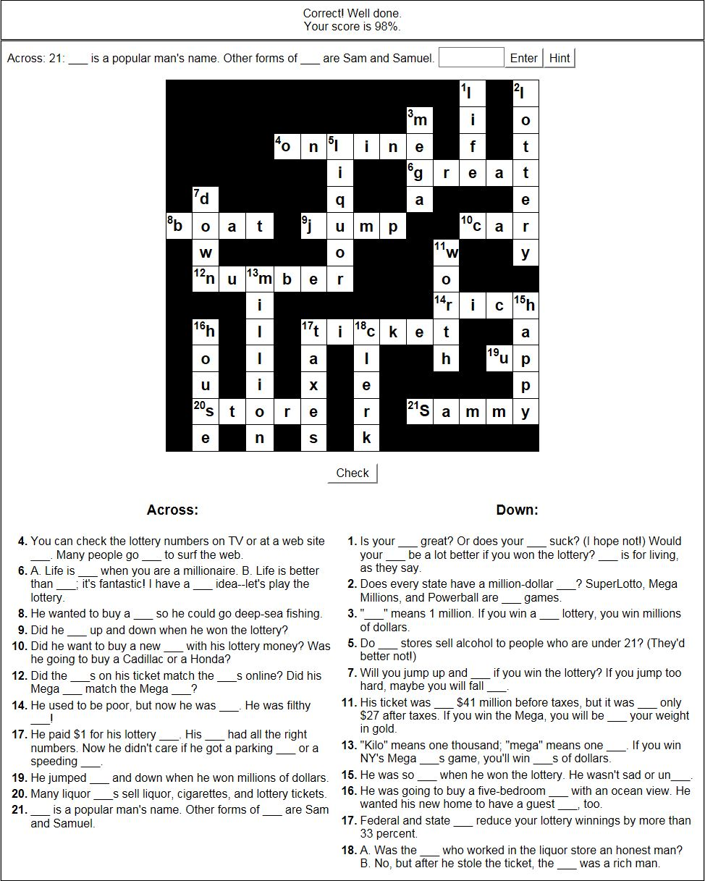

Mixed-up Sentence Exercise

lottery he ? win the did

were ticket the his numbers those . on

$44 worth before his million was ticket taxes .

a he house . to was going buy new

. he store took the to his ticket liquor

Sammy’s the ran of clerk . store with out ticket the



