TITLE | Time machine
INSTRUCTOR |  |  |  | Ss’ LEVEL | AGE GROUP | No of Ss | LENGTH
Irene(Yoory Kim) |  |  |  |  | 60-75 | 8 | 50

MATERIALS
AIMS 1. |  | Ss will practice past tense of target verb by completing story.
2. |  | Ss will have a chance to express their ideas and feelings to others.
3. |  | Ss will come up with their knowledge of language by describing pictures.

LANGUAGE SKILLS
Listening |  |  | Listen Teacher’s instruction and group members
Speaking |  |  | Discuss as a group and generate language
Reading |  |  | Read a worksheet
Writing |  |  | Describe pictures and fill a worksheet
LANGUAGE SYSTEMS
Phonology |  |  | See lexis
Lexis |  |  | Was,were,
Grammar |  |  | Past tense of target verb
Discourse |  |  | Question and answering
Functions |  |  | Describing, inquiring/questioning, Expressing opinion

ASSUMPTIONS

Ss know the verbs as a present simple form.
This class is for elders who are from 60 to 75 years old so they know well about the events in 1955~1989

ANTICIPATED ERRORS AND SOLUTIONS

Ss might confuse among changing forms of verb
- With listening teachers introduction and practice repeatedly, they could be used to it

REFERENCES
-Pulitzer pictures : http://www.pulitzer.org/
-Story pictures “UP” captured by : www.youtube.com/watch?v=LaLegF2hAxI
-Musics : <Tr who made this lesson plan have these songs so if you don’t have use youtube site> www.youtube.com
-Pictures: ko.wikipedia.org/wiki/

NOTES

<Plan B>
-Making letter for myself : Ss imagine their past memeries and write a letter by using target verb’s past tence.
-group talking and draw a picture : If I could use a time machine for past?

PRETASK TITLE |  |  | Look at the pictures and express their feeling
AIMS |  |  |  | MATERIALS
To be able to express feelings with pictures |  |  |  | Computer,projecter
TIME | SET UP | STUDENTS |  |  | TEACHER
7min |  | ♦ Greeting to the teacher and classmate |  |  | ♦Greeting Ss
 |  | ♦ relax  ♦ look at the picture with listening to music  <Apply desuggestopidia>  -Do you remember this picture?  -What did you do? <I remembered…>  -Did you have a dream at that time? <had>  -Who loved you before? <loved, met, left>  -What did you like? <like, did>  -Did you spend the time to watching movies or listening music? <spent, saved>  -Did he want to fix his face? <wanted, fixed> |  |  | ♦ playing music
3min |  | ♦ introduce topic for today  -Do you miss this time?  -Do you want to go back at that time?  -We will go to time before using time machine. |  |  | ♦ show Ss the Hat(It was a hat for noble people at Chosun Dynasty) as a time machine.  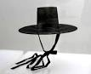

NOTES

If Ss have a difficulty of saying their memories in past tense, Tr can help Ss with eliciting.

Plan B : If you don’t have The hat, Use another things which could connect with past(.eg.pictures)

TASK PREPARATION TITLE |  |  | Time machine
AIMS |  |  |  | MATERIALS
To practice past tense of target verbs by stimulate their knowledge with Time machine |  |  |  | Projector, Computer, Hats for King or noble people in Joseon Dinesty.
TIME | SET UP | STUDENTS |  |  | TEACHER
3min |  | ♦ Introduce Time machine for going past  <CCQ and Elicit>  -Do you know these hat?  -Are these for now ? future? Past?  <Draw the time line and make Ss know past,now,future> |  |  | ♦put Hats on
6min |  | ♦ practice to change target verb with Time machine.  <Demonstration target verb with realia>  <Use pictures of pretask :refer to appendix>  -When wearing hats, we talk about before.  -When removing hats, we talk about now. |  |  | ♦ Be careful about Ss reaction  ♦ Give every Ss chances to talk

NOTES

If Ss can’t understand meaning of vocabulary, eliciting by gestures or examples.

TASK REALISATION TITLE |  |  | Making story “UP” using past tense
AIMS |  |  |  | MATERIALS
To develop changing grammar form “ past tense” easily  To generating language by discussing as a group |  |  |  | Computer. Projector. Time machine hat.
TIME | SET UP | STUDENTS |  |  | TEACHER
4min |  | ♦ have a picture one by one and look carefully  ♦ Vocabulary check with pictures and motion by Tr  <Elicit > |  |  | ♦ Give SS Picture
4min |  | ♦ Giving tesk  Ss will discuss how to describe pictures with target form.  <CCQ or ICQ>  -Can you find your picture’s number?  -Can you describe each picture which you have?  -Do you use or this form (put the Hat on)?  -Who are the main character?  -Do you want to know what happened with them? |  |  | ♦ Give Ss Task instruction  ♦ monitor Ss
10min |  | ♦ discuss and sharing ideas  <divide two groups>
4 min |  | ♦ Complete story  -Ss who has number 1 picture will present their sentence using past tense and following number will be presented by Ss who have the number.  -when they put The Hat on they can say(their turn)  <ICQ>  -Which Ss will be the first one? Who will be the next?  -How can you get talking change?  -When Ss present their sentence, What others will do? |  |  | ♦ Show them picture and check their sentence  ♦Encourage Ss and try to make Ss expose target form as many as possible

NOTES

If Ss want to know more vocabulary in picture, elicit by gesture or synonym.
Plan B-If computer or projector were not working, show them picture

POST TASK TITLE |  |  | Rush activity
AIMS |  |  |  | MATERIALS
To come up with their knowledge about past tense. |  |  |  | Computer, projector, white board, markers
TIME | SET UP | STUDENTS |  |  | TEACHER
4min |  | ♦<Instruction and ICQ>  -Look at the board carefully and check the verb  -watch Tr’s demonstration  -Can you make a one line each group?  -As you see me, you will go to the board and white past tense one by one.  -Who will be the winner?  -Which team gets a price?  ->The team which finish the test quickly. |  |  | ♦ introduce the rules of activity  ♦ demonstrate activity
5 min |  | ♦ let Ss do the rush activity.  <feedback and reward>  -Can you fix this form?  -So which team is winner?  ♦ greet to Tr and finish class |  |  | ♦ check and feedback their output and encourage SS

NOTES

Plan B - IF time is remained,
-Making letter for myself : Ss imagine their past memories and write a letter by using target verb’s past tense.
-group talking and draw a picture : If I could use a time machine for past?

Worksheets, handouts and lesson materials
Introduce pictures and related verbs
1950’s  Happy for ending world war2  Roman Holiday (1953) | 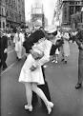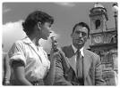 | Was, were  Met. left  Loved, married  e.g I was happy.  I met him and l left him  They loved,married.
1960’s  Beatles | 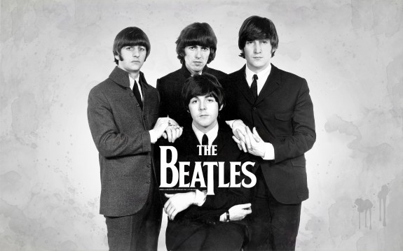 | Spent  Promised  Made  e.g. I spent time to listen songs  They promised it together  They made great songs
1970’s  Star wars started(1977) |  | Dreamed  Had  e.g.I dreamed about future.  I had a dream
1980’s  Michael Jackson |  | Wanted  Fixed  Left  e.g He wanted to be a superstar.  He fixed his face.

Making story pictures
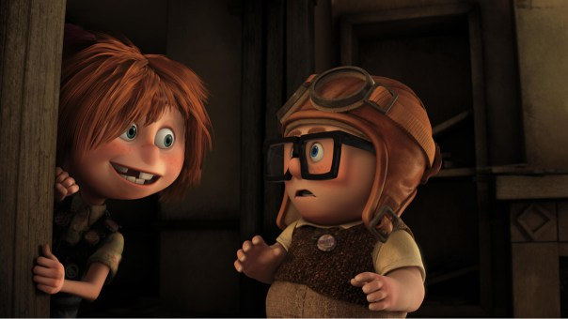 | 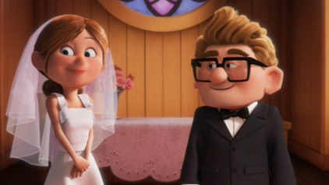
When they were young, they met at old house | They loved and married
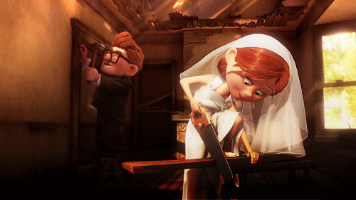 | 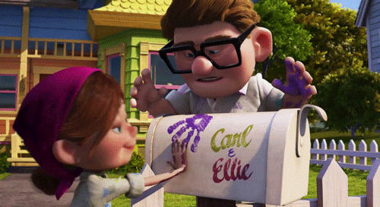
They fixed the old house | They made their love house
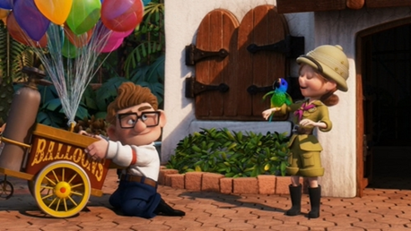 | 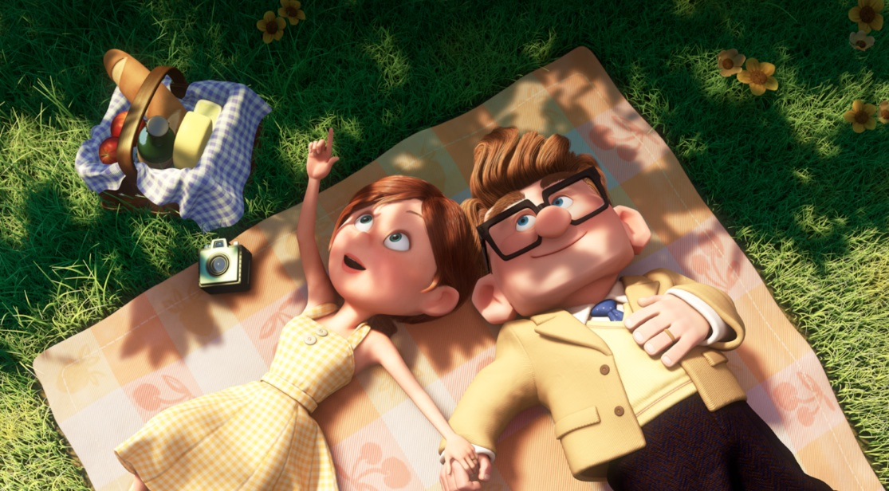
Their life was wonderful | They had a same dream.
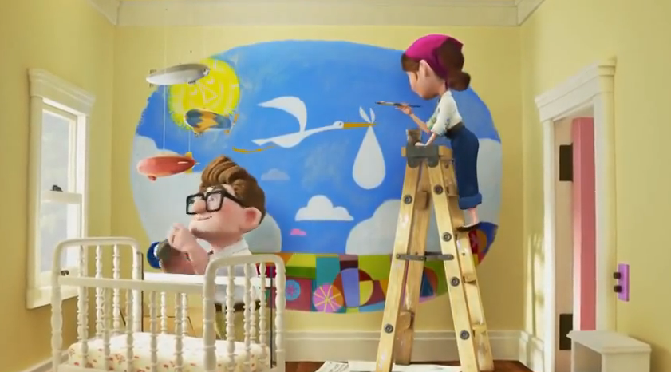 | 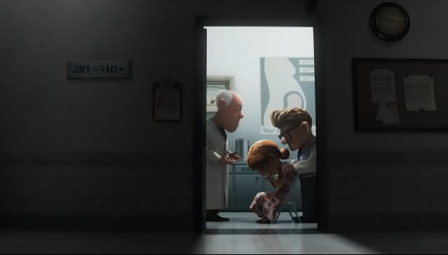
They wanted to have babies | But they could not
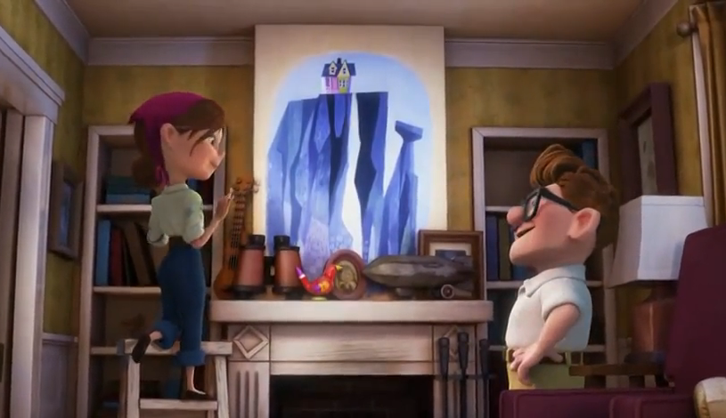 | 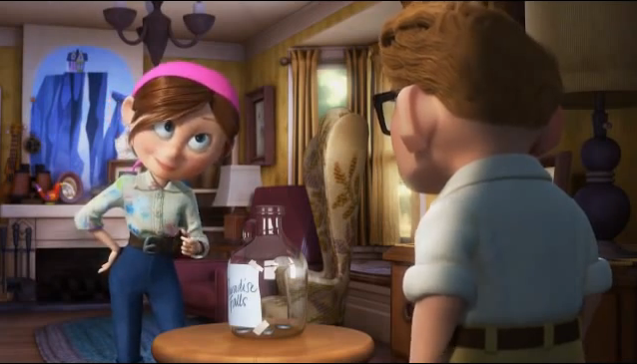
They remembered their first dream | They promised to save money for dream
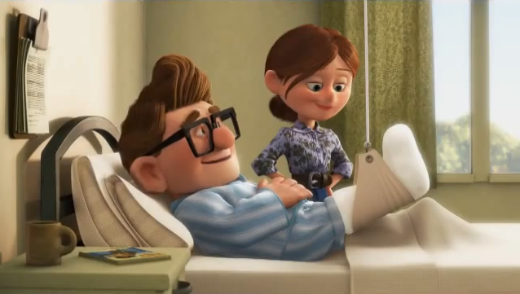 | 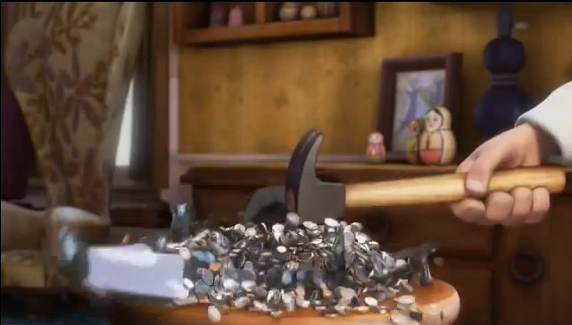
But he was sick | So they spent their money
 | 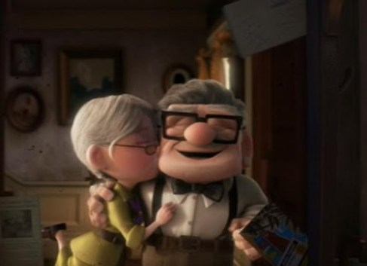
But they were happy | They loved even they were old
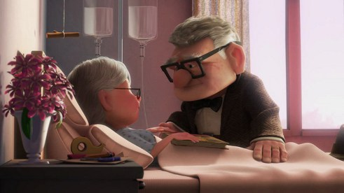 | 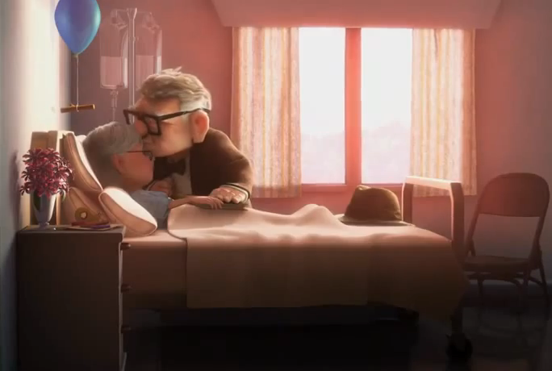
She were sick | But they still loved
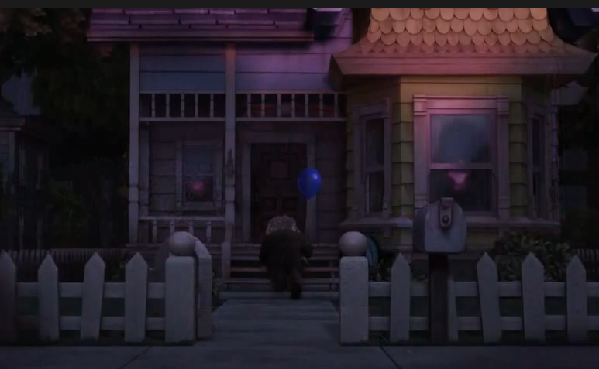
He left alone at their house
Rush activity
Team A | verbs | Team B
 | Have
 | Make
 | Dream
 | Leave
 | fix
 | Want
 | Meet
 | love
 | Marry
 | Promise
 | spend
 | am/is
 | are

