TITLE | Apartment for Rent
INSTRUCTOR |  |  |  | Ss’ LEVEL | AGE GROUP | No of Ss | LENGTH
Haera Im (Heather) |  |  |  | Elementary | Adult | 13 | 50min

MATERIALS

White board, Markers, Eraser, 13 Worksheets, 13 slips of paper
AIMS 1. |  | To develop reading comprehension skills through reading authentic materials
2. |  | To learn useful vocabularies and expressions for renting apartments
3. |  | To generalize language through practicing how to rent and rent out apartments in spoken English

LANGUAGE SKILLS
Listening |  |  | T’s instruction and questions, Other Ss speaking, Answering questions
Speaking |  |  | Reading out loud, Group discussion, Renting apartments activity
Reading |  |  | Worksheets, Activity scripts, Teacher’s writing on the board
Writing |  |  | Answers about questions on the worksheets, T’s instructions, Group discussions
LANGUAGE SYSTEMS
Phonology |  |  | Reading out loud, Apartment
Lexis |  |  | Utilities, Spacious, Deposit, Stunning, Drop-off laundry/ Coin laundry…
Grammar |  |  | I am looking for -, I want to, I would like to,
Discourse |  |  | Finding the right person who is a match for the apartment, Q&A,
Functions |  |  | Identifying, Discussing, Wishing and hoping, Explaining, Asking for information

ASSUMPTIONS

T might explain that they are not perfectly written sentences but they are true to life e.g.s

Ss have different ideas, priorities when renting an apartment

Some of Ss might have had experience hunting apartments for rent on the Internet

Ss need more practice in web searching and comprehension by reading

ANTICIPATED GRAMMATICAL ERRORS AND SOLUTIONS
- Ss might be confused with Present-passive voice
> First write active voice sentence on the board and then change it to passive voice sentence, so that Ss can better understand and more clearly see the difference
- Ss might be confused with not perfect grammar sentences in the script
> Explain Ss that they are informal way and teach Ss how we could fix the sentences in formal way

REFERENCES

1. At the end of this lesson plan
2. Desktop > Tesol > Reading > ‘Rent apartment’.doc

NOTES
Plan B
Task-realization
Instead of reading it out loud all together, one S reads one sentence out loud at a time
If printer/ photocopy machine doesn’t work, show them the real ads by searching on the internet

Cut Off plan
Task-preparation
- Skip telling Ss about personal experience if you took too much time before Task-realization

SOS activity
Post-task
Play Bingo game instead of ‘Hunt for your apartment’
T is a hunter and Ss are brokers
1. Ss make 5X5 Bingo cards
2. Write any 25 vocabularies about renting apartment
3. T chooses and dictates/reads out the vocabularies by T’s choice (There is no fixed list)
4. Ss mark the vocabulary at the teacher calls out if they have it on the bingo card
e.g. T says ‘I want a window in my bedroom’ > Ss can mark ‘window’ and ‘bedroom’ both if they have both words
e.g. T says ‘I want a non-smoker’ > Ss can mark ‘non-smoker’ if they have the word
5. The first S to make one or two lines is the winner (T can choose one line or two lines)

PRETASK TITLE |  |  | Apartment for Rent
AIMS |  |  |  | MATERIALS
- To elicit Ss to think about renting apartment  - To talk about renting apartment by sharing experiences  - To learn more vocabularies about renting apartments |  |  |  | White board, markers, eraser
TIME | SET UP | STUDENTS |  | TEACHER
5mins |  | Greet  Sitting in 4 groups  Ss answer T’s questions  - What is ‘Rent’?  - When you want to move out and change your apartment, what should you do?  - When we rent an apartment, what are we concerned about?  List as many as possible, at least 10 things |  | Greet students  13 Ss in 4 groups  Ask questions to elicit Ss to think about renting apartments  Have Ss talk and discuss about what they would look for when renting a place to live.

NOTES

Rent : Synonyms – Lease / Pay or charge fee for using something
When Ss couldn’t guess or understand, give some examples for better understanding
T controls time and is careful not to take too much time for greeting and not to stray from the subject

TASK PREPARATION TITLE |  |  | Where & How can I get the rent information
AIMS |  |  |  | MATERIALS
To prepare the student to think about rent  To practice reading out loud and other Ss listen to the Ss’ reading and pronunciation  To get Ss ready to read and know what they will do the next |  |  |  | 13 Worksheets, white board, markers and a eraser
TIME | SET UP | STUDENTS |  |  | TEACHER
2 min |  | Check how many things Ss listed  The group that has the most list reads the list out loud so that every S can hear |  |  | Check what Ss listed  Ask Ss how many things they listed in each group  Ask the group that has the longest list to read the list out loud
5 min |  | Answer T’s question  - Where can we find information about rooms/apts for rent?  e.g. Newspapers, Magazines, Internet, SNS…  Get more ideas about how to search for and rent an apartment by listening T & Ss’ experiences |  |  | Ask Ss a question  - How do we look for an apartment?  - Where can we get the information about renting?  Tell Ss how I normally find a new place  Ask Ss if anybody has found a new apartment through Internet before
3 min |  | Listening the instructions from T and understand  - Every S takes a worksheet  - Read the main script ‘looking for a roommate’ ad on the top of the worksheet  - Read the 3 messages from different persons and pick one person who should get the apartment in the main script  - Have 5 mins to read and figure it out  Answer T’s questions  - What is the script for?  - How many ppl are looking for rent?  - How long do you have to read it? |  |  | Give Ss instructions  -Show them the worksheet and explain what it is about  - Hand out worksheets to every each Ss  - Explain what we will do with the worksheet in the class  - CCQ / ICQ

NOTES
Give clear and simple instructions and check if Ss clearly understood by CCQ and ICQ
Cut-off: Skip telling Ss about the experiences if you took too much time before Task-realization

TASK REALISATION TITLE |  |  | Who would make a suitable roommate?
AIMS |  |  |  | MATERIALS
To develop comprehensive reading skills  To be familiar with useful grammar structures and vocabularies in rent apartment |  |  |  | 13Worksheets, white board, markers and eraser
TIME | SET UP | STUDENTS |  |  | TEACHER
5 mins |  | Read the scripts and choose the answer |  |  | Monitor Ss and check if everyone is following well
2min |  | Answer T’s question  - Who would be the most likely to live in the apartment?  Compare other Ss answers |  |  | Ask which one Ss chose  Check how many Ss got which answers
18mins |  | Read the script out loud together double checking with Q&As at the same time  e.g. One single room available from January 3  > From when can you live in the apartment?  Read 3 messages and answer why it’s the right and/or wrong person for the situation  Ask vocabularies Ss might not sure/ know |  |  | Make sure Ss understand the meanings and how to pronounce the vocabularies  ICQ & CCQ

NOTES
ICQ&CCQ
What is the location of the apartment? Brooklyn, NYC
What utilities are included in the apartment? Wifi, Electricity, Air Conditioning
What kind of person is Sara looking for? Clean, organised, friendly, respectful and won’t bring the party home
How much is the rental housing fee? 900 deposit + 1100 per month
Plan B : Instead of reading it out loud all together, one S reads one sentence out loud at a time
Use the white board to help better understanding
Elicit Ss to learn new vocabularies, instead of telling them the answer right away

POST TASK TITLE |  |  | Hunt for your apartment!
AIMS |  |  |  | MATERIALS
To generalize the vocabularies and expressions about renting apartment  To make light of the situation  To encourage interaction between the Ss  Speaking in a real life active context. |  |  |  | 13 slips of paper
TIME | SET UP | STUDENTS |  |  | TEACHER
8mins |  | Listen to T’s instruction about rule of the activity  7 hunters and 6 brokers  7 hunters must find their apartment for rent from 6 brokers  ‘Hunt for your apartment!’  1. Each S takes one slip of paper  2. 7 hunters go find brokers and ask questions for rent  3. 6 brokers go find hunters and ask questions to rent out  4. Find the right partner and get broker’s signature on the slips of paper |  |  | Explain the activity’s rules  Hand out the papers written with descriptions of an apartment  Monitor if Ss are doing well  Answer questions if Ss have any Qs
2mins |  | Q&A  Homework  - Write an advertisement for renting out your apartment |  |  | Check if every S got permissions/ signatures  Give Ss homework for the next class  Give them instructions  CCQ/ ICQ

NOTES
Monitor while they are doing the activity. Make sure Ss are having fun, understanding the rules
For homework, it is not acceptable to write the statement in L1 and then translate into English.
Writing should be written in clear and simple English that can be easily understood by peers.
SOS Activity
Play Bingo game instead of ‘Hunt for your apartment’
T is a hunter and Ss are brokers
1. Ss make 5X5 Bingo cards
2. Write any 25 vocabularies about renting apartment
3. T chooses and dictates/reads out the vocabularies by T’s choice (There is no fixed list)
4. Ss mark the vocabulary at the teacher calls out if they have it on the bingo card
e.g. T says ‘I want a window in my bedroom’ > Ss can mark ‘window’ and ‘bedroom’ both if they have both words
e.g. T says ‘I want a non-smoker’ > Ss can mark ‘non-smoker’ if they have the word
5. The first S to make one or two lines is the winner (T can choose one line or two lines)

Who would make a suitable roommate?
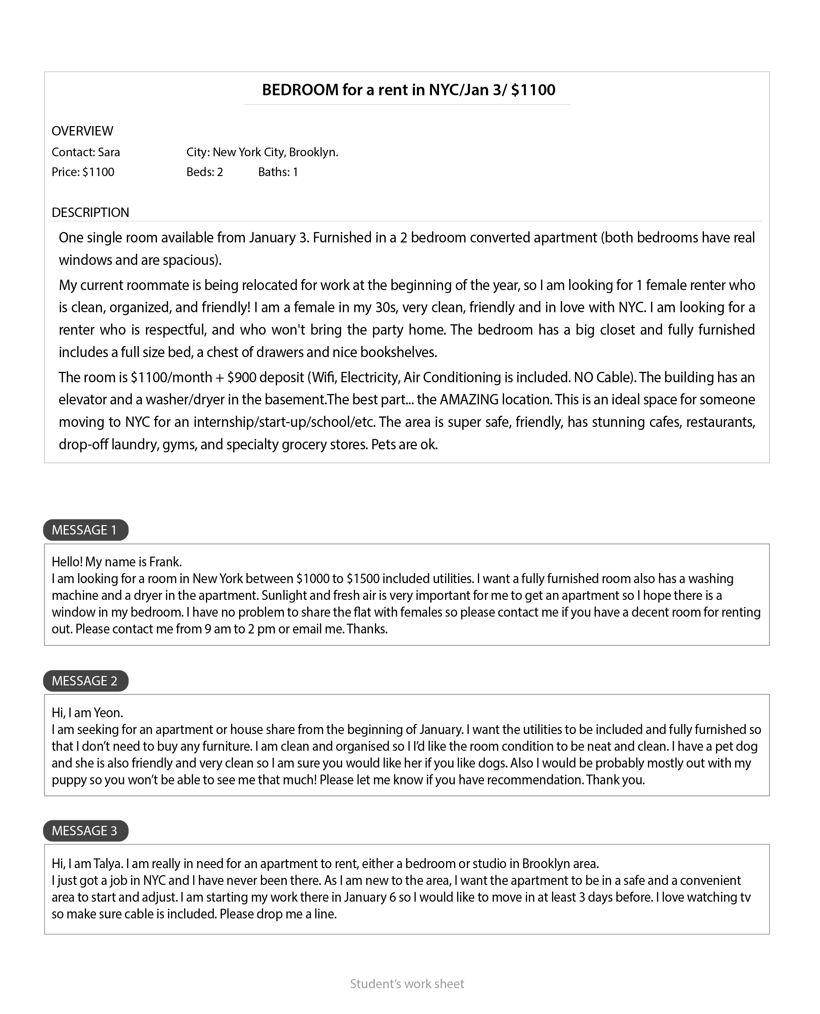

13 Slips of paper – Cut the lines and hand out to Ss

Looking for a roommate - $1000 / 1 bedroom / 1 bathroom / 1 kitchen / fully furnished / pets are ok /

Looking for 2 housemates - $1000 each / 3 bedrooms / 1 bathroom / Wifi, electricity included/ unfurnished /
cooking is not allowed / pets are ok

Broker - $3500-4000 / pool / gym / no sauna / 3 bedrooms / 1 bathroom / utilities excluded

Broker - $3500-3800 / pool / sauna / gym / 2 bedrooms / 1 bathroom / not allowed cooking

Broker - $3500-3800 / 3 bedrooms / 1 bathroom / 1 kitchen / unfurnished / utilities included

Broker - $1000-1500 / 1 bedroom / 1 bathroom / 1 kitchen / fully furnished / utilities included / no pets

Renter - $800-1000 / 1 bedroom / 1 bathroom / 1 kitchen / fully furnished / have a dog

Renter - $1000 - 1500 / 1 bedroom / 1 bathroom / Wifi, electricity included / fully furnished

Renter - $1000 - 1500 / 1 bedroom / 1 bathroom / Wifi, electricity included / fully furnished

Renter - $3000-3600 / pool / gym / 3 bedrooms / 1 bathroom

Renter - $3000-3600 / pool / sauna / gym / 2 bedrooms / 1 bathroom

Renter - $3400-3600 / 3 bedrooms / 1 bathroom / 1 kitchen / utilities included

Renter - $1200-1500 / 1 bedroom / 1 bathroom / 1 kitchen / fully furnished / need WIFI

