Listening Lesson Plan
TITLE | Getting Hired
INSTRUCTOR | LEVEL | STUDENTS | AGE GROUP | LENGTH
Hauri Park | Intermediate | 10 | Adult | 100 mins.

MATERIALS
- Warm up exercise worksheet (10 copies)
- Listening activity worksheet (10 copies)
  - Three parts: Part 1 Matching Vocabulary, Part 2: Listening Comprehension Questions,
Part 3: Fill in the blanks
- E-mail message and script of the dialogue (10 copies)
- Writing worksheet (SOS plan - 10 copies)
- Audio file, computer with speaker or other audio file players
- White board and board markers

AIMS
- To practice listening to dialogues applicable on real-office-life settings through pre-recorded office scenario dialogues.
- To learn vocabulary and expressions used in real-office-life by completing the listening exercises comprising of vocabulary matching, comprehension questions, and fill in the blanks.
- To enhance listening comprehension skills by answering comprehension questions following the dialogue.
- To be able to create predictable dialogues useful when accepting/declining job offers through dialogue practices.
- To enhance speaking skills by practicing dialogues with partners.

LANGUAGE SKILLS
Listening  Reading  Speaking  Writing | Dialogue of two persons about getting hired, role play of other students  All exercises in the worksheets, print outs of the e-mail message and script of the dialogue.  Verbally answering questions, doing pair/group work, and presenting the role play.  A answering worksheets, doing a mind map, coming up with dialogues with their partners.

LANGUAGE SYSTEMS
Lexis  Phonology  Grammar  Function | Students will be focusing on words commonly used in office life.  Students will be practicing accurate pronunciation to ensure successful communication during dialogue exercises.  Students will be mainly focusing on generally using simple present tense and future tense to convey their current status as an employer/ employee and negotiate for their future demands, responding to job offers, and/or negotiating salary and benefits.  Dialogue from the pre-recorded audio file; dialogue between partners.

ASSUMPTIONS
- Students are adult learners with majority of them having experience in an office setting.
- Students as adult learners have experience getting a job offer and/or have knowledge of how job offers generally take place.
ANTICIPATED ERRORS AND SOLUTIONS
- Students may not be familiar with phone conversations
  - Start with the warm up exercise and briefly explain where and how the conversation is taking place.
- If the audio file does not work
  - Read the dialogue to the students using different voices
- Students may not be able to pick up details from listening
  - After playing the whole audio file once, chunk the listening by pause-play-pause-play.
- Students might need more time for certain activities
  - Adjust the time allotted for other activities. Have the students verbally recite their answers instead of writing them on the board
- If all activities finish early
  - Make use of the SOS plan to further develop students' knowledge on the topic

REFERENCES
- www.google.com
- www.esllibrary.com
- www.englishisapieceofcake.com
- www.123rf.com

Lead-In
Materials White board, white board markers (different colors), warm up exercise worksheet
TIME | SET UP | TEACHER | STUDENTS
5 | Class | Start the introduction and elicit from Ss of their past experience getting a job or getting hired | Students will verbally give various answers about their past experiences
5 | Class | Distribute and ask the warm up questions | Students will call out adjectives/key words to quickly answer the warm up questions
 |  | Divide the board into sections; write down the answers of Ss in key words
 |  | Introduce the listening task

Pre-Activity
Materials Listening worksheet - Part 1: Matching Vocabulary
TIME | SET UP | TEACHER | STUDENTS
5 | Groups of 3 (and one 4) | Divide the class into groups, distribute the vocabulary worksheet and introduce the task | Students will work in groups to answer the vocabulary worksheet
15 | Class | Elicit the meaning of each vocabulary word and give explanations, synonyms, antonyms, examples, etc. if necessary | Students will share their answers and correct their answers if necessary, give examples, or use the words in a sentence

Main Activity
Materials Audio file, Listening worksheet - Part 2: Listening Comprehension, Part 3: Fill in the blanks
TIME | SET UP | TEACHER | STUDENTS
5 | Class | Play the whole audio file once | Students are to listen to the whole dialogue to get the general idea of the conversation
 |  | Elicit if the students have gotten the general idea of the dialogue | Students are encouraged to draw a mind map to summarize and further build on vocabulary words not tackled in the vocabulary exercise
5 | Class | Play the audio file again, in chunks (pause-play-pause-play) | Students should be able to add more information in their mind map or some may even have taken down notes
10 | Individual | Distribute the comprehension and fill in the blank worksheets; introduce the task | Students will work individually to answer the comprehension questions and fill in the blanks
10 | Class | Discuss the answers to the two exercises | Students will share their answers
Post-Activity
Materials Script and e-mail message
TIME | SET UP | TEACHER | STUDENTS
15 | Pairs | Distribute the script and e-mail message of the audio file; introduce the task. Monitor actively by participating in the group discussions | Students will work in pairs to make their own dialogue making use of the newly learned vocabulary words. Students may refer to the script and e-mail to make their dialogue. Students will practice writing, speaking and listening
10 | Class | Have some pairs do the role play | Students will practice speaking and listening by doing the role play
5 | Class | Conclude the lesson; ask for feedback | Students may share on how they will make use of the vocabulary and/or dialogue learned today in real-life situations

Getting Hired
Lee - prospective employee | Mr. Michaels - employer
Warm-up Question

Answer and discuss the following questions with the class.

- Describe your current/previous job.

- How did the company contact you of your acceptance to the company? By e-mail? By phone?

- What kind of negotiations done for your salary and benefits?

- How much time did you need before taking the job?

- Have you ever declined a job offer? Why?

Getting Hired
Listening Activity

I. Matching Vocabulary
Form a group of 3 or 4. Discuss with your group to match the following vocabulary words to their correct meanings.

- ____ sharp a. to take, to agree
- ____ employer b. be exactly on time
- ____ drive a hard bargain c. to deal or bargain
- ____ qualifications d. to give a chance to take the job
- ____ job offer e. a written agreement
- ____ accept f. qualities or skills fit for a function
- ____ set up g. something paid above the agreed amount
- ____ negotiate h. to arrange, to plan
- ____ position i. be good at negotiating
- ____ salary j. person that employs
- ____ two week's notice k. answer or reply
- ____ on board l. amount paid to do the job
- ____ contract m. post you take at work
- ____ bonus n. be part of the team
- ____ response o. time required before leaving the current job

Notes
II. Listening Comprehension
Work individually to answer the following comprehension questions.

1. What did Mr. Michaels want to discuss over the phone with Lee?

2. What were the two things that Lee did not agree with the offers of Mr. Michaels?

3. If Mr. Michaels had not offered a bonus, would Lee have taken the job?

4. Why wasn't Lee able to start the job right away?

5. What are the important things you consider before taking a job? Why?

6. What do you think are the skills to better negotiation?

III. Fill in the blanks
Work individually to fill in the blanks with the correct vocabulary words from Part I.

- I think Ms. Smith has the right_________________ fit for the position.
- John did not ______________ the job offer because of the working hours.
- Employees with good evaluations are given _____________ at the end of each quarter.
- The two companies signed a multi-million dollar _________________ to build better facilities.
- My boss always wants his meeting at 10 a.m. _________________.
- Jane was not satisfied with the _________________ at her new job, but she was happy with the benefits that the company offered.
- Lee had to give his current boss a ___________________ before he could take the new job.
- She got a ________________ from Samsung to take the position as Marketing Team Head.
- Peter had to call in ________________ to the e-mail he received from his client.
- It was hard to _______________ the price as there were too many interested buyers.

Getting Hired

E-mail
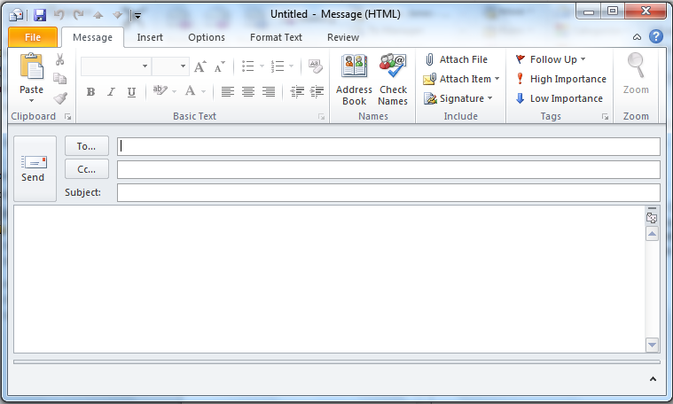
July 7th, 2014
Dear Lee,

Based on the interview we had last week, I am very confident that your qualifications meet the position we are hoping to fill. With this regard, I would like to let you know that our company is offering you a full-time job as a sales representative. I believe you will be an asset to our team.

Please call me to set up your start date and to discuss your salary.

Sincerely,
William Michaels

lee1234@email.com

Job Offer

Script - Dialogue Practice
Lee: Hello, Mr. Michaels. This is Lee Timson. I'm calling in response to your email message. I'm very excited about the job offer.
Mr. Michaels: Hello, Lee. Thanks for calling. We need to negotiate your start date and salary.
Lee: When do you want me to start?
Mr. Michaels: I'd like you to start next week.
Lee: I need to give my employer two week's notice.
Mr. Michaels: I understand. You can start in two weeks then. How about July 21st?
Lee: That sounds good.
Mr. Michaels: Let's discuss your salary next. The starting salary is $24,000 a year.
Lee: I know that is for a new person, but I do have some experience. I'd like to start at a higher salary. I'd like to make $29,000.
Mr. Michaels: You drive a hard bargain. I could go up to $28,000 and set up a bonus plan for good sales.
Lee: I like the idea of a bonus plan. I accept.
Mr. Michaels: Great! I'll write the contract and I'll see you at 9 a.m. sharp on July 21st. Great to have you on board, Lee.
Lee: Good to be on board, Mr. Michaels!

Getting Hired

Writing
Write your views on the following questions.

1. Describe the kind of job and position you would like to have.

2. What do you think are the required qualifications to get the job you want in question no. 1?

3. What kind of salary do you want?

4. Do you think you can drive a hard bargain? Why or Why not?

5. What other factors do you consider before accepting a job offer? (environment, benefits, employee welfare, etc.)

6. What is your dream job?

