

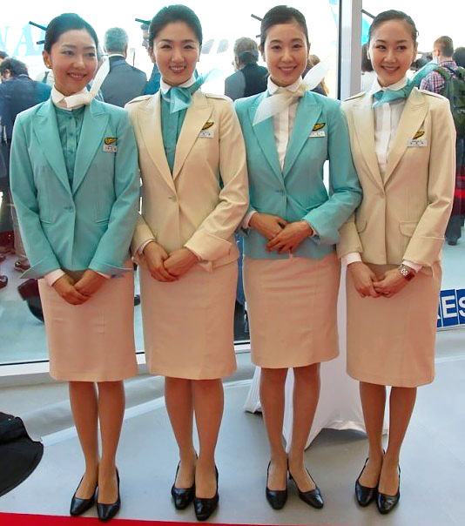

[](http://www.google.co.kr/imgres?imgurl=https://originaltop10.files.wordpress.com/2011/07/singapore_airlines_logo.jpg&imgrefurl=http://imgkid.com/korean-airlines-logo.shtml&h=709&w=1535&tbnid=JF7xv0e-hg0VUM:&zoom=1&docid=VUhCeln8HZ1SUM&ei=oBwYVfGHHaPcmgXcr4GABw&tbm=isch&ved=0CGIQMygrMCs)

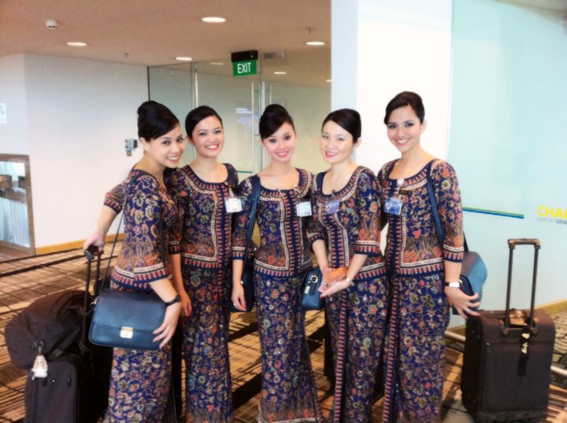



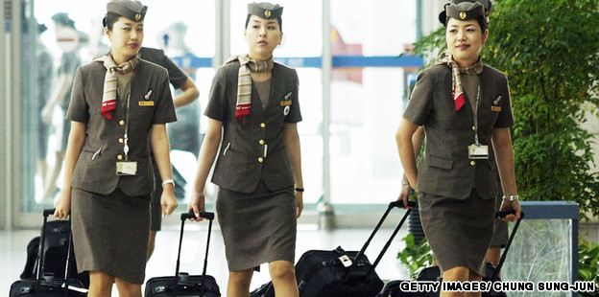

[](http://www.google.co.kr/imgres?imgurl=http://topnews.ae/images/imagecache/bigthumb/Emirates-Airline1.jpg&imgrefurl=http://topnews.ae/content/2114-dubai-airport-terminal-3-launched-smoothly&h=240&w=240&tbnid=eBkmtyr4Q5w2yM:&zoom=1&docid=bMYas3B__l75VM&ei=Uh8YVfP2Bcbq8AWU14DYAg&tbm=isch&ved=0CDgQMygWMBY)

