Listening Lesson Plan

Grace(Lee KyoungHwa)
April 5, 2015
TESOL 110th WK

Listening Lesson Plan
TITLE |  |  |  | To be aware of the importance of strength training by listening to a video clip and discussions.
INSTRUCTOR |  |  |  |  | Ss’ LEVEL |  |  |  | AGE GROUP |  | No. of Ss |  | LENGTH
Grace |  |  |  |  | Intermediate |  |  |  | Adult |  | 15 |  | 50 mins
MATERIALS
Computer, whiteboard, markers, papers, pens, worksheets(1-4)
AIMS |  |  | 1. To improve listening skills with health related topics by listening a video clip and learning new vocabulary about health and fitness  2. To practice speaking skills by discussing the topic
LANGUAGE SKILLS
Listening |  |  |  | Students will listen to a native speaker in the video clip as well as his or her classmates during the discussion.
Speaking |  |  |  | Students will be discussing their experiences as well as opinions about strength training.
Reading |  |  |  | Students will be reading the script of the video clip that contains several blank spaces and worksheet.
Writing |  |  |  | Students will be summarizing the discussion on the board.
LANGUAGE SYSTEMS
Phonology |  |  |  | Students will practice on pronunciation of new vocabulary
Lexis |  |  |  | Students will learn new vocabulary about health issues and fitness
Grammar |  |  |  | Students will have indirect experience of correct grammar through the video clip
Functions |  |  |  | To understand health related topics better
Discourse |  |  |  | To make conversation with classmates
ASSUMPTIONS
Students will be able to discuss their personal experiences about health and fitness.
Anticipated Errors and Solutions
Students might not know new vocabulary on health issues and fitness.
-Help students become familiar with new vocabulary beforehand by eliciting, demonstrating, using materials.
Students might need more time to finish their activity.
-Be flexible with the time. Give students more time to complete their activity and cut off the time of post activity as necessary.
REFERENCES
www.sharecare.com, www.exercise4weightloss.com,
NOTES
If the video clip doesn’t work, teacher will read out the script of the video clip
Monitor students during every task both passively and actively.
PRETASK TITLE |  |  |  |  |  |  | Warmer
AIMS |  |  |  |  |  |  |  |  |  | MATERIALS
To learn new vocabulary on health issues and fitness |  |  |  |  |  |  |  |  |  | Whiteboard, markers and pens, pictures
TIME |  | SET UP |  |  |  | STUDENTS |  |  |  |  |  | TEACHER
8mins  by | Class |  |  |  |  | Students will be naming the pictures of different types of exercises.  Students will be pronouncing new lexis with correct stress. |  |  |  |  |  | Elicit vocabulary.
NOTES
Demonstrate to help students understand new vocabulary clearly.
Use synonyms and antonyms as necessary.
TASK PREPARATION TITLE |  |  |  |  |  |  |  | Free discussion
AIMS |  |  |  |  |  |  |  |  |  | MATERIALS
To help students become familiar with the content of the video clip by talking about their experience. |  |  |  |  |  |  |  |  |  | worksheet1, pens
TIME |  | SET UP |  |  |  | STUDENTS |  |  |  |  |  | TEACHER
7mins  6mins |  | Groups of 5  Class |  |  |  | Students discuss their personal experiences of strength training and chronic pain.  One student of each group will summarize their discussion in front of the class. |  |  |  |  |  | Monitor passively in the beginning and more actively later.  Instruct and monitor.
NOTES
Try to monitor passively during discussion unless there is a struggling group.
TASK REALISATION TITLE |  |  |  |  |  |  |  | Video clip and discussions
AIMS |  |  |  |  |  |  |  |  |  | MATERIALS
To understand the message from the video clip and express their thoughts about the importance of strength training. |  |  |  |  |  |  |  |  |  | Whiteboard, markers, pens, worksheet2
TIME |  | SET UP |  |  |  | STUDENTS |  |  |  |  |  | TEACHER
6mins |  | Class |  |  |  | Students watch the video clip of strength training twice.  Students fill the blank spaces on the second time individually.  Students listen to the video clip again. |  |  |  |  |  | Distribute worksheet 2.  Monitor passively.  Elicit correct answers.
7mins |  | Groups of 5 |  |  |  | Students discuss the benefits of strength training. |  |  |  |  |  | Monitor actively.
NOTES
When opening the link to video clip, skip the ad part by starting on mute.
Encourage groups that finished discussion earlier than given time to discuss further the other types of exercises in terms of benefits.
Offer some new ideas and other pre-searched information on the topic.
POST TASK TITLE |  |  | Summary and resolution
AIMS |  |  |  | MATERIALS
To confirm comprehension of the topic and implement the main idea. |  |  |  | Whiteboard and markers
TIME | SET UP | STUDENTS |  |  | TEACHER
6mins | Groups of 5 | Each student will write more than one benefits of strength training on the board. |  |  | Instruct and monitor passively.
10mins | Groups of 5 | Each student tells a resolution on health and fitness. |  |  | Encourage each student with their resolution.
NOTES
Monitor student’s writing skills on the board and correct errors when necessary.
Make sure every student participates in writing on the board.
Video clip link: http://www.sharecare.com/video/diet-and-fitness/strength-training/how-strength-training-helps-your-health
Warmer
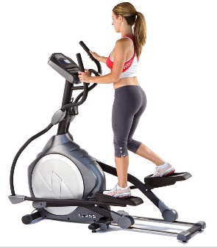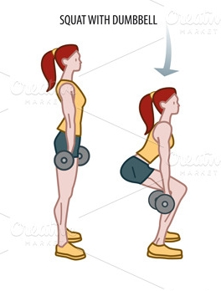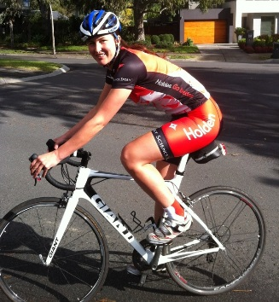
A)Elliptical machine B)Squat with dumbbells C)Cycling
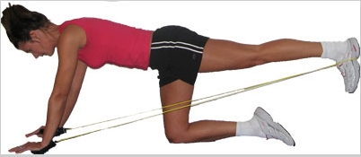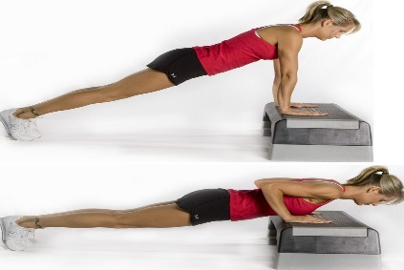
D)Aerobic dance E)Resistance Bands F)Push-up

Free discussion (Worksheet 1)
1 .Do you have any chronic pain in your body?
2. What are strength training workouts?
3. Have you ever tried strength training?

Video Clip and discussions (Worksheet 2)
Hi, I'm Doctor Mike Clark. If you're wondering if a strength training program is right for you, consider this, many research studies show that strength training has great health benefits and should be an integral part of just about everyone's exercise routine, perhaps the most obvious impact of (1)_________ training is on your weight.
It stimulates your body to maintain or increase muscle tissue which helps your body burn more calories throughout the day without doing anything extra. Of course you would expect that (2) ________ training would help build muscle to keep you lean, but it has other great benefits too, it can help prevent (3) ________diseases like diabetes, it helps prevent low back pain and osteoporosis too.
(4)_________ also prevents age-related loss of muscle mass, that helps you maintain physical functioning as you get older in particular preventing debilitating pulse. So whether you lift dumbbells, use (5)__________ or pick up a resistance band, (6)______ can boost your health now and in the future.

