Listening Lesson Plan
TITLE | How to Develop Healthy Eating Habits
INSTRUCTOR |  |  |  | Ss’ LEVEL | AGE GROUP | No of Ss | LENGTH
Christine |  |  |  | Pre-intermediate | Adult | 8 | 50mins

MATERIALS
- Computer, MP3 file
- Speaker
- White board, board markers
- Note books and pens
- Pictures
- Listening worksheet (8 copies each)
AIMS 1. |  | To practice listening skills by watching a video
2. |  | To practice speaking skills during discussions
3. |  | To learn new expressions related to health and understand healthy eating habits

LANGUAGE SKILLS
Listening |  |  | Students will be listening to a video, teacher guidance and students’ opinions.
Speaking |  |  | Students will be talking about their eating habits in groups.
Reading |  |  | Students will be reading worksheet by completing blanks on worksheet.
Writing |  |  | Students will be writing notes when making a list of their eating habit and healthy eating habits.
LANGUAGE SYSTEMS
Phonology |  |  | Student will practice the pronunciation of new vocabulary and phrases.
Lexis |  |  | Student will learn new vocabulary about health and eating habits.
Grammar |  |  | Students will practice past, present and future tense.
Discourse |  |  | Conversation with classmates
Functions |  |  | Developing Healthy eating habits

ASSUMPTIONS

- Students will know the name of food.

-Students will be able to discuss their past experiences and the vocabulary in the lexical fields.
- Most students have gone on a diet for their health before.

ANTICIPATED ERRORS AND SOLUTIONS
- Students may not remember what they ate yesterday,
- Let students make their own list of what they want to eat now.

- Students may not be able to fill in blanks from the listening,
- Chunk the listening (pause-play- pause-play)

- If time is short
- Cut post-activity discussion short and ask a couple of students to share their opinions about what kinds of eating habits are good/bad for their health.

- If students finish their tasks earlier than anticipated,
- Ask as many as students as possible about their ideas of good eating habits

REFERENCES

https://www.youtube.com/watch?v=WSWPgFkUUeU

NOTES

- Students must be monitored.

- If the computer does not work, teacher will play the audio file in his/her ipad or read the script aloud.

Lead-In
Aims  To make students think about today’s topic and talk about what they ate yesterday |  |  | Materials  Board, markers, note books, pens, pictures
Time | Setup | Students |  | Teacher
3 | Class | Students see pictures and guess what today’s topic is.  Students think about what they ate what time they had breakfast/lunch/dinner yesterday and write it down on their note books. |  | Show food pictures and elicit response  Introduce today’s topic and let Ss think about what they ate yesterday.  Give instructions and ICQ
4 | Groups | Students talk about what they wrote to each other. |  | Monitor
Notes

Pre-Activity
Aims  To learn new vocabulary |  |  | Materials  Pictures, board and markers
Time | Setup | Students |  | Teacher
10 | Class | Students learn new vocabulary |  | Show pictures of new vocabulary  Elicit the meaning from Students  CCQ
Notes
If students have difficulties to understand the meaning of the vocabulary, give more example sentences and use gestures.

Main Activity
Aims  To practice listening/speaking skills and learn healthy eating habits |  |  | Materials  Computer, speaker, listening worksheet, board and markers
Time | Setup | Students |  | Teacher
4 | Class | Students watch the video.  First time they will focus on listening and watching the video.  Students answer the questions |  | Give instructions and ICQ  Play the video  Don’t distribute handouts until video is over.  Ask them what was about?
3 | Class | And second time they will fill in the blanks in the worksheet. |  | After video is finished, distribute the listening worksheet and let Ss fill in the blanks.
6 | Class | Students see if it is correct.  Students will understand the script. |  | Play the video 2 times more, in chunks (pause-play-pause-play)  Monitor  Give corrections
4 | Class | Students read the script aloud. |  | Give corrections on pronunciation
8 | Groups | Students talk about their eating habits and discuss what eating habits are good/bad for them.  Students share their opinions to class. |  | Elicit experiences  Give instructions and ICQ  Monitor
Notes
If dictation takes time more than planned, adjust the time for post-activity.

Post Activity
Aims  To plan their healthy eating habits for the future |  |  | Materials  board
Time | Setup | Students |  | Teacher
4 | Class | Students review vocabulary and expressions. |  | Elicit vocabulary
4 | Class | Each of the Students shares their opinions to class. |  | Elicit Ss plan for healthy eating habits  Encourage students to share their opinions  Give instructions and ICQ  Monitor
Notes



Vocabulary

processed


lean meat
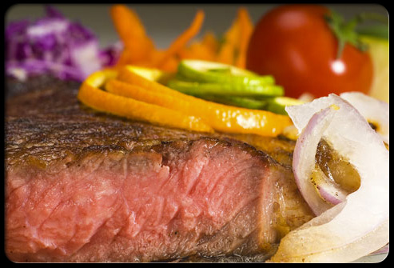

saturated fat
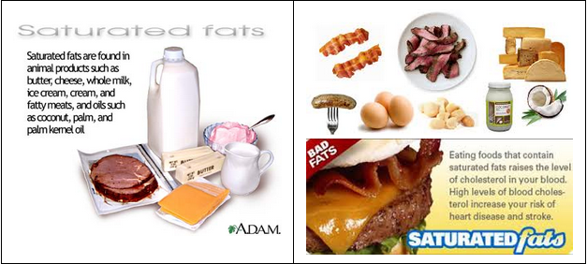

rev up


metabolism
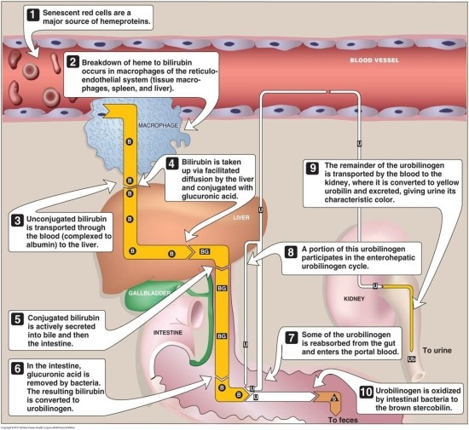
digestive system
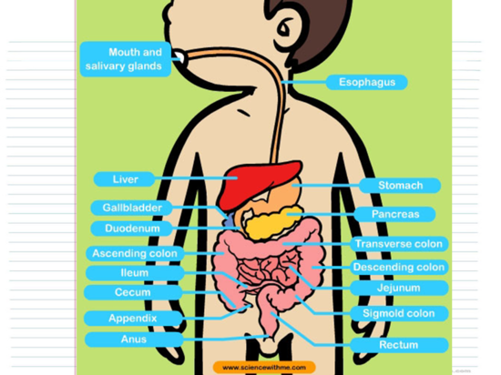

obese
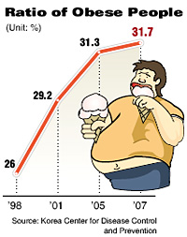

Listening worksheet

Good health is just a matter of taking a new approach to _______________________________.

Step 1: Cook your own meals
____________________________ as often as you can. This will help you avoid eating processed and fast foods, which are higher in sodium and fat.

Tip
Healthy, low-fat recipes and guidance are available in bookstores and on the internet.

Step 2: Make a shopping list
Plan _____________ and make _______________. Fill your cart with lots of fresh fruits and vegetables, whole-grain foods, and lean meats.

Step 3: Read nutrition labels
Read ______________. Pay attention to saturated fat, sodium, and sugar. The higher their numbers, ____________ they are.

Step 4: Eat breakfast
Eat breakfast every day. Breakfast helps to rev up your metabolism. __________________________ within the first hour after you wake up.

Step 5: Eat every three to four hours
Try to eat small meals every three to four hours. ____________________________________________.

Step 6: Drink plenty of water
_____________________________. Water hydrates the body and aids the digestive system. And it's calorie-free!

Step 7: Feel the difference
______________________________ -- more energy and stamina -- as well as sharper thinking as you feed your body healthy foods.

Step 8:
A study found that _____________________________________ are obese.

Listening script

Good health is just a matter of taking a new approach to eating and making simple changes.

Step 1: Cook your own meals
Cook and prepare your own meals as often as you can. This will help you avoid eating processed and fast foods, which are higher in sodium and fat.

Tip
Healthy, low-fat recipes and guidance are available in bookstores and on the internet.

Step 2: Make a shopping list
Plan healthy meals and make a shopping list. Fill your cart with lots of fresh fruits and vegetables, whole-grain foods, and lean meats.

Step 3: Read nutrition labels
Read nutrition labels. Pay attention to saturated fat, sodium, and sugar. The higher their numbers, the unhealthier they are.

Step 4: Eat breakfast
Eat breakfast every day. Breakfast helps to rev up your metabolism. Make it a habit to eat something within the first hour after you wake up.

Step 5: Eat every three to four hours
Try to eat small meals every three to four hours. Aim for three small, balanced meals and two snacks.

Step 6: Drink plenty of water
Drink plenty of water every day. Water hydrates the body and aids the digestive system. And it's calorie-free!

Step 7: Feel the difference
Feel the difference in your body -- more energy and stamina -- as well as sharper thinking as you feed your body healthy foods.

Step 8:
A study found that more than 16 percent of U.S. children and teens are obese.

