Speaking Lesson Plan
TITLE | The Perfect Alibi
INSTRUCTOR | LEVEL | STUDENTS | AGE GROUP | LENGTH
Hauri Park | Advanced | 10 | Adult | 50 mins.

MATERIALS
- Introductory images (3 images)
- Background Information (10 copies)
- Vocabulary exercise worksheet (10 copies)
- Situation Cards (10 copies) and paper cups, books or folders to cover up
- Homework (SOS plan – 10 copies; for further comprehension if necessary)
- Vocabulary worksheet (SOS plan – 10 copies)
- White board and board markers

AIMS
- Students will be able to practice and past progressive tenses while questioning and answering during the interview.
- Students will learn vocabulary related to the case by answering the vocabulary worksheet and by practical application of the learned words during task-realization.
- Students will enhance their speaking and listening skills by conducting the two-way interview with their partners and also by reporting to the whole class after the interview.
- Students will enhance their writing skills by preparing and constructing sentences for the interview during the task preparation activity.

LANGUAGE SKILLS
Speaking  Listening  Reading  Writing | Participating in class discussions; asking and answering during the pair activity/interview and during the reporting activity.  Teacher's elicitation, background information (scenario) of the case, Ss' responses to during the interview, Ss' reports during the group activity.  Vocabulary worksheet, situation cards  Vocabulary worksheet, note-taking (while preparing for the interview and while writing down information during the interview)

LANGUAGE SYSTEMS
Lexis  Phonology  Grammar  Function  Discourse | Alibi, suspect, evidence  Correct pronunciation of the vocabulary words  Past progressive tenses  Asking (eliciting) and giving information; concluding from elicited information  Class discussions, interviewing partners, reporting

ASSUMPTIONS
Students are familiar with:
- the teacher's teaching style
- the vocabulary words presented
- the vocabulary words presented in the situation cards as they are at an advance level
- the past progressive tenses (learned in the previous lessons)
- expressing their opinions in English

ANTICIPATED ERRORS AND SOLUTIONS
- Students may work in groups during the interview preparation
  - Remind them to work individually during the preparation and as pairs during the actual interview
- Students may find it difficult to come up with questions based on the situation cards prepared by their partners
  - Give sample questions or structures they can use to ask the question
- Students may find it difficult to come up with their own sentences using the situation cards
  - Give them sample sentences using the situation cards
- Students may take longer to finish the task than expected
  - Adjust the time allotted for other activities or limit the number of questions which can be asked
- If all activities finish early
  - Make use of the SOS plan to further develop students' knowledge on the topic
- If not all students have comprehended the topic
  - Give out homework to further enhance their comprehension

REFERENCES
http://www.usingenglish.com/files/pdf/business-english-alibi-game-worksheet.pdf
https://en.islcollective.com/resources/printables/worksheets_doc_docx/alibi_activity/past-simple-/8296

Pre-task
Aims  To help students be familiar with the topic prepared |  |  | Materials  Whiteboard, marker, introductory images, background information
TIME | SET UP | STUDENTS |  | TEACHER
5 | Class | Students will talk about their own experience or their own way of finding suspects in different incidents. |  | Greet students and open the discussion about finding suspects.
5 | Class | Students will guess or give words which are commonly used in solving incidents/cases. |  | Elicit some vocabulary words related to solving incidents/cases.  Introduce the background information and task.
Notes
Have students share their experience while eliciting some words that they will be using during the activity.

Task Preparation
Aims  To prepare and construct sentences for questioning and answering during the main task |  |  | Materials  Situation cards, background information (from pre-task)
TIME | SET UP | STUDENTS |  | TEACHER
10 | Individual/  Pairs | Students will pair up and each student will choose from the situation cards the alibi they need to create for the interview. |  | Instruct and monitor the class.
Notes
Students are all suspects in this activity. Guide students to set up the perfect alibi to get away with the crime. If they have difficulty forming the sentences, give them sample sentences using the situation cards.

Task Realization
Aims  To practice speaking using past progressive tenses through Q&A |  |  | Materials  Situation cards (from task preparation)
TIME | SET UP | STUDENTS |  | TEACHER
15 | Pairs | Students will work in pairs for the two-way interview to question their partner and also answer their partner's questions. |  | Instruct and monitor the class.
10 | Class | Students will report to the whole class about their partner (focusing on the facts they had on their situation cards and the questions they were not able to answer correctly or clearly). |  | Instruct and monitor the class.
Notes
Encourage students to use past progressive tenses when questioning and answering.
All the students might have been able to answer accurately during the interview (based from the situation cards they chose) - then Teacher should conclude that the murderer is not from the class.

Post Task
Aims  To confirm the effectiveness of the activity and to check whether Ss have enjoyed the activity |  |  | Materials  Whiteboard, markers, homework (if necessary)
TIME | SET UP | STUDENTS |  | TEACHER
5 | Whole Class | Students will give their feedback and share their opinions about the effectiveness of the lesson/task. |  | Ask if students enjoyed the activity.
Notes
While Ss are giving their feedback, monitor to check if all the Ss have understood the lesson. If the teacher feels that not all Ss have understood the lesson, give homework to further enhance their vocabulary.

Introductory Images
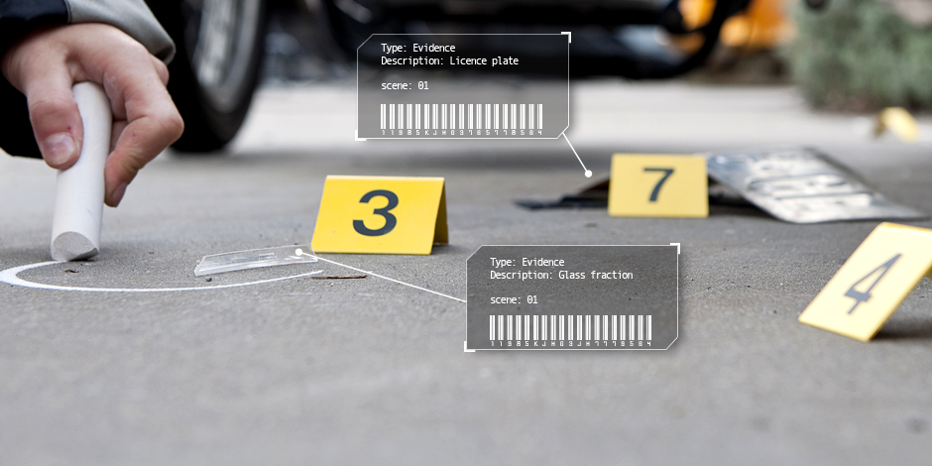
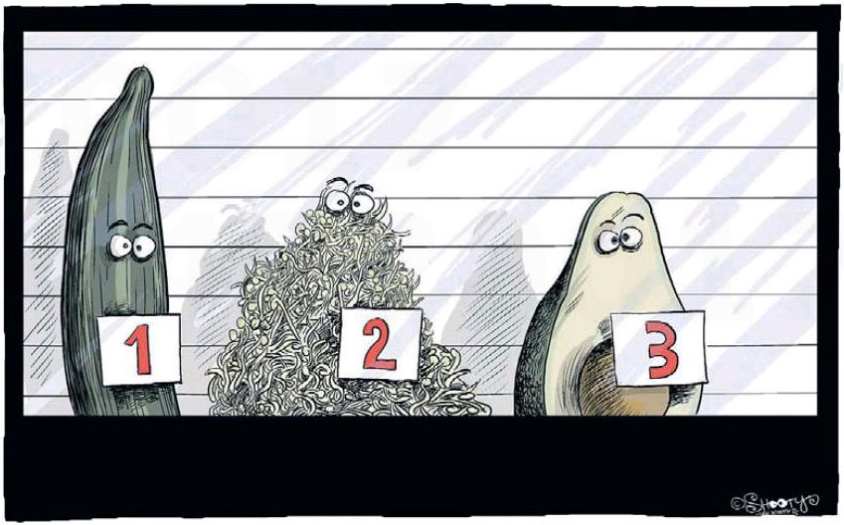

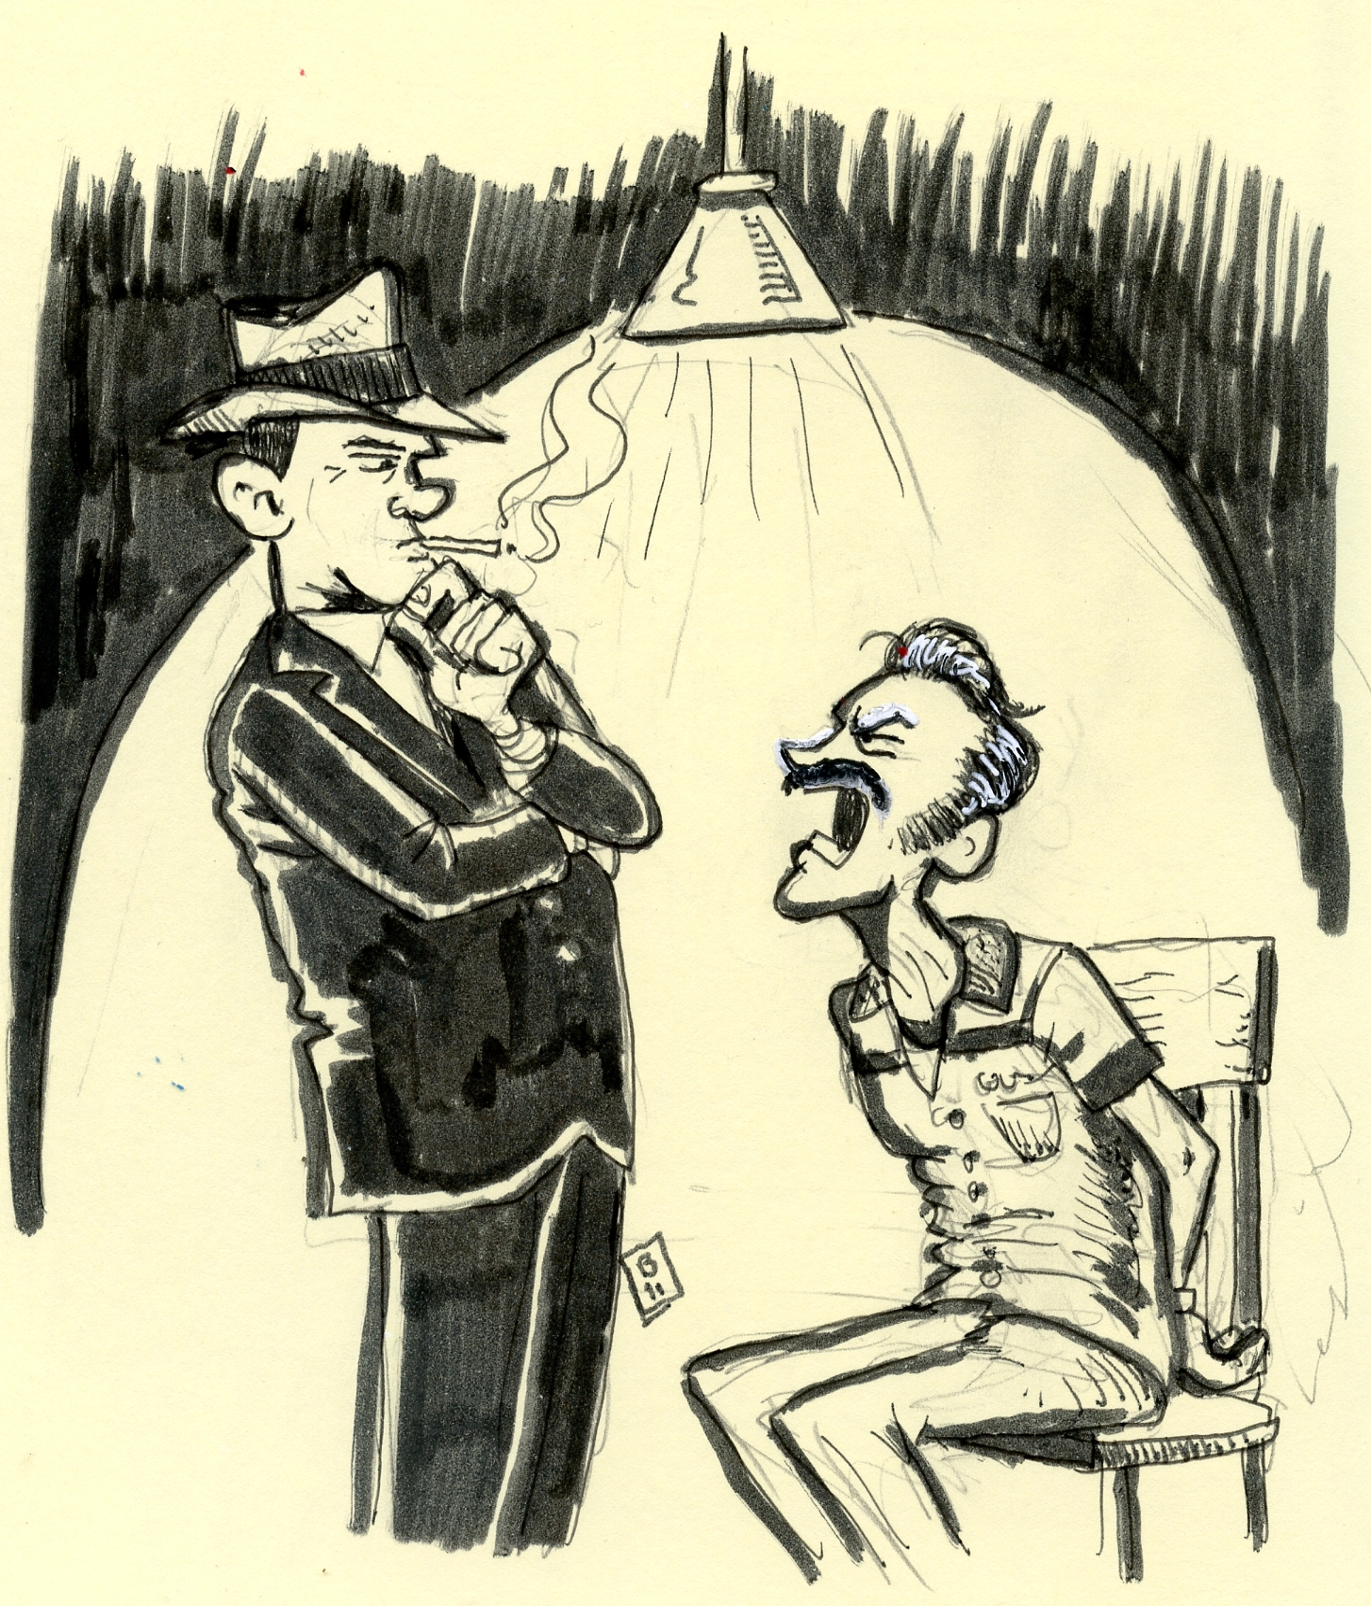
I was playing cards with my friends at his house!!!
Where were you at 1:45 p.m. last Friday?

Background Information

Last Friday at 1:45 p.m., one of your coworkers got murdered. Someone in this room killed her! Seven of you were in the office on Friday. The police found her body in the meeting room beside the reception. The last outgoing call from her cell phone was at 1:43 p.m., so she was alive at that time. Your job is to find out who killed her, when and why.

Notes

Vocabulary Exercise
Give the definition of each vocabulary words.

1. alibi:

2. witness:

3. interrogate:

4. investigation:

5. suspect:

6. evidence:

7. criminal:

8. guilty:

9. innocent:

Situation Cards

1:45 p.m. on Friday
Work ends
Work starts
Arrive at the office
Doing paperwork
On the phone for job interview
Typing on the computer
Meeting starts
Meeting ends
Drinking coffee
Having a bathroom break
Writing notes
Making coffee for coworker
Talking to Roger (your boss)
Talking to your coworker
Talking to you mom on the phone
Talking to the receptionist
Having a cigarette break
Cleaning up
Eating lunch
Before the meeting
After the meeting
Using the photocopy machine
Printing contracts
Receives a call from client
At 1 p.m.
At 1:30 p.m.
Before the class ended
Before the class began
During lunch time
Out to buy lunch
Playing games on your mobile phone
Leave notes on coworker's desk
Shopping online
Reading the newspaper
Out for a meeting with clients

