Speaking Lesson Plan
TITLE Shopping

INSTRUCTOR |  | Ss’ LEVEL |  | AGE GROUP |  | No of Ss |  | LENGTH
Rebecca |  | Pre-intermediate |  | Adult |  | 12 students |  | 50 minutes
MATERIAL
White board, Markers, Pictures #1(three copies each for the group), Picture #2 (Six copies each for the pair), Worksheet #1, #2(twelve copies each for student)
AIMS
- To practice speaking skills by making their own dialogues and discussing
- To practice expressions and vocabulary related to shopping through worksheets
LANGUAGE SKILLS
-Listening: Listening to teacher and classmates
-Speaking: Comparing and sharing ideas within groups and individual
-Reading: Comprehension worksheet
-Writing: Filling in the blanks using expressions and vocabulary
LANGUAGE SYSTEMS
-Phonology: Listening to teacher and classmates speaking
-Lexis: Learning vocabulary related to shopping
(E.g. credit card, refund etc.)
-Discourse: Understanding dialogue and discussing with classmates-
-Function: Sharing ideas through describing pictures
-Grammar: Making sentences considering grammar structure
ASSUMPTIONS
- Ss already know the Ts style of teaching and how the classroom works
- Ss are pre-intermediate level
- They are mostly inactive so T should encourage them to speak out loud
- Familiar with sharing ideas and group work.
REFERENCES
Insight Series; Greg Berrette (Published on February 15, 2012/Published by Etopia)
Google; Image searching (Shopping)
Anticipated Errors and Solutions
If Ss don’t understand key vocabularies
￫ Teacher tells them synonyms and antonyms or explains if needed. (can be used L1)
If Ss have hard time to make own story
￫ Give them some examples
PRETASK TITLE Guessing the topic
AIMS  To introduce the topic with brainstorming |  |  |  |  | MATERIALS  Picture #1, Whiteboard, marker
TIME | SET UP |  | STUDENTS |  |  |  | TEACHER
7 | Groups |  | Picture #1  -Discuss about the picture and speak out all words that come to their minds  -Try to guess what the today’s topic is |  |  |  | -Monitoring  (To check how much Ss know the vocabularies)  - Eliciting  -Write words on the whiteboard
TASK PREPARATION TITLE Words & Expressions
AIMS  To learn key vocabulary and expressions |  |  |  |  | MATERIALS  Worksheet #1
TIME | SET UP |  | STUDENTS |  |  |  | TEACHER
10 | Class |  | Worksheet #1  -Read the words out loud together  -Try to figure out key vocabulary  -Read the key expressions and try to match the sentences with the right situations |  |  |  | -Teacher will read the words and expressions first and students will follow  -Teacher will elicit
NOTES
If there are some Ss who have hard time to find the answers, teacher can tell them the meaning of vocabulary (can be used L1)
TASK REALISATION TITLE Own dialogue
AIMS  Sharing ideas with classmates |  |  |  |  | MATERIALS  Picture #2
TIME | SET UP |  | STUDENTS |  |  |  | TEACHER
10 | Pair |  | Picture #2  -Look at the pictures and try to make own dialogue |  |  |  | -Monitor
10 | Pair |  | -Role play in front of the class |  |  |  | -Feedback with class

POST TASK TITLE Worksheets #2
AIMS  Describing pictures and making own sentences |  |  | MATERIALS  Worksheet #2
TIME | SET UP | STUDENTS |  | TEACHER
8 | Group | Worksheet #2  -Try to make a story through describing pictures |  | -Monitor
5 | Group | -Speak out their own story |  | -Check the sentences and pronunciations
NOTES
If Ss have hard time to make own story, T can give them some examples.

Picture #1

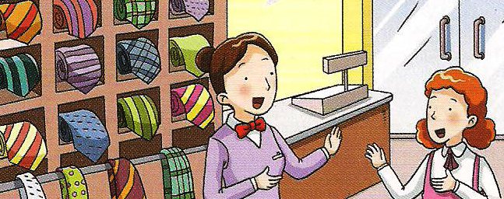

Picture #2

(A)

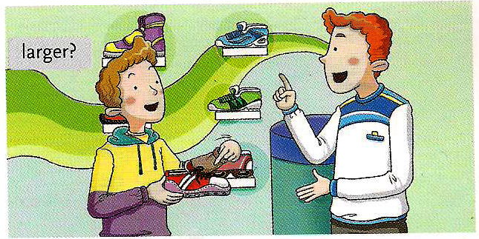
(B)

Worksheet #1

Refund

Exchange

Credit Card
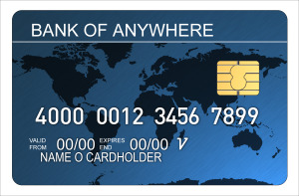

- Can I get a refund?
- Can I exchange it for another one?
- I’ll pay by credit card

★ Read the dialogues and match with the key expressions
(You have to write down the sentences)

1. W: Hello. Happy Home Shopping. How can I help you?
M: Hi, I’d like to order the washing machine you showed on TV
W: Great. How would you like to pay for it?
M:

2. M: Can I help you?
W: Yes, I bought this coat here yesterday but there’s a problem with it
M: Oh, what is it?
W: There’s one button missing
M: I see. What do you want me to do?
W: Well,
I really like this style
M: No problem.

3. W: Hello. How can I help you?
M: I bought these shoes yesterday, but they’re too small
W: Let me check. Oh I’m sorry, but we’re out of bigger sizes
M: Well,
I have the receipt here
W: Okay

Worksheet #2
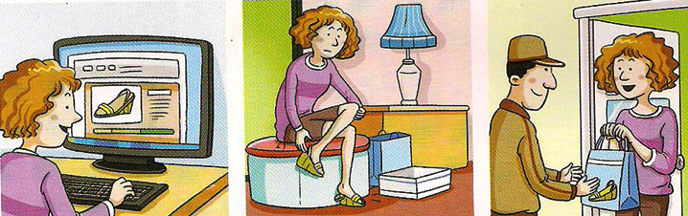

1. Look at the pictures and write all the words that come to mind

2. Look at the pictures and make a story based on them. Share your own story with classmates.

