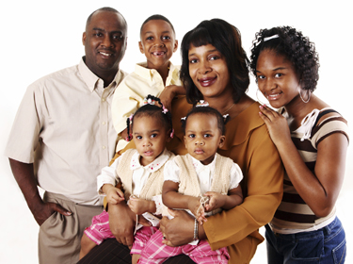
Pre-Activity
Vocabulary-Definition Matching Worksheet

Vocabularies:

- Pupils
- Beehive
- Blond
- Spiky
- Pacifier

- Mustache
- Beard
- Strapless

Definitions:

- ________: Yellow/golden hair
- ________: Hair on the chin and lower cheeks of a man's face
- ________: A rubber or plastic nipple for a baby to suck on
- ________: Place where bees live and make honey
- ________: Hair on the upper lips
- ________: The central opening in the iris of the eye
- ________: No shoulder straps
- ________: Pointy

[Answers] Vocabulary-Definition

Vocabularies:

- Pupils
- Beehive
- Blond
- Spiky
- Pacifier

- Mustache
- Beard
- Strapless

Definitions:

- ___J____: Yellow/golden hair
- ___ G___: Hair on the chin and lower cheeks of a man's face
- ____L___: A rubber or plastic nipple for a baby to suck on
- ___ I____: Place where bees live and make honey
- ___ F____: Hair on the upper lips
- ____E____: The central opening in the iris of the eye
- ____ H___: No shoulder straps
- ____ K___: Pointy

Main Activity

He has got blue eyes and blond wavy hair.
He has got a small nose with thin lips. He has got a brown moustache. He is happy.

Reading to Draw

Father
He has a big round belly due to his love for donuts and beer. He had rich black hair back when he was young, but now only has few strands left on his head. He enjoys wearing a white collared t-shirt (short sleeved), blue jeans and black shoes. He has big eyes but has small black pupils. He has small ears and has a short brown beard around his lips. He has yellowish skin.

Mother
She usually wears a strapless green dress, red flat shoes, and a tight red pearl necklace. She has big eyes but has small black pupils. She has beautiful long eyelashes. Her hair is very long and curvy. She likes to put her blue hair up and tall similar to the shape of the beehive. She has yellowish skin.

Eldest Child
He has blond spiky hair. He wears an orange short-sleeved shirt, blue short pants, and blue-white shoes. He has big eyes but has small black pupils. He has yellowish skin.

Second Child
She usually wears an orange strapless dress, a white pearl necklace, with her orange sandals. Her hair is blond, and has a 'starfish' like hairstyle. She has big eyes but has small black pupils. She has beautiful eyelashes. She has yellowish skin.

Youngest Child
Her hair is blond, and has a 'starfish' like hairstyle. She wears a small blue ribbon hairpin at the center of her head. She has big eyes but has small black pupils. She has beautiful eyelashes. She wears her blue long-sleeve sleeping dress. She always has her orange pacifier in her mouth. She has yellowish skin.
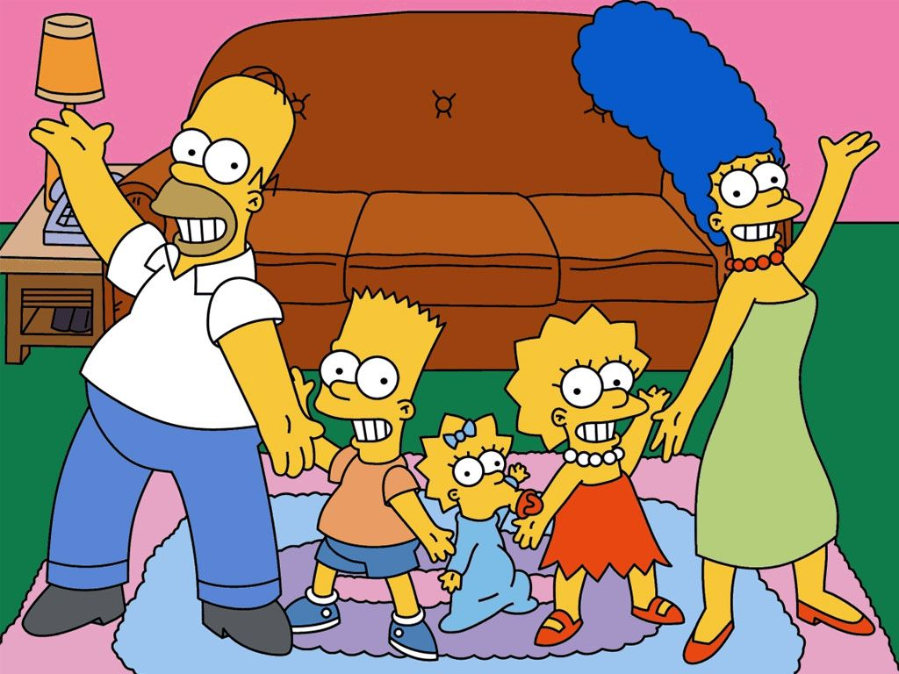
Lisa ♥ Milhouse

Post Activity
Put in the Correct Order

“Tomorrow will be the best day of my life,” Lisa said. “Yes, it will be,” said her mom. “I’m so happy for you. Milhouse is such a good man. He will make a great husband and father. And he’s so nice. Your dad and I both love him.” Lisa met Milhouse after she broke her leg.

They fell in love with each other. “I never thought a broken leg would be a good thing,” Lisa told her mom.

After Lisa’s leg healed, she and Milhouse started dating. They went to the movies and restaurants. They went to the beach.

She broke her leg skiing. Milhouse was the doctor who fixed her leg. He visited her every day in the hospital. Then he visited her at home. He brought her Get Well cards and gifts.

“But it was the best thing that ever happened to you. Life is strange sometimes,” her mom replied.

They even went skiing. They were so happy together. One day Milhouse asked Lisa to marry him. “Can we have lots of kids?” she asked. “Of course! But let ME teach them how to ski” he replied. They both laughed.

[Answers] Put in the Correct Order

1-3-5-2-4-6

Original Text

“Tomorrow will be the best day of my life,” Lisa said. “Yes, it will be,” said her mom. “I’m so happy for you. Milhouse is such a good man. He will make a great husband and father. And he’s so nice. Your dad and I both love him.” Lisa met Milhouse after she broke her leg.

She broke her leg skiing. Milhouse was the doctor who fixed her leg. He visited her every day in the hospital. Then he visited her at home. He brought her Get Well cards and gifts.

They fell in love with each other. “I never thought a broken leg would be a good thing,” Lisa told her mom.

“But it was the best thing that ever happened to you. Life is strange sometimes,” her mom replied.

After Lisa’s leg healed, she and Milhouse started dating. They went to the movies and restaurants. They went to the beach.

They even went skiing. They were so happy together. One day Milhouse asked Lisa to marry him. “Can we have lots of kids?” she asked. “Of course! But let ME teach them how to ski” he replied. They both laughed.

