Reading Lesson Plan
TITLE Flight Fee for the Obese

INSTRUCTOR |  |  | Ss’ LEVEL |  | AGE GROUP |  | No of Ss |  | LENGTH
Rebecca |  |  | Upper-intermediate |  | Adult |  | 12 students |  | 50 minutes
MATERIAL
White board, Markers, Picture #1 (three copies each for the group), Worksheet #1 (six copies each for the pair), Worksheet #2, #3 (twelve copies each for the student), Worksheet #4 (three copies each for the group)
AIMS
- Ss will be able to get the main idea through skimming the passage
- Ss will practice speaking by discussing with classmates
- Ss will remember the details of the story
- Ss will improve scanning skill by answering the detail questions
LANGUAGE SKILLS
-Reading: Comprehension and reading worksheet
-Listening: Listening to teacher’s instructions and classmates
-Speaking: Comparing and sharing ideas within groups and individual
-Writing: Answering the questions and filling in the blanks
LANGUAGE SYSTEMS
-Phonology: Listening to teacher and classmates speaking
-Lexis: Learning vocabulary related to topic
(E.g. obese, excess, overweight etc.)
-Discourse: Expressing opinion
-Function: Giving and receiving opinions, debating
ASSUMPTIONS
- Ss already know the Ts style of teaching and how the classroom works
- Ss are Upper-intermediate level
- Ss are familiar with sharing ideas and group work.
-There are a few slower learners so T should monitor them to check their comprehension
- Ss have already known some vocabulary in the story
-Ss are mostly active.
REFERENCES
Reading Forward for knowledge; Dong-sook Kim
(Published 5th January 2011 /Published by Neungyule Education)
Anticipated Errors and Solutions
Ss don’t understand key vocabulary
￫T tells example sentences using the key vocabularies.
Ss may not be able to pick up details from the reading
￫Chunk the story and give them more time to read
PRETASK TITLE Guessing the topic
AIMS  To introduce the topic through brainstorming |  |  |  |  |  | MATERIALS  Picture #1 (three copies each for the group), Whiteboard, marker
TIME | SET UP |  |  | STUDENTS |  |  |  | TEACHER
5 | Groups |  |  | Picture #1  -Discuss about the picture  -Try to guess what the today’s topic is |  |  |  | -Monitor  - Elicit  -Write words on the whiteboard
TASK PREPARATION TITLE Vocabulary
AIMS  To learn key vocabulary |  |  |  |  |  | MATERIALS  Worksheet #1
TIME | SET UP |  |  | STUDENTS |  |  |  | TEACHER
8 | Pairs |  |  | Worksheet #1  -Fill in the blanks  -Read own answers to classmates |  |  |  | - Monitor  -Check answers  (give correction)
NOTES
While filling in the blanks, Ss can share the answers
￫ If there are some difficult words, Ss will discuss about them
TASK REALISATION TITLE Reading the topic
AIMS  To get the main idea and remember the details |  |  |  |  |  | MATERIALS  Worksheet #2, Worksheet #3
TIME |  | SET UP |  | STUDENTS |  |  |  | TEACHER
5 |  | Class |  | Worksheet #2  -Skim passages for 10 seconds  - After skimming, tell T and classmates what they learned |  |  |  | -Monitor
10 |  | Class |  | Worksheet #2  -Read the text and try to remember the details |  |  |  | -Monitor
10 |  | Class |  | Worksheet #3  - Read again for detail and answer the questions.  - Tell classmates the answers |  |  |  | -Monitor  -Check answers

POST TASK TITLE Debating
AIMS  To tell Ss’ own opinion about the topic |  |  | MATERIALS  Worksheet #4
TIME | SET UP | STUDENTS |  | TEACHER
12 | Group | -Tell own opinion about the topic  -After debating, write names and opinion |  | -Monitor

Picture #1. (group -3)
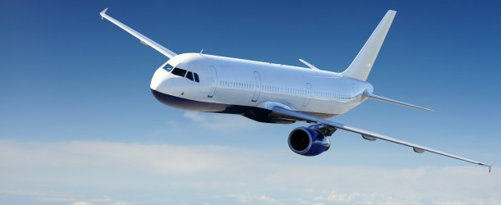
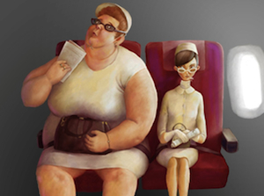

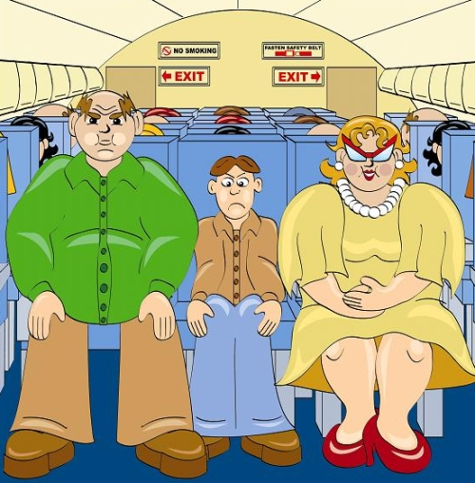
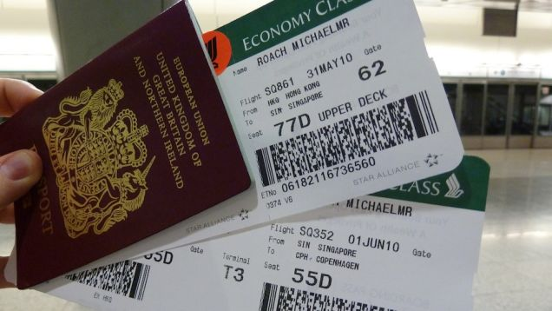

Worksheet #1
charge obese passenger debate discomfort complaint excess offensive
- Fill in the blanks with the correct words

- Something that is upsets or embarrasses people because it is rude

- If someone is , they are extremely fat.

- A in a vehicle such as a bus, boat, or plane is a person who is travelling in it, but who is not driving it or working on it.

- is an expression of regret, pain, dislike

- is a discussion about a subject on which people have different views.

- is a painful feeling in part of your body when you have been uncomfortable for a long time.

- of something is a larger amount than is needed, allowed, or usual.

- is an amount of money that you have to pay for a service.

Worksheet #2 (12)

Flight Fee for the Obese

Some airlines started charging obese passengers more than others. They must buy two seats if they can’t fit into one. Some students are debating this issue.

Robert: I think every passenger has the right to have a comfortable trip. However, when extremely large people sit next to you, you have to share your seat, which can be uncomfortable. I heard that last year some Airlines in America received hundreds of discomfort complaints for this reason. Airlines had to do something to fix this problem!

Sophie: Airlines don’t care about obese customers. This is not how service companies are supposed to act. Instead of charging them more, airlines could have made some effort to offer them bigger seats! Disneyland in California, for instance, made their ride seats larger to fit the needs of their big-sized customers. Airlines should learn from them.

Cathy: As a business, an airline must consider high gas prices. The heavier the plane is, the more gas it uses. That’s why they charge more for excess baggage. So why not for people? If a person weighs so much that the airline must pay more for gas, then that customer should share the burden!

Daniel: I don’t think human beings should be compared with baggage. Charging them more for being too fat is rude and offensive. What’s more, in many cases being obese isn’t a matter of choice. Many obese people aren’t overweight simply because of a lack of self-control when it comes to food. Instead, it’s a serious medical condition. These people need extra care, not another embarrassing situation.

Worksheet #3
Comprehension
1. Who supports charging obese passengers more money? (Choose two)
① Robert ② Sophie ③ Cathy ④ Daniel

2. What does Sophie say airlines should learn from Disneyland?
① How to increase profits
② How to please customers
③ How to avoid obese customers
④ How to make new facilities safer

3. Daniel thinks obese passengers need extra care because

4. Who agrees with the following idea?
It’s reasonable that airline companies follow economic principles

① Robert ② Sophie ③ Cathy ④ Daniel

5. One word in each sentence is not correct. Find the word and cross it out and write the correct word.
a comfortable
① Robert thinks every passenger has the right to have an uncomfortable trip

② Roberts heard that last year some Airlines in Korea received hundreds of discomfort complaints.

③ Sophie thinks airlines care about obese customers

④ Cathy thinks the lighter the plane is, the more gas it uses

⑤ Daniel thinks charging the obese more for being too fat is polite and offensive

Worksheet #4
Charging Obese Passenger More Money
PROS | CONS
Robert:  1. Sitting next to obese passengers causes discomfort  2. Many people complain for this reason | Sophie:  1. Airlines should care about obese passengers.  2. Bigger seats are needed for them
Cathy:  1. The heavier the plane is, the more gas it uses  2. Obese people have to share the costs of gas | Daniel:  1. It’s rude and offensive to obese people  2. Obesity is a serious medical condition, so these people need more attention

