Grammar Lesson Plan
TITLE Comparative

INSTRUCTOR |  |  | Ss’ LEVEL |  | AGE GROUP |  |  | No of Ss |  | LENGTH
Rebecca |  |  | Upper beginner |  | Adult |  |  | 12 students |  | 50 minutes
MATERIAL
White board, Markers, Picture 1-6 (1copies each), Scotch tape, Projector, Worksheet #1, #2, #3 (6copies each for the pair)
AIMS
- Ss will be able to know the form of comparative through understanding teacher’s explanation and doing the worksheets
- Ss will make comparative sentences by describing pictures and charts
- Ss will make grammatically correct sentences through worksheets
LANGUAGE SKILLS
-Reading: Worksheets instructions & questions
-Listening: Listening to teacher’s instructions and classmates
-Speaking: Making comparative sentences
-Writing: Answering the questions
LANGUAGE SYSTEMS
-Phonology: Listening to teacher and classmates speaking
-Grammar: Making comparative sentences
-Lexis: Learning more adjectives
-Discourse: Sharing their sentences using comparative form
ASSUMPTIONS
- Ss already know the Ts style of teaching and how the classroom works
- Ss are familiar with sharing ideas and group work.
- Ss have already known some adjectives
Anticipated Errors and Solutions
Ss don’t understand vocabulary
→T tells example sentences using the vocabulary
Ss may not clearly understand the form of comparative
→ provide more examples
Ss may have a hard time drilling
→ error correct immediately & give Ss more chances to practice
REFERENCES
- Bricks Smart Grammar 2 -Publisher: Chul Ho Yoon
-Published by Sahoipyoungnon Publishing Co.,Inc.
(Bricks Education)
- Google image searching
- http://www.eflnet.com/tutorials/adjcompsup.php
PRETASK TITLE Review adjectives
AIMS  To Remind adjectives that learned in previous lesson |  |  |  |  |  |  | MATERIALS  Picture 1-6(1copies each), Scotch tape, Whiteboard, Marker
TIME | SET UP |  |  | STUDENTS |  |  |  |  | TEACHER
5 | Class |  |  | Picture 1-6  -Ss will guess some words looking at the pictures on the whiteboard  -Ss will complete the sentences |  |  |  |  | -Elicit  -Make sentences with blanks
TASK PREPARATION TITLE How to make the comparative form
AIMS  To learn the comparative form |  |  |  |  |  |  | MATERIALS  Whiteboard, Markers, Projector, Worksheet#1 (6copies each for the pair)
TIME | SET UP |  |  | STUDENTS |  |  |  |  | TEACHER
5 | Class |  |  | -Ss will learn what comparative is through teacher’s explanation |  |  |  |  | -Explain what comparative is  -Explain how to make comparative form
8 | Pair |  |  | Worksheet #1  -Ss will learn how to make comparative form  and practice through worksheet  -Ss will write their own answers on the board (projector) |  |  |  |  | -Demonstrate using projector  -Monitor  -Give correction
NOTE
T should monitor closely if there are some students who have hard time to complete the worksheet #1
￫ give Ss more explanation and examples
￫ encourage them to finish the worksheet
TASK REALISATION TITLE Comparative sentences
AIMS  To make comparative sentences through practicing on worksheets |  |  |  |  |  |  | MATERIALS  Material #1, Worksheet #2,Worksheet#3 (6copies each for the pair), Projector, Whiteboard, Markers
TIME |  | SET UP |  | STUDENTS |  |  |  |  | TEACHER
5 |  | Class |  | Material #1 (projector)  -Ss will look at the board and listen to teacher  -Ss will try to answer the questions and fill in the blanks |  |  |  |  | -Show them how to make comparative sentences through giving examples
12 |  | Pair |  | Worksheet #2  -Ss will practice making sentences through filling in the blanks  -After finishing worksheet, Ss will write their own answers on the board (projector) |  |  |  |  | -Monitor  -give correction
8 |  | Pair |  | Worksheet #3  -Ss will make their own charts and sentences with partner |  |  |  |  | -Monitor
POST TASK TITLE Sharing
AIMS  To share the chart and sentences with class |  |  |  |  |  | MATERIALS  Worksheet #3
TIME | SET UP |  |  | STUDENTS |  |  |  |  | TEACHER
7 | Class |  |  | Worksheet #3  -Ss will share their comparative sentences with classmates |  |  |  |  | -Monitor

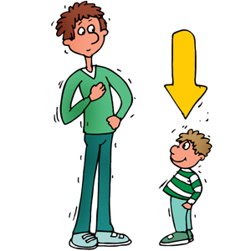
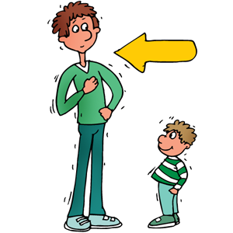

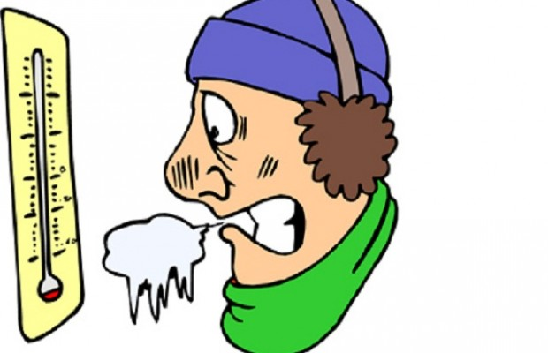
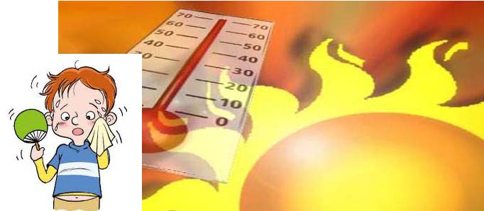

Worksheet #1

Forming Comparative
One-Syllable Adjective | Comparative Form
- old
- young
- fast
One-Syllable Adjective with Final -e | Comparative Form
- large
- wise
- nice
One-Syllable Adjective Ending with a Single Consonant with a Single Vowel before It | Comparative Form
- hot
- big
- thin
Two-Syllable Adjective Ending with -y | Comparative Form
- happy
- heavy
- busy
Adjectives with three or more syllables | Comparative Form
- beautiful
- expensive
- important

Worksheet #2 (using projector to write correct answer)
1. Write the adjectives of city life or country life in the right boxes. Then write comparative sentences below.
fast slow loud quiet
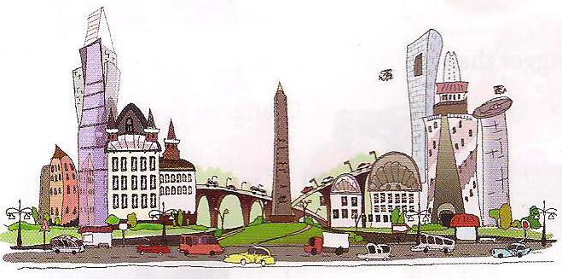  City life: fast, | 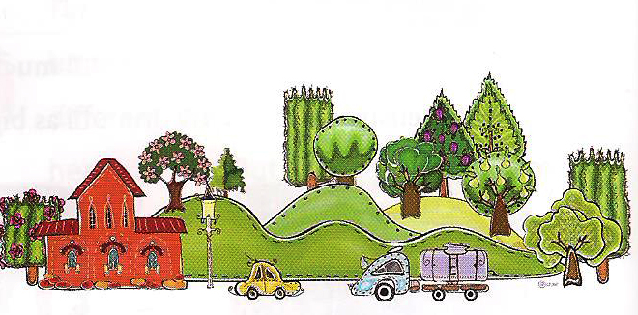  Country life:

(1) City life is than country life
(2) City life is country life
(3) Country life is city life
(4) Country life is city life

2. Look at the chart and make sentences comparing the children
 | Age | Height | Weight
Jane | 12 | 105cm | 40kg
Mary | 10 | 100cm | 38kg
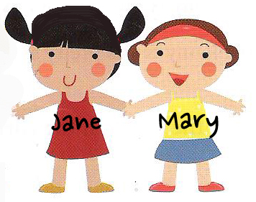
(1) Jane is
(2) Jane is
(3) Jane is
(4) Mary is
(5) Mary is
(6) Mary is
Worksheet #3

★Make your own chart and sentences

(1)
(2)
(3)
(4)
(5)
(6)

John | Mike
180cm | 175cm
- John is than Mike
- Mike is than John
Teaching material #1 (using projector)
Tina | Jenny
30 years old | 28 years old
- Tina is Jenny
- Jenny is Tina
Train | Plane
70 km/h | 700 km/h
- Train is
- Plane is

